IDE-LAB: BATCH 5

Platform used: Spyder and VS-code

Batch Numbers:

MADHURI BOMMI - 121810318030

YASHO MOULI - 121810318034

VISHNU VARDHAN - 121810318036

BAISA ROHAN - 121810318037

SAI KISHORE - 121810318043

ProblemStatement – MP3 player

A desktop application to play mp3 songs available in your pc

Scenarios testing and working:

1. Playing selected songs, controlling volume(working)
2. Mute , pause and play buttons (working)

Enhancements Needed:

1. Add a create playlist option and shuffle, repeat songs

Source code:

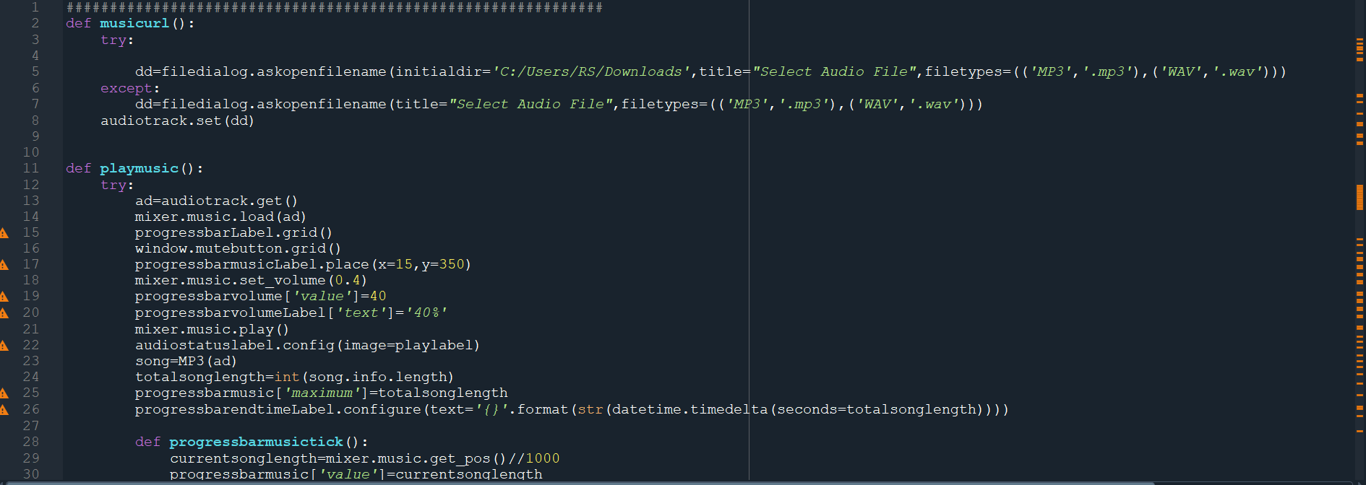

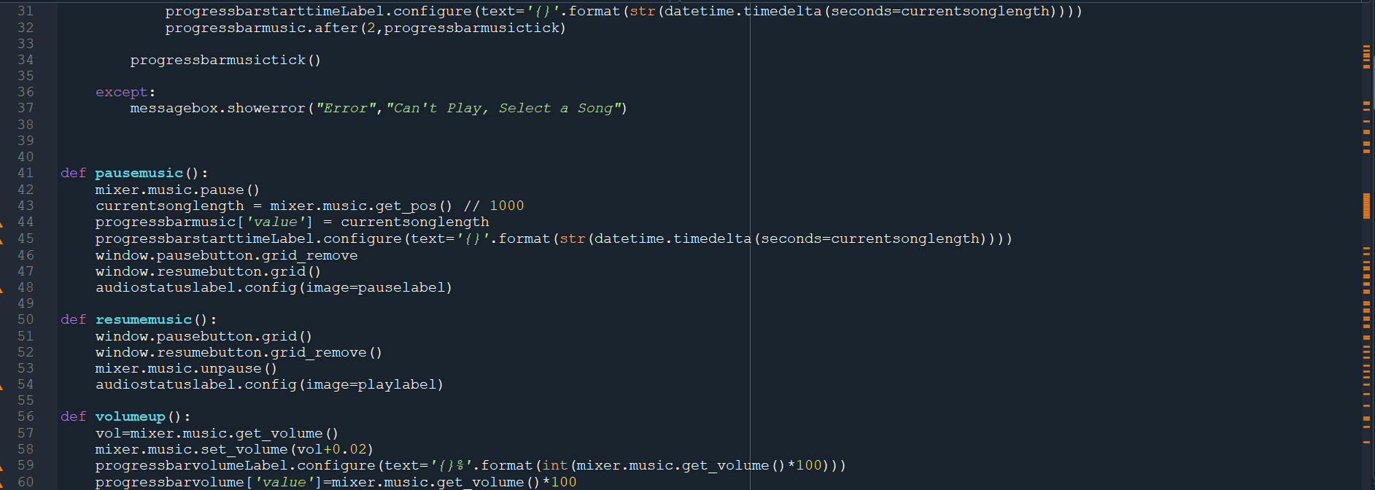

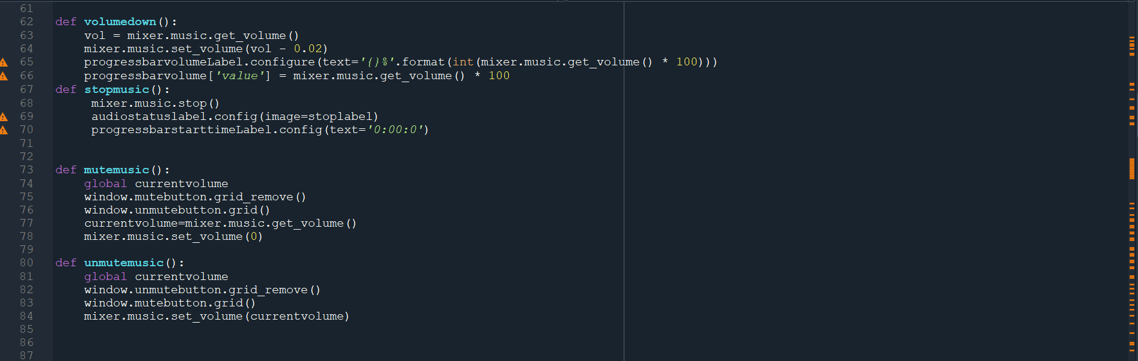

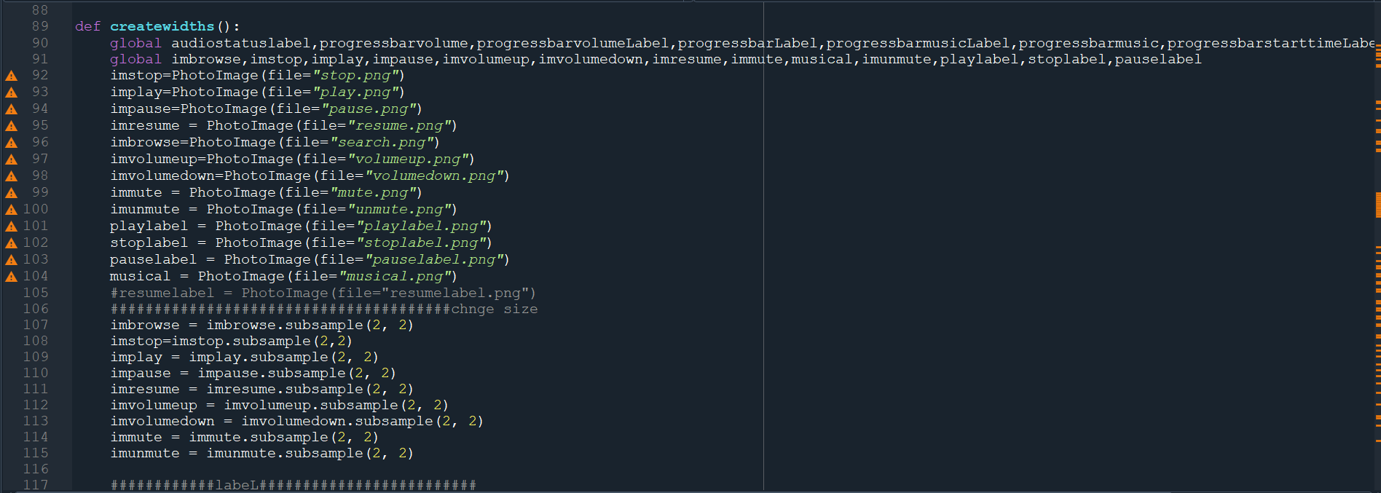

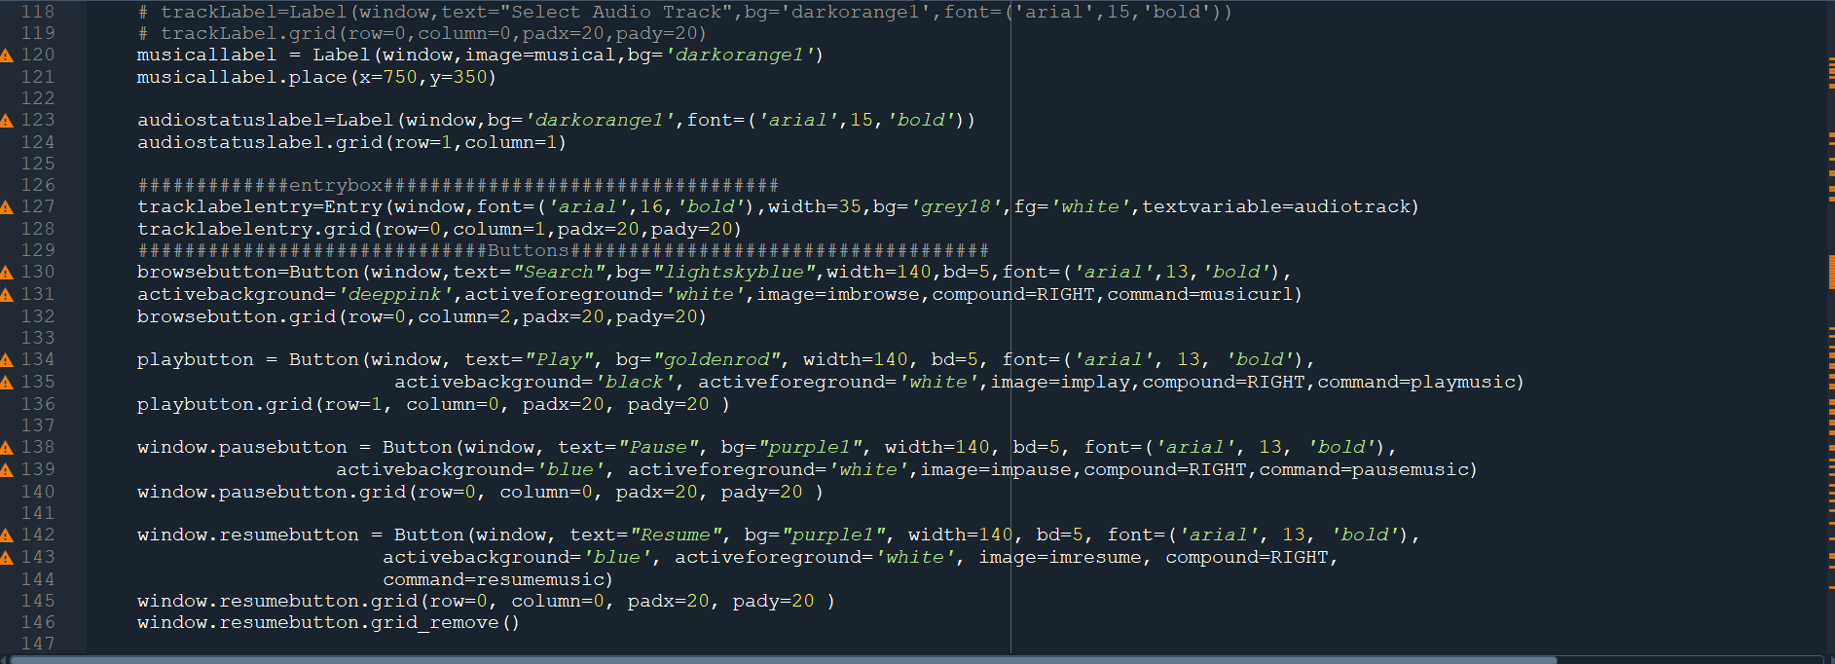

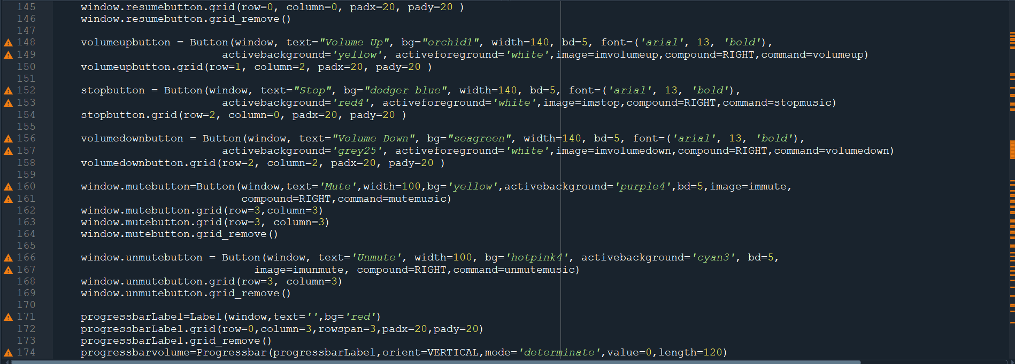

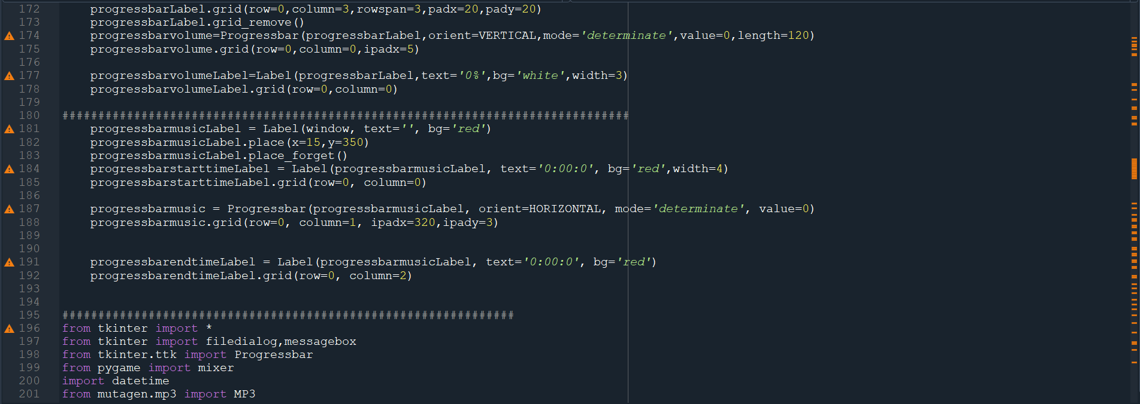

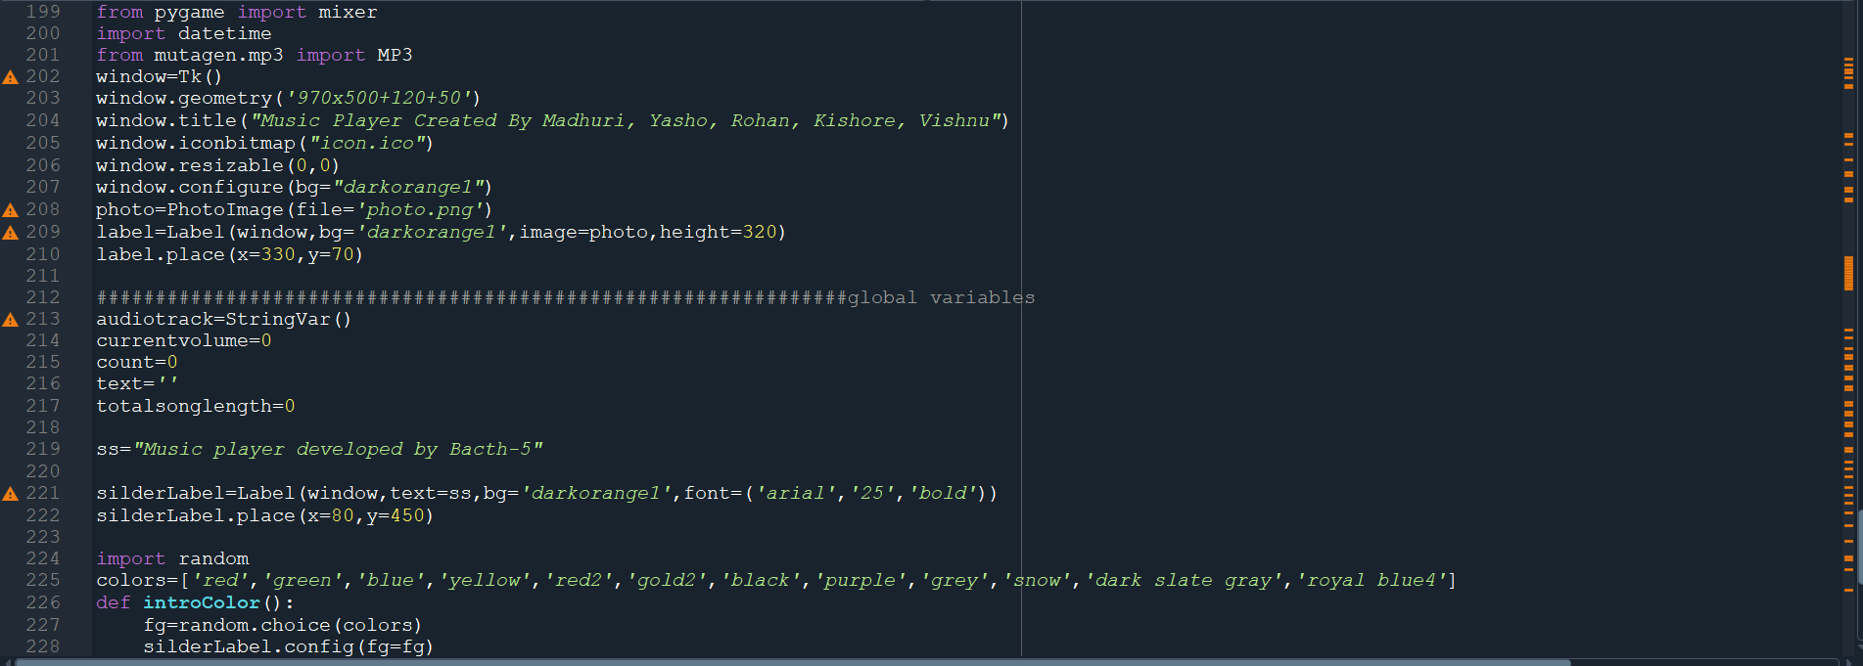

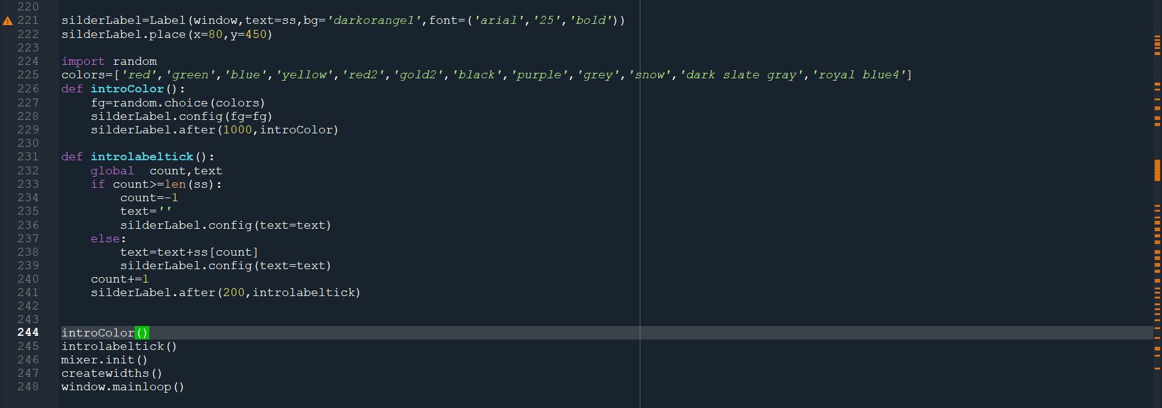

Output:

