Assignment – 9.3

Task – 1:

Code:

Output:

Task – 2:

Code:

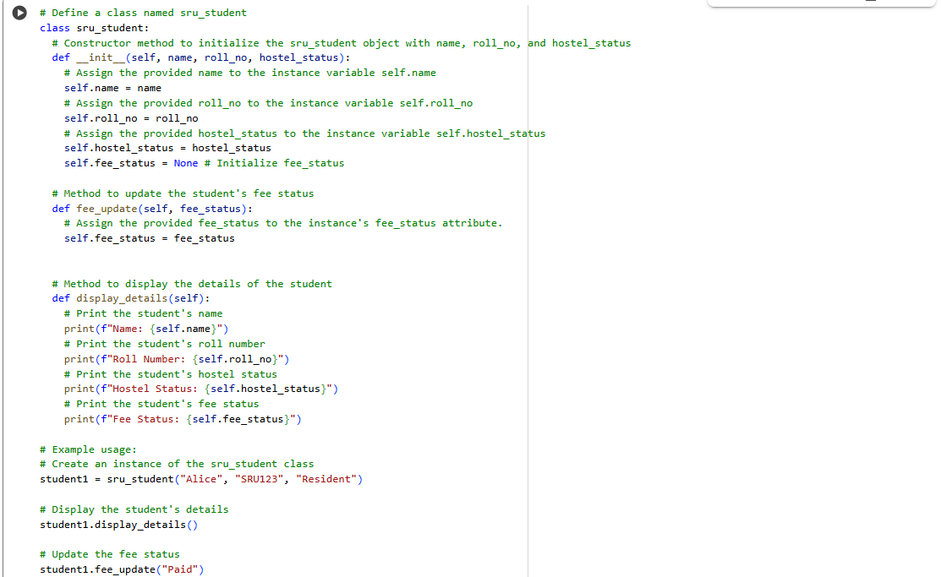

Output:

Task – 3:

Code:

Output:

\*\*\*\*\*