Step 1:

<https://gradle.org/install/>

Step 2:

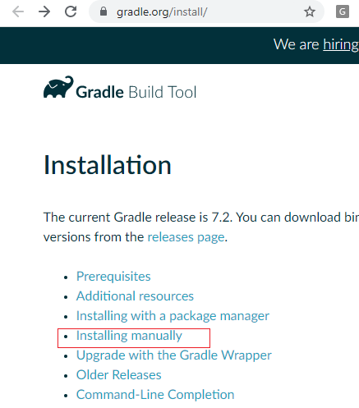

Step 3:

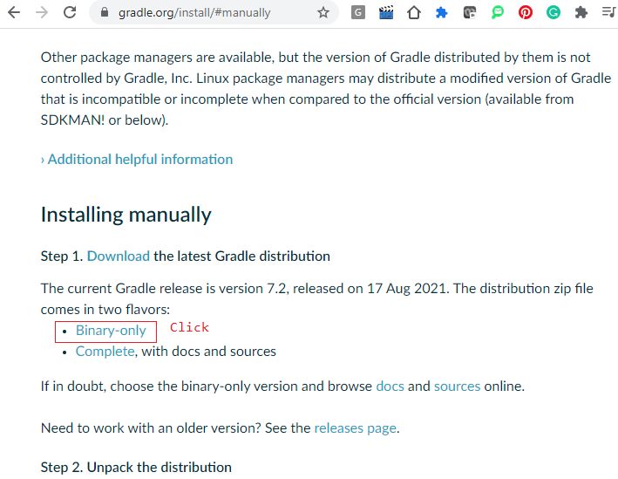

Unzip Software then go to bin folder

Step 4 : Set to path

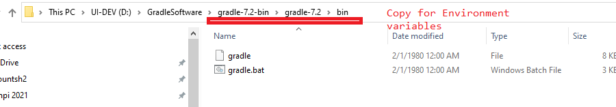

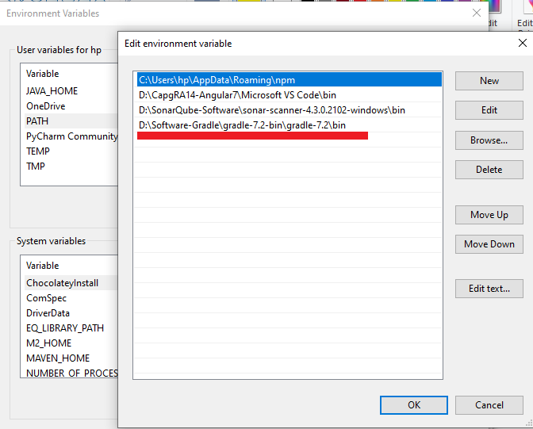

Step 5 : Set GRADLE_HOME

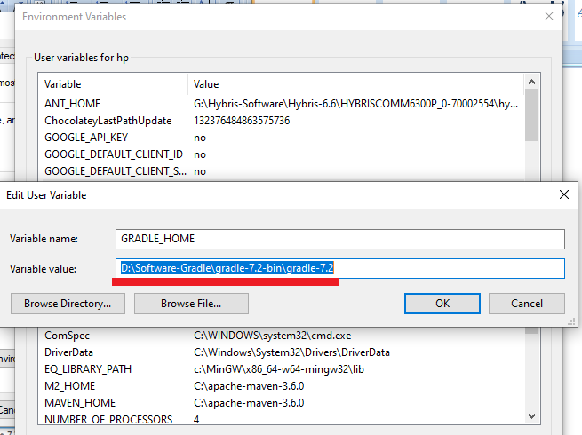S

Setp 6: Check Version c:\>gradle v

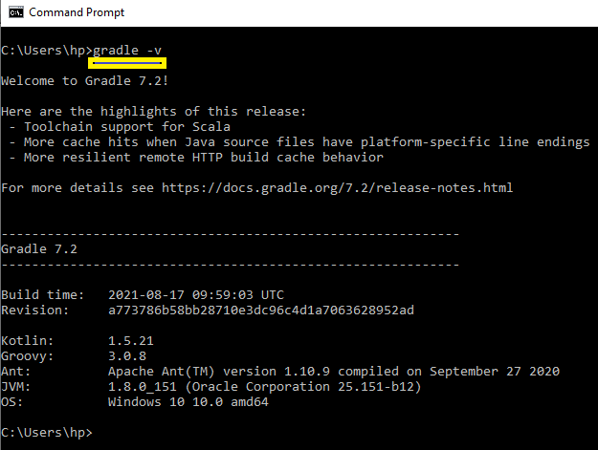

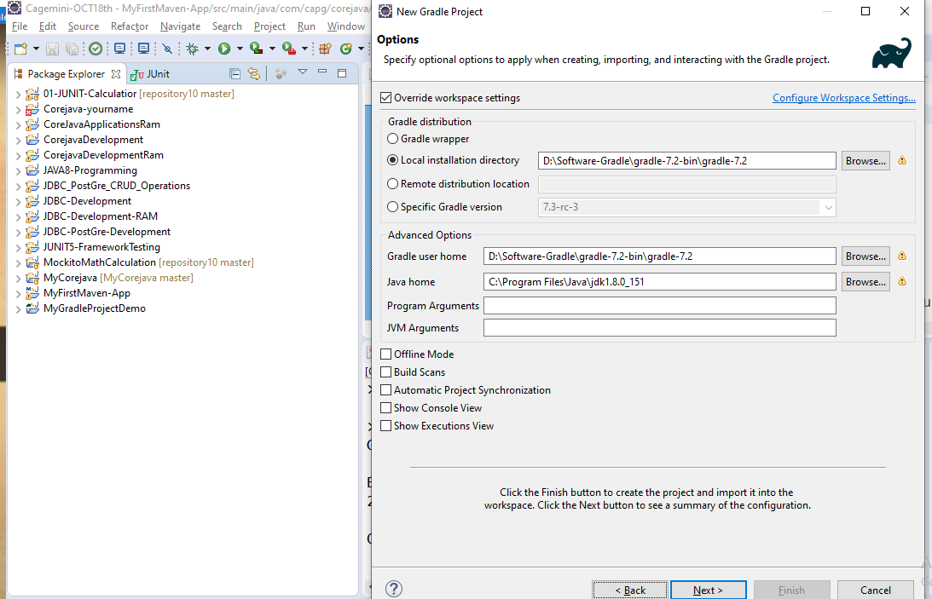

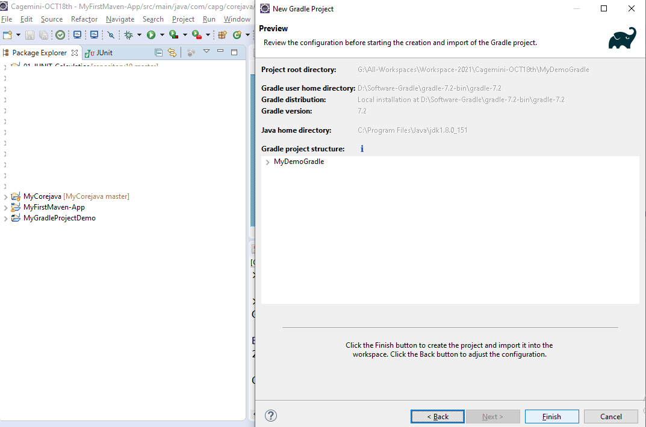

Download mysql depency from net

<https://mvnrepository.com/artifact/mysql/mysql-connector-java/5.1.5>

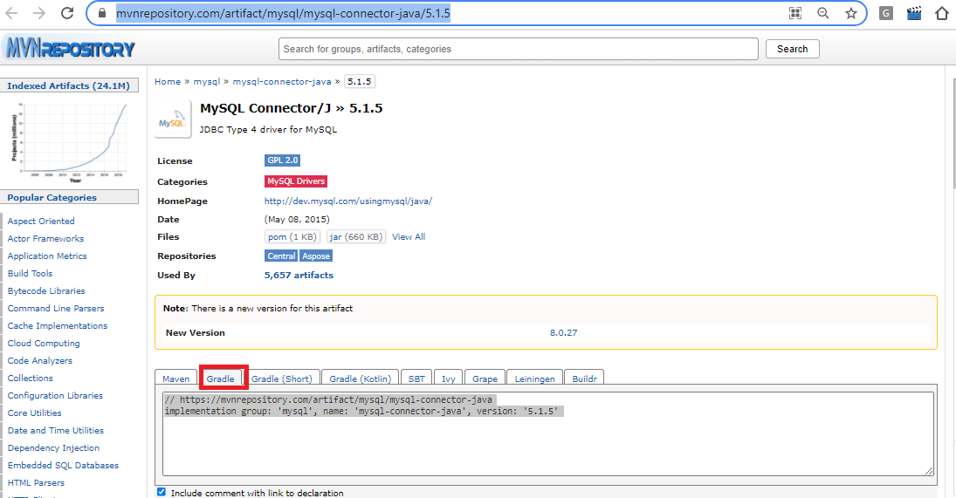

How to add dependency to Gradle

Got to build.gradle file

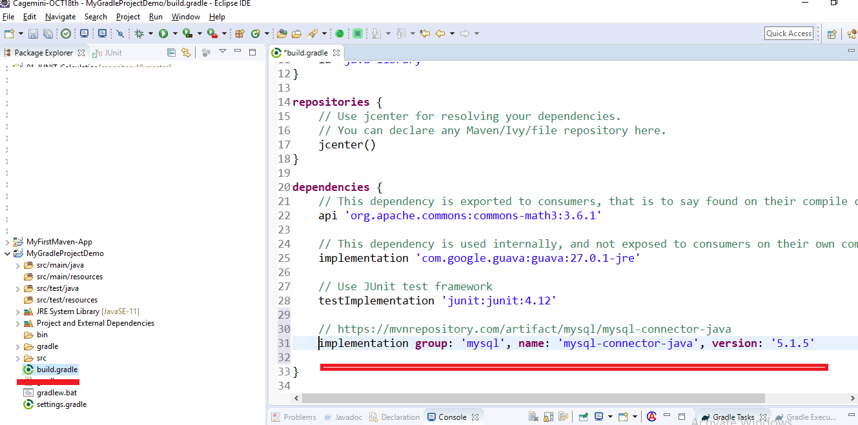

Refresch build.gradel file

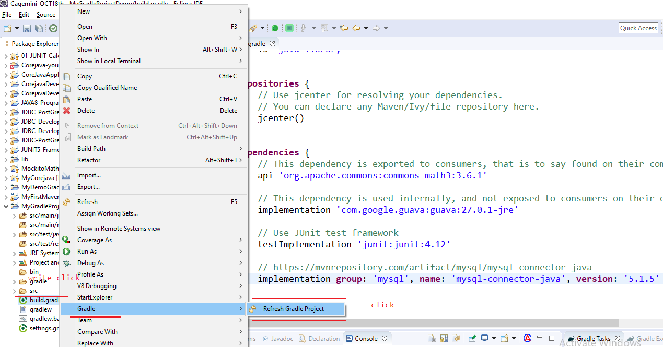

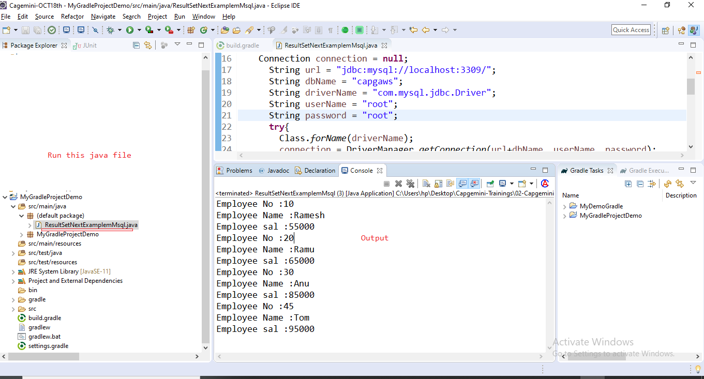s