# Name: B. Vishnu Vardhan

# Roll no: 2403A510F2

# Branch:CSE

# Batch:06

# Task Description#1

* Try 3 different prompts to generate a factorial function.

# Expected Output#1

* Comparison of AI-generated code styles

Prompt-1:

Generate a function that prints factorial of a given number

Code:

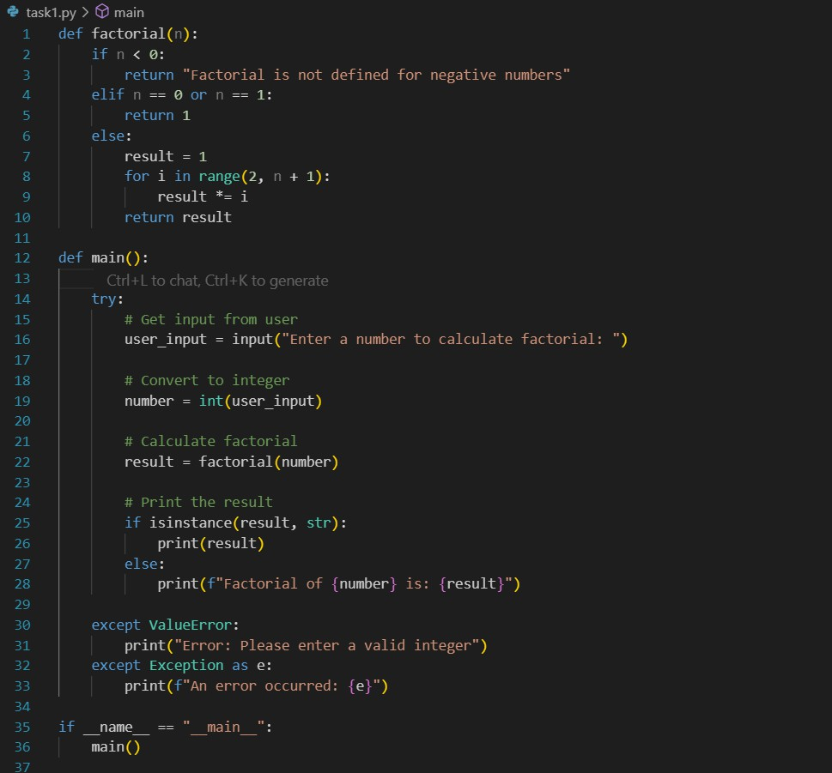

Output:

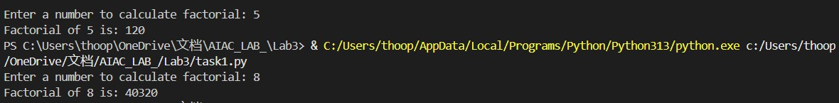

Prompt 2:

Write a simple python function to find factorial of a number ,collect input from the console

Code:

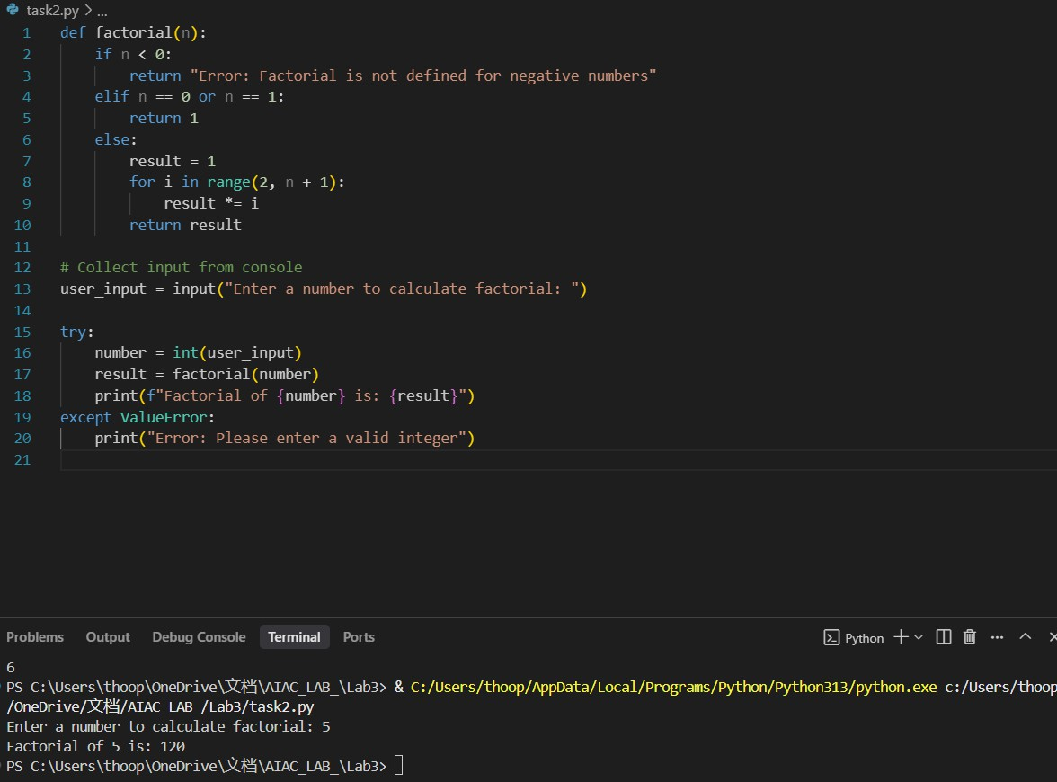

Prompt-3:

Create a simple python function that gives factorial of a number,use input from the programmer

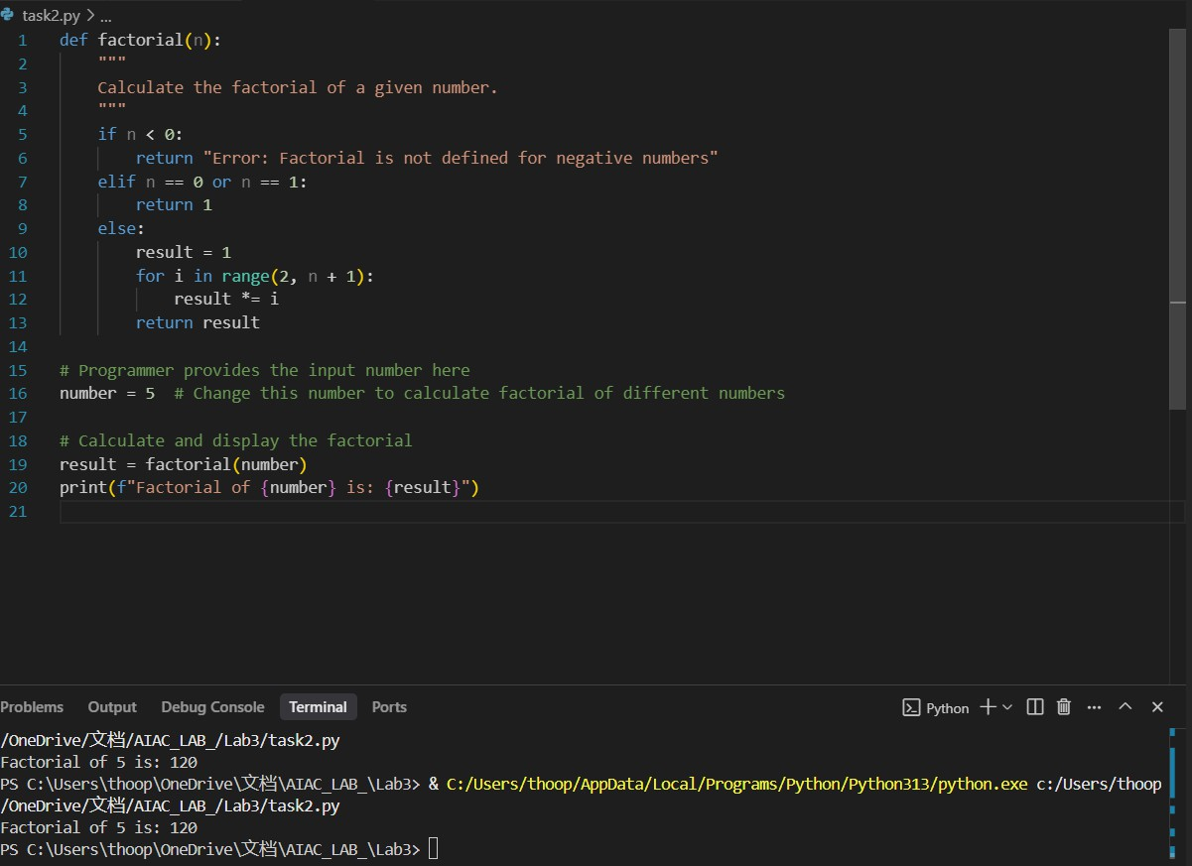

# Task Description#2

* Provide a clear example input-output prompt to generate a sorting function.

# Expected Output#2

* Functional sorting code from AI

Prompt:

Generate a python code that takes a input list from the user and sort the list Ascending order

Code along with output:

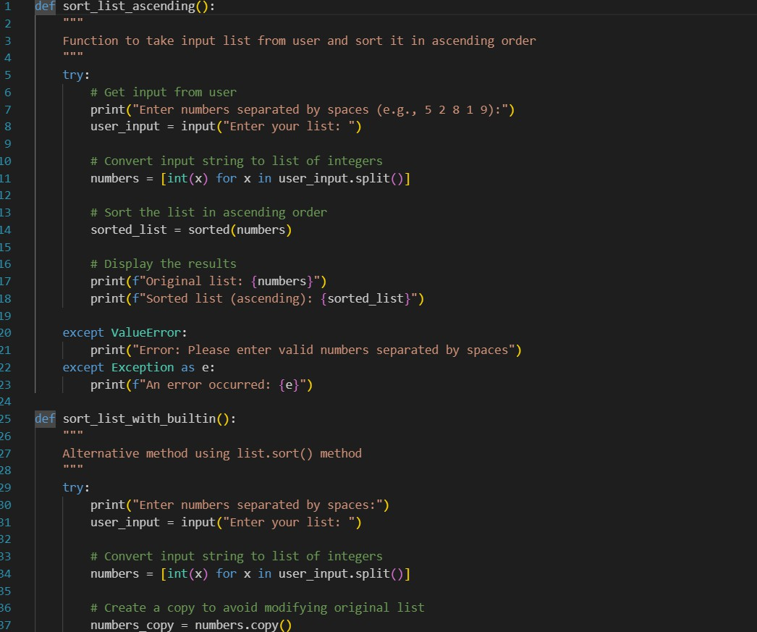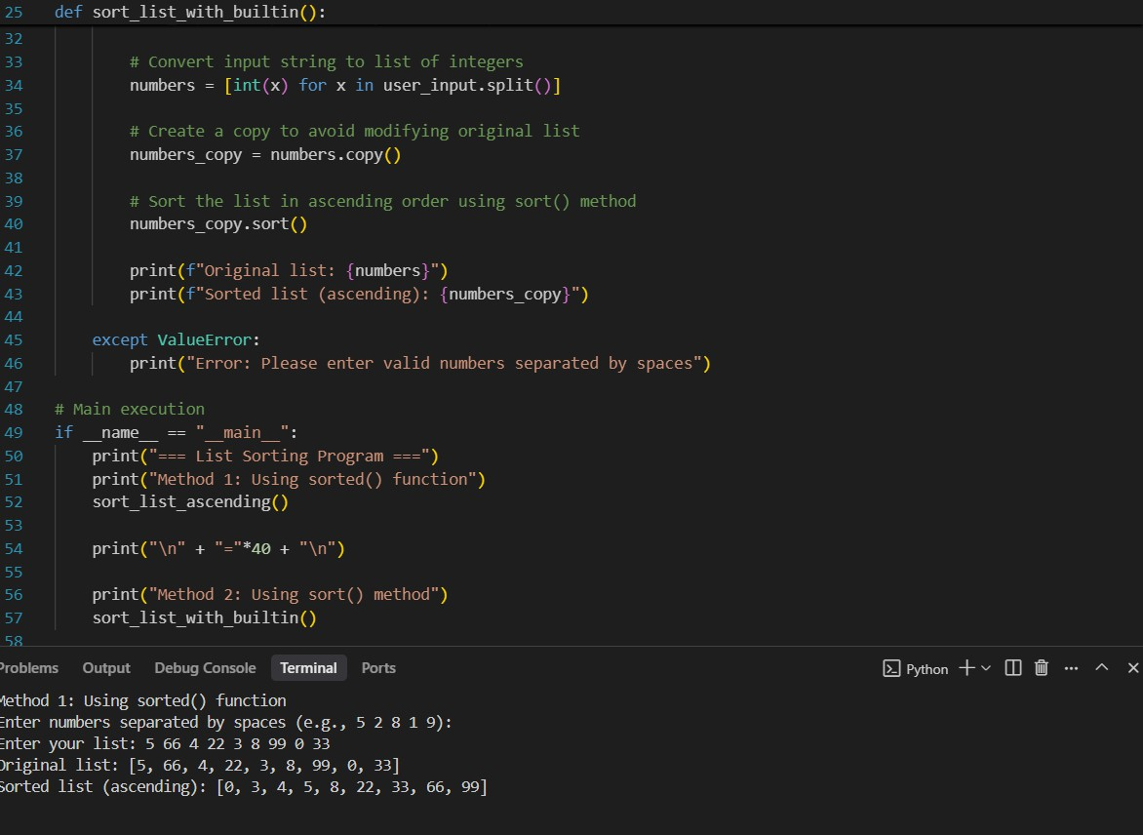

# Task Description#3

* Start with the vague prompt “Generate python code to
* calculate power bill” and improve it step-by-step

# prompt:

**generate a python code to calculate powerbill containing previous units**

**,present units ,read input units from the console**

code:

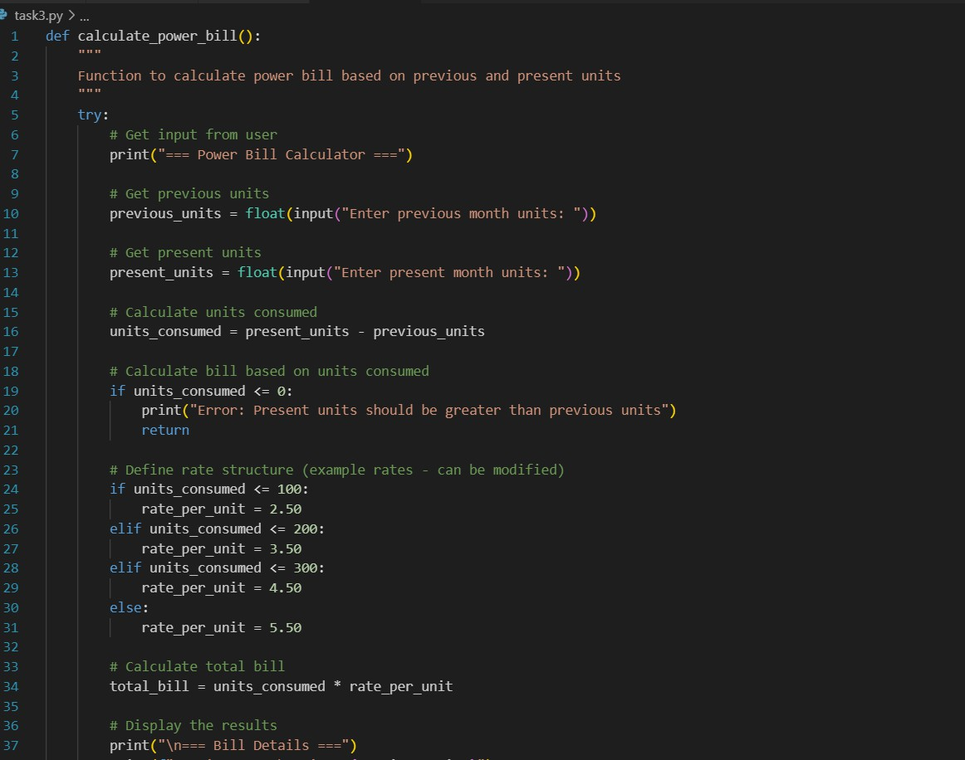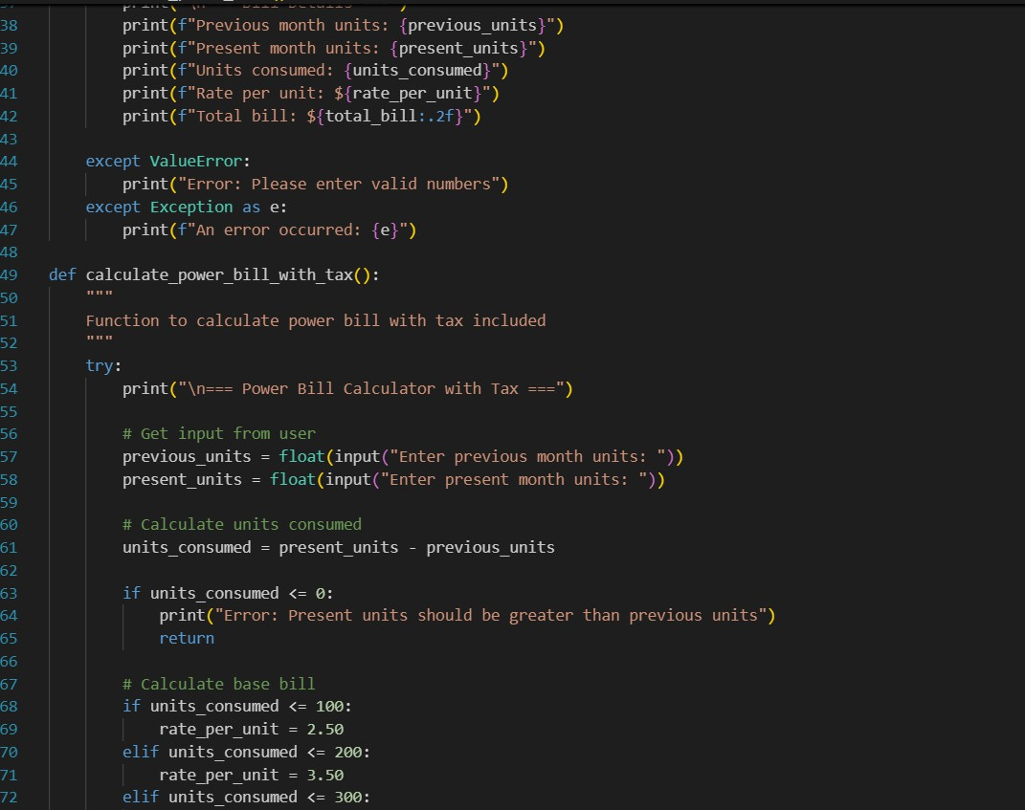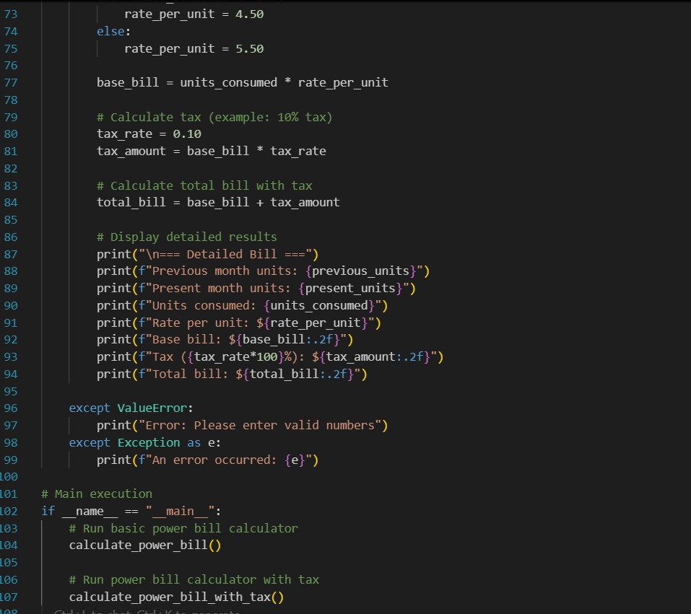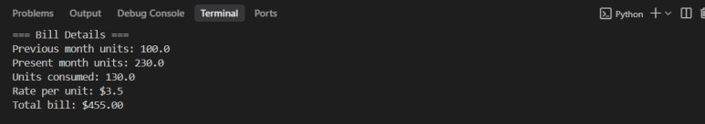

# Task Description#4

* Write structured comments to help AI generate two linked functions (e.g., login_user() and register_user()).

Prompt:

Generate simple two python linked functions one is for register user and login user for account creation

Code:

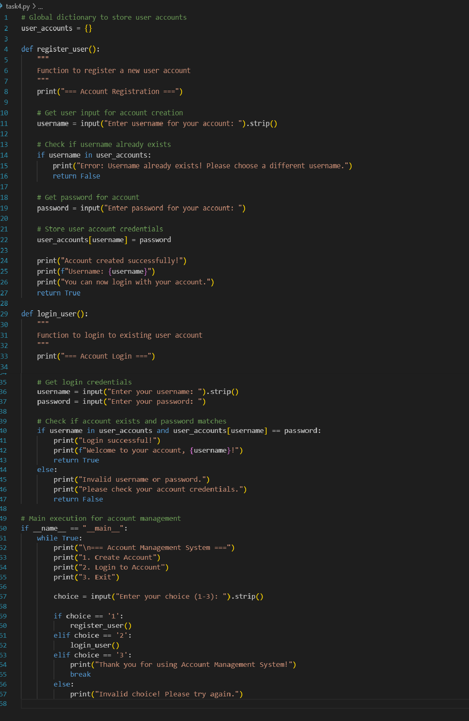

Output:

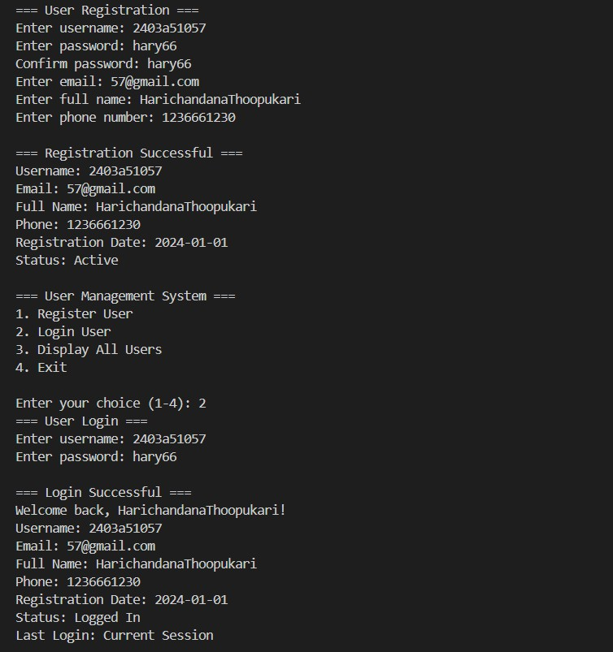

**Task Description#5**

* Analyzing Prompt Specificity: Improving Temperature Conversion Function with Clear Instructions

Prompt1:

Write a Python function to convert temperature from Celsius to Fahrenheit or vice-versa as for the user`s selection

Code:

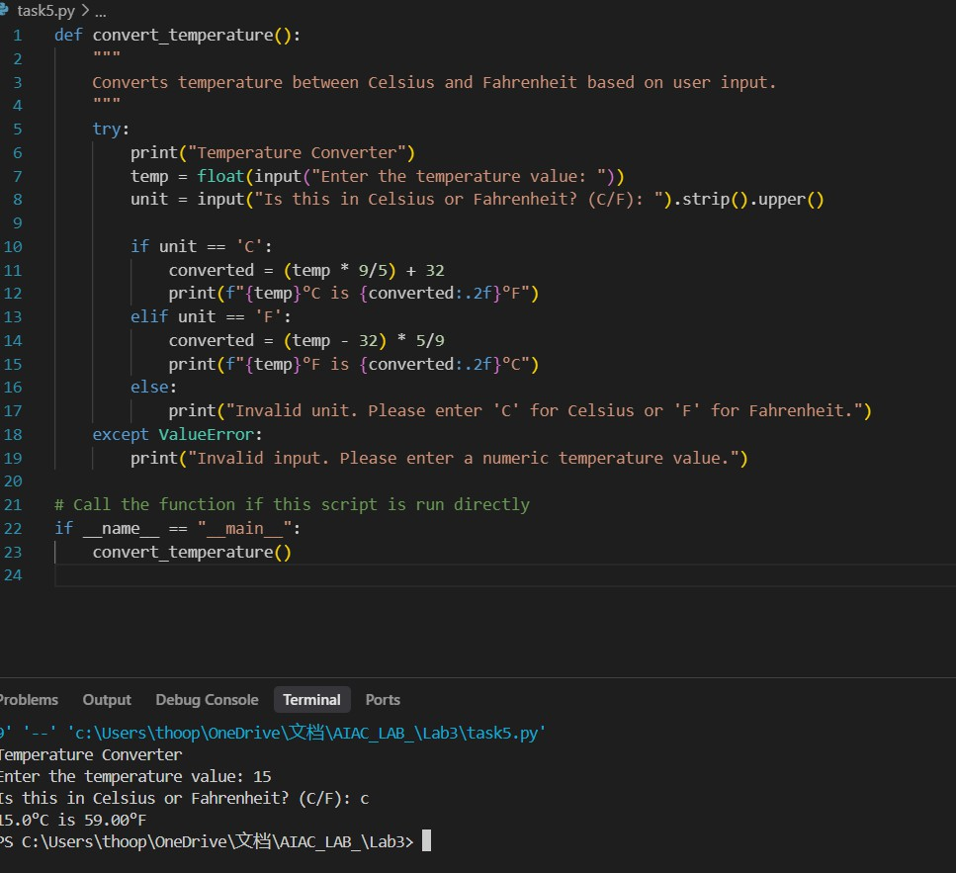

Prompt2:

Write a Python function to convert temperature from Celsius to Fahrenheit or vice-versa as for the user`s selection.

Code along with output:

