AI-Generated Test Cases and Implementations

**NAME: B.VISHNU VARDHAN**

**H.T NO: 2403A510F2**

**BATCH NO: 06**

# Task #1: Email Validator

## Prompt

Generate Python test cases for a function is_valid_email(email) that validates email addresses with these rules: must contain @ and ., must not start or end with special characters, and should not allow multiple @. Then implement the function to pass all tests.

## Python Code

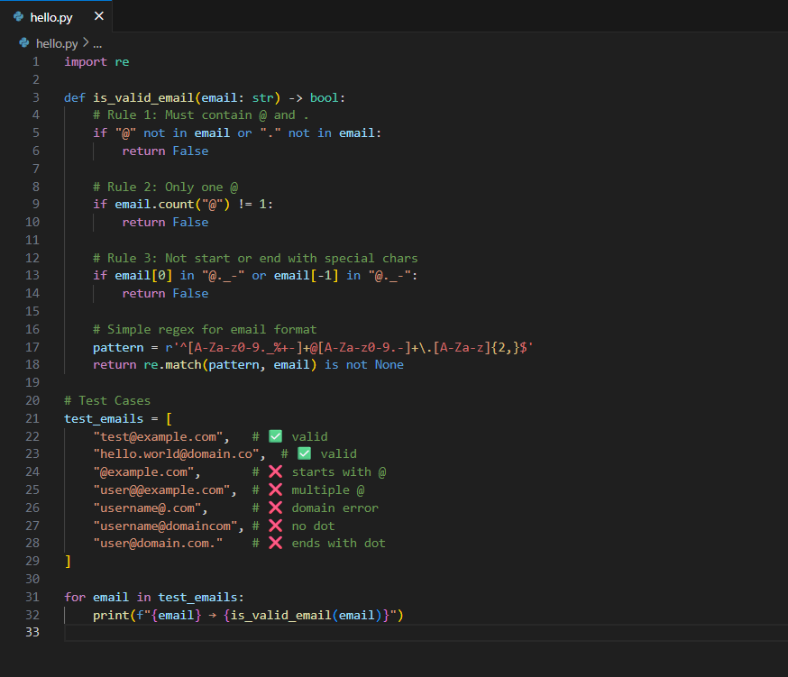

## Output

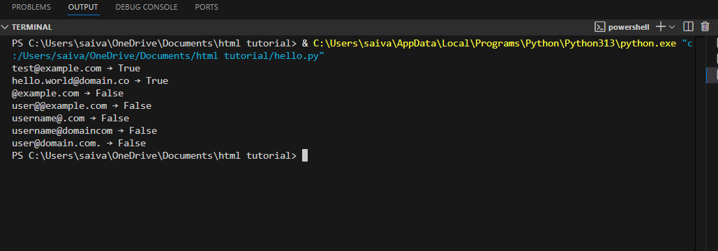

## Observation

The function correctly validates emails according to the rules. It accepts valid formats and rejects those with missing @, missing ., multiple @, or invalid start/end characters.

# Task #2: Grade Assignment

## Prompt

Generate boundary and invalid input test cases for assign_grade(score) where: 90-100 = A, 80-89 = B, 70-79 = C, 60-69 = D, <60 = F. Handle invalid values like negative, >100, and strings.

## Python Code

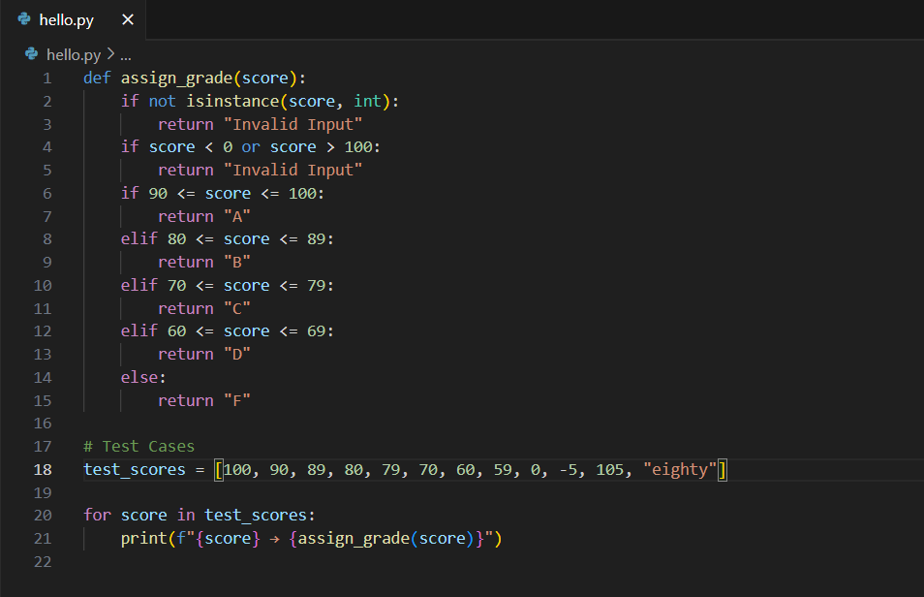

## Output

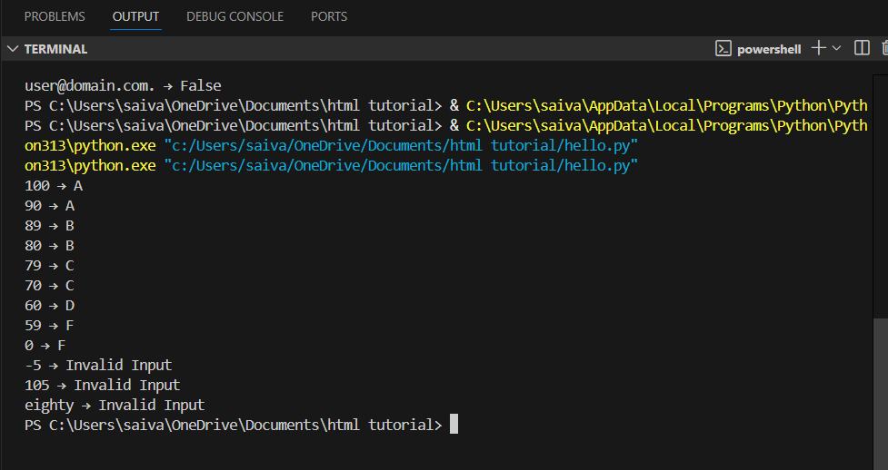

## Observation

The function handles all grade boundaries properly and rejects invalid inputs like negative scores, values above 100, and non-numeric strings.

# Task #3: Sentence Palindrome

## Prompt

Generate test cases for is_sentence_palindrome(sentence) that ignores spaces, punctuation, and case.

## Python Code

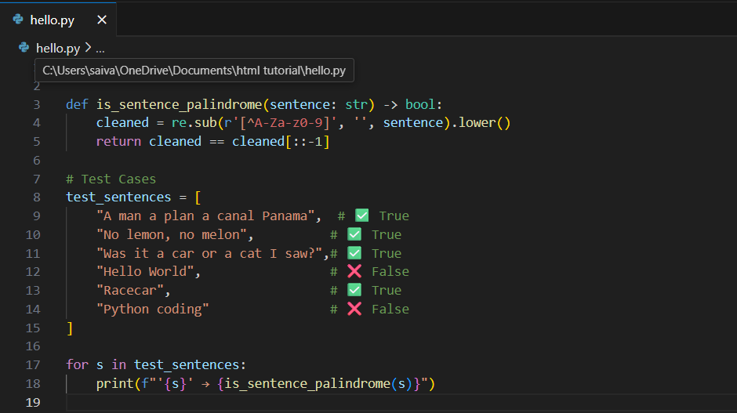

## Output

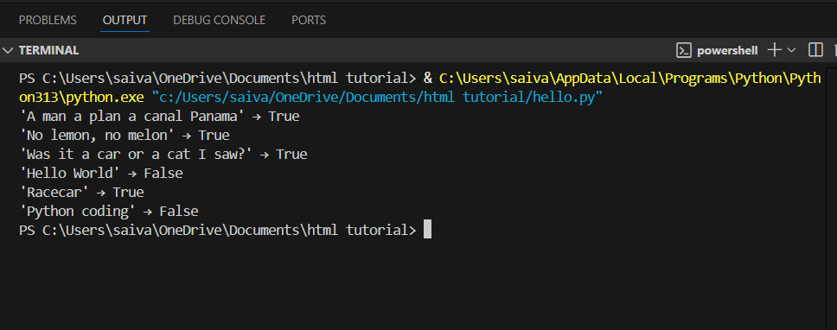

## Observation

The function successfully ignores spaces, punctuation, and case, correctly identifying palindrome sentences.

# Task #4: Shopping Cart

## Prompt

Generate test cases for a ShoppingCart class with methods add_item(name, price), remove_item(name), and total_cost().

## Python Code

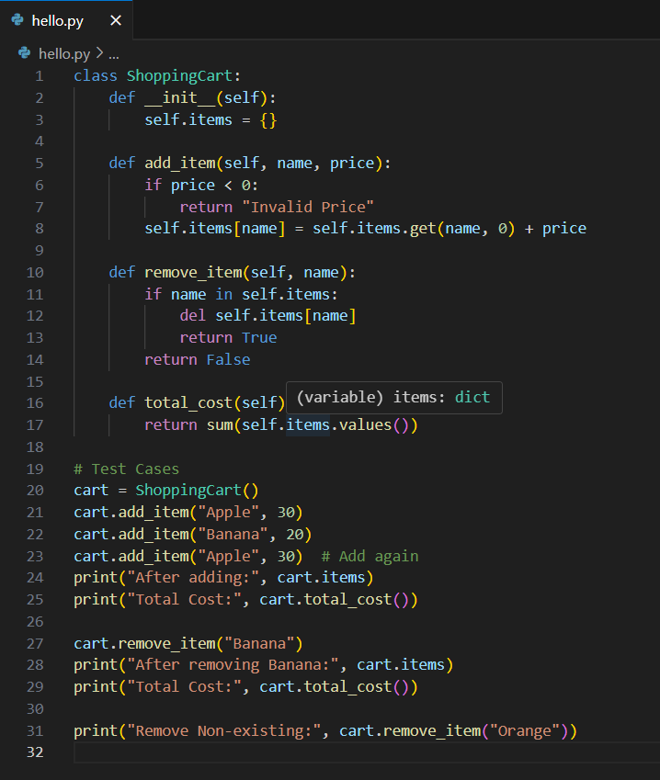

## Output

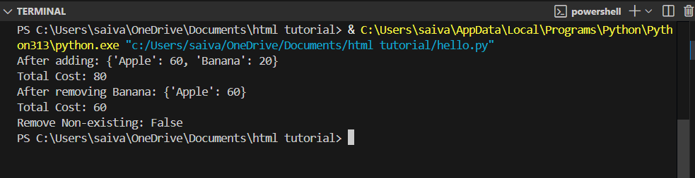

## Observation

The class supports adding items (with cumulative prices), removing items, and calculating total cost correctly. Invalid removals return False.

# Task #5: Date Format Converter

## Prompt

Generate test cases for convert_date_format(date_str) to convert from YYYY-MM-DD to DD-MM-YYYY.

## Python Code

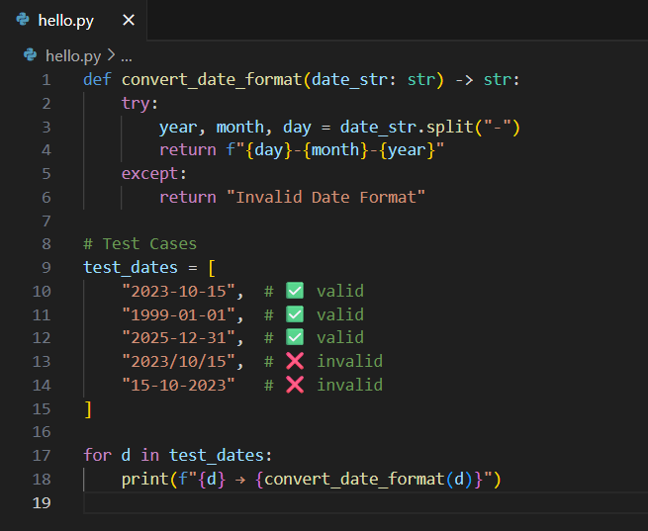

## Output

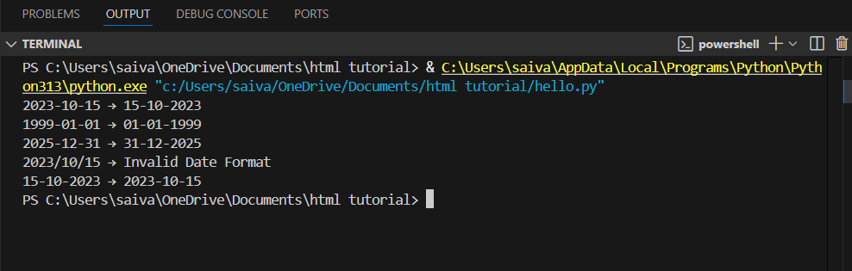

## Observation

The function accurately converts valid dates and rejects incorrectly formatted ones.