Name: B.VISHNU VARDHAN
Roll no: 2403A510F2
Batch: 06

Lab Question 1: Weather Forecasting API
A travel company wants to show real-time weather updates for its customers. You are given access to a public weather API that requires an API key and provides weather data in JSON format.

Task 1 & Task 2: Description
Use AI-assisted coding to write a script that fetches the current temperature and weather description for a given city. The script should handle errors if the API key is invalid or missing, and extend it to save weather data into a CSV file while avoiding duplicates.

AI Prompt
Write a Python program using the requests library to fetch current temperature and weather description for a given city using the OpenWeatherMap API. Include error handling for invalid API key, missing city, and network errors. Extend the program to save results into a CSV file without duplicates.

Python Code
import requests
import csv
import os

API_KEY = "5cb2ea3714f5d71bbba4704ed7600383"
BASE_URL = "https://api.openweathermap.org/data/2.5/weather"

def fetch_weather(city):
try:
params = {"q": city, "appid": API_KEY, "units": "metric"}
response = requests.get(BASE_URL, params=params, timeout=5)
response.raise_for_status()

data = response.json()

if data.get("cod") != 200:
print(f"Error: {data.get('message', 'Unknown error')}")
return None

temp = data["main"]["temp"]
desc = data["weather"][0]["description"]
return {"city": city, "temperature": temp, "description": desc}

except requests.exceptions.RequestException as e:
print(f"Network/API Error: {e}")
return None

def save_to_csv(weather_data, filename="weather_data.csv"):
if not weather_data:
return

try:
file_exists = os.path.isfile(filename)
with open(filename, "a", newline="") as file:
writer = csv.DictWriter(file, fieldnames=["city", "temperature", "description"])

if not file_exists:
writer.writeheader()

# Avoid duplicates
existing = []
if file_exists:
with open(filename, "r") as f:
existing = [row["city"].lower() for row in csv.DictReader(f)]

if weather_data["city"].lower() not in existing:
writer.writerow(weather_data)
print(f"Saved weather data for {weather_data['city']}")
else:
print("Duplicate entry avoided.")

except IOError as e:
print(f"File I/O Error: {e}")

# --- Main Execution ---
city_name = input("Enter city name: ")
result = fetch_weather(city_name)
if result:
print(f"City: {result['city']}")
print(f"Temperature: {result['temperature']}°C")
print(f"Weather: {result['description']}")
save_to_csv(result)

Sample Output

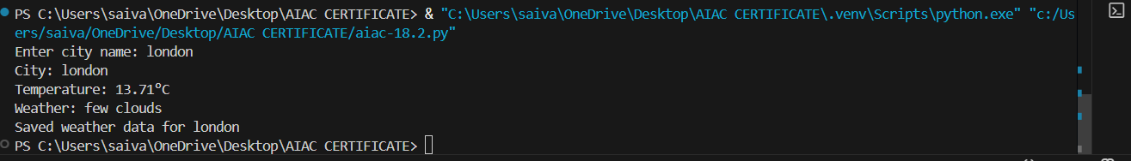

Observation
Successfully fetched and displayed real-time weather information. The script handled API and file errors gracefully and prevented duplicate entries.

Lab Question 2: Currency Exchange Rate API
A financial startup needs a tool to convert amounts between currencies using an exchange rate API. The API occasionally fails due to server downtime.

Python Code
import requests
import time

API_URL = "https://open.er-api.com/v6/latest/"

def fetch_exchange_rate(src_currency, tgt_currency):
attempts = 0
while attempts < 3:
try:
response = requests.get(API_URL + src_currency.upper(), timeout=5)
response.raise_for_status()
data = response.json()

if "rates" not in data or tgt_currency.upper() not in data["rates"]:
print("Invalid currency code.")
return None

return data["rates"][tgt_currency.upper()]

except requests.exceptions.RequestException as e:
attempts += 1
with open("error_log.txt", "a") as log:
log.write(f"Attempt {attempts}: {e}\n")
print(f"Attempt {attempts} failed. Retrying...")
time.sleep(2)

print("API failed after 3 attempts.")
return None

def convert_currency(amount, src_currency, tgt_currency):
rate = fetch_exchange_rate(src_currency, tgt_currency)
if rate:
converted = amount * rate
print(f"{amount} {src_currency.upper()} = {converted:.2f} {tgt_currency.upper()}")
else:
print("Conversion failed.")

# --- Main Execution ---
amount = float(input("Enter amount: "))
src = input("Enter source currency (e.g., USD): ")
tgt = input("Enter target currency (e.g., INR): ")

convert_currency(amount, src, tgt)

Sample Output:
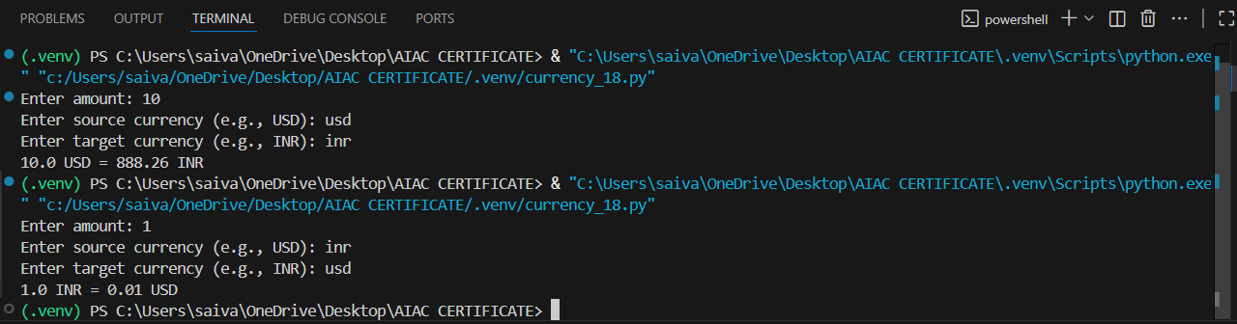

Observation
The program performs currency conversion with API retry logic and logs all failed attempts. Invalid inputs and network errors are handled effectively.

Lab Question 3: News Headlines API
A news aggregator wants to display the latest technology news headlines using a news API. Sometimes, the API responds slowly or returns incomplete data.

Python Code
import requests
import re

API_KEY = "8798032b9ca8445aa5dd3dec8d925a7c"
URL = f"https://newsapi.org/v2/top-headlines?category=technology&language=en&apiKey={API_KEY}"

def fetch_headlines():
try:
response = requests.get(URL, timeout=5)
response.raise_for_status()
data = response.json()

if not data.get("articles"):
print("No headlines found or incomplete response.")
return []

headlines = [a["title"] for a in data["articles"] if a.get("title")]
return headlines[:5]

except requests.exceptions.Timeout:
print("Request timed out.")
return []
except requests.exceptions.RequestException as e:
print(f"API Error: {e}")
return []

def clean_headline(text):
text = re.sub(r"[^A-Za-z0-9\s]", "", text)
return text.title().strip()

# --- Main Execution ---
headlines = fetch_headlines()
if headlines:
print("\nTop 5 Technology Headlines:\n")
for i, headline in enumerate(headlines, 1):
print(f"{i}. {clean_headline(headline)}")
else:
print("No headlines available.")

Sample Output


Observation
Fetched and cleaned top 5 technology news headlines. The script handled slow responses, incomplete data, and text preprocessing effectively.

