1.6:
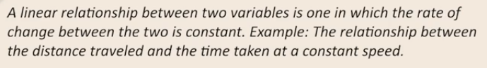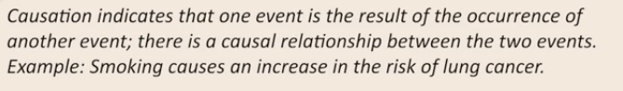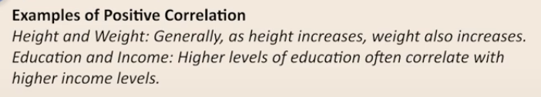
Q: Because it makes comparisons incredibly easy, ____ is a very popular technique to measure the degree of association between variables. Correlation
Correlation helps in quantifying relationships between variables, and hence it is a very popular technique to measure the degree of association.
Q: Which of the following is unitless? Correlation
Correlation is unitless because the units in the numerator and denominator(while calculating correlation) cancel out each other, giving us a unitless measure.
Q: Correlation does not imply causation. True
Correlation does not imply causation, it just signifies the relationship. The cause may or may not be the variables themselves.
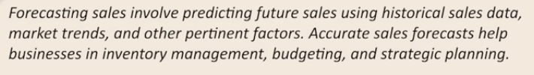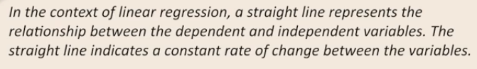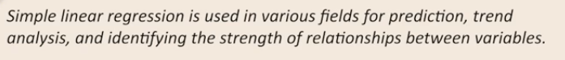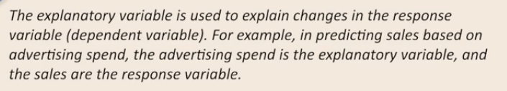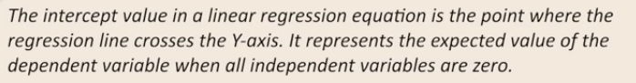
Q: Linear Regression is a guided learning process, i.e., the data needs to come with labels/targets, and then the regression model is trained to minimize the error. True
Linear regression is a Supervised Learning algorithm, and hence requires labels/targets to formulate a minimum error model.
Q: In Simple Linear Regression, what is the role of the independent variable?
It is used to predict the dependent variable
In Simple Linear Regression, the independent variable (predictor variable) is used to predict or explain variations in the dependent variable.
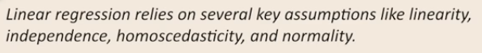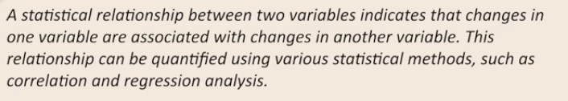
Q: If the coefficient for the independent variable is negative in Linear Regression, what does this suggest about the relationship between the variables?
As the independent variable increases, the dependent variable tends to decrease
A negative coefficient in Linear Regression suggests that as the independent variable increases, the dependent variable tends to decrease
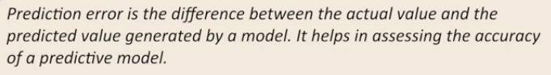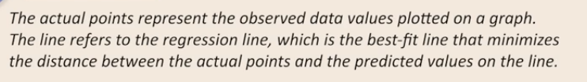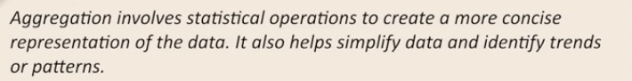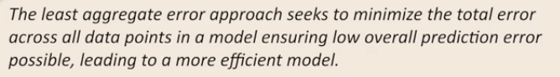
Q: What is the primary objective of the best-fit line in Linear Regression?
To minimize the the sum of the differences between actual and predicted values
The best-fit line in Linear Regression aims to minimize the error, which represents the discrepancies between observed and predicted values of the dependent variable.
Q: How can one interpret the intercept of the best-fit line in Linear Regression?
It represents the value of dependent variable when the value of the independent variable is 0
The intercept of the best-fit line in Linear Regression represents the predicted value of the dependent variable when the independent variable is zero, providing a starting point for predictions.
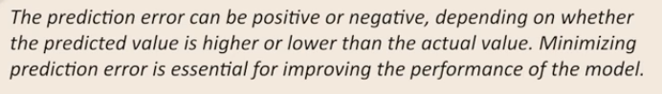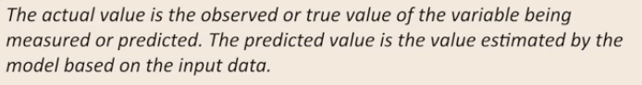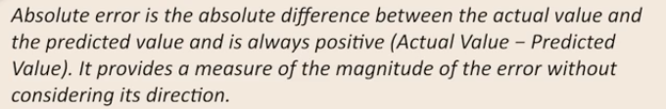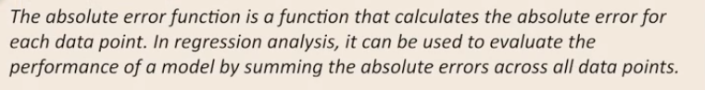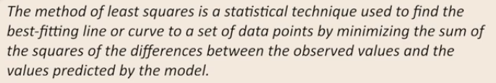
Q: Which of the following is minimized in a linear regression model? Mean Squared Error
The mean absolute error of a model is the mean of the absolute values of the individual prediction errors and is not differentiable at 0. This makes minimizing it a problem. The mean squared error (MSE) is the mean of the squared values of the individual prediction errors and is differentiable everywhere. So, it is minimized to find the best-fit hyperplane in linear regression.
Q: Which of the following statements is true about the model given below?
Sales = 4600 + 7.7*(Advertising Expenditure)
For every unit increase in Advertising Expenditure, Sales are expected to increase by 7.7 units
For Advertising Expenditure = 0 unit: Sales = 4600
For Advertising Expenditure = 1 units : Sales = 4600 + 7.7*(1)
For Advertising Expenditure = 2 units : Sales = 4600 + 7.7*(2)
Hence, we can see a increase of 7.7 in Sales for every unit increase in Advertising Expenditure.
1.11 Multiple Linear Regression: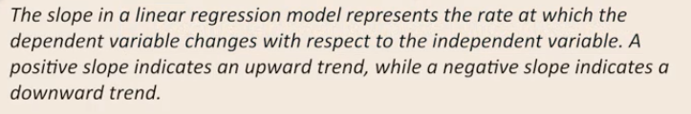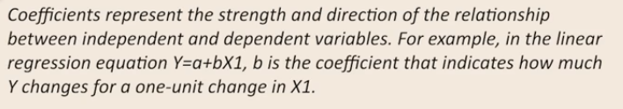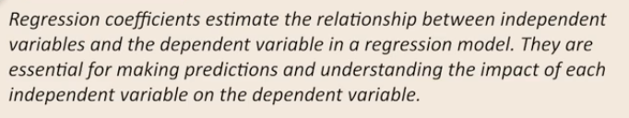
Q: When interpreting coefficients in Multiple Linear Regression, what does a negative coefficient for an independent variable indicate?
As the independent variable increases, the dependent variable tends to decrease, provided all other independent variables are held constant.
A negative coefficient for an independent variable in Multiple Linear Regression indicates that as the independent variable increases, the dependent variable tends to decrease, holding other variables constant.
Q: What is the key advantage of using Multiple Linear Regression over Simple Linear Regression?
It handles more than one independent variable
The primary advantage of Multiple Linear Regression over Simple Linear Regression is that it can incorporate multiple independent variables to predict the dependent variable.
Q: The visualization of a simple linear regression equation and a multiple linear regression equation with two independent variables is the same. False
For simple linear regression, the visualization is in the form of a straight line, whereas, for multiple linear regression, it changes to a plane (in three dimensions).
1.12 Categorical Variables in Regression: 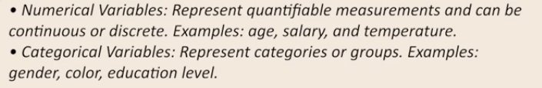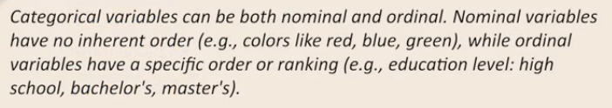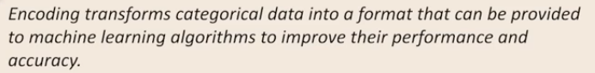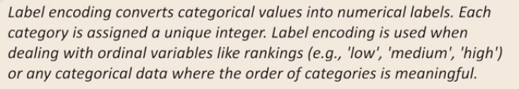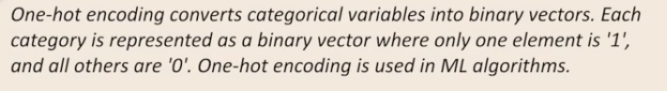
Q: Categorical variables can't be used directly in a linear regression because
The best fit lines needs to be fit on numerical values and categorical values represent categories
Categorical variables represent categories while the best-fit line needs to be fit on numerical values. So, they are encoded before being used in linear regression.
Q: In regression analysis, how are categorical variables typically handled?
They are converted into numerical values
Categorical variables in regression analysis are often converted into numerical dummy variables to represent different categories.
1.13 Evaluation Metrics for Regression: 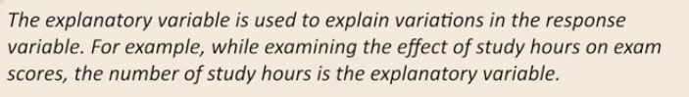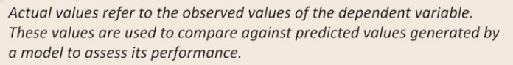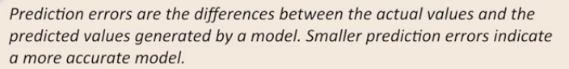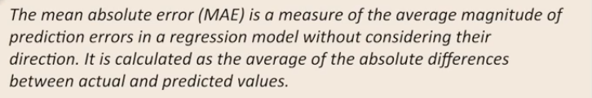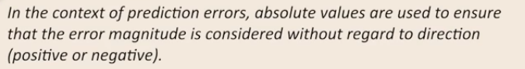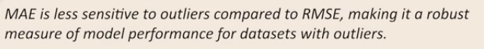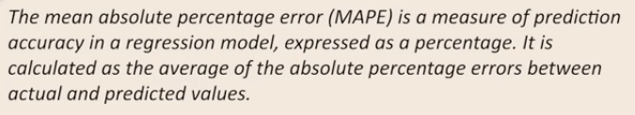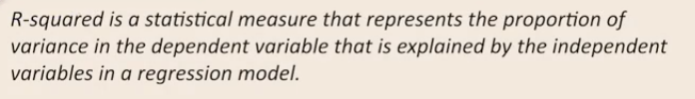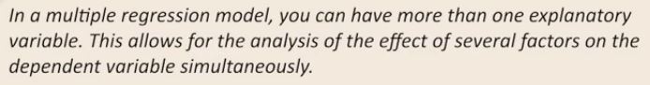
Q: While building a multiple linear regression model, it was found that the addition of a variable decreased the value of the adjusted R-squared.
Which of the following statements is correct?
The new variable should not be added in the final model
The decrease in adjusted R-squared value signifies that the newly added variable does not add value to the model performance. And hence should not be included.
1.14 Problem Statement and Loading the Data - Hands-on: 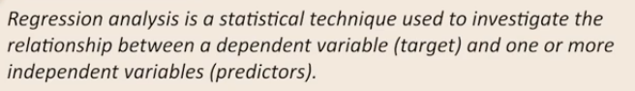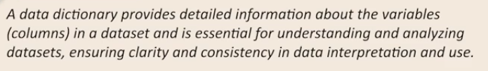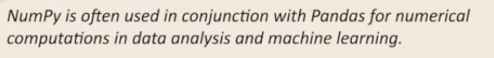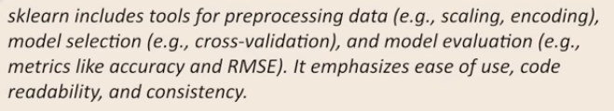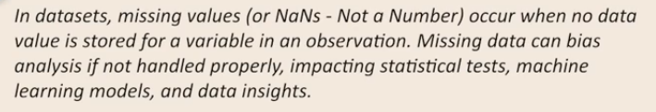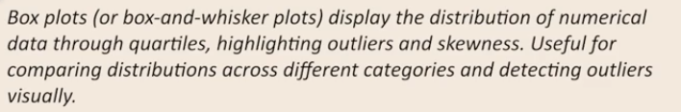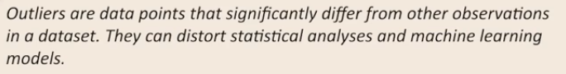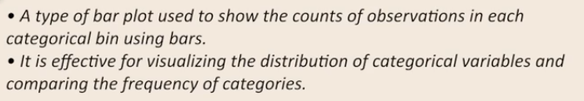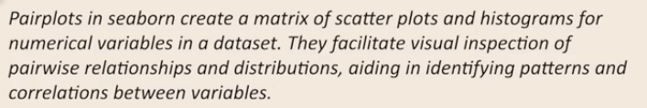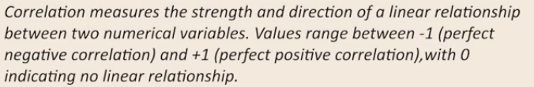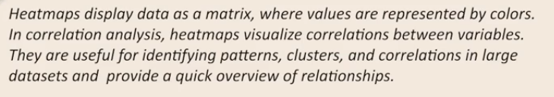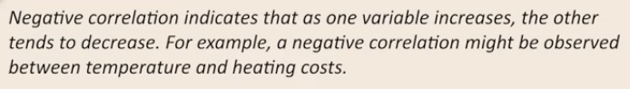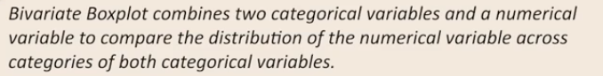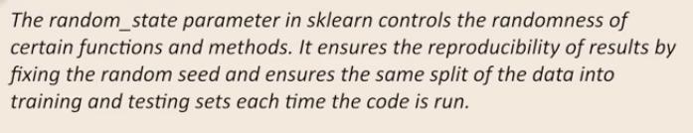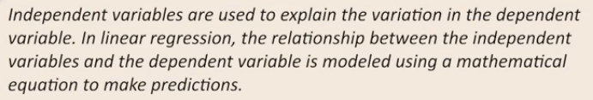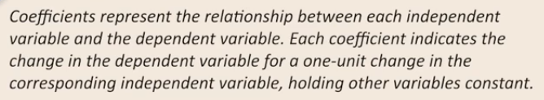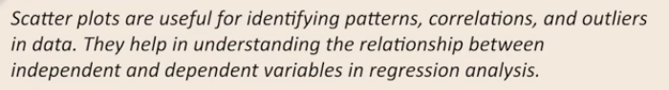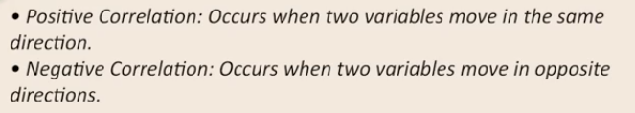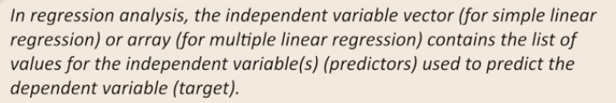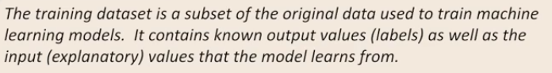
Q: What does the following code return after fitting a Multiple Linear Regression model stored in the variable model? The coefficients for each predictor variable
The coef_ attribute of sklearn.linear_model.LinearRegression contains the coefficients of the predictors in the linear regression model. These coefficients indicate the change in the target variable for a unit change in the corresponding predictor, holding all other predictors constant.
Q: Which attribute of the LinearRegression object in scikit-learn contains the intercept of the fitted model? model.intercept_
The intercept_ attribute of sklearn.linear_model.LinearRegression represents the y-intercept of the regression line, indicating the expected value of the target variable when all the feature values are zero.
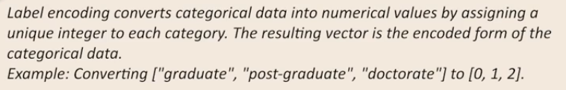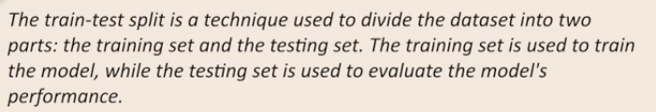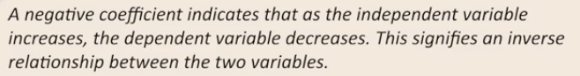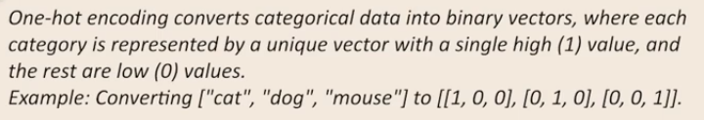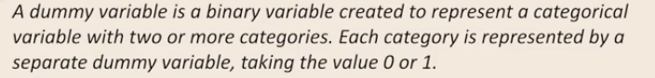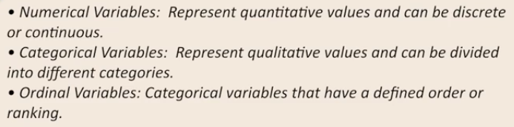
Q: Which of the following pandas functions can be used to encode categorical variables?
get_dummies()
The get_dummies() function from pandas converts categorical variables into a format that can be provided to machine learning algorithms by creating one-hot encoded columns.
Q: For a dataset df containing a categorical variable Education with values 'High School', 'Bachelor's Degree', and 'Master's Degree', we can use pandas get_dummies() to label-encode the data before fitting the model. False
pandas get_dummies() performs one-hot encoding and not label encoding.
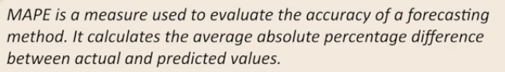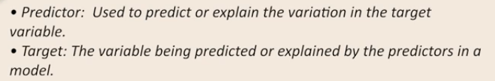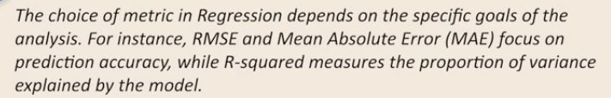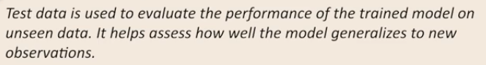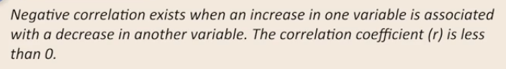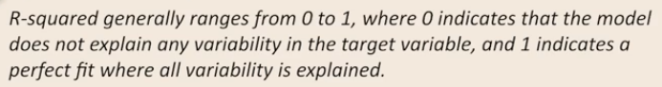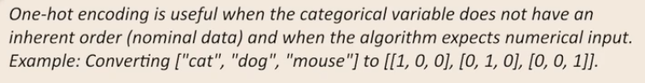
Q: How do you calculate Mean Squared Error (MSE) for a Linear Regression model in scikit-learn?
mse = mean_squared_error(y_test, y_pred)
mean_squared_error function of sklearn is used to compute the MSE. It takes two inputs - the actual values and the predicted values of the target variable.
Q: Which metric evaluates how well the regression model explains the variability in the dependent variable? R-squared
- RMSE (Root Mean Squared Error): RMSE measures the square root of the average squared differences between actual and predicted values, providing a metric that is in the same units as the target variable and penalizes larger errors more heavily.
- MAPE (Mean Absolute Percentage Error): MAPE calculates the average absolute percentage difference between actual and predicted values, expressing prediction accuracy as a percentage and allowing for easy interpretation across different scales.
- R² (Coefficient of Determination): R² indicates the proportion of the variance in the dependent variable that is predictable from the independent variables, with values closer to 1 signifying a better fit.
- MAE (Mean Absolute Error): MAE measures the average absolute difference between the actual and predicted values, providing a straightforward metric of prediction accuracy.
Q: When a linear regression was trained, it was found that its R-squared value was 0.75. Which of the following statements is correct? The model explains 75% of the variance
An R-squared value of 0.75 indicates that the model captures 75% of the variation in the target variable.
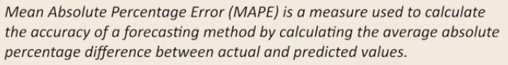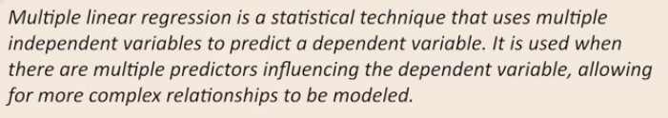
Q: Which of the following metrics is NOT used to evaluate the performance of a regression model?
Correlation
- MAE (Mean Absolute Error): MAE measures the average absolute difference between the actual and predicted values, providing a straightforward metric of prediction accuracy.
- MSE (Mean Squared Error): MSE calculates the average squared differences between actual and predicted values, emphasizing larger errors than MAE.
- R² (Coefficient of Determination): R² indicates the proportion of the variance in the dependent variable that is predictable from the independent variables, with values closer to 1 signifying a better fit.
- Correlation: In linear regression, correlation measures the strength and direction of the linear relationship between the independent and dependent variables.
Q: How do you interpret a high Mean Squared Error (MSE) in the context of model performance comparison for sales forecasting? The model makes large errors in predicting sales
A large MSE value indicates that the model is making large errors in predicting sales. This can be in either training data, test data, or both.

