Part 3 — Snort IDS Setup & Alert Analysis (True vs False Positives)
Instructor Name: Zag Elsayed, PhD

Problem Statement
In any enterprise network, the earliest signs of an intrusion usually appear during reconnaissance—when an attacker tries to discover active hosts, open ports, and exploitable services. These attempts often take the form of ICMP ping sweeps, TCP SYN scans, and service probing.
The problem addressed in this lab is to detect these early-stage scanning activities using Snort, a signature-based Intrusion Detection System (IDS).
The objective of this experiment is to:
- Install and configure Snort on a Linux machine to act as an Intrusion Detection System (IDS).
- Create custom Snort rules to detect suspicious network activities like ICMP scanning and Nmap SYN scanning.
- Generate controlled attack traffic from a Windows host.
- Analyze and interpret alerts produced by Snort, identifying true positives and false positives.

Background
Snort is one of the most widely deployed open-source IDS solutions, used in both commercial and government environments. It works by inspecting every packet that enters the network and comparing it against a set of rules. These rules define what malicious or suspicious traffic looks like, for example:
- repeated ICMP echo requests (ping sweeps),
- TCP SYN packets sent to multiple ports (Nmap scans),
- anomalous flag combinations (XMAS scans),
- shellcode or exploit signatures.
When Snort sees traffic matching a rule, it generates an alert describing the issue, the packet details, and the attack classification.
In this lab:
- Snort runs on Kali Linux, acting as the monitored victim.
- A Windows 11 machine generates legitimate and malicious network traffic.
- The goal is to observe how Snort interprets and reports this activity.
This setup resembles how security teams deploy IDS sensors inside a network to detect internal or external reconnaissance.

Solution

Block Diagram
The block diagram represents how network traffic flows from the attacker machine to the victim machine, and how Snort analyzes that traffic inside the virtual environment. Both systems are connected through a VMware virtual network.
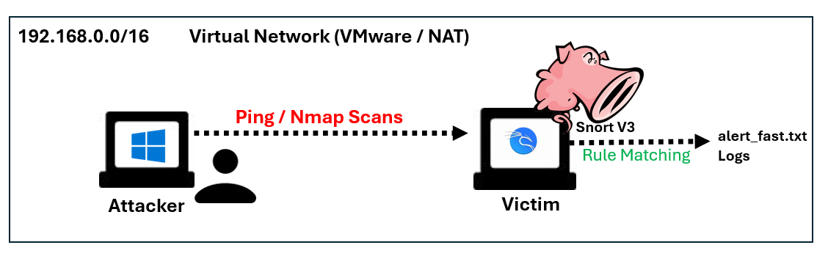
- The attacker machine (Windows) sends reconnaissance traffic such as ping requests and Nmap scans toward the victim.
- All attacker traffic travels across this virtual network and reaches the Kali Linux victim machine.
- Snort V3 is running on the victim, and it monitors all incoming packets using the custom rules configured in the system.
- When Snort identifies suspicious activity (ICMP scans, SYN scans, etc.), it matches the packets against the rule signatures.
- Snort then generates alerts and writes them into alert_fast.txt, which serves as the IDS output log for further analysis.

Installing snort
Snort was installed using the official Kali package repositories to ensure access to the latest stable version. The installation process was carried out via terminal commands, and successful installation was confirmed by running a snort version.
Commands:
#sudo apt-get install snort
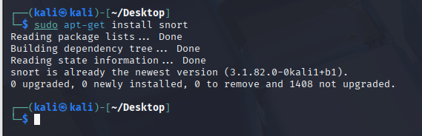
- Verified by using command snort -v
#snort -v
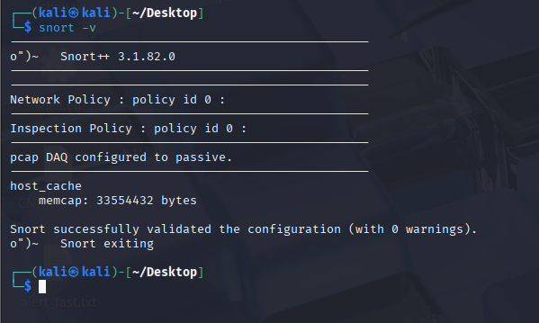

Understanding Snort Rule Syntax
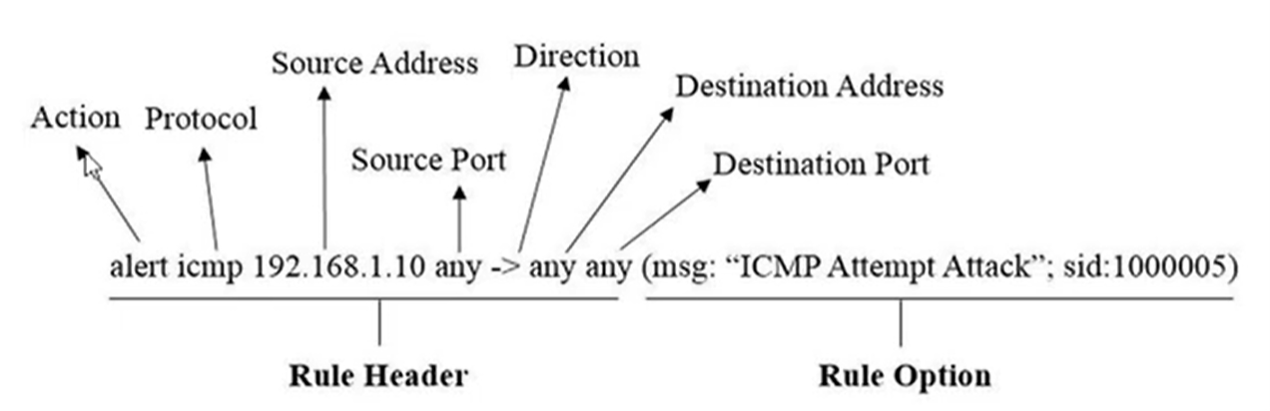
The provided diagram breaks down a Snort rule into components:
- Action: alert, drop, log
- Protocol: TCP, UDP, ICMP
- Source + Destination IP/Ports
- Direction operator (->)
- Rule options (msg, sid, content, classtype)

Configuring Custom Rules
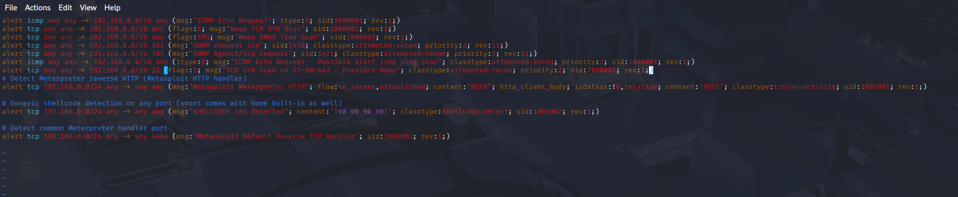
The rule file (local.rules) contains multiple signatures such as:
ICMP Echo Request Detection | alert icmp any any -> 192.168.0.0/16 any (msg:"ICMP Echo Request"; itype:8; sid:1000001; rev:1;)  alert icmp any any -> 192.168.0.0/16 any (itype:8; msg:"ICMP Echo Request - Possible alert icmp ping scan"; classtype:attempted-recon; priority:2; sid:2000001; rev:1;)
Nmap TCP SYN Scan Detection | alert tcp any any -> 192.168.0.0/16 any (flags:S; msg:"Nmap TCP SYN Scan"; sid:1000002; rev:1;)  alert tcp any any -> 192.168.0.0/16 22 (flags:S; msg:"TCP SYN scan on 22-80-443 - Possible Nmap"; classtype:attempted-recon; priority:2; sid:2000002; rev:1;)
Nmap XMAS Tree Scan | alert tcp any any -> 192.168.0.0/16 any (flags:FPU; msg:"Nmap XMAS Tree Scan"; sid:1000003; rev:1;)

Running Snort in IDS Mode
Snort was launched in IDS mode, referencing the configured rule set and specifying parameters for interface monitoring and alert logging location. The tool was run from a chosen directory to ensure that alert files (e.g., alert.fast.txt) would be accessible for immediate review and analysis.
Commands:
#sudo snort -c /etc/snort/snort.lua -i eth0 -A alert_fast

This command tells Snort to start in IDS mode using my snort.lua configuration file, monitor all traffic on interface eth0, and log all alerts quickly into alert_fast.txt. This lets me watch real-time attacks as they happen.
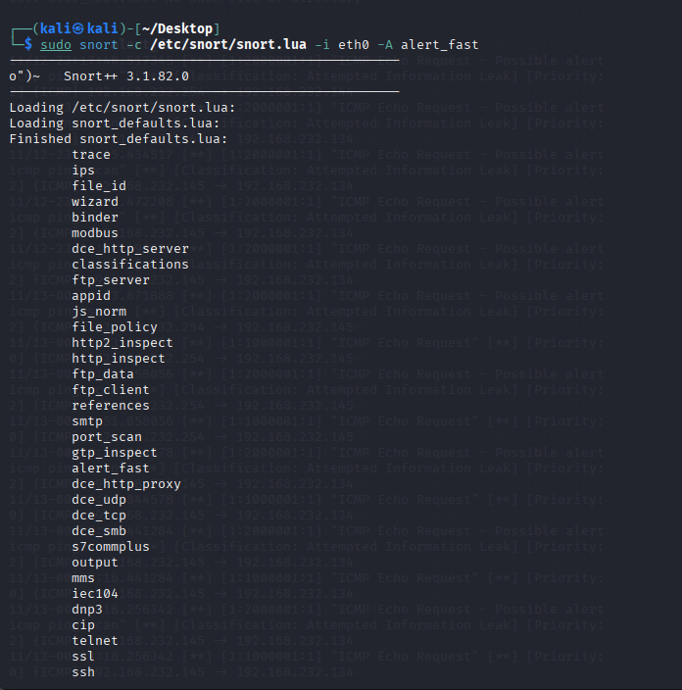

System Implementation
The system implementation stage focuses on putting the theoretical concepts of intrusion detection into practice. This section describes how the Kali Linux machine was configured to function as the Snort-based IDS and how the Windows system was set up to generate realistic attack traffic. By detailing the configuration steps, tools used, and environment setup, this section demonstrates how the IDS operates within a controlled network and how it responds to the simulated reconnaissance activities.
Victim: Kali Linux (Snort IDS)
The victim machine in this setup functions as the monitored host where Snort is deployed. Its purpose is to analyze incoming traffic, apply custom detection rules, and generate alerts for any suspicious activity originating from the network.
- Snort installed and configured
- Custom rules enabled
- Alert logging configured
Attacker: Windows 11
The attacker machine is used to simulate realistic reconnaissance activities against the victim system. This Windows host generates ICMP pings, Nmap scans, and other probing techniques that an adversary would typically perform during the early stages of an intrusion.
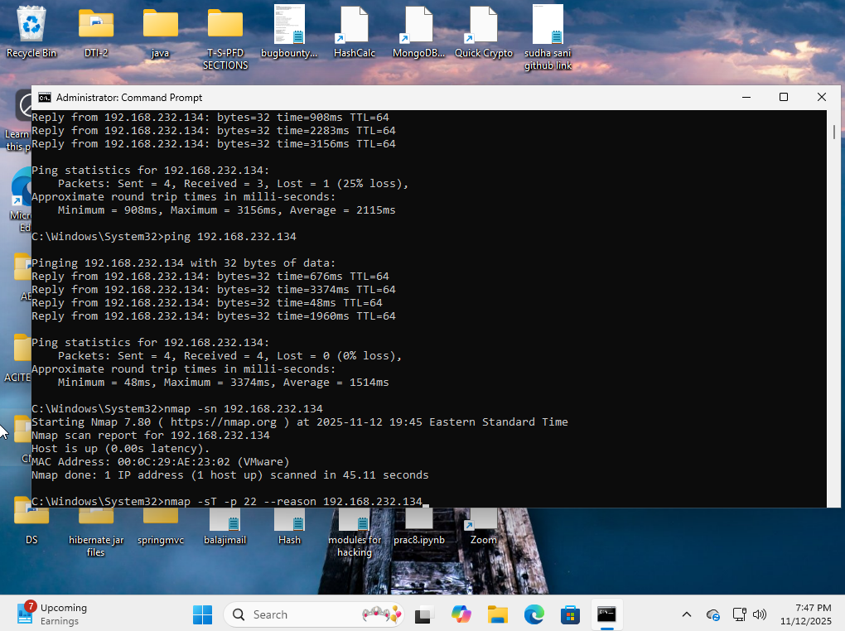

The Windows machine generates the following traffic:
Ping Sweeps | ping 192.168.232.134
Nmap Host Discovery | nmap -sn 192.168.232.134
Nmap Port Scan | nmap -sT -p 22,80,443 --reason 192.168.232.134

Result & Sample Output
This section displays the alerts and logs generated during the experiment, showing exactly how Snort identified and recorded the different types of traffic sent from the attacker.
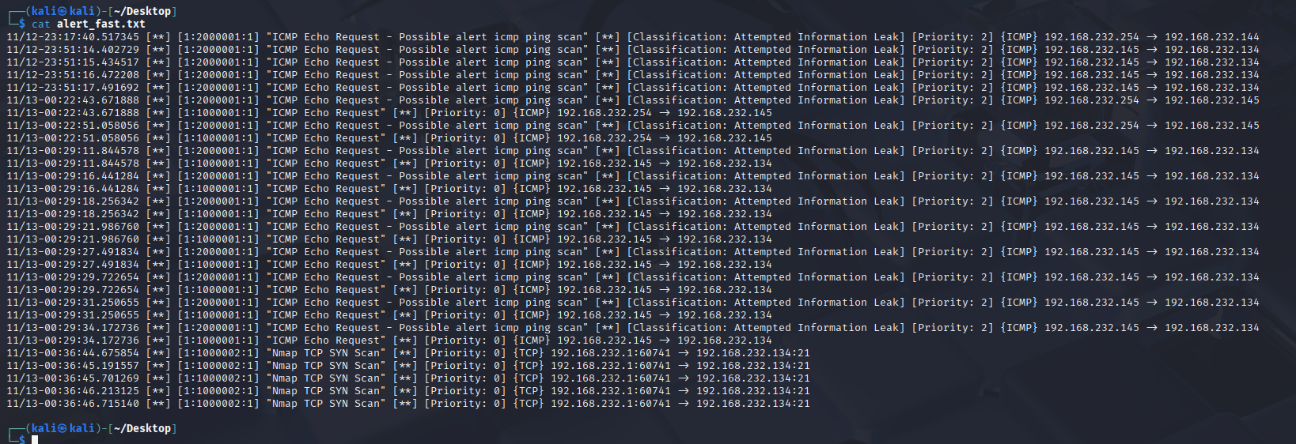

ICMP Echo Request Alerts (Ping Sweep Detection)
The attacker initiated repeated ICMP echo requests (ping commands) toward the victim machine. Snort successfully detected each request and generated corresponding alerts. A sample of the logged alerts is shown below:
11/13-00:29:11.844578 [**] [1:1000001:1] "ICMP Echo Request" [**] [Priority: 0] {ICMP} 192.168.232.145 -> 192.168.232.134
11/13-00:29:16.441284 [**] [1:2000001:1] "ICMP Echo Request - Possible alert icmp ping scan" [**] [Classification: Attempted Information Leak] [Priority: 2] {ICMP} 192.168.232.145 -> 192.168.232.134
11/13-00:29:16.441284 [**] [1:1000001:1] "ICMP Echo Request" [**] [Priority: 0] {ICMP} 192.168.232.145 -> 192.168.232.134
11/13-00:29:18.256342 [**] [1:2000001:1] "ICMP Echo Request - Possible alert icmp ping scan" [**] [Classification: Attempted Information Leak] [Priority: 2] {ICMP} 192.168.232.145 -> 192.168.232.134
11/13-00:29:18.256342 [**] [1:1000001:1] "ICMP Echo Request" [**] [Priority: 0] {ICMP} 192.168.232.145 -> 192.168.232.134

Attempted Information Leak” Alerts (Snort Classification)
This alert was generated when the attacker performed a TCP SYN scan targeting common service ports such as 22, 80, and 443. Snort identified the repeated SYN packets as a potential Nmap scan and classified the activity as an ‘Attempted Information Leak,’ since the attacker was trying to discover which services were running on the victim machine.
"TCP SYN scan on 22-80-443 - Possible Nmap" [ ** ] [Classification: Attempted Information Leak] [Priority: 2] {TCP} 192.168.217.129:10121 > 192.168.217.128:22

Observation & Discussion
This section examines how Snort responded to the simulated attacks and analyzes which alerts represent real reconnaissance attempts versus normal background traffic, highlighting the presence of both true and false positives.
Alert Message | Example src->dst | What triggered it | Assessment
ICMP Echo Request- Possible alert icmp ping scan | 192.168.x.x → 192.168. x.x | Manual ping from Windows to Kali | True positive for “ping recon” rule. The scan rule is meant to fire on ICMP echo; we intentionally sent echoes. In a production network, normal troubleshooting pings could make this rule noisy and act as false positives.
ICMP Echo Request - Possible alert icmp ping scan | 192.168.x.254 → 192.168. x.x /x.x | Background ICMP from VMware / virtual gateway | False positive from an operational point of view. Traffic is routine infrastructure traffic, not hostile recon, but still matches the generic ICMP rule.
Nmap TCP SYN Scan | 192.168. x.x → 192.168. x.x | nmap -sT/-sS scan from Windows host | True positive. Rule is meant to spot Nmap-style SYN scans, and it fired exactly while the scan was running.
True Positives:
- ICMP Echo Requests from Windows → Kali
  - Generated intentionally by attacker
  - Correctly detected as "ICMP ping scan"
- Nmap SYN Scans
  - Snort detected each SYN packet sent by the Nmap command
  - Shows Snort’s ability to catch early scanning behavior
False Positives:
- ICMP Traffic from VMware Gateway
This experiment successfully demonstrated how Snort can be used as a practical IDS for detecting reconnaissance traffic. Snort was installed and configured on Kali Linux, custom rules were added, and attack traffic was generated from a Windows machine. The resulting alerts provided clear evidence of both ICMP scanning and TCP SYN probing.
The analysis also revealed realistic false positives, showing why IDS tuning is essential in real deployments. Overall, the lab effectively reflected how security teams use Snort to detect early intrusion attempts inside modern networks.

