7PAM2000 Applied Data Science 1 Assignment 1: Visualisation - Copy 2

**Student’s name:vishnuvardhan reddy pandikunta**

**Student’s ID:22035079**

**Data source link: https://databank.worldbank.org/metadataglossary/global-economic-prospects/series/NYGDPMKTPKDZ**

**Github link :** **https://github.com/vishnuvardhanreddy1990/gep/upload/main**

Table of Contents

Introduction 3

Visualization 1: 4

Visualization 2: 4

Visualization 3: 4

Conclusion 5

References 6

# Introduction

This is the report that is performing the visualization of the datasets, the graphs are created that are produced while using the PyPlot functions, and under this, the data of the series code, country name, and country code are produced and read while using the pandas that is applied while to make use of the three types of the visualization methods that help in extracting the meaningful information. Under this, the box plot graphs, plotting, and histograms are created that is analysing the year-wise estimation of the different countries in terms of the series code.

# Visualization 1:

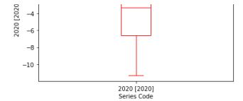

While using the series code the box plots are created that help in analysing and analysing the data of the different countries. Also, the GDP growth of the country has to analyse the data year-wise. For labelling the year plt.title has been used that supports in representing the title of the graph, plt.xlabel and plt.ylabel supports representing the x-axis and the y-axis in the graph. In the panda boxplot () is used to create the boxplot graph. plt.label supports in providing the title to the graph, plt.show() helps in showing the graph. This box plot could manage as well as display a breakdown of something like a vast collection of information given the various data presentation (Tang, et, al, 2022). The midpoint or median of something like the sampling length, this same greater and lesser percentile rank, or the percentages situated between the top and lowest quarter of something like the information, together with the highest and lowest numerical values are all shown in a plotted graph. It's effective to cope with massive quantities of information that are too overwhelming for the other visualizations, also including lines graphs or stems and leaves displays, by arranging the information in some kind of a plotted graph employing 5 fundamental elements (Pham, et, al, 2022).

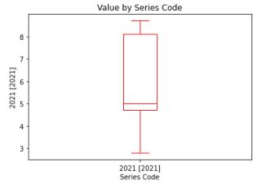

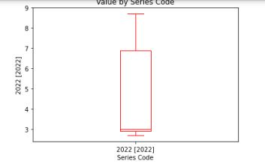

# Visualization 2:

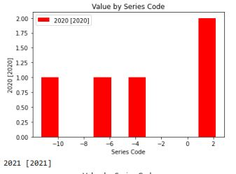

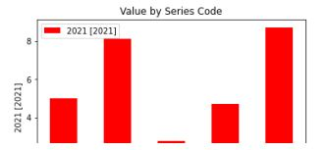

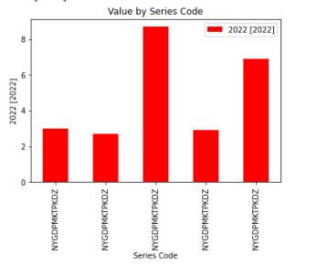

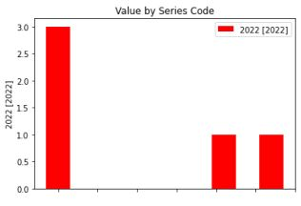

Under this, the data of the value of the series code is analysed while using the hist_plot. The role of the histogram is to analyse the data and summarize it effectively. Plt.xlabel() supports in labelling the year of the histogram (Davey, et, al, 2022). Someone who uses accurate measurements, seeks to comprehend how values are distributed, then wants to search for anomalies, they should use histograms. All continuous observations are plotted in bars, which are categories of quantities. The overall number or fraction of samples which thus fall around each bin are shown as bars beside every bin. Leaf and branch plots but also histograms remain analogous (Bobek, et, al, 2022).

# Visualization 3:

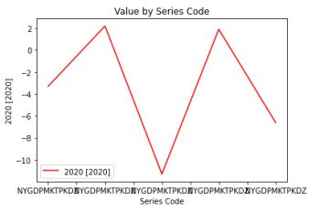

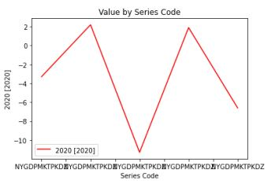

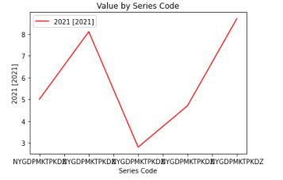

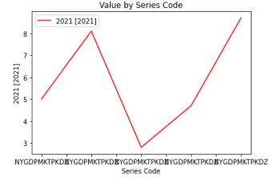

The line graph helps in presenting and to analyse the situation of the value series code as per the aspect of the different country names, and country codes and to analyse the data as per the situation of the year wise. In python, the line plot supports analysing the data. Under the datagram, the plotting needs to represent as per the line format also representing the line in red colour.

# Conclusion

Three types of visualization methods help in extracting meaningful information. Under this, the box plot graphs, plotting, and histograms are created that is analysing the year-wise estimation of the different countries in terms of the series code

# References

Bobek, S., Tadeja, S.K., Struski, Ł., Stachura, P., Kipouros, T., Tabor, J., Nalepa, G.J. and Kristensson, P.O., 2022. Virtual reality-based parallel coordinates plots enhanced with explainable ai and data-science analytics for decision-making processes. *Applied Sciences*, *12*(1), p.331.

Pham, L., Schindler, A., Schutz, M., Lampert, J., Schlarb, S. and King, R., 2022, March. Deep learning frameworks applied for audio-visual scene classification. In *Data Science–Analytics and Applications: Proceedings of the 4th International Data Science Conference–iDSC2021* (pp. 39-44). Wiesbaden: Springer Fachmedien Wiesbaden.

Tang, D., Chen, J., Wang, X., Zhang, S. and Yan, Y., 2022. A new detection method for LDoS attacks based on data mining. *Future Generation Computer Systems*, *128*, pp.73-87.

Davey, A., van Herk, M., Faivre-Finn, C. and McWilliam, A., 2022. radial data mining to identify density–dose interactions that predict distant failure following SABR. *Frontiers in Oncology*, *12*, p.838155.