

**Python and Deep Learning Programming**

ICP - 1

Name : Vishnu vardhan reddy Manne Student ID: 16290738

Email ID [:vmpg6@mail.umkc.edu](mailto:vmpg6@mail.umkc.edu)

**Department of Computer Science**

**University of Missouri, Kansas City**

**1. State differences between Python 2 and Python 3 version?**

Python version 2:

* The syntax of python 2 is comparatively difficult to understand.
* Not difficult to port programs written in python 2 to python 3.
* For the print function the braces are not used.
* When two integers are divided you always provide integer value.
* The implicit str type is ASCII.

Python version 3:

* The syntax is simple and easy to understand.
* Python 3 is not backwardly compatible with python 2.
* For the print function the braces are used.
* When two integers are divided we always get a float value.
* The implicit str type is Unicode.

**2. Write a python program for the following:**

* **Input the string “Python” as a list of characters from console, delete at least 2 characters, reverse the resultant string and print it.**

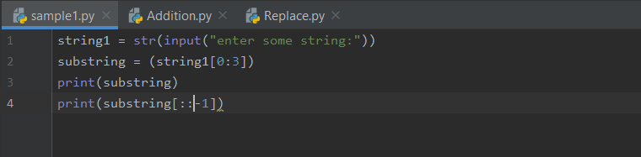

Output:

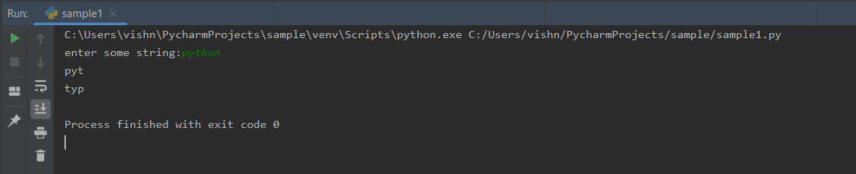

* **Take two numbers from user and perform arithmetic operations on them.**

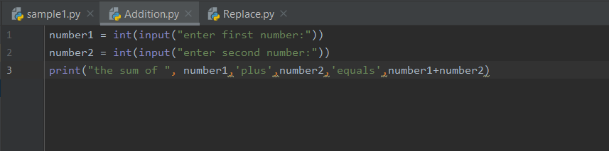

Output:

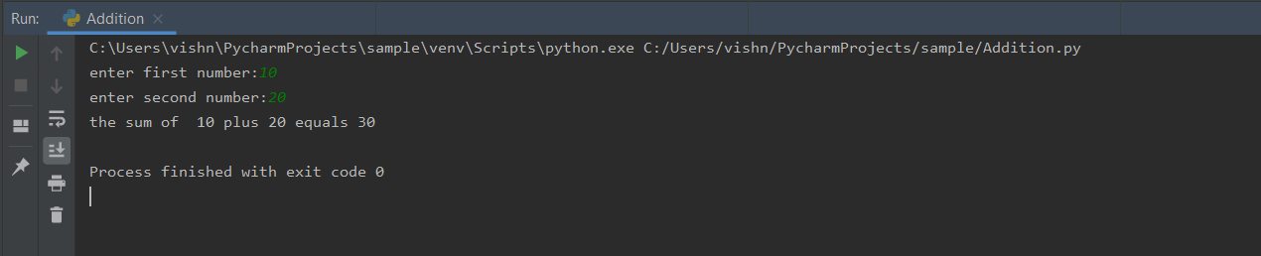

**3. Write a program that accepts a sentence and replace each occurrence of ‘python’ with ‘pythons’ without using regex**

* **Sample input: I love playing with python**

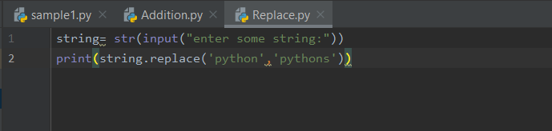

Output:

