

**Python and Deep Learning Programming**

ICP - 2

Name : Vishnu vardhan reddy Manne Student ID: 16290738

Email ID [:vmpg6@mail.umkc.edu](mailto:vmpg6@mail.umkc.edu)

**Department of Computer Science**

**University of Missouri, Kansas City**

1. **Write a program, which reads weights (lbs.) of N students into a list and convert these weights to kilograms in a separate list using:**

* **Loops :**

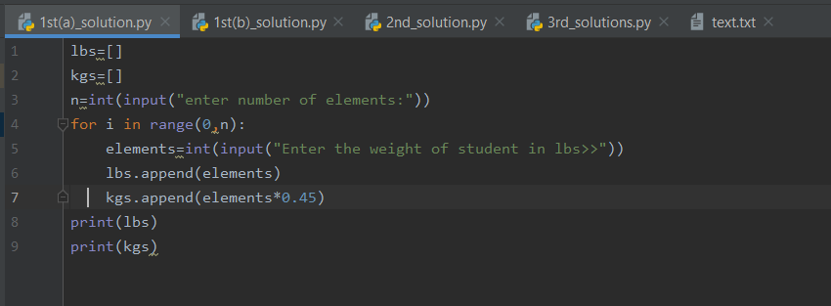

**Output:**

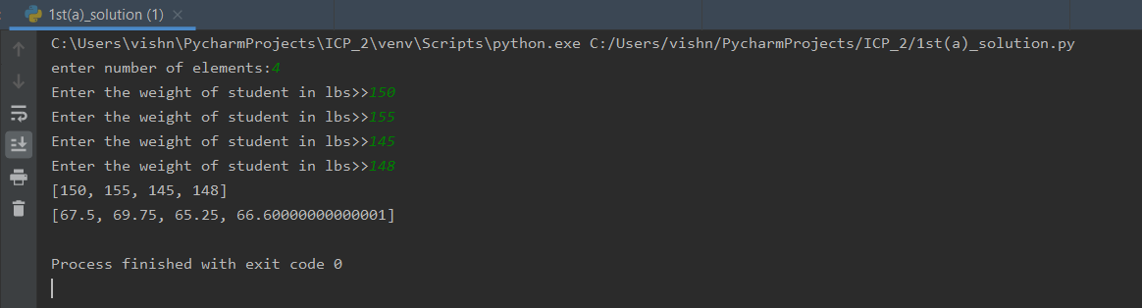

* **List comprehensions:**

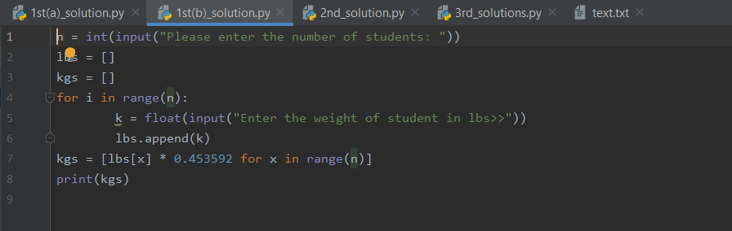

**Output:**

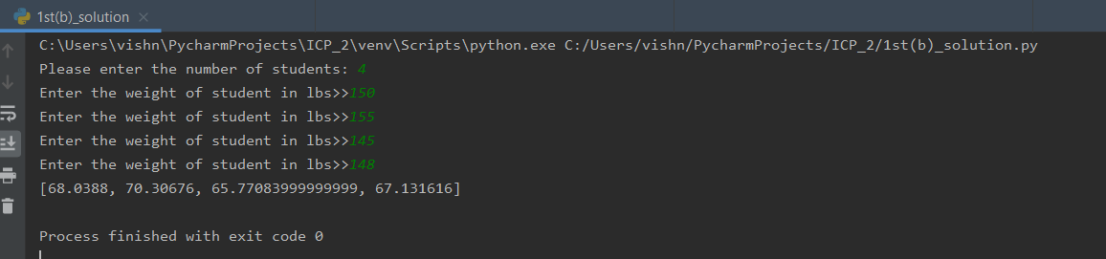

1. **Write a program that returns every other char of a given string starting with first using a function named “string_alternative”**

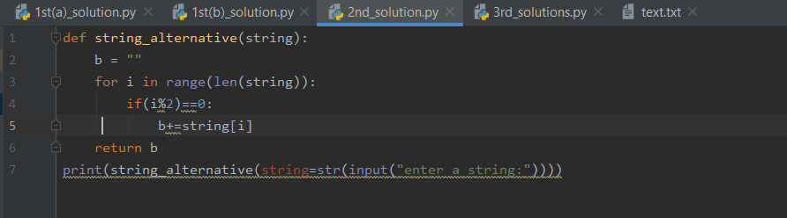

**Output:**

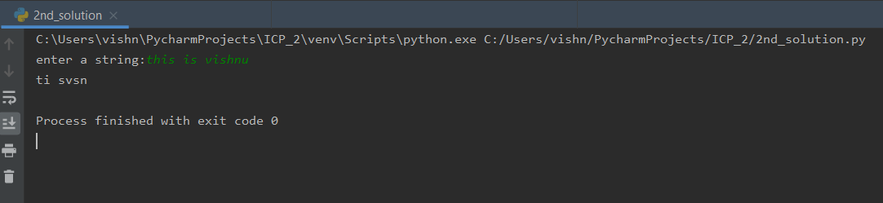

**3. Write a python program to find the wordcountin a file for each line and thenprint the output.Finally store the output back to the file.**

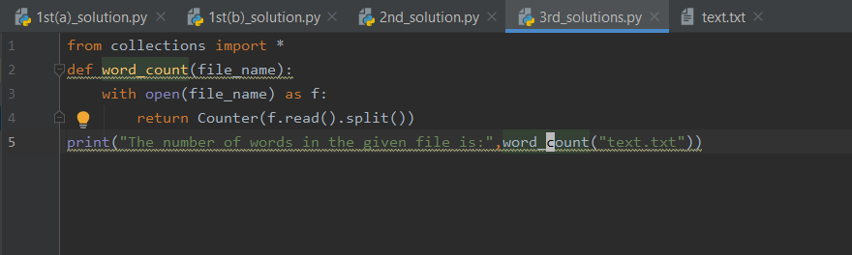

**Output:**

