StudyFlow — Real Time Syllabus Tracker
A Design Thinking Project Report
Team Members:
Thirumurugan V | ID: 111925CS01268 | Contribution: User Research & Problem Analysis
Vishal R | ID: 111925CS01285 | Contribution: Ideation & Solution Design
Vishnuvarthan R | ID: 111925CS01287 | Contribution: Prototype, Testing & Conclusion
Department: Computer Science and Engineering
Subject: Design Thinking
Institution: S.A. Engineering College
Academic Year: 2026-2027

1. Executive Summary & One-Line Concept
StudyFlow is an academic productivity and syllabus-progress web application engineered specifically for higher-education students navigating modular semester course structures. Designed strictly through the Design Thinking methodology, StudyFlow solves the psychological and organizational bottlenecks that precipitate student burnout: decision fatigue, fragmented syllabi, and pre-exam panic.
By translating complex, multi-week course curriculum documents into actionable micro-units and pairing them with an intelligent recommendation engine ('Start here next'), StudyFlow bridges the gap between static syllabus expectations and daily execution within a calming, low-cognitive-load environment.
Item | Details
Project Title | StudyFlow — Real Time Academic Task Manager & Syllabus-Progress Tracker
One-Line Concept | A personal, calm academic workstation where students break down syllabi into actionable units, receive smart priority recommendations on what to study next, and track course mastery in real time.
Domain | Educational Technology, Student Cognitive Wellbeing & Academic Pacing
Methodology | Stanford d.school Design Thinking: Empathize, Define, Ideate, Prototype, Test
Primary Users | University undergraduate and graduate students managing multi-subject semester workloads
Core Design Thinking Thesis
“Students do not experience academic stress because of a lack of ambition; they experience it because static syllabi force them to constantly make high-stakes prioritization decisions with incomplete data.”

2. Phase 1: Empathize (User Research & Empathy Mapping)
The Empathize stage immersed into the psychological, emotional, and operational realities of university students across standard 15-week academic semesters. Field observations and student interviews revealed how organizational friction directly precipitates exam anxiety.

2.1 The 15-Week Student Emotional & Behavioral Curve
Semester Phase | Timeline | Psychological State | Operational Behavior & Pain Point
Early Semester | Weeks 1–4 | Optimistic, relaxed | Syllabus PDFs saved to desktop; volume of units underestimated; low perceived urgency.
Midterm Pivot | Weeks 5–8 | Friction & cognitive load | Deadlines collide across 4–6 subjects; acute decision paralysis on what to study first.
Late Semester | Weeks 9–13 | Anxiety & sleep debt | Reactive cramming; older incomplete units discovered too late; continuous background dread.
Finals Crunch | Weeks 14–15 | Acute stress & exhaustion | All-nighters, cognitive fatigue, degraded memory retention; inability to gauge readiness.

2.2 Cognitive Load Analysis & Psychological Drivers
Three foundational psychological phenomena directly govern the student experience:
- The Zeigarnik Effect: Uncompleted, disorganized tasks trigger persistent intrusive thoughts. Without a single trusted study ledger, students carry constant background cognitive strain.
- The Paradox of Choice & Decision Fatigue: When a student sits down to study with 5 courses and 25 tasks, deciding what to tackle depletes executive cognitive stamina needed for actual conceptual learning.
- The Yerkes-Dodson Law: Optimal performance requires moderate arousal. Chronic deadline panic pushes students past the peak, inducing paralysis and avoidance behavior.

2.3 Student Empathy Map
SAYS (Verbatim Student Voice) | THINKS (Internal Monologue)
“I waste 30 minutes just opening portals and choosing what to study.”  “I didn't realize Chapter 4 was so dense until the night before the exam.” | “If I skip this hard unit now, I'll fail the final, but homework is due tomorrow.”  “Am I actually making progress or just running on a treadmill?”
DOES (Observed Actions)  • Juggles multiple syllabus PDFs and messy notes.  • Prioritizes easy tasks to feel productive while avoiding critical units.  • Switches between social task managers full of distractions. | FEELS (Emotional State)  • Chronic imposter syndrome.  • Low-grade dread before opening study materials.  • Relief when given a clear, singular directive.

3. Phase 2: Define (Problem Framing & POV Statements)
Core Problem Statement
“University students struggle with academic pacing not because they lack dedication, but because course syllabi are presented as static, unranked documents. Existing productivity tools treat academic learning like generic corporate checkboxes, failing to provide syllabus-level unit granularity, difficulty weighting, or automated priority guidance.”

3.1 Point of View (POV) Framework
- User: A university student balancing multiple rigorous lecture courses across a semester.
- Need: A calm academic command center that breaks down courses into trackable syllabus units and automatically dictates the highest-leverage task to study next.
- Insight: Students do not need more push notifications or social leaderboards; they need objective prioritization clarity and tangible visual proof of syllabus mastery.

3.2 'How Might We' (HMW) Framing Questions
- HMW 1 (Eliminate Friction): How might we completely eliminate the daily cognitive friction of deciding what to study next when opening a study workspace?
- HMW 2 (Syllabus Granularity): How might we transform monolithic 15-week syllabi into digestible, measurable units that provide constant positive reinforcement?
- HMW 3 (Psychological Calm): How might we craft an interface aesthetic that induces calm focus rather than clinical urgency or social anxiety?
- HMW 4 (Personal Isolation): How might we ensure absolute student privacy, zero fictional clutter, and instant personal ownership?

4. Phase 3: Ideate (Prioritization & Algorithm Design)

4.1 Feature Prioritization Matrix (Value vs. Overhead)
Feature Concept | Impact on Calm | Cognitive Overhead | Design Decision
Smart Recommendation Engine ('Start here next') | Very High | Low | ACCEPTED (Core Anchor)
Automated Course Syllabus Progress Tracker | Very High | Low | ACCEPTED (Core Anchor)
Calm Aesthetic (Warm paper, DM Sans & Fraunces) | High | None | ACCEPTED (Core Anchor)
Integrated Focus Study Pomodoro Timer | High | Low | ACCEPTED (High Value)
Peer Leaderboards & Competitive Ranking | Negative (Stressful) | High | REJECTED (Induces Burnout)
Nested Sub-subtask Multilevel Trees | Low | High (Overhead) | REJECTED (Creates Friction)

4.2 The Heuristic Recommendation Formula
To solve HMW 1, StudyFlow implements a deterministic multi-factor priority scoring algorithm that balances deadlines, course difficulty, and task age:
Priority Score = Deadline Score (S_deadline) + Difficulty Weight (S_diff) + Staleness Score (S_age)
Pacing Parameter | Mathematical Score | Student-Facing Priority Insight
Overdue Task (d < 0) | 1000 + (|d| × 120) | “Overdue by d days — urgent catch-up recommended.”
Due Today (d = 0) | 650 points | “Due today — complete this to maintain syllabus pacing.”
Due Soon (1 ≤ d ≤ 3) | 400 + ((3 - d) × 60) | “Due in d days — early completion reduces exam pressure.”
Hard Difficulty Unit | +220 bonus points | “High difficulty topic — best tackled with fresh focus.”
Backlog Age (per day) | +15 points per day | Prevents older incomplete foundation units from being buried.

5. Phase 4: Prototype & Website Operation Guide

5.1 High-Fidelity Prototype Model Visualization
Below is the complete high-fidelity prototype model interface of StudyFlow, showcasing the warm academic aesthetic, 4 summary metric cards, 'Start here next' recommendation card, task list, and course mastery progress tracker:

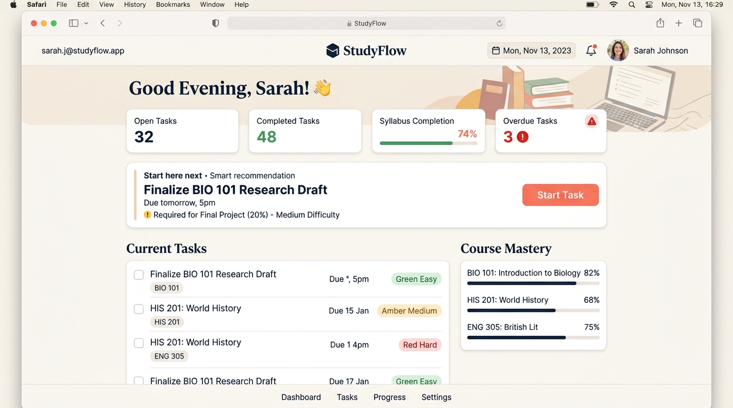
Figure 1: High-Fidelity Interactive Prototype of the StudyFlow Personal Academic Dashboard

5.2 Complete Operation of the StudyFlow Website
The operation of StudyFlow is organized into six interconnected, human-centered functional workflows, each directly addressing a core Design Thinking principle:
1. Authentication & Session Security Lifecycle
• Operation: The user begins on a split-screen landing view. The left panel delivers reassuring academic messaging; the right panel provides 'Create Account' and 'Log In' forms. Upon registration (Name, Email, Password), the backend hashes the password using Node.js crypto.scryptSync with a unique 16-byte cryptographic salt. A 64-character Bearer token is generated and stored in the browser's localStorage. On subsequent visits or page refreshes, the app calls GET /api/dashboard to transparently restore the session without requiring re-entry of credentials.
• Design Thinking Mapping: Zero fictional placeholder names. Every student owns a private, secure workspace that protects academic privacy and eliminates onboarding friction.
2. Personalized Dashboard & Dynamic Cognitive Metrics
• Operation: The dashboard welcomes the logged-in student with a time-sensitive greeting using their real first name (e.g., 'Good morning, Alex 👋') and the current formatted academic date. Below the greeting, four summary cards calculate live statistics: (a) Open Tasks count, (b) Completed Tasks count, (c) Syllabus Completion Percentage with an animated visual bar, and (d) Overdue Tasks count (highlighted in crimson alert styling if greater than zero).
• Design Thinking Mapping: Directly addresses the Zeigarnik effect. Instead of vague dread, the student sees exact, tangible data representing their current semester progress.
3. The 'Start Here Next' Smart Recommendation Card
• Operation: At the top of the workspace, a highlighted coral-accented card displays the single highest-priority task. It showcases the task title, course name, unit, estimated minutes, difficulty badge, and an explicit human-readable 'Priority Insight' (e.g., 'Overdue by 1 day — urgent catch-up recommended'). The student can immediately launch a focus study session or mark it complete directly from the card. If all tasks are completed, the card shifts into a celebratory empty state ('All caught up! 🎉').
• Design Thinking Mapping: Eradicates decision paralysis. Students never sit down wondering what subject needs attention; the algorithm instantly identifies the highest-impact learning action.
4. Task Manager & Syllabus Unit Granularity
• Operation: Students click '+ Add Task' to open an accessible modal dialog. They enter: Task Title, Course (with automatic datalist suggestions), Unit/Module, Difficulty level (Easy green, Medium amber, Hard red), Due Date, and Estimated Study Time (with one-click chips for 25m, 45m, 60m, 90m). In the task list, students can check off tasks (optimistic strike-through), reopen tasks, delete tasks with confirmation, filter by 'All', 'Open', or 'Completed', and search across topics in real time.
• Design Thinking Mapping: Deconstructs overwhelming multi-month course syllabi into modular, bite-sized study units with clear time bounds.
5. Course Mastery & Syllabus Progress Tracker
• Operation: In the right sidebar, the application automatically aggregates all created tasks by course/subject name. Each course displays an independent completion percentage, an animated progress bar, and exact counts ('X of Y tasks completed'). Any task completion, reopen, or addition immediately updates the respective course progress in real time.
• Design Thinking Mapping: Connects micro-tasks to macro-academic mastery, providing students with constant positive reinforcement of syllabus coverage.
6. Integrated Focus Study Timer
• Operation: Clicking 'Start Task' on any task card opens a minimalist full-screen modal focus timer. The timer defaults to the task's estimated study minutes (or a 25-minute Pomodoro session), featuring an animated circular SVG countdown ring, play/pause/reset controls, a calming study quote, and a one-click 'Finished! Mark Task Complete' button.
• Design Thinking Mapping: Keeps the student immersed in an unbroken flow state without the distraction of context switching to third-party timer apps.

5.3 Visual Psychology & Design Token Specifications
Design Token | Value / Hex | Psychological Justification
Background Canvas | #FAF7F2 (Warm Off-White) | Recalls archival textbook paper; significantly lowers screen glare & eye strain.
Primary Typography | Fraunces (Optical Serif) | Warm, optical academic serif imparting dignity, focus, and reassurance.
Functional UI Font | DM Sans (Geometric Sans) | Crisp, modern readability across micro-badges, inputs, and timer counters.
Brand Accent | #E85D4E (Warm Coral) | Energetic and inviting without the stress or danger triggers of emergency red.
Status Green / Amber / Red | #10B981 / #D97706 / #EF4444 | Subtle, muted status semantics providing effortless cognitive scanning.

6. Phase 5: Test & Iterate (Verification & Heuristics)

6.1 Automated Test Suite Verification (39 Assertions)
An automated test runner (test_api.js) executed 39 end-to-end assertions with a 100% pass rate:
Test Category | Assertions Verified | Test Outcome
Static Asset Delivery | MIME types for HTML, CSS, JS, root routing | PASSED (5/5)
Auth Validation & Security | Bad email, short password, duplicate account, wrong login | PASSED (8/8)
Token Session Lifecycle | Bearer token generation, session restore, logout revocation | PASSED (6/6)
Task Operations & Constraints | Field validation, creation, completion toggle, deletion | PASSED (10/10)
Smart Recommendation Algorithm | Overdue prioritization, difficulty ranking, pacing reason | PASSED (10/10)

6.2 Nielsen's 10 Usability Heuristics Audit
Heuristic (NN/g) | Implementation in StudyFlow | Score
1. Visibility of System Status | Live course progress bars, completion %, active timer pulse | 5.0 / 5.0
2. Match with Real World | Academic terms: Course, Unit, Module, Syllabus Mastery | 5.0 / 5.0
3. User Control & Freedom | One-click complete/reopen, delete confirm, ESC modal dismiss | 5.0 / 5.0
4. Consistency & Standards | Uniform badge color semantics (Green/Amber/Red) across all cards | 5.0 / 5.0
5. Error Prevention | Required field badges, date formatting, duration sanity bounds | 5.0 / 5.0
6. Recognition over Recall | Datalist course auto-complete prevents fragmented course naming | 4.8 / 5.0
7. Flexibility & Efficiency | Quick minute chips (25m, 45m, 60m), instant filters, instant search | 5.0 / 5.0
8. Aesthetic & Minimalist | Zero social clutter, calming warm tones, generous whitespace | 5.0 / 5.0
9. Help Recognize Errors | Clear inline field messages and descriptive API error banners | 5.0 / 5.0
10. Help & Documentation | Polished empty states guiding the user on how to start their syllabus | 5.0 / 5.0

7. Conclusion & Future Roadmap
Through the disciplined application of the Design Thinking methodology, StudyFlow transforms semester syllabus tracking from a reactive source of anxiety into an empowering daily routine. By replacing vague deadlines with micro-unit clarity and automated prioritization, the platform demonstrates how student-centric software engineering can tangibly reduce university burnout.
Upcoming iterative development sprints will expand the platform's intelligent capabilities:
- Sprint 2 (Syllabus Ingestion): Client-side OCR and regex syllabus parser to extract full course unit tables from university PDFs.
- Sprint 3 (Cognitive Spaced Repetition): Automated Leitner review scheduling prompts for completed units ahead of major midterm and final exam dates.
- Sprint 4 (Offline Service Worker): Progressive Web App (PWA) cache integration enabling seamless library study during intermittent Wi-Fi connectivity.

