Vishnu Vasan Nehru +91-74113 67797
7+Years - ECU SW & Test Development Engineer vishnuvasan@vishnuvasan.com

+CONTACT
Current Address | Site No: 562, TR Muniswamappa Building, 1st Main,  6th Cross, Ramagondanahalli  Bangalore  India - 560066
Permanent Address | B10,New Housing Unit,  Mannargudi,Thiruvarur(D.t)  TamilNadu  India - 614001
Date of birth | November 9,1987 (29 years old) |  | Gender/Nationality |  | Male/Indian

+ EXPERIENCE
        Sep 2013 – Till Date | Mercedes Benz Research and Development India, Bangalore,India  Senior Technical Lead – Real Time HiL Test Development  Onsite Assignment @ Daimler AG,Stuttgart,Germany:  2014: Mar–Jun, Sep-Dec | 2015: Mar–Jun, Oct-Dec | 2016: Oct- Dec |  2017: Jan-Mar  - Test Automation Development/Testing for Sensor Diagnostic Functions - Engine ECU in Provetech:TA for dSpace HiL Environment  - Test Automation Development/Testing for Transmission ECU Functions and Maximum CPU Load Measurement  - Developed Real Time Scripts for Multi Processor Environments to test Engine & Transmission ECU Functions    - Effective Communication/Coordination with Function Developers for better understanding of the Functionality and also serving as coordination point for 6 associates  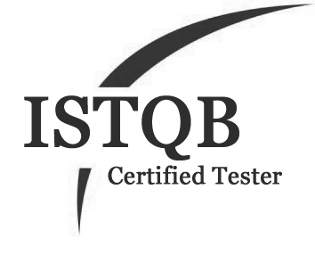  - Developed Multiple Generic Libraries and distributed across the whole team for better Efficiency  - Multiple Onsite Assignments for Performing Validation of V Cycle SW Releases for all Daimler Engine Sws
Feb 2011 – Sep 2013        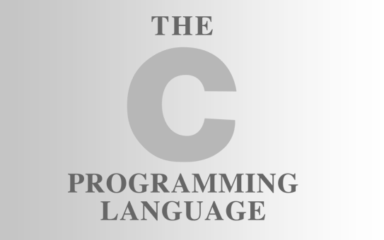 | Robert Bosch Engineering and Business Solutions,Coimbatore,India  Senior Software Engineer – ECU Application SW Model Development  - Development of Engine ECU Functions in ASCET– OFBD Actuator Test, Torque Distribution/Reservation during Maximum Load, Idle Speed Control  - Involved in Development of Stateflow/State Machine Design in MATLAB and ASCET  - Involved in Integration of Customer Specific AUTOSAR Functions into ECU SW and also developed necessary adapters for the interface  - Involved in Variant Specific Software Customization/Optimization based on System Architecture  - Involved in various Automation Activities – Majorly Data to Model(D2M) – For Conversion of Autosar Interface Data directly to ASCET Models without human Intervention and received accolades  - Some other Tools Developed are A2L Extractor,A2L Generator,E-Hooks Generator  
Mar 2010 – Feb 2011    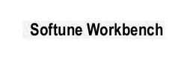 | Automotive Infotronics ( A Joint Venture between Continental AG & Ashok Leyland ),Chennai,India  Graduate Engineer Trainee – ECU Application SW Development/Testing  - Implementation of Tire Configuration Computation Algorithm in LogiCAD-KIBES 32 for Intelligent Tire System Display Unit  - Involved in Development of Various Screens and Integration of Screens with Logical Modules for ITS.  - Development of Tell Tale Module,Power on Self Test for Cluster  - Black Box Testing for Integrated Body Control Module & Instrument Cluster

+ IT PROFESSIONAL SKILLS
Modeling Tools | MATLAB Simulink/Stateflow,  ASCET,LogiCAD – KIBES,SciLab |  |  | Programming Languages |  | VBA,C,Python,  Perl,Ruby,Scala,  Embedded C
ECU Tools | Provetech TA,INCA,Softune, Gravis, CANlyzer, VehicleSpy,  dSpace HiL,ETAS Lab Car, RTPC, Control Desk
Other Skills | Git,Django,Js,  HTML,D3Js |  |  | Operating System |  | Windows,OS X,  Linux
Open Source Projects | https://github.com/vishnuvasan

+ EDUCATION
2004 - 2008 |  | Bachelor of Engineering – Electronics and Communication Engineering  77% - I Class  Anna University/ Saranathan College of Engineering,Trichy, TamilNadu,India

+ LANGUAGES
Languages |  | Tamil - Mother Tongue  English - (Very good command both written and spoken)  German – (A1- Ongoing)

+ ACHIEVEMENTS
- Awarded with One Time Achievement (OTA) Award @ BOSCH for Implementation of Data to Model Converter
- Awarded with Above and Beyond Call of Duty (ABCD) @ Mercedes for Work in Sensor Tests
- Trained Inter Departmental Colleagues under Various Situations over the topic of Automotive Software Development and Tools
- School Topper in 10th Standard with 84%
- Secured 93% in 12th Standard

