Vishnu Vasan Nehru +91-88611 94875
8+Years – Model Dev & Test Automation Engineer vishnuvasan@vishnuvasan.com

+CONTACT
Current Address | Site No: 562, TR Muniswamappa Building, 1st Main,  6th Cross, Ramagondanahalli  Bangalore  India - 560066
Permanent Address | B10,New Housing Unit,  Mannargudi,Thiruvarur(D.t)  TamilNadu  India - 614001
Date of birth | November 9,1987 (30 years old) | Gender/Nationality |  | Male/Indian

+ EXPERIENCE
        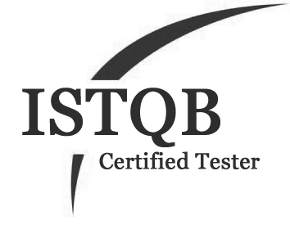 |   Mercedes Benz Research and Development India, Bangalore,India  Sep 2013 – Till Date  Senior Technical Lead – Real Time HiL Test Development  Onsite Assignment @ Daimler AG,Stuttgart,Germany:  2014: Mar–Jun, Sep-Dec | 2015: Mar–Jun, Oct-Dec | 2016: Oct- Dec |  2017: Jan-Mar, Oct-Dec  - Test Automation Development/Testing for Sensor Diagnostic Functions - Engine ECU in Provetech:TA for dSpace HiL Environment  - Test Automation Development/Testing for Transmission ECU Functions and Maximum CPU Load Measurement  - Developed Real Time Automation Tests in Multi Core Architecture for Real Time Multiple ECU Interaction/Environment  - Developed Multiple Generic Libraries and distributed across the Internal Test Automation Community for better Efficiency    - Effective Communication/Coordination with Function Developers over Test Requirements/Specifications  - Utilized lot of Functional Programming concepts and Developed multiple Tools in Multiple Languages like VB Script, VBA, Perl, Javascript etc.,  - Multiple Onsite Assignments for Performing Validation of V Cycle SW Releases for all Daimler Engine/Transmission Sws  - Leading a Test Automation Team of 7 Engineers
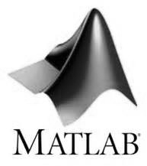      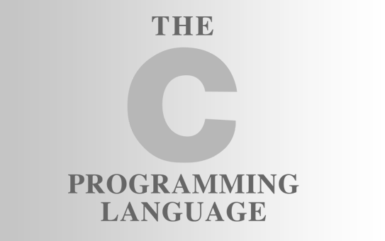 |   Robert Bosch Engineering and Business Solutions,India  Feb 2011 – Sep 2013  Senior Software Engineer – ECU Application SW Model Development  - SW Model Development of Engine ECU Functions in ASCET– Actuator Test, Torque Distribution/Reservation during Maximum Load, Idle Speed Control  - Development of Stateflow/State Machine Design in MATLAB and ASCET  - Developed Multiple Tools – Majorly Data to Model(D2M) – For Conversion of Autosar Interface Data directly to ASCET Models without human Intervention and received accolades  - Involved in Integration of Customer Specific AUTOSAR Functions into ECU SW and also developed necessary adapters for the interface  - Involved in Variant Specific Software Customization/Optimization based on System Architecture  - Been Instrumental in Multiple Efficiency Improvements and Developed tools like A2L Extractor,A2L Generator,E-Hooks Generator etc.,  
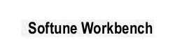   | Automotive Infotronics ( A Joint Venture between Continental AG & Ashok Leyland ),Chennai,India  Mar 2010 – Feb 2011  Graduate Engineer Trainee – ECU Application SW Development/Testing  - Model Implementation of Tire Configuration Computation Algorithm in LogiCAD-KIBES 32 for Intelligent Tire System Display Unit  - Development of Various Screens and Integration of Screens with Logical Modules for ITS.  - Development of Tell Tale Module,Power on Self Test for Cluster  - Black Box Testing for Integrated Body Control Module & Instrument Cluster

+ IT PROFESSIONAL SKILLS
Modeling Tools | MATLAB Simulink  Stateflow  ASCET  LogiCAD – KIBES  SciLab  Octave |  | Programming Languages | C  VBA  R  Perl  Python  Scala
ECU Tools | Provetech Test Automation Suite  INCA  CANlyzer, CANape, VehicleSpy  Softune  Gravis  dSpace HiL, Control Desk  ETAS Lab Car, RTPC
Other Skills | SVN, Git  Js, D3Js  HTML, CSS  Django |  | Operating System | Linux  Windows  Mac OS
Open Source Projects | https://github.com/vishnuvasan
Enjoys | Code/Model/Algorithm Development, Problems/Challenges  Programming, Foraying into New Technologies  Colloboration, Diversity, Openness, Camaraderie

+ EDUCATION
2004 - 2008 | Bachelor of Engineering – Electronics and Communication Engineering  77% - I Class  Anna University/ Saranathan College of Engineering,Trichy, TamilNadu,India

+ LANGUAGES
Languages | German – A1  English - Fluent  Tamil - Mother Tongue

+ ACHIEVEMENTS
- Awarded with One Time Achievement (OTA) Award @ BOSCH for Implementation of Data to Model(D2M) Converter
- Awarded with Above and Beyond Call of Duty (ABCD) @ Mercedes for Work in Sensor Tests and received Multiple Accolades in Multiple occasions
- Trained Inter/Intra Departmental Colleagues under Various Situations over the topic of Automotive Software Development and Tools
- School Topper in 10th Standard with 84%
- Secured 93% in 12th Standard

