ASSIGNMENT 10.2

Loading data into hbase using pig script...........

step1

[acadgild@localhost ~]$ hadoop fs -put /home/acadgild/vishnu/student.txt /vishnu
17/11/02 08:31:31 WARN util.NativeCodeLoader: Unable to load native-hadoop library for your platform... using builtin-java classes where applicable
[acadgild@localhost ~]$
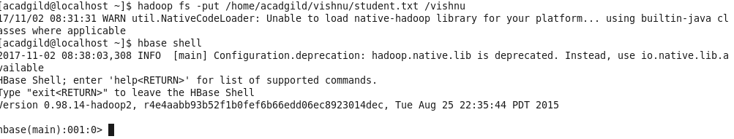
step 2
hbase(main):001:0> create 'studentAcad','student_data'
SLF4J: Class path contains multiple SLF4J bindings.
SLF4J: Found binding in [jar:file:/usr/local/hbase/lib/slf4j-log4j12-1.6.4.jar!/org/slf4j/impl/StaticLoggerBinder.class]
SLF4J: Found binding in [jar:file:/usr/local/hadoop-2.6.0/share/hadoop/common/lib/slf4j-log4j12-1.7.5.jar!/org/slf4j/impl/StaticLoggerBinder.class]
SLF4J: See http://www.slf4j.org/codes.html#multiple_bindings for an explanation.
2017-11-02 08:40:37,701 WARN [main] util.NativeCodeLoader: Unable to load native-hadoop library for your platform... using builtin-java classes where applicable
0 row(s) in 12.0840 seconds

=> Hbase::Table – studentAcad

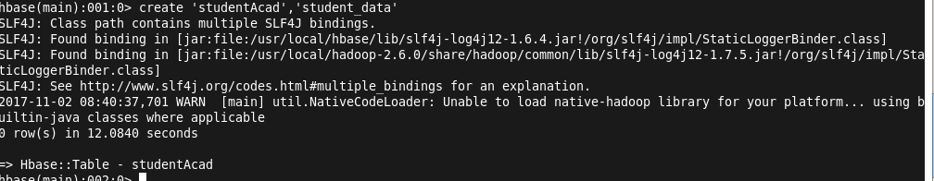
step 3

grunt> rawD = LOAD '/vishnu/student.txt' USING PigStorage(',') AS (name:chararray,sector:chararray,dob:chararray,qualification:chararray,score:int,state:chararray,randomName:chararray);

step 4

grunt> STORE rawD INTO 'hbase://studentAcad' USING org.apache.pig.backend.hadoop.hbase.HBaseStorage('student_data:sector,student_data:dob,student_data:qualification,student_data:score,student_data:state,student_data:randomName');

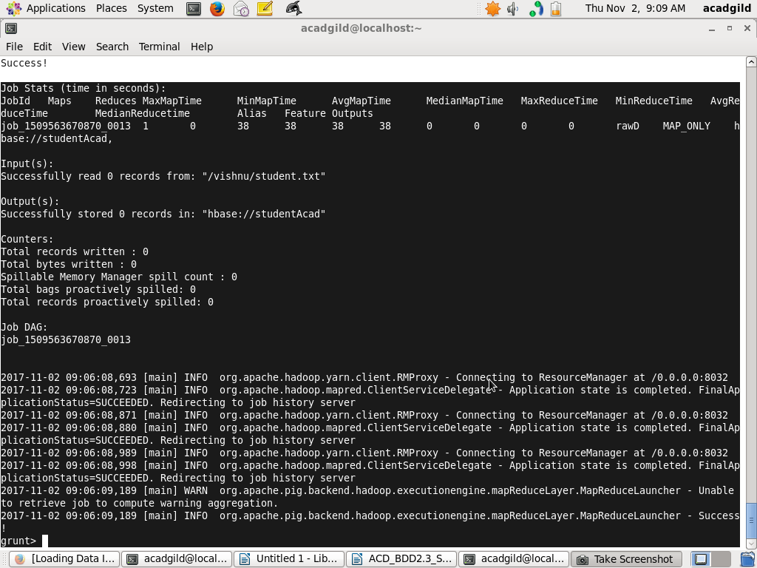

step 5

hbase(main):003:0> scan 'studentAcad'

