ASSIGNMENT11.3

Twitter Data Using Flume

Apache Flume is a Hadoop ecosystem component used to collect, aggregate and moves a large amount of log data from different sources to a centralized data store.

PROCESS

Fetching keys from twitter

Consumer Key (API Key) 1L2iVignj32qR6oiNVwJPagBw
Consumer Secret (API Secret) Qzt87kyoSg0JhlYb6SQD7Mis3iuUyjGE8I8EtPypRjDfVdbjwW

Access Token 926550535196459008-K4Z7ATvxvduW1C5JdO2gPlZ08csQBUA
Access Token Secret OJBCrroLNk0JzrzWoN9M5hnvCGNQkfoXtLSE2X6SIKyvz

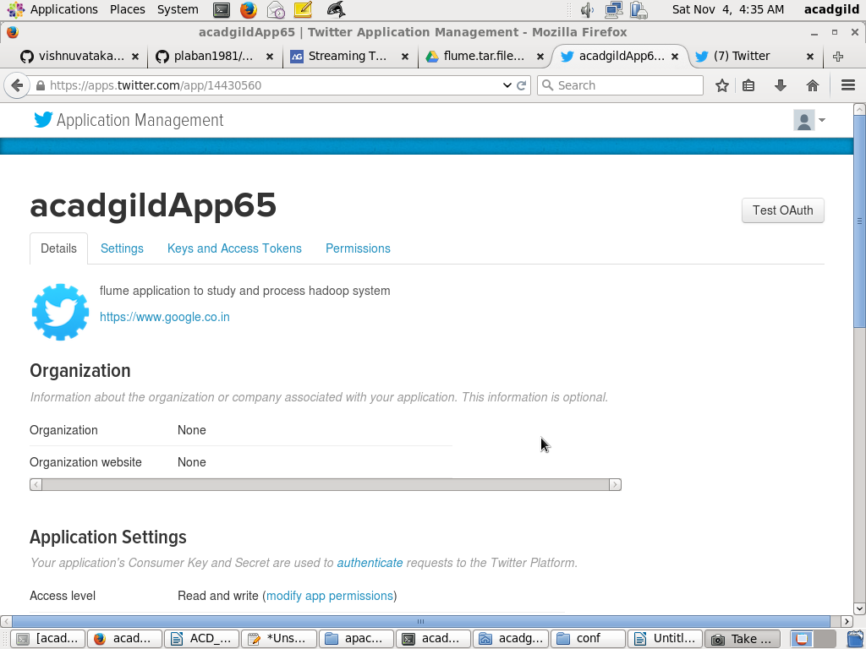

Flume config file
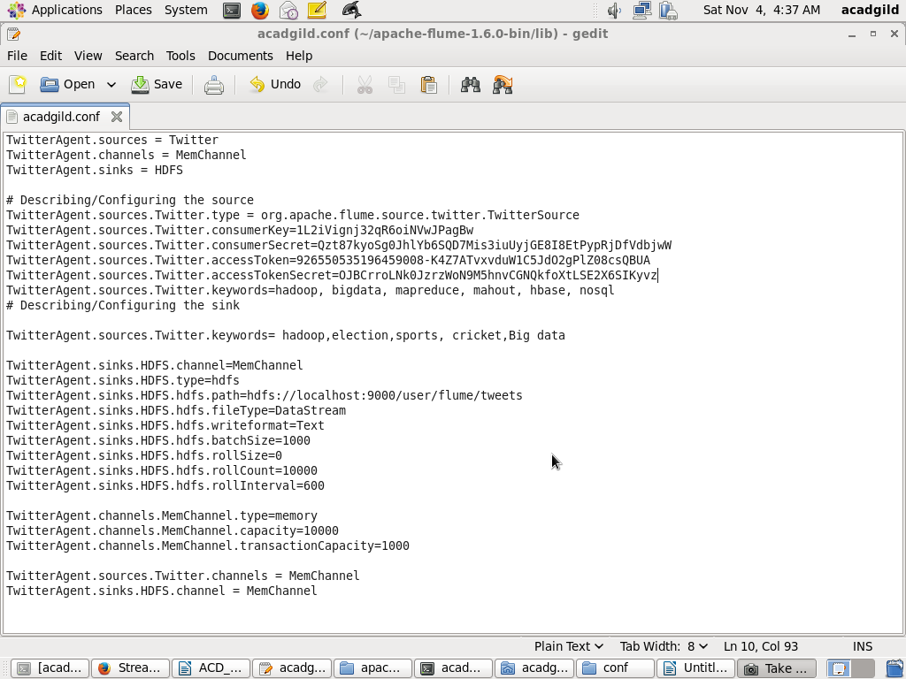

Create a new directory inside HDFS path, where the Twitter tweet data should be stored.

hadoop fs -mkdir -p /vihnu/tweet

For fetching data from Twitter, Use the below command to fetch the twitter tweet data into the HDFS cluster path.

[acadgild@localhost ~]$ flume-ng agent -n TwitterAgent -f /home/acadgild/apache-flume-1.6.0-bin/conf/acadgild.conf

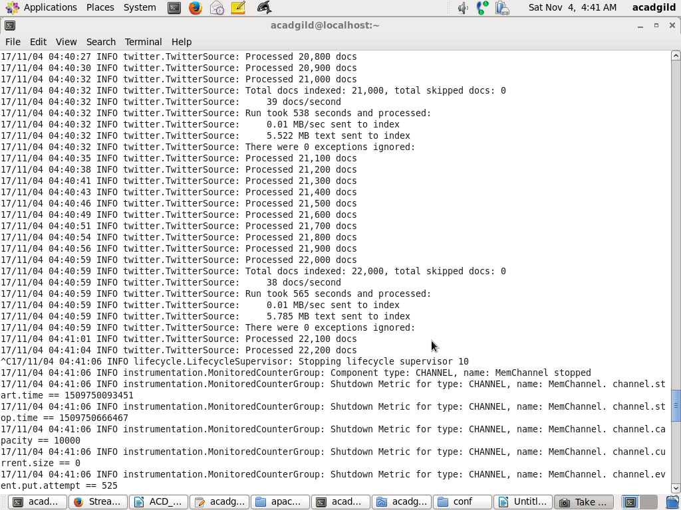

To check the contents of the tweet data we can use the following command:
[acadgild@localhost ~]$ hadoop fs -ls /user/flume/tweets
17/11/04 05:13:12 WARN util.NativeCodeLoader: Unable to load native-hadoop library for your platform... using builtin-java classes where applicable
Found 4 items
-rw-r--r-- 1 acadgild supergroup 9618092 2017-11-04 04:41 /user/flume/tweets/FlumeData.1509750097545
-rw-r--r-- 1 acadgild supergroup 5004481 2017-11-04 04:56 /user/flume/tweets/FlumeData.1509751295968
-rw-r--r-- 1 acadgild supergroup 9419766 2017-11-04 05:07 /user/flume/tweets/FlumeData.1509751661597
-rw-r--r-- 1 acadgild supergroup 3230141 2017-11-04 05:11 /user/flume/tweets/FlumeData.1509752272196

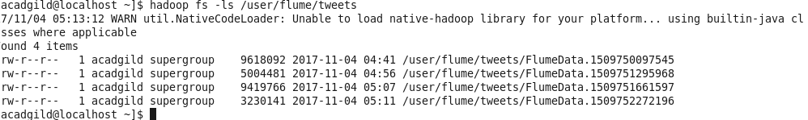

We can use the ‘cat’ command to display the tweet data
[acadgild@localhost ~]$ hadoop fs -cat /user/flume/tweets/FlumeData.1509750097545
