ASSIGNMENT15.1

1.Write a simple program to show inheritance in scala.

abstract class Parent(name:String)//parent class
{
//functions of parent class
def statement = name + " is a " + typeOfAnimal
def typeOfAnimal: String
}
//class cat extends parent class
class Cat(name:String) extends Parent(name){
override def typeOfAnimal = "Cat"
}
//class Tiger extends parent class
class Tiger(name:String) extends Parent(name){
override def typeOfAnimal = "Tiger"
}
//object of main class
object inher {
def main(args:Array[String])
{
var obj1=new Cat("Tom")//object of class cat
println(obj1.statement)
var obj2=new Tiger("Gadu")//object of class tiger
println(obj2.statement)
}

}

OutPut

Tom is a Cat
Gadu is a Tiger

ScreenShots

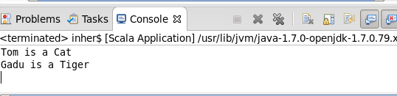

2.Write a simple program to show multiple inheritance in scala.

//multiple inheritance in scala via trait
trait One
{
def show() //function show
{
println("class one")
}
def displayone()
{
println("class one normal method")
}
}
trait Two extends One
{
override def show() //function overriding
{
println("class two")
}
def displaytwo()
{
println("class two normal method")
}
}
//class four extends two trait and inheritance its features
class four extends One with Two //multiple inheritance

object MulInher {
def main(args:Array[String])
{
var obj=new four() //object of the class four
obj.show() //calling show it will call show in trait two
obj.displayone()
obj.displaytwo()
}

}

OutPut

class two
class one normal method
class two normal method

Screeshots

