ASSIGNMENT15.2

1. Write a partial function to add three numbers in which one number is constant and two
numbers can be passed as inputs and define another method which can take the partial
function as input and squares the result.

//class partial function
class PartiallyAppliedFunctions() {
//normal sum and square function
private def sum(x : Int, y : Int) = {
x + y + 10
}

private def square(x :Int) = {

x * x

}
def getsum() : (Int, Int) => Int = { //input function with two inputs

sum( _ : Int, _ : Int) //call sum function
}
//input the result of partial function
def getsquare() : (Int) => Int = {

square( _ : Int) //call square function
}
}

object PartiallyAppliedFunction { //object of class

def main(args:Array[String]){
val obj = new PartiallyAppliedFunctions()
val r = obj.getsum()(4, 4)
println("sum is")
println( obj.getsum()(4, 4))
println("square is")
println(obj.getsquare()(r))
}
}

output

sum is
18
square is
324

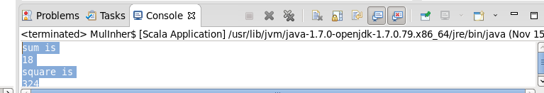

2]
Write a program to print the prices of 4 courses of
Acadgild:
Android-12999,
Big Data Development-17999,
Big Data Administartion-17999,
Spark-19999
using match and add a default condition if the user enters any other course

object AcadgildCourse extends App {
//map initialization
val course=Map(1->"Android",
2->"Bigdata development",
3->"Bigdata Administrator",
4->"spark")
for(i<-course.keys)//for loop for key values
{
print(i+" ")
//match statement for keys
i match
{
//case statements for values 1,2,3,4 and default cases
case 1 =>println(course(i)+" price 12999")
case 2 =>println(course(i)+" price 17999")
case 3=>println(course(i)+" price 17999")
case 4=>println(course(i)+" price 19999")
case _=>println("unknown course")
}
}

}

output

1 Android price 12999
2 Bigdata development price 17999
3 Bigdata Administrator price 17999
4 spark price 19999

Screenshots

