ASSIGNMENT17.2

Given a dataset of college students as a text file (name, subject, grade, marks) :

Problem1

1] Read the text file, and create a tupled rdd

val data=sc.textFile("data.txt")

val tuplerdd=data.map(x=>x.split(",")).map(array=>(array(0),array(1),array(2),array(3).toInt,array(4).toInt))

tuplerdd.collect

Array[(String, String, String, Int, Int)] = Array((Mathew,science,grade-3,45,12), (Mathew,history,grade-2,55,13), (Mark,maths,grade-2,23,13), (Mark,science,grade-1,76,13), (John,history,grade-1,14,12), (John,maths,grade-2,74,13), (Lisa,science,grade-1,24,12), (Lisa,history,grade-3,86,13), (Andrew,maths,grade-1,34,13), (Andrew,science,grade-3,26,14), (Andrew,history,grade-1,74,12), (Mathew,science,grade-2,55,12), (Mathew,history,grade-2,87,12), (Mark,maths,grade-1,92,13), (Mark,science,grade-2,12,12), (John,history,grade-1,67,13), (John,maths,grade-1,35,11), (Lisa,science,grade-2,24,13), (Lisa,history,grade-2,98,15), (Andrew,maths,grade-1,23,16), (Andrew,science,grade-3,44,14), (Andrew,history,grade-2,77,11))

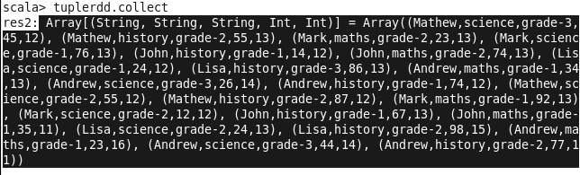

2 ]Find the count of total number of rows present.

scala> tuplerdd.count
res3: Long = 22

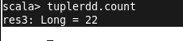

3]What is the distinct number of subjects present in the entire school

val subjects = tuplerdd.map(subject =>subject._2)
val x=subjects.distinct
x.collect
x.count

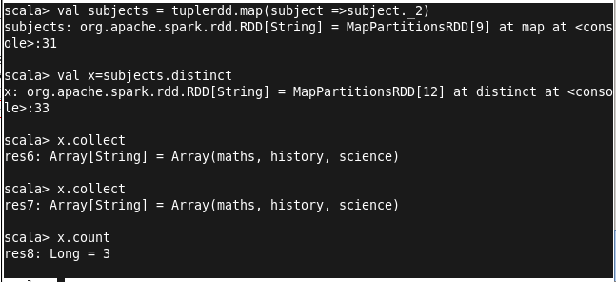

4]What is the count of the number of students in the school, whose name is Mathew and
marks is 55

scala> val student=tuplerdd.filter(_._1 == "Mathew")
student: org.apache.spark.rdd.RDD[(String, String, String, Int, Int)] = MapPartitionsRDD[9] at filter at <console>:25

scala> val mathew=student.filter(_._4 == 55)
mathew: org.apache.spark.rdd.RDD[(String, String, String, Int, Int)] = MapPartitionsRDD[10] at filter at <console>:27

scala> mathew.collect
res7: Array[(String, String, String, Int, Int)] = Array((Mathew,history,grade-2,55,13), (Mathew,science,grade-2,55,12))

scala> mathew.count
res8: Long = 2

