ASSIGNMENT18.2

scala> case class transport(mode:String,revenue:Int)
defined class transport

scala> val rdd=sc.textFile("Transport.txt")
rdd: org.apache.spark.rdd.RDD[String] = MapPartitionsRDD[263] at textFile at <console>:27

scala> val transportrdd=rdd.map{x=>x.split(",")}.map{cols=>transport(cols(0),cols(1).trim.toInt)}
transportrdd: org.apache.spark.rdd.RDD[transport] = MapPartitionsRDD[265] at map at <console>:41

scala> val transportDf=transportrdd.toDF()
transportDf: org.apache.spark.sql.DataFrame = [mode: string, revenue: int]

scala> transportDf.show
+--------+-------+
| mode|revenue|
+--------+-------+
|airplane| 170|
| car| 140|
| train| 120|
| ship| 200|
+--------+-------+

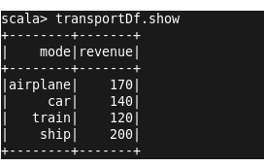

1]which route is generating the most revenue per year

scala> val maxrevn=sqlContext.sql("select * from transportTable where revenue=max(revenue)")
maxrevn: org.apache.spark.sql.DataFrame = [mode: string, revenue: int]

scala> maxrevn.show
+----+-------+
|mode|revenue|
+----+-------+
|ship| 200|
+----+-------+

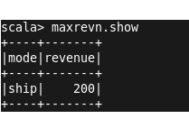

2]
scala> case class user(id:Int,name:String,age:Int)
defined class user

scala> val rdd=sc.textFile("User.txt")
rdd: org.apache.spark.rdd.RDD[String] = MapPartitionsRDD[335] at textFile at <console>:27

scala> val userrdd=rdd.map{x=>x.split(",")}.map{cols=>user(cols(0).trim.toInt,cols(1),cols(2).trim.toInt)}
userrdd: org.apache.spark.rdd.RDD[user] = MapPartitionsRDD[337] at map at <console>:41

scala> val userDf=userrdd.toDF()
userDf: org.apache.spark.sql.DataFrame = [id: int, name: string, age: int]

scala> userDf.show
+---+------+---+
| id| name|age|
+---+------+---+
| 1| mark| 15|
| 2| john| 16|
| 3| luke| 17|
| 4| lisa| 27|
| 5| mark| 25|
| 6| peter| 22|
| 7| james| 21|
| 8|andrew| 55|
| 9|thomas| 46|
| 10| annie| 44|
+---+------+---+

