Assignment19.1

Using spark-sql, Find:
1. What is the total number of gold medal winners every year?
2. How many silver medals have been won by USA in each sport?

scala> val rdd=sc.textFile("Sports_data.txt")
rdd: org.apache.spark.rdd.RDD[String] = MapPartitionsRDD[1] at textFile at <console>:27

scala> val head=rdd.first()
head: String = firstname,lastname,sports,medal_type,age,year,country

scala> val filter_set=rdd.filter(x=>x!=head)
filter_set: org.apache.spark.rdd.RDD[String] = MapPartitionsRDD[2] at filter at <console>:31

scala> val sports=filter_set.map(x=>x.split(",")).map(arrays =>(arrays(0),arrays(1),arrays(2),arrays(3),arrays(4),arrays(5),arrays(6))).toDF("firstname","lastname","sports","medal_type","age","year","country")
sports: org.apache.spark.sql.DataFrame = [firstname: string, lastname: string, sports: string, medal_type: string, age: string, year: string, country: string]

scala> sports.registerTempTable("sportstable")

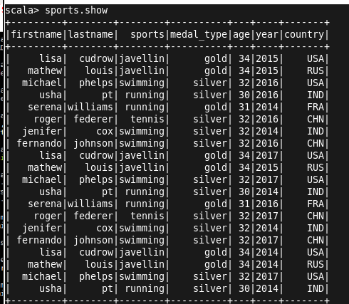

- What is the total number of gold medal winners every year?

scala> val goldmedal= sqlContext.sql("SELECT year, count(*) FROM sportsTable where medal_type='gold' group by year order by year")
goldmedal: org.apache.spark.sql.DataFrame = [year: string, _c1: bigint]

scala> goldmedal.show
+----+---+
|year|_c1|
+----+---+
|2014| 3|
|2015| 3|
|2016| 2|
|2017| 1|
+----+---+

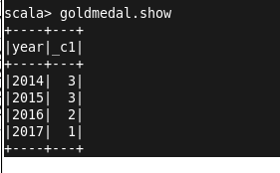

- How many silver medals have been won by USA in each sport?

scala> val silver= sqlContext.sql("SELECT country, sports, count(*) FROM sportsTable where country='USA' and medal_type='silver' group by country,sports");
silver: org.apache.spark.sql.DataFrame = [country: string, sports: string, _c2: bigint]

scala> silver.show
+-------+--------+---+
|country| sports|_c2|
+-------+--------+---+
| USA|swimming| 3|
+-------+--------+---+

