Assignment19.2

Using udfs on dataframe
1. Change firstname, lastname columns into
Mr.first_two_letters_of_firstname<space>lastname
for example - michael, phelps becomes Mr.mi phelps.

scala> val rdd=sc.textFile("Sports_data.txt")
rdd: org.apache.spark.rdd.RDD[String] = MapPartitionsRDD[1] at textFile at <console>:27

scala> val head=rdd.first()
head: String = firstname,lastname,sports,medal_type,age,year,country

scala> val filter_set=rdd.filter(x=>x!=head)
filter_set: org.apache.spark.rdd.RDD[String] = MapPartitionsRDD[2] at filter at <console>:31

scala> val sports=filter_set.map(x=>x.split(",")).map(arrays =>(arrays(0),arrays(1),arrays(2),arrays(3),arrays(4),arrays(5),arrays(6))).toDF("firstname","lastname","sports","medal_type","age","year","country")
sports: org.apache.spark.sql.DataFrame = [firstname: string, lastname: string, sports: string, medal_type: string, age: string, year: string, country: string]

scala> sports.registerTempTable("sportstable")

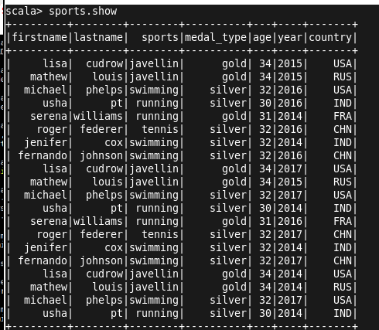

probelem1

scala> val name=udf((fname:String,lname:String)=>{"Mr."+fname.slice(0,2)+" "+lname+""})
name: org.apache.spark.sql.UserDefinedFunction = UserDefinedFunction(<function2>,StringType,List(StringType, StringType))

scala> val first=sports.withColumn("Fullname",name($"firstname",$"lastname"))
first: org.apache.spark.sql.DataFrame = [firstname: string, lastname: string, sports: string, medal_type: string, age: string, year: string, country: string, Fullname: string]

scala> val result=first.drop("firstname").drop("lastname")
result: org.apache.spark.sql.DataFrame = [sports: string, medal_type: string, age: string, year: string, country: string, Fullname: string]

scala> first.show
+---------+--------+--------+----------+---+----+-------+--------------+
|firstname|lastname| sports|medal_type|age|year|country| Fullname|
+---------+--------+--------+----------+---+----+-------+--------------+
| lisa| cudrow|javellin| gold| 34|2015| USA| Mr.li cudrow|
| mathew| louis|javellin| gold| 34|2015| RUS| Mr.ma louis|
| michael| phelps|swimming| silver| 32|2016| USA| Mr.mi phelps|
| usha| pt| running| silver| 30|2016| IND| Mr.us pt|
| serena|williams| running| gold| 31|2014| FRA|Mr.se williams|
| roger| federer| tennis| silver| 32|2016| CHN| Mr.ro federer|
| jenifer| cox|swimming| silver| 32|2014| IND| Mr.je cox|
| fernando| johnson|swimming| silver| 32|2016| CHN| Mr.fe johnson|
| lisa| cudrow|javellin| gold| 34|2017| USA| Mr.li cudrow|
| mathew| louis|javellin| gold| 34|2015| RUS| Mr.ma louis|
| michael| phelps|swimming| silver| 32|2017| USA| Mr.mi phelps|
| usha| pt| running| silver| 30|2014| IND| Mr.us pt|
| serena|williams| running| gold| 31|2016| FRA|Mr.se williams|
| roger| federer| tennis| silver| 32|2017| CHN| Mr.ro federer|
| jenifer| cox|swimming| silver| 32|2014| IND| Mr.je cox|
| fernando| johnson|swimming| silver| 32|2017| CHN| Mr.fe johnson|
| lisa| cudrow|javellin| gold| 34|2014| USA| Mr.li cudrow|
| mathew| louis|javellin| gold| 34|2014| RUS| Mr.ma louis|
| michael| phelps|swimming| silver| 32|2017| USA| Mr.mi phelps|
| usha| pt| running| silver| 30|2014| IND| Mr.us pt|
+---------+--------+--------+----------+---+----+-------+--------------+
only showing top 20 rows

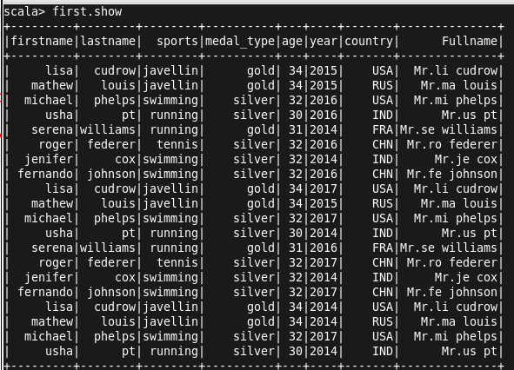

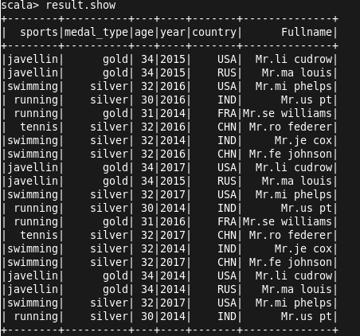

2. Add a new column called ranking using udfs on dataframe, where:
Gold medalist, with age >= 32 are ranked as pro
Gold medalists, with age <= 31 are ranked amateur
Silver medalist, with age >= 32 are ranked as expert
Silver medallists, with age <= 31 are ranked rookie.
Add new column into the created UDF.

scala> val player=udf((medal:String,age:String)=>{if(age.toInt<=31&&medal=="silver"){"rookie";}else{if(age.toInt>=32&&medal=="silver"){"expert";}else{if(age.toInt<=31&&medal=="gold"){"amateur";}else{if(age.toInt>=32&&medal=="gold"){"pro";}else{"could not determine class";}}}}})
player: org.apache.spark.sql.UserDefinedFunction = UserDefinedFunction(<function2>,StringType,List(StringType, StringType))

scala> val result_set=sports.withColumn("class",player($"medal_type",$"age"))
result_set: org.apache.spark.sql.DataFrame = [firstname: string, lastname: string, sports: string, medal_type: string, age: string, year: string, country: string, class: string]

scala> result_set.show
+---------+--------+--------+----------+---+----+-------+-------+
|firstname|lastname| sports|medal_type|age|year|country| class|
+---------+--------+--------+----------+---+----+-------+-------+
| lisa| cudrow|javellin| gold| 34|2015| USA| pro|
| mathew| louis|javellin| gold| 34|2015| RUS| pro|
| michael| phelps|swimming| silver| 32|2016| USA| expert|
| usha| pt| running| silver| 30|2016| IND| rookie|
| serena|williams| running| gold| 31|2014| FRA|amateur|
| roger| federer| tennis| silver| 32|2016| CHN| expert|
| jenifer| cox|swimming| silver| 32|2014| IND| expert|
| fernando| johnson|swimming| silver| 32|2016| CHN| expert|
| lisa| cudrow|javellin| gold| 34|2017| USA| pro|
| mathew| louis|javellin| gold| 34|2015| RUS| pro|
| michael| phelps|swimming| silver| 32|2017| USA| expert|
| usha| pt| running| silver| 30|2014| IND| rookie|
| serena|williams| running| gold| 31|2016| FRA|amateur|
| roger| federer| tennis| silver| 32|2017| CHN| expert|
| jenifer| cox|swimming| silver| 32|2014| IND| expert|
| fernando| johnson|swimming| silver| 32|2017| CHN| expert|
| lisa| cudrow|javellin| gold| 34|2014| USA| pro|
| mathew| louis|javellin| gold| 34|2014| RUS| pro|
| michael| phelps|swimming| silver| 32|2017| USA| expert|
| usha| pt| running| silver| 30|2014| IND| rookie|
+---------+--------+--------+----------+---+----+-------+-------+
only showing top 20 rows

