Assignment 21.2

Aviation data analysis

Problem Statement 1
Find out the top 5 most visited destinations.

scala> val delayed_flights = sc.textFile("file:///home/kiran/Documents/datasets/Airline/DelayedFlights.csv")
delayed_flights: org.apache.spark.rdd.RDD[String] = MapPartitionsRDD[118] at textFile at <console>:27

scala> val delayed_flights = sc.textFile("file:///home/acadgild/DelayedFlights.csv")
delayed_flights: org.apache.spark.rdd.RDD[String] = MapPartitionsRDD[120] at textFile at <console>:27

scala> val mapping = delayed_flights.map(x => x.split(",")).map(x => (x(18),1)).filter(x => x._1!=null).reduceByKey(_+_).map(x => (x._2,x._1)).sortByKey(false).map(x => (x._2,x._1)).take(5)
mapping: Array[(String, Int)] = Array((ORD,108984), (ATL,106898), (DFW,70657), (DEN,63003), (LAX,59969))
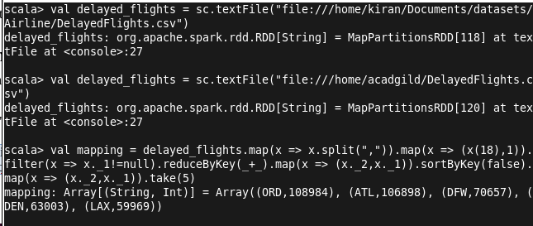

Problem Statement 2
Which month has seen the most number of cancellations due to bad weather?

scala> val canceled = delayed_flights.map(x => x.split(",")).filter(x => ((x(22).equals("1"))&&(x(23).equals("B")))).map(x => (x(2),1)).reduceByKey(_+_).map(x => (x._2,x._1)).sortByKey(false).map(x => (x._2,x._1)).take(1)
canceled: Array[(String, Int)] = Array((12,250))

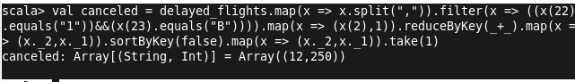

Problem Statement 3
Top ten origins with the highest AVG departure delay

val avg = delayed_flights.map(x => x.split(",")).map(x => (x(17),x(16).toDouble)).mapValues((_, 1)).reduceByKey((x, y) => (x._1 + y._1, x._2 + y._2)).mapValues{ case (sum, count) => (1.0 * sum)/count}.map(x => (x._2,x._1)).sortByKey(false).map(x => (x._2,x._1)).take(10)

Problem Statement 4
Which route (origin & destination) has seen the maximum diversion?

val diversion = delayed_flights.map(x => x.split(",")).filter(x => ((x(24).equals("1")))).map(x => ((x(17)+","+x(18)),1)).reduceByKey(_+_).map(x => (x._2,x._1)).sortByKey(false).map(x => (x._2,x._1)).take(10).foreach(println)

