Assignment22.1

Go through below blog and reiterate the same at your end.
https://docs.google.com/document/d/1csLBlMiEXs_hXWV2Z8VpBlrj_R6RoDQLlZUnA0uBT
Ck/edit

scala> val census_data = sc.textFile("file:///home/acadgild/census.csv").map(x => x.split(",")).map(x => (x(0),x(2),x(3),x(4),x(5),x(6),x(7),x(8),x(9),x(10),x(11),x(12),x(13),x(14),x(15),x(16),x(17),x(18),x(19),x(20),x(21),x(22))).toDF("State" ,"Persons","Males" ,"Females" ,"Growth_1991_2001" ,"Rural" ,"Urban" ,"Scheduled_Caste_population" ,"Percentage_SC_to_total" ,"Number_of_households" ,"Household_size_per_household" ,"Sex_ratio_females_per_1000_males " ,"Sex_ratio_0_6_years" ,"Scheduled_Tribe_population" ,"Percentage_to_total_population_ST" ,"Persons_literate" ,"Males_Literate" ,"Females_Literate" ,"Persons_literacy_rate" ,"Males_Literatacy_Rate" ,"Females_Literacy_Rate" ,"Total_Educated").registerTempTable("census")
census_data: Unit = ()

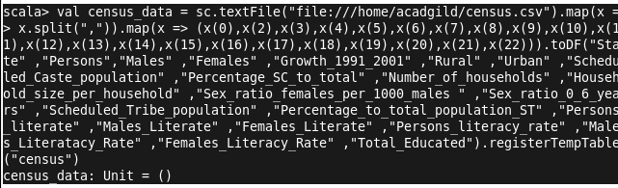

1. Find out the state wise population and order by state

scala> val population = sqlContext.sql("select state,sum(persons) as total_population from census group by state order by total_population desc").show
+-----------+----------------+
| state|total_population|
+-----------+----------------+
| UP| 1.66197921E8|
|Maharashtra| 9.6878627E7|
| Bihar| 8.2998509E7|
| WB| 8.0176197E7|
| Andhra| 7.1308587E7|
| TN| 6.2405679E7|
| MP| 6.0348023E7|
| Rajasthan| 5.6507188E7|
| Karnataka| 5.2850562E7|
| Gujarat| 5.0671017E7|
| Orrisa| 3.5664657E7|
| Kerala| 3.1841374E7|
| Jharkhand| 2.6945829E7|
| Assam| 2.6655528E7|
| Punjab| 2.4358999E7|
| Haryana| 2.1144564E7|
| CG| 2.0833803E7|
| Delhi| 1.3850507E7|
| JK| 1.01437E7|
| Uttranchal| 8489349.0|
+-----------+----------------+
only showing top 20 rows

population: Unit = ()

scala>

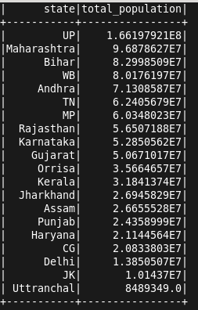

2. Find out the Growth Rate of Each State Between 1991-2001

scala> val growth_rate = sqlContext.sql("select state,avg(Growth_1991_2001) as total_growth from census group by state").show
+----------------+------------------+
| state| total_growth|
+----------------+------------------+
| Maharashtra|19.607142857142865|
| TN|10.127666666666668|
| Gujarat| 20.8248|
| Orrisa|15.551379310344826|
| Sikkim|31.834999999999997|
| AN| 18.665|
| Chandigarh| 40.33|
| Bihar|28.605945945945955|
| HP| 17.53083333333333|
| UP| 25.70228571428572|
|ArunachalPradesh| 25.46999999999999|
| Tripura|15.405000000000001|
| D_N_H| 59.2|
| Uttranchal|17.092307692307692|
| Haryana|27.816842105263152|
| CG|17.506249999999998|
| WB|18.424999999999997|
| Manipur|29.240000000000002|
| JK|28.785714285714285|
| Lakshdweep| 17.19|
+----------------+------------------+
only showing top 20 rows

growth_rate: Unit = ()

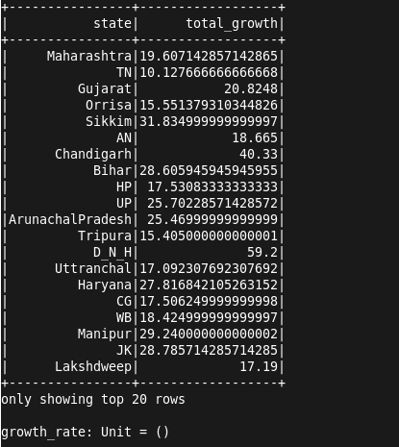

3. Find the literacy rate of each state
scala> val literacy = sqlContext.sql("select state,avg(Persons_literacy_rate) from census group by state").show
+----------------+------------------+
| state| _c1|
+----------------+------------------+
| Maharashtra| 74.55342857142857|
| TN| 72.94266666666665|
| Gujarat| 67.07480000000001|
| Orrisa| 59.97965517241381|
| Sikkim| 66.9975|
| AN| 77.41999999999999|
| Chandigarh| 81.94|
| Bihar| 46.42135135135135|
| HP| 75.50833333333333|
| UP| 56.01057142857144|
|ArunachalPradesh|53.166923076923084|
| Tripura| 70.27000000000001|
| D_N_H| 57.63|
| Uttranchal| 72.01769230769231|
| Haryana| 68.24473684210527|
| CG| 63.02312499999999|
| WB| 66.07|
| Manipur| 68.6125|
| JK|54.867142857142845|
| Lakshdweep| 86.66|
+----------------+------------------+
only showing top 20 rows

literacy: Unit = ()

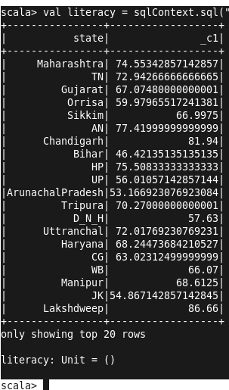

4. Find out the States with More Female Population

scala> val female_pop = sqlContext.sql("select state, sum(Males)-sum(Females) from census group by state").show
+----------------+---------+
| state| _c1|
+----------------+---------+
| Maharashtra|3922565.0|
| TN| 396139.0|
| Gujarat|2100137.0|
| Orrisa| 482015.0|
| Sikkim| 36117.0|
| AN| 29792.0|
| Chandigarh| 113241.0|
| Bihar|3489081.0|
| HP| 97980.0|
| UP|8932817.0|
|ArunachalPradesh| 61914.0|
| Tripura| 85247.0|
| D_N_H| 22842.0|
| Uttranchal| 162499.0|
| Haryana|1583342.0|
| CG| 114633.0|
| WB|2755773.0|
| Manipur| 20533.0|
| JK| 578152.0|
| Lakshdweep| 1612.0|
+----------------+---------+
only showing top 20 rows

female_pop: Unit = ()
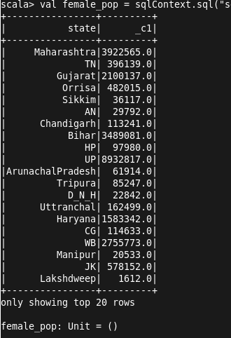

5. Find out the Percentage of Population in Every State

scala> val percenet_pop = sqlContext.sql("select state, (sum(persons) * 100.0) / SUM(sum(persons)) over() as percent_pop_by_state from census group by state").show
17/12/03 22:53:14 WARN Window: No Partition Defined for Window operation! Moving all data to a single partition, this can cause serious performance degradation.
+----------------+--------------------+
| state|percent_pop_by_state|
+----------------+--------------------+
| Maharashtra| 9.475494209385522|
| TN| 6.103767861999858|
| Gujarat| 4.956025317815201|
| Orrisa| 3.488284891601744|
| Sikkim| 0.05289949576432755|
| AN| 0.03483447606726582|
| Chandigarh| 0.08808921009243792|
| Bihar| 8.117909138174843|
| HP| 0.5944665819347776|
| UP| 16.25546817511578|
|ArunachalPradesh| 0.10738993468694186|
| Tripura| 0.31290729895613395|
| D_N_H| 0.02156566193106157|
| Uttranchal| 0.8303253233652121|
| Haryana| 2.0681052152192616|
| CG| 2.0377103371415317|
| WB| 7.841864753141607|
| Manipur| 0.19662075848548596|
| JK| 0.9921339059826262|
| Lakshdweep|0.005932048601382...|
+----------------+--------------------+
only showing top 20 rows

percenet_pop: Unit = ()

