Assignment 5.3

REGISTER '/home/acadgild/vishnu/piggybank.jar';

A = load '/home/acadgild/vishnu/Pokemon.csv' USING org.apache.pig.piggybank.storage.CSVExcelStorage(',','NO_MULTILINE','UNIX','SKIP_INPUT_HEADER');
B = FOREACH A GENERATE (int)$0 as Sno,(chararray)$1 as Name,(chararray)$2 as Type1, (chararray)$3 as TYpe2,(int)$4 as Total,
(int)$5 as HP,(int)$6 as Attack,(int)$7 as DEfense,(int)$8 as SpAtk,(int)$9 as SpDef,(int)$10 as Speed;
dump B;

Ques 1: Find the list of players that have been selected in the qualifying round (DEFENCE>55).

grunt> selected_list = FILTER Load_Data BY Defense>55;
grunt> dump selected_list;
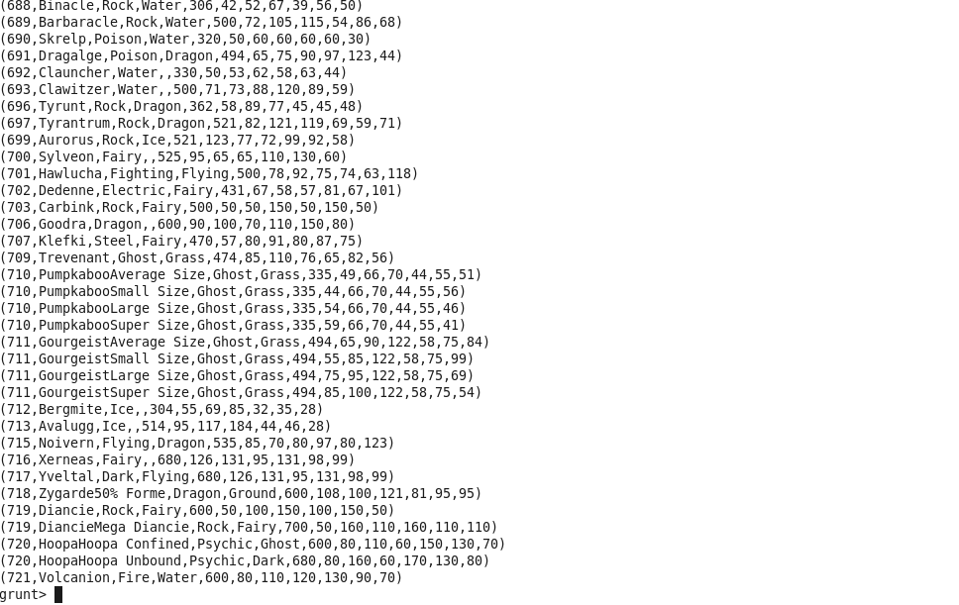

Ques 2: State the number of players taking part in the competition after getting selected in the qualifying round.
gourp_selcted_list = Group selected_list All;
count_selcted_list = foreach gourp_selcted_list GENERATE COUNT(selected_list);
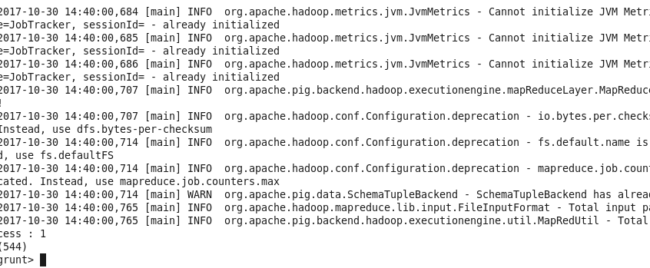

Ques 3: Using random() generate random numbers for each Pokémon on the selected list.
random_include1 = foreach selected_list GENERATE RANDOM(),Name,Type1,Type2,Total,HP,Attack,Defense,SpAtk,SpDef,Speed;

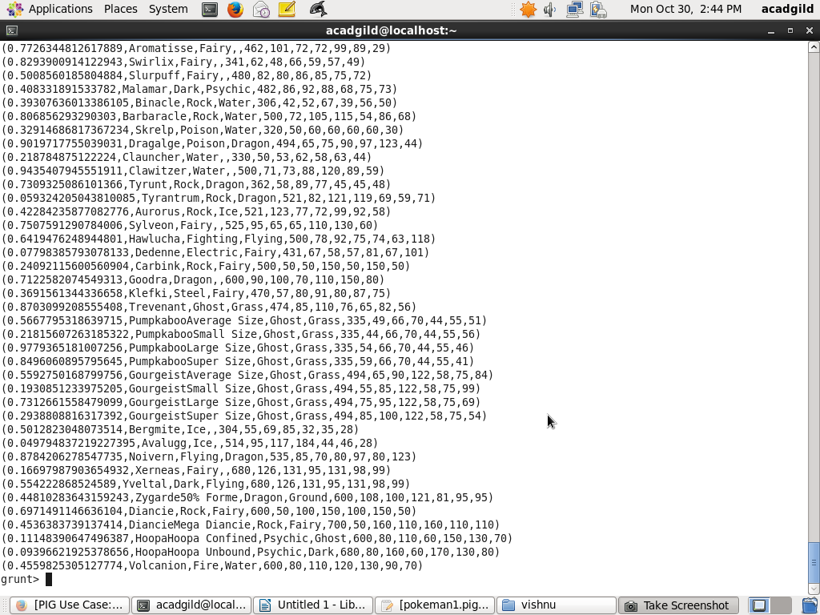

Ques 4: Arrange the new list in a descending order according to a column randomly.
Explanation: This will give us consequently a layer arranged to pick the random list which 1st player will choose.

random1_desending = ORDER random_include1 BY $0 DESC;

