ASSIGNMENT 6.2

Problem 1
Fetch date and temperature from temperature_data where zip code is greater than
300000 and less than 399999.
output...................................
hive> select date,temperature from temperature_date where zipcode>300000 and zipcode<400000;
OK
10-03-1990 15
10-01-1991 22
12-02-1990 9
10-03-1991 16
10-01-1990 23
12-02-1991 10
10-03-1993 16
10-01-1994 23
12-02-1991 10
10-03-1991 16
10-01-1990 23
12-02-1991 10
Time taken: 0.649 seconds, Fetched: 12 row(s)
hive>

Problem 2
Calculate maximum temperature corresponding to every year from temperature_data
table.
hive> select date,MAX(temperature) from temperature_date group by date;
output..................

Total MapReduce CPU Time Spent: 5 seconds 460 msec
OK
10-01-1990 23
10-01-1991 22
10-01-1993 11
10-01-1994 23
10-03-1990 15
10-03-1991 16
10-03-1993 16
12-02-1990 9
12-02-1991 10
14-02-1990 12
14-02-1991 11
14-02-1994 12
Time taken: 66.551 seconds, Fetched: 12 row(s)

Problem 3

Calculate maximum temperature from temperature_data table corresponding to those
years which have at least 2 entries in the table.
output...............................

hive> select date,MAX(temperature) from temperature_date group by date having count(*)>1;

10-01-1990 23
10-01-1991 22
10-03-1991 16
12-02-1991 10
14-02-1990 12
Time taken: 50.53 seconds, Fetched: 5 row(s)

Problem 4.............................................................
Create a view on the top of last query, name it temperature_data_vw.
output.........

hive> create view temperature_data_vw as select date,MAX(temperature) from temperature_date group by date having count(*)>1;
OK
Time taken: 0.415 seconds

hive> select * from temperature_data_vw;

10-01-1990 23
10-01-1991 22
10-03-1991 16
12-02-1991 10
14-02-1990 12
Time taken: 50.026 seconds, Fetched: 5 row(s)

Problem 5........

Export contents from temperature_data_vw to a file in local file system, such that each
file is '|' delimited.
output........
hive> insert overwrite local directory '/home/acadgild/vishnu'
> row format delimited
> fields terminated by '|'
> select * from temperature_data_vw;

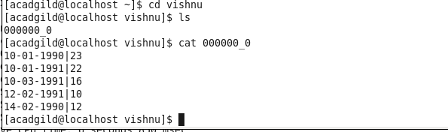
Screen shot............

