ASSIGNMENT

Transactions in Hive

ACID stands for Atomicity, Consistency, Isolation, and Durability.
Atomicity means, a transaction should complete successfully or else it should fail completely i.e. it should not be left partially. Consistency ensures that any transaction will bring the database from one valid state to another state. Isolation states that every transaction should be independent of each other i.e. one transaction should not affect another. And Durability states that if a transaction is completed, it should be preserved in the database even if the machine state is lost or a system failure might occur.
These ACID properties are essential for a transaction and every transaction should ensure that these properties are met.

Transactions are provided at the row-level in Hive 0.14. The different row-level transactions available in Hive 0.14 are as follows:

Insert Delete Update

Row-level Transactions
The below properties needs to be set appropriately in hive shell , order-wise to work with transactions in Hive:

hive> set hive.support.concurrency = true;
hive> set hive.enforce.bucketing = true;
hive> set hive.exec.dynamic.partition.mode = nonstrict;
hive> set hive.txn.manager = org.apache.hadoop.hive.ql.lockmgr.DbTxnManager;
hive> set hive.compactor.initiator.on = true;
hive> set hive.compactor.worker.threads = a positive number on at least one instance of the Thrift metastore service;

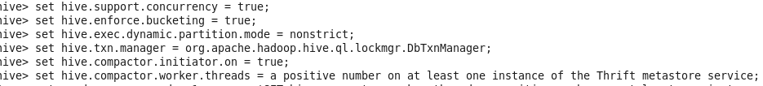

Creating a Table That Supports Hive Transactions

CREATE TABLE person(id int,name string,loc string) clustered by (id) into 5 buckets stored as orc TBLPROPERTIES('transactional'='true');

