Problem 1

Find out the districts who achieved 100 percent objective in BPL cards

Export the results to mysql using sqoop

Pig Script to calculate 100% Objective

input data set

[acadgild@localhost ~]$ hadoop fs -ls /pig
17/11/07 04:01:27 WARN util.NativeCodeLoader: Unable to load native-hadoop library for your platform... using builtin-java classes where applicable
Found 1 items
-rw-r--r-- 1 acadgild supergroup 717414 2017-11-07 01:45 /pig/state.xml

Problem1.pig

--register piggybank lib

REGISTER /home/acadgild/piggybank-0.15.0.jar

--defining xml-xpath for importing datas

DEFINE XPath org.apache.pig.piggybank.evaluation.xml.XPath();

data = LOAD '/pig/state.xml' using org.apache.pig.piggybank.storage.XMLLoader('row') as (x:chararray);

--reading proper values for computation from xml file

State = FOREACH data GENERATE XPath(x,'row/State_Name') AS statename, XPath(x,'row/District_Name') AS disname,XPath(x,'row/Project_Objectives_IHHL_BPL') AS BPL,XPath(x,'row/Project_Objectives_IHHL_TOTAL') AS total ;

--filtering as per logic

Obj = FILTER State BY BPL == total;

--store in the hdfs

STORE Obj INTO '/vishnu/pigout' USING PigStorage(',');

Output Content

[acadgild@localhost ~]$ hadoop fs -ls /vishnu/pigout
17/11/07 04:09:08 WARN util.NativeCodeLoader: Unable to load native-hadoop library for your platform... using builtin-java classes where applicable
Found 2 items
-rw-r--r-- 1 acadgild supergroup 0 2017-11-07 04:08 /vishnu/pigout/_SUCCESS
-rw-r--r-- 1 acadgild supergroup 889 2017-11-07 04:08 /vishnu/pigout/part-m-00000

[acadgild@localhost ~]$ hadoop fs -cat /vishnu/pigout/part-m-00000
17/11/07 04:10:10 WARN util.NativeCodeLoader: Unable to load native-hadoop library for your platform... using builtin-java classes where applicable
Arunachal Pradesh,ANJAW,3232,3232
Arunachal Pradesh,DIBANG VALLEY,1085,1085
Arunachal Pradesh,KURUNG KUMEY,22036,22036
Arunachal Pradesh,LOHIT,8800,8800
Arunachal Pradesh,WEST SIANG,11472,11472
Bihar,BANKA,82439,82439
D & N Haveli,DADRA AND NAGAR HAVELI,2480,2480
Goa,NORTH GOA,15000,15000
Jammu & Kashmir,KARGIL,8475,8475
Jammu & Kashmir,KISHTWAR,22318,22318
Jammu & Kashmir,LEH (LADAKH),6090,6090
Jammu & Kashmir,REASI ,21500,21500
Jammu & Kashmir,SAMBA ,9849,9849
Jammu & Kashmir,SHOPIAN ,10196,10196
Kerala,KANNUR,34121,34121
Manipur,CHANDEL,17610,17610
Nagaland,LONGLENG,6438,6438
Nagaland,TUENSANG,13027,13027
Nagaland,ZUNHEBOTO,20570,20570
Puducherry,PONDICHERRY,18000,18000
Punjab,FARIDKOT,6000,6000
Punjab,HOSHIARPUR,11112,11112
Punjab,MOGA,37170,37170
Punjab,MUKTSAR,33148,33148

Copy the output to HDFS

Run MySQL using the following commands
sudo service mysqld start
mysql -u root

Create a new Database:
mysql>create database state;
mysql>use state;

Create a table similar to the structure of the output file contents:
mysql> create table stateBpl (state varchar(20),district varchar(20),
-> bpl int,total int);
Query OK, 0 rows affected (0.01 sec)

Run the sqoop command to Export the Pig Script analysis from HDFS to MySQL:

[acadgild@localhost ~]$ sqoop export --connect jdbc:mysql://localhost/state --username 'root' -P --table stateBpl --export-dir '/vishnu/pigout/part-m-00000' --input-fields-terminated-by ',' -m 1

Output Sql

mysql> select * from stateBpl;
+-------------------+----------------------+-------+-------+
| state | district | bpl | total |
+-------------------+----------------------+-------+-------+
| Arunachal Pradesh | ANJAW | 3232 | 3232 |
| Arunachal Pradesh | DIBANG VALLEY | 1085 | 1085 |
| Arunachal Pradesh | KURUNG KUMEY | 22036 | 22036 |
| Arunachal Pradesh | LOHIT | 8800 | 8800 |
| Arunachal Pradesh | WEST SIANG | 11472 | 11472 |
| Bihar | BANKA | 82439 | 82439 |
| D & N Haveli | DADRA AND NAGAR HAVE | 2480 | 2480 |
| Goa | NORTH GOA | 15000 | 15000 |
| Jammu & Kashmir | KARGIL | 8475 | 8475 |
| Jammu & Kashmir | KISHTWAR | 22318 | 22318 |
| Jammu & Kashmir | LEH (LADAKH) | 6090 | 6090 |
| Jammu & Kashmir | REASI | 21500 | 21500 |
| Jammu & Kashmir | SAMBA | 9849 | 9849 |
| Jammu & Kashmir | SHOPIAN | 10196 | 10196 |
| Kerala | KANNUR | 34121 | 34121 |
| Manipur | CHANDEL | 17610 | 17610 |
| Nagaland | LONGLENG | 6438 | 6438 |
| Nagaland | TUENSANG | 13027 | 13027 |
| Nagaland | ZUNHEBOTO | 20570 | 20570 |
| Puducherry | PONDICHERRY | 18000 | 18000 |
| Punjab | FARIDKOT | 6000 | 6000 |
| Punjab | HOSHIARPUR | 11112 | 11112 |
| Punjab | MOGA | 37170 | 37170 |
| Punjab | MUKTSAR | 33148 | 33148 |
+-------------------+----------------------+-------+-------+
24 rows in set (0.00 sec)

Screen Shots

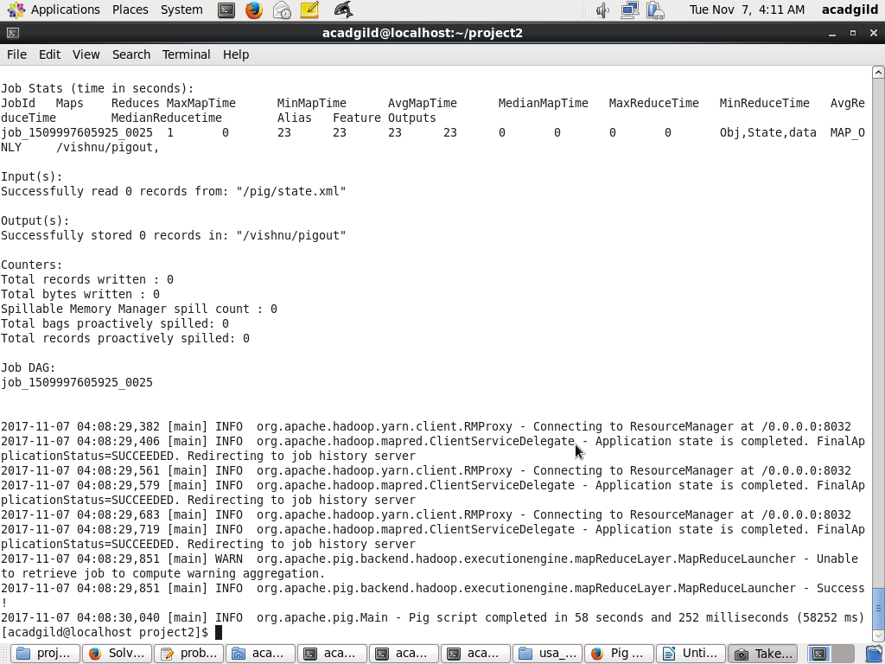

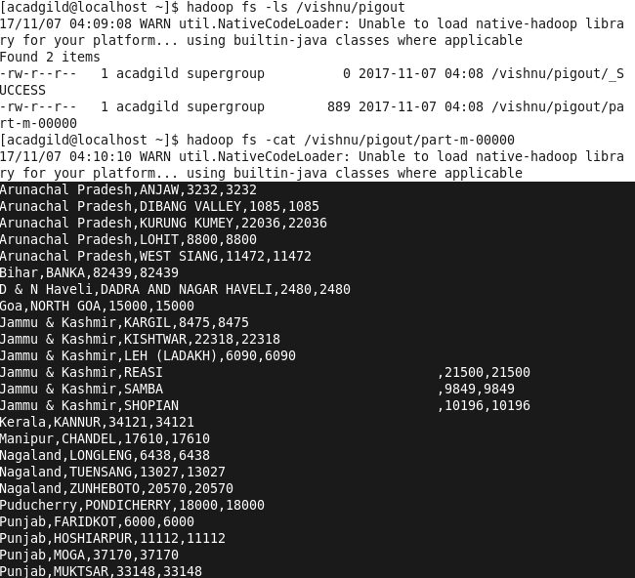

Screen Shots SQL Table

