Explore Hyderabad

A one stop website for all tourist places, lakes, parks, hospitals, malls and historical monuments. It is a great resource for people who are new to the city of Nawabs – Hyderabad, which is also an IT Hub of India. The project is developed using HTML, CSS, JavaScript Technologies and also there is usage of Jquery and Bootstrap Libraries.

Total code for the project is available on google drive link: <https://drive.google.com/drive/folders/0B7INNgFkb2_aVGNZamZSQjAxTEU?usp=sharing>

A snippet of code for the home page is shown below.

Home page:

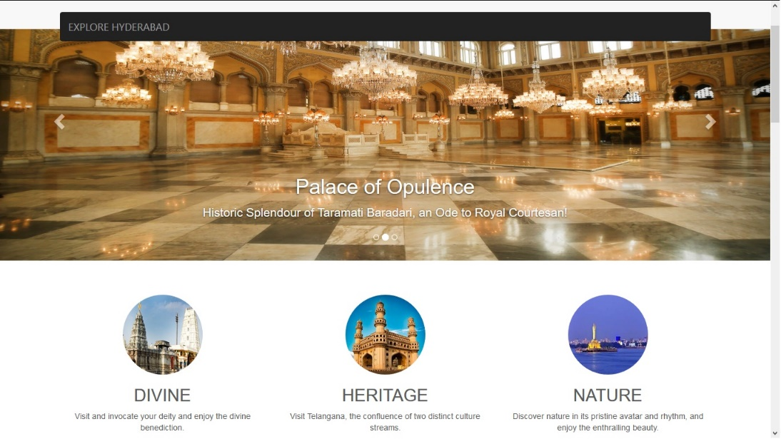

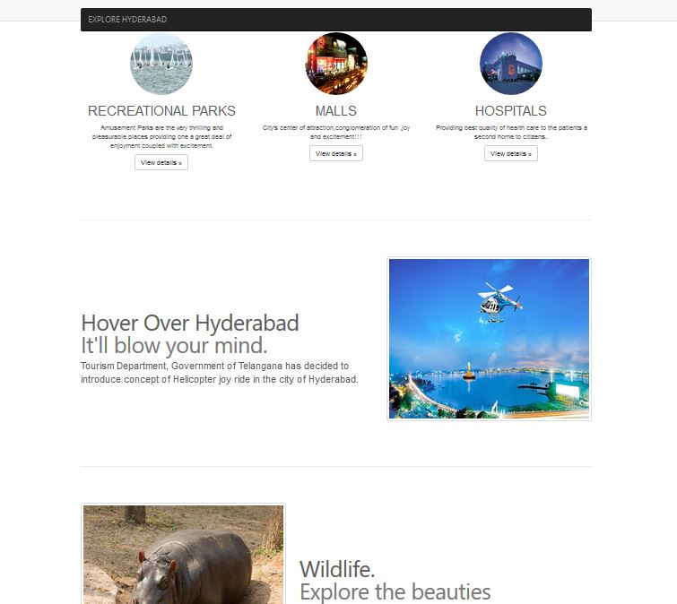

Code for the Home page:

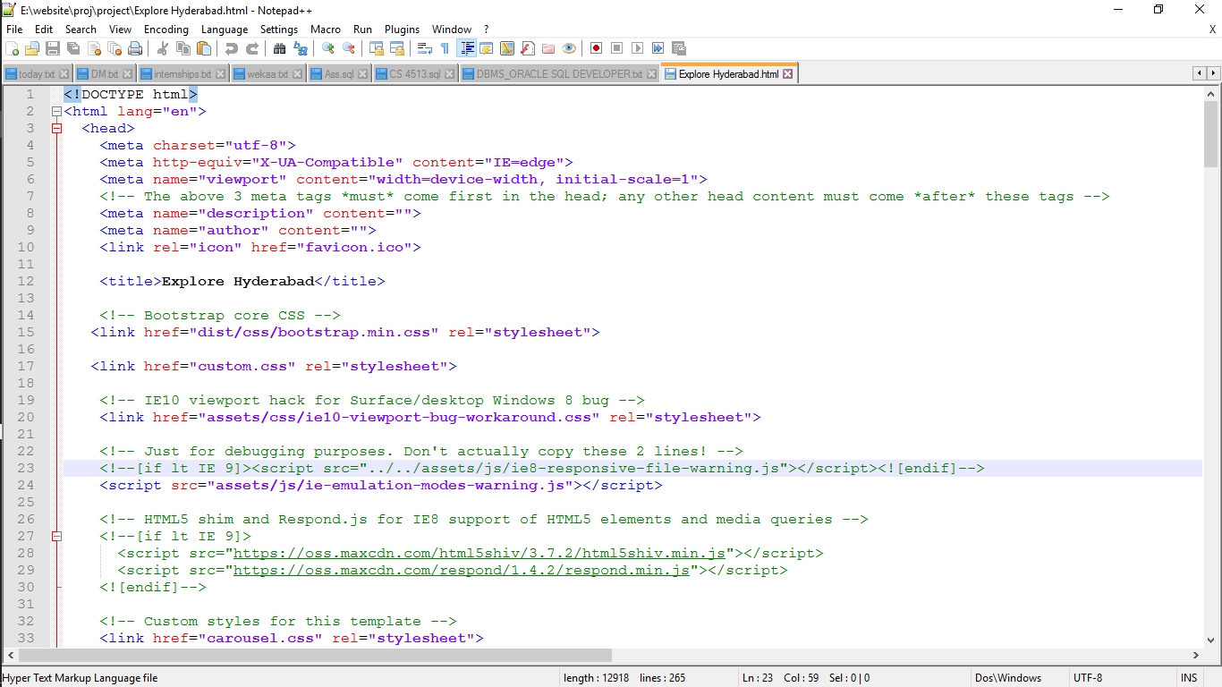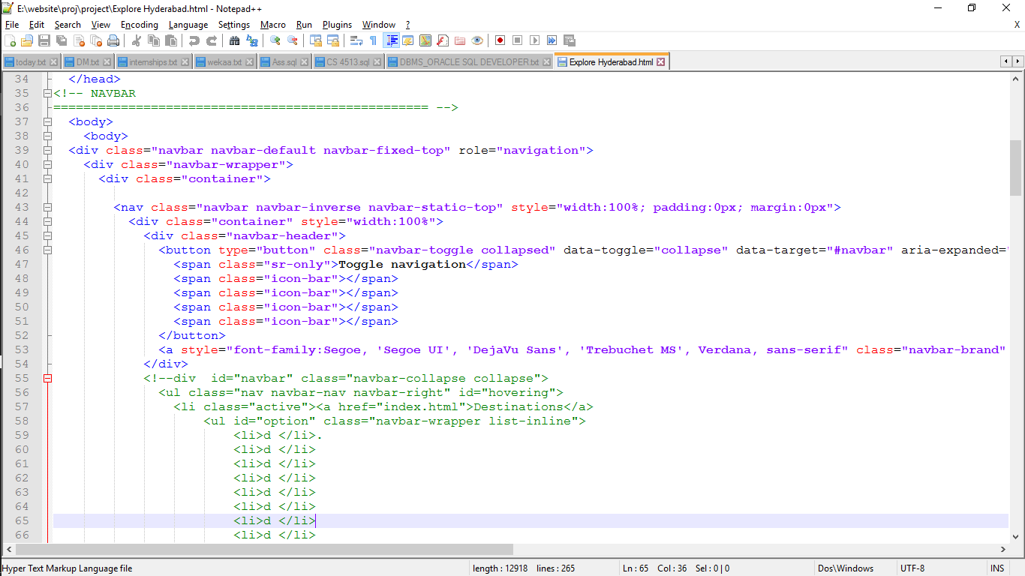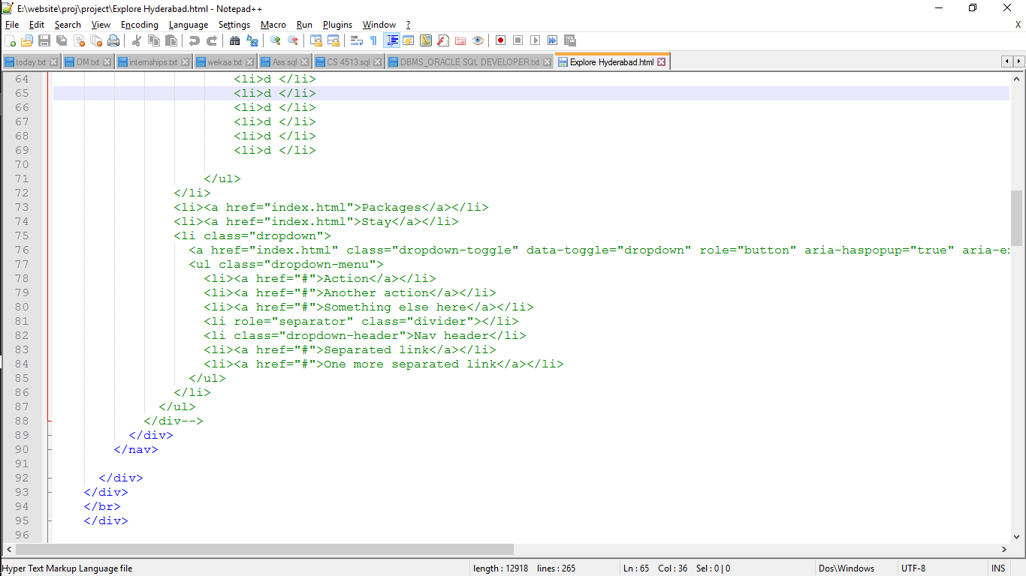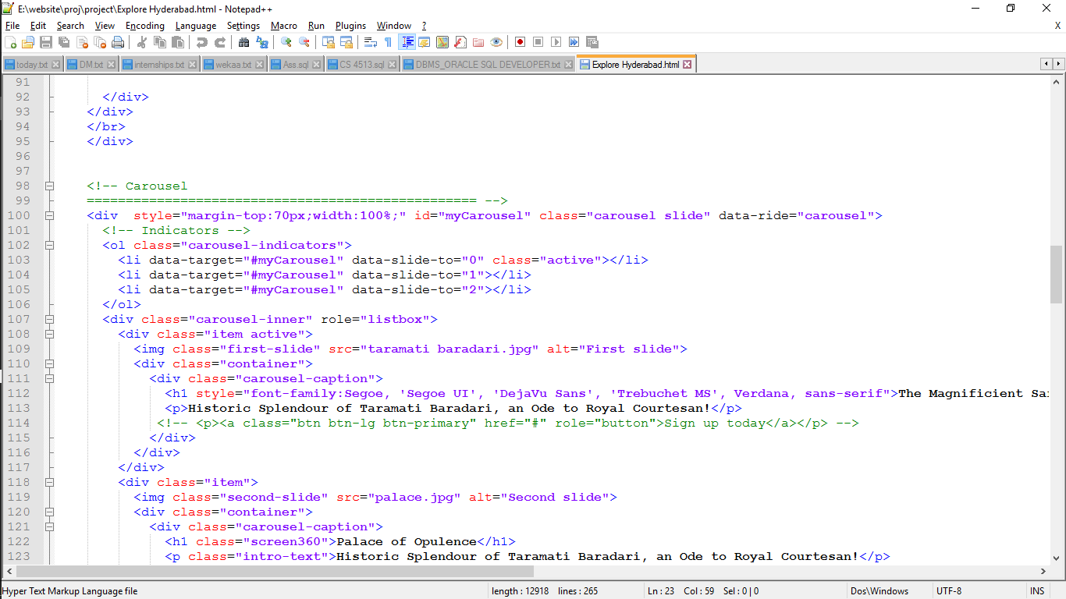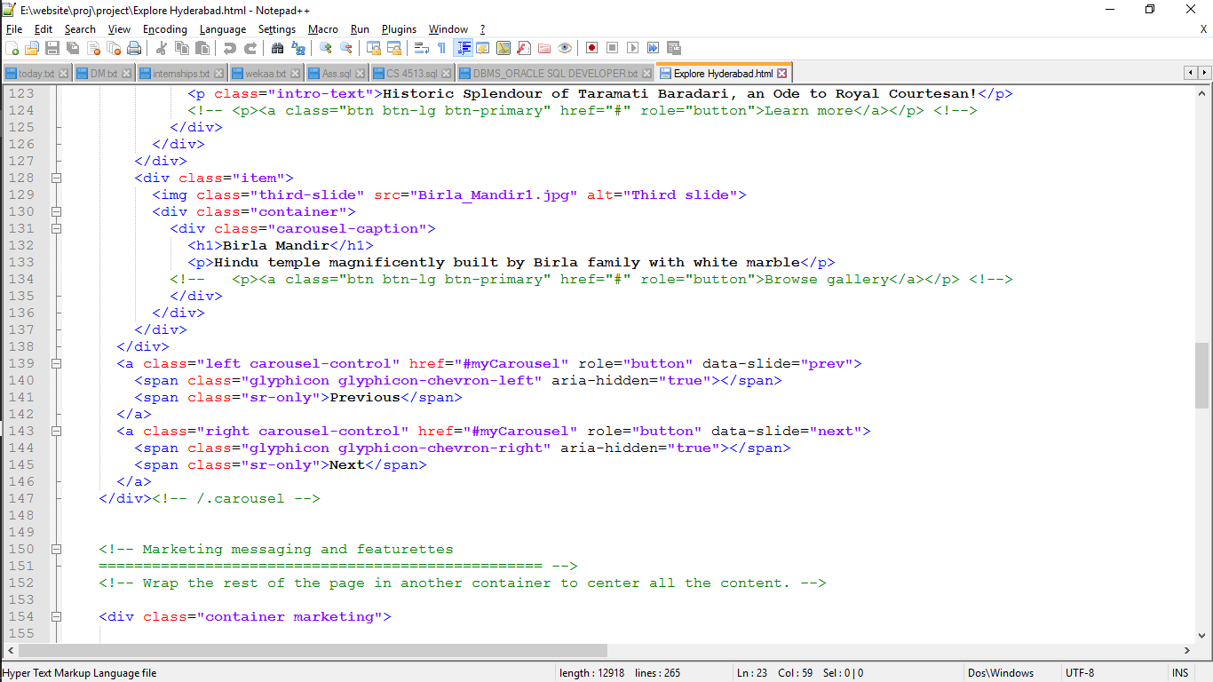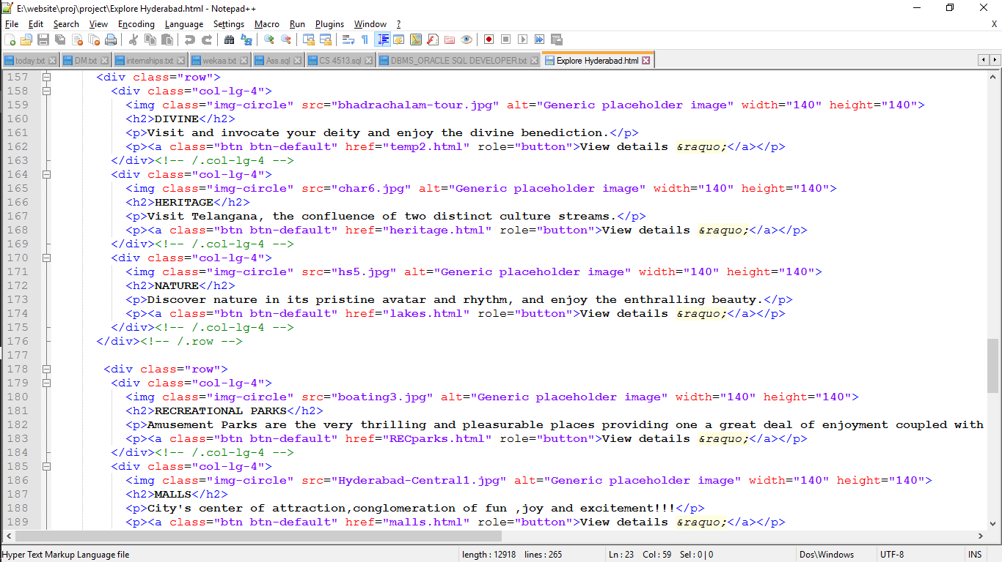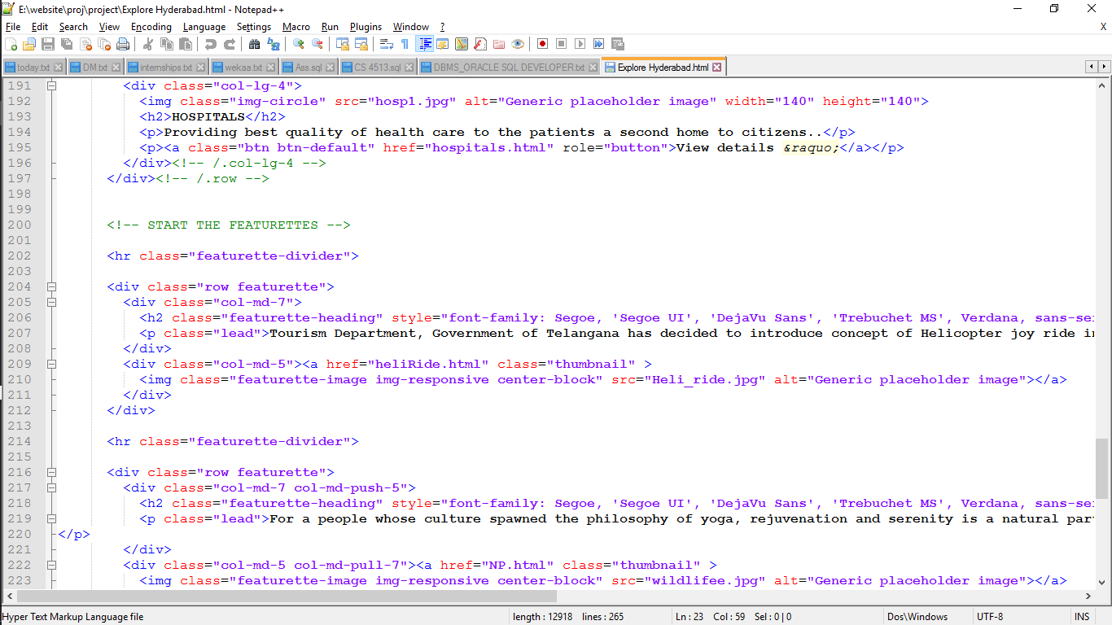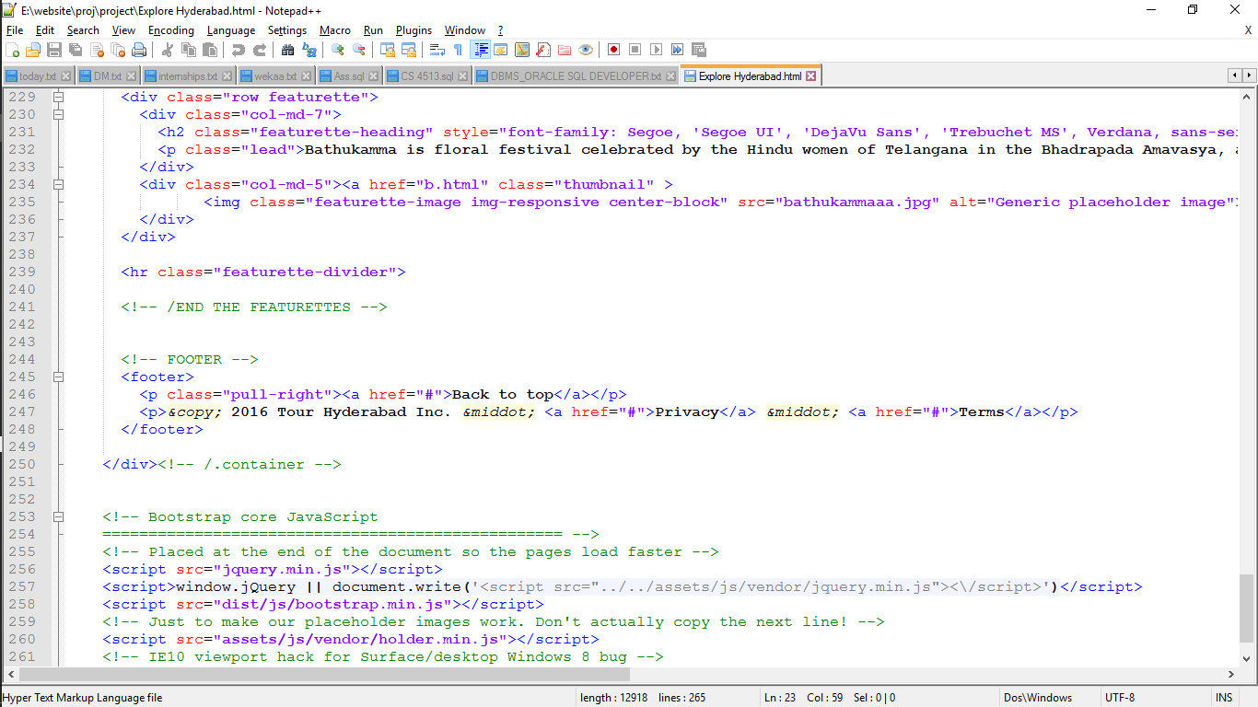

The above is the code for the home page of Explore Hyderabad Page.

Malls Webpage

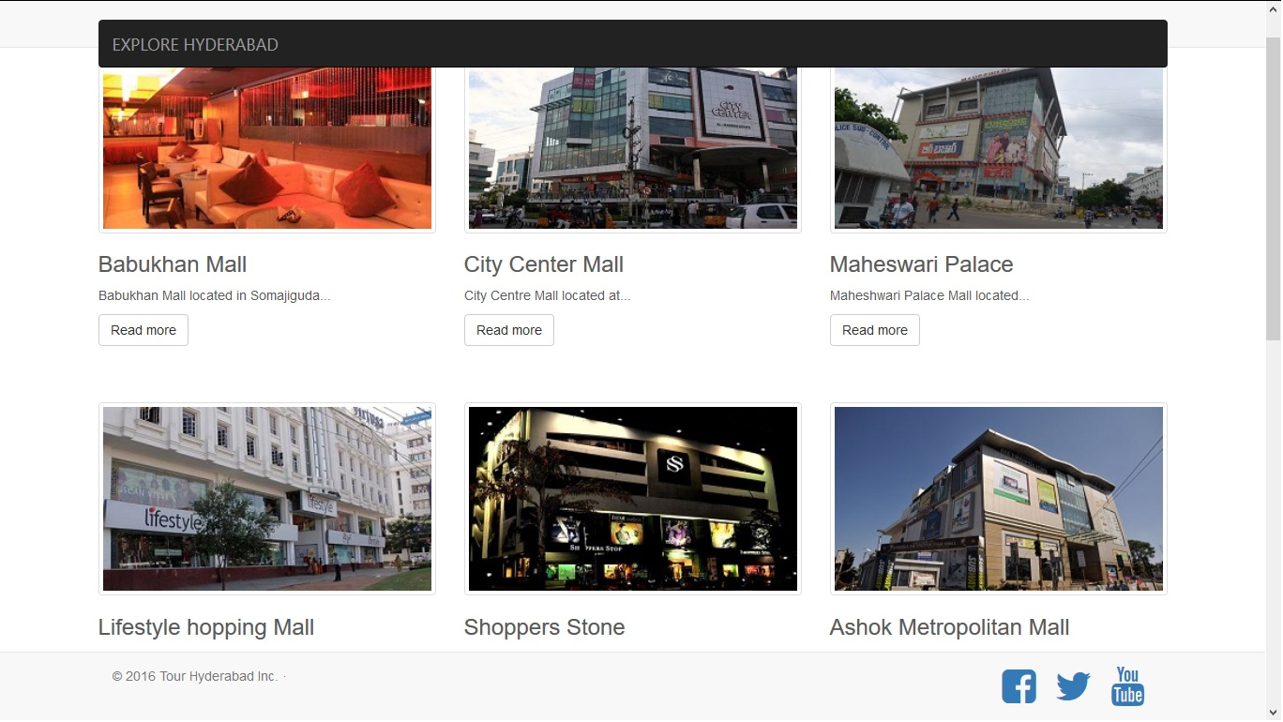

Recreational Parks Webpage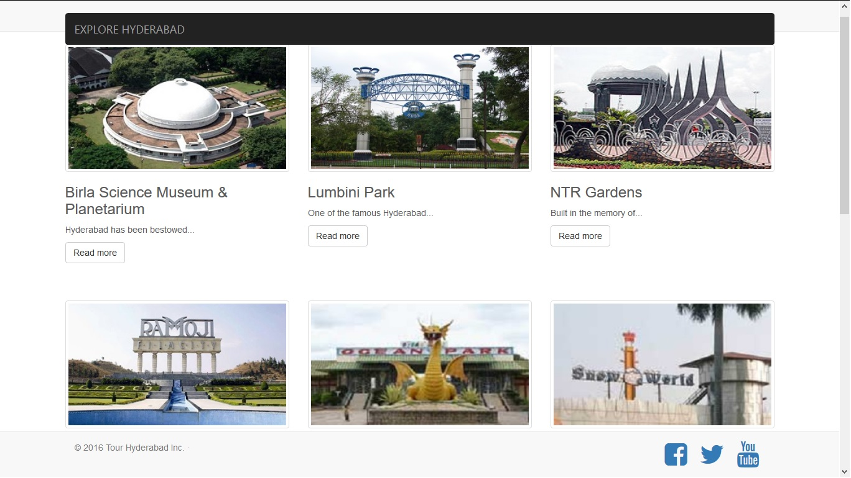

Lakes Webpage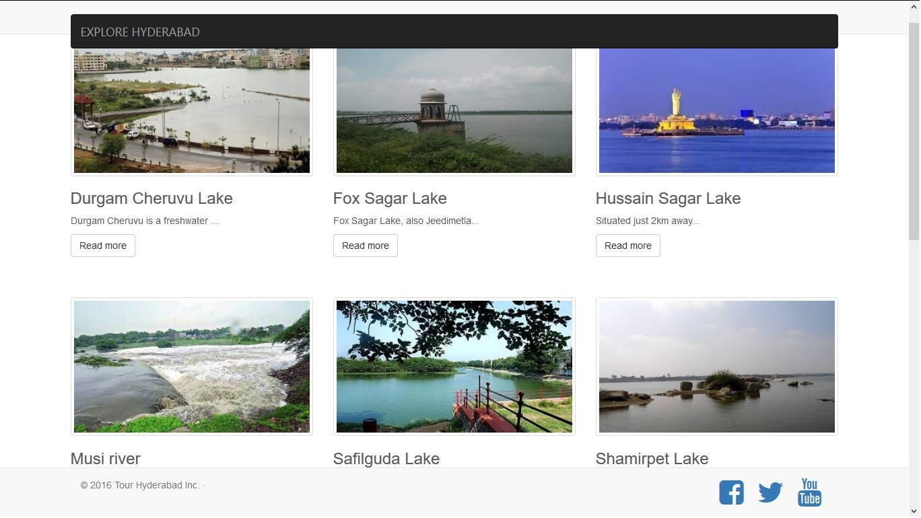

Temples Webpage

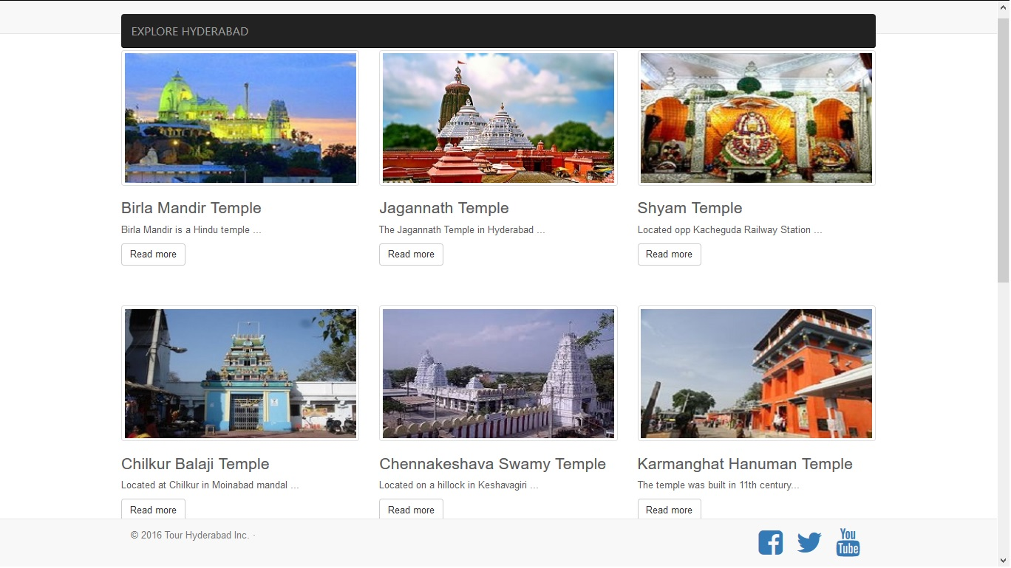

Monuments Webpage

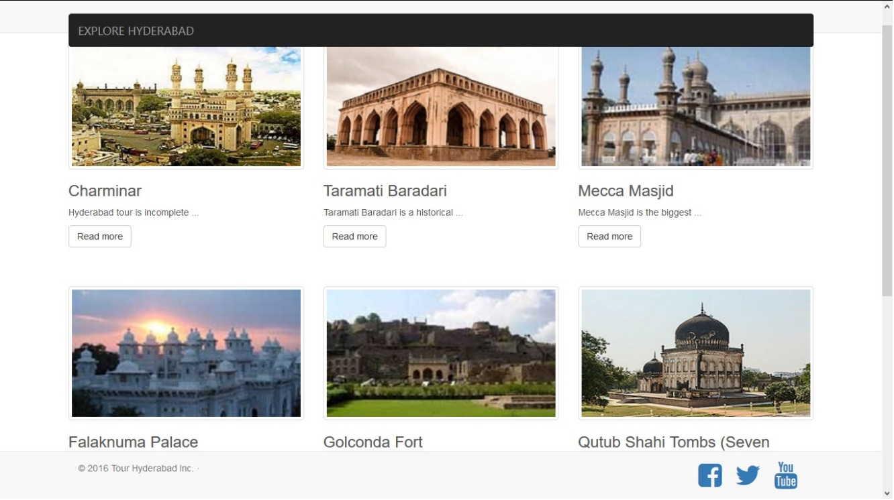

These are the different webpages which are linked to the each subgroup of the homepage. The code for entire site is placed in the google drive link.