# NOX analysis

## Classes 'data.table' and 'data.frame': 3408 obs. of 46 variables:  
## $ fuel_id : Factor w/ 2 levels "0","1": 2 2 2 2 2 2 2 2 2 2 ...  
## $ voc_id : Factor w/ 9 levels "1","2","3","4",..: 7 7 7 7 7 7 7 7 7 7 ...  
## $ class_id : Factor w/ 6 levels "2","3","4","5",..: 6 6 6 6 6 6 6 6 6 6 ...  
## $ drive_id : Factor w/ 3 levels "0","1","2": 1 1 1 1 1 1 1 1 1 1 ...  
## $ trip_count : int 4 1 5 3 7 3 3 4 3 3 ...  
## $ total_average_speed : num 9.38 7.45 8.28 9.41 6.36 ...  
## $ max_speed : num 61.2 32.1 66.2 50 68.1 ...  
## $ driving_average_speed : num 21.9 12 27.8 16.3 24.6 ...  
## $ distance_total : num 172.9 22.3 87.4 148.9 40.3 ...  
## $ acceleration_events_per_mile : num 6.78 13.82 5.61 9.4 6.62 ...  
## $ deceleration_events_per_mile : num 6.78 13.82 5.61 9.4 6.62 ...  
## $ total_stops : int 317 69 111 365 53 185 248 212 222 188 ...  
## $ average_stop_duration : num 121.3 59.3 384.3 75.3 1173.7 ...  
## $ max_elevation : num 1134 980 1069 960 1053 ...  
## $ min_elevation : num 812 829 815 795 814 ...  
## $ max_climbing_rate : num 8.06 3.69 7.65 5.87 5.43 ...  
## $ average_climbing_rate : num 0.82 0.691 0.944 0.69 0.79 ...  
## $ max_descending_rate : num -3.14e-05 -1.95e-05 -2.50e-05 -9.59e-05 -4.17e-04 ...  
## $ average_descending_rate : num -0.821 -0.563 -1.039 -0.599 -0.82 ...  
## $ max_road_grade : num 0.181 0.13 0.187 0.112 0.134 ...  
## $ mean_road_grade : num 1.93e-04 -1.47e-03 4.06e-04 -7.37e-04 -7.39e-05 ...  
## $ maximum_kinetic_power_density_demand : num 18.3 8.11 16.83 14.37 17.6 ...  
## $ total_kinetic_power_density_demand : num 55900 4841 18194 47218 7780 ...  
## $ average_kinetic_power_density_demand : num 3.86 1.51 3.1 3 2.62 ...  
## $ maximum_potential_power_density_demand : num 24.1 11 22.9 17.6 16.2 ...  
## $ total_potential_power_density_demand : num 35276 6232 16921 31872 7110 ...  
## $ average_potential_power_density_demand : num 2.45 2.07 2.82 2.06 2.36 ...  
## $ total_aerodynamic_power_density_demand : num 20563015 705082 19443171 12368140 9663613 ...  
## $ aerodynamic_speed : num 12.16 6.27 16.63 10.16 17.26 ...  
## $ kinetic_intensity : num 1.655 5.828 0.643 2.36 0.571 ...  
## $ average_aerodynamic_power_density_demand: num 723 106 1716 376 1638 ...  
## $ maximum_rolling_power_density_demand : num 268 140 290 219 298 ...  
## $ total_rolling_power_density_demand : num 2728965 351831 1379374 2349934 636325 ...  
## $ average_rolling_power_density_demand : num 94.9 52.1 120.6 70.6 106.9 ...  
## $ characteristic_acceleration : num 0.245 0.229 0.178 0.244 0.17 ...  
## $ characteristic_deceleration : num -0.245 -0.231 -0.178 -0.244 -0.172 ...  
## $ maximum_kinetic_power_density_regen : num -31.5 -11.6 -26.6 -18.7 -21.5 ...  
## $ total_kinetic_power_density_regen : num -55900 -4841 -18194 -47218 -7780 ...  
## $ average_kinetic_power_density_regen : num -3.91 -1.36 -3.26 -2.69 -2.6 ...  
## $ maximum_potential_power_density_regen : num -29.5 -11.9 -25.8 -13.4 -18.8 ...  
## $ total_potential_power_density_regen : num -35291 -6287 -16894 -31895 -7216 ...  
## $ average_potential_power_density_regen : num -2.45 -1.68 -3.11 -1.79 -2.45 ...  
## $ NOX : num 1292 167 653 1112 301 ...  
## $ CO : num 297.2 38.3 150.2 256 69.3 ...  
## $ PM2.5 : num 30.61 3.95 15.47 26.35 7.14 ...  
## $ PM10 : num 33.2 4.28 16.78 28.59 7.74 ...  
## - attr(*, ".internal.selfref")=<externalptr>

## Loading required package: Matrix

## Loaded glmnet 3.0-2

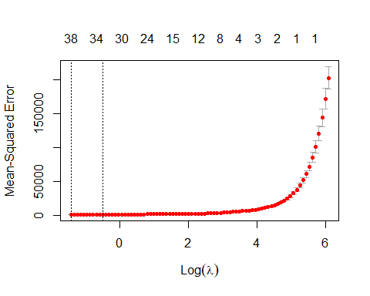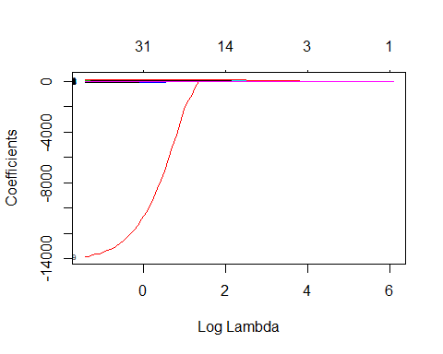

## 53 x 1 sparse Matrix of class "dgCMatrix"  
## s0  
## fuel_id1 -9.754377e+00  
## voc_id2 -5.257105e+01  
## voc_id3 3.275812e+01  
## voc_id4 -4.037110e+01  
## voc_id5 -1.461798e+00  
## voc_id6 -4.152938e+01  
## voc_id10 .   
## voc_id14 1.907952e+01  
## voc_id18 3.542905e+01  
## class_id3 -3.156637e+01  
## class_id4 9.698163e+00  
## class_id5 2.493173e+01  
## class_id6 1.063122e+02  
## class_id7 1.524440e+02  
## drive_id1 9.029535e+00  
## drive_id2 -4.162445e+00  
## trip_count -6.987761e-01  
## total_average_speed -8.142364e-02  
## max_speed .   
## driving_average_speed .   
## acceleration_events_per_mile 3.691779e+00  
## deceleration_events_per_mile .   
## total_stops -2.014486e-02  
## average_stop_duration 8.588344e-03  
## max_elevation 3.316464e-03  
## min_elevation 2.903117e-03  
## max_climbing_rate -2.980791e-01  
## average_climbing_rate -1.151607e+02  
## max_descending_rate -1.336417e+04  
## average_descending_rate 2.577070e+01  
## max_road_grade -4.150383e+00  
## mean_road_grade .   
## maximum_kinetic_power_density_demand .   
## total_kinetic_power_density_demand -9.662679e-04  
## average_kinetic_power_density_demand 1.490891e+01  
## maximum_potential_power_density_demand 6.814117e-02  
## total_potential_power_density_demand 5.607671e-03  
## average_potential_power_density_demand 1.860170e+01  
## total_aerodynamic_power_density_demand .   
## aerodynamic_speed -2.608464e+00  
## kinetic_intensity -9.217575e+00  
## average_aerodynamic_power_density_demand .   
## maximum_rolling_power_density_demand .   
## total_rolling_power_density_demand 4.534515e-04  
## average_rolling_power_density_demand .   
## characteristic_acceleration .   
## characteristic_deceleration -1.176687e+02  
## maximum_kinetic_power_density_regen 8.254462e-02  
## total_kinetic_power_density_regen 2.930839e-03  
## average_kinetic_power_density_regen .   
## maximum_potential_power_density_regen -1.113333e-01  
## total_potential_power_density_regen -1.055351e-05  
## average_potential_power_density_regen .

## Loading required package: nlme

## This is mgcv 1.8-31. For overview type 'help("mgcv-package")'.

## out of sample mean square error for NOx GAM model: 727.9452

## IN sample mean square error for NOx GAM model: 576.2415

##   
## Family: gaussian   
## Link function: identity   
##   
## Formula:  
## NOX ~ drive_id + fuel_id + voc_id + class_id + acceleration_events_per_mile +   
## max_climbing_rate + average_climbing_rate + max_descending_rate +   
## average_descending_rate + total_kinetic_power_density_demand +   
## average_kinetic_power_density_demand + average_potential_power_density_demand +   
## total_rolling_power_density_demand + characteristic_deceleration +   
## total_kinetic_power_density_regen + s(trip_count) + s(maximum_potential_power_density_regen) +   
## s(maximum_kinetic_power_density_regen) + s(average_stop_duration) +   
## s(total_potential_power_density_regen) + s(maximum_potential_power_density_demand) +   
## s(total_potential_power_density_demand) + s(max_road_grade) +   
## s(total_stops) + s(total_average_speed) + s(kinetic_intensity) +   
## s(aerodynamic_speed) + s(min_elevation) + s(max_elevation)  
##   
## Parametric coefficients:  
## Estimate Std. Error t value Pr(>|t|)  
## (Intercept) -1.687e+02 1.250e+01 -13.493 < 2e-16  
## drive_id1 1.101e+01 2.133e+00 5.160 2.65e-07  
## drive_id2 -1.141e+01 6.826e+00 -1.672 0.094720  
## fuel_id1 -6.025e+00 4.716e+00 -1.278 0.201530  
## voc_id2 -6.489e+01 8.817e+00 -7.359 2.44e-13  
## voc_id3 4.603e+01 4.855e+00 9.481 < 2e-16  
## voc_id4 -3.666e+01 3.163e+00 -11.589 < 2e-16  
## voc_id5 -2.529e+01 4.657e+00 -5.430 6.15e-08  
## voc_id6 -4.043e+01 3.603e+00 -11.220 < 2e-16  
## voc_id10 3.314e+01 4.161e+00 7.964 2.44e-15  
## voc_id14 2.970e+01 2.820e+00 10.534 < 2e-16  
## voc_id18 5.237e+01 5.167e+00 10.135 < 2e-16  
## class_id3 2.080e+01 6.619e+00 3.142 0.001696  
## class_id4 8.089e+01 8.239e+00 9.817 < 2e-16  
## class_id5 7.691e+01 7.312e+00 10.519 < 2e-16  
## class_id6 1.695e+02 7.811e+00 21.701 < 2e-16  
## class_id7 2.057e+02 7.845e+00 26.215 < 2e-16  
## acceleration_events_per_mile 4.324e+00 6.656e-01 6.496 9.79e-11  
## max_climbing_rate -2.452e+00 4.349e-01 -5.638 1.90e-08  
## average_climbing_rate -1.806e+01 1.592e+00 -11.344 < 2e-16  
## max_descending_rate -1.724e-01 1.544e-02 -11.168 < 2e-16  
## average_descending_rate 5.115e+01 8.970e+00 5.703 1.31e-08  
## total_kinetic_power_density_demand 3.272e-02 1.004e-02 3.258 0.001134  
## average_kinetic_power_density_demand 2.058e+01 1.922e+00 10.708 < 2e-16  
## average_potential_power_density_demand 1.124e+01 3.101e+00 3.624 0.000296  
## total_rolling_power_density_demand 4.564e-04 3.656e-06 124.852 < 2e-16  
## characteristic_deceleration 5.993e+00 1.767e+00 3.392 0.000705  
## total_kinetic_power_density_regen 3.699e-02 1.004e-02 3.683 0.000235  
##   
## (Intercept) ***  
## drive_id1 ***  
## drive_id2 .   
## fuel_id1   
## voc_id2 ***  
## voc_id3 ***  
## voc_id4 ***  
## voc_id5 ***  
## voc_id6 ***  
## voc_id10 ***  
## voc_id14 ***  
## voc_id18 ***  
## class_id3 **   
## class_id4 ***  
## class_id5 ***  
## class_id6 ***  
## class_id7 ***  
## acceleration_events_per_mile ***  
## max_climbing_rate ***  
## average_climbing_rate ***  
## max_descending_rate ***  
## average_descending_rate ***  
## total_kinetic_power_density_demand **   
## average_kinetic_power_density_demand ***  
## average_potential_power_density_demand ***  
## total_rolling_power_density_demand ***  
## characteristic_deceleration ***  
## total_kinetic_power_density_regen ***  
## ---  
## Signif. codes: 0 '***' 0.001 '**' 0.01 '*' 0.05 '.' 0.1 ' ' 1  
##   
## Approximate significance of smooth terms:  
## edf Ref.df F p-value   
## s(trip_count) 3.366 4.233 1.651 0.127450   
## s(maximum_potential_power_density_regen) 3.660 4.592 2.724 0.020397 *   
## s(maximum_kinetic_power_density_regen) 1.001 1.001 0.280 0.596464   
## s(average_stop_duration) 5.650 6.686 5.061 2.18e-05 ***  
## s(total_potential_power_density_regen) 2.731 3.139 3.672 0.012220 *   
## s(maximum_potential_power_density_demand) 4.162 5.220 4.701 0.000177 ***  
## s(total_potential_power_density_demand) 5.310 5.703 1.982 0.049809 *   
## s(max_road_grade) 4.963 6.044 10.206 3.78e-11 ***  
## s(total_stops) 7.310 7.840 11.710 4.02e-16 ***  
## s(total_average_speed) 4.800 5.879 4.187 0.000396 ***  
## s(kinetic_intensity) 3.182 4.110 4.169 0.001674 **   
## s(aerodynamic_speed) 6.081 7.086 15.635 < 2e-16 ***  
## s(min_elevation) 2.786 3.557 25.942 < 2e-16 ***  
## s(max_elevation) 7.382 7.651 13.451 < 2e-16 ***  
## ---  
## Signif. codes: 0 '***' 0.001 '**' 0.01 '*' 0.05 '.' 0.1 ' ' 1  
##   
## Rank: 133/154  
## R-sq.(adj) = 0.996 Deviance explained = 99.6%  
## GCV = 863.67 Scale est. = 836.78 n = 2775

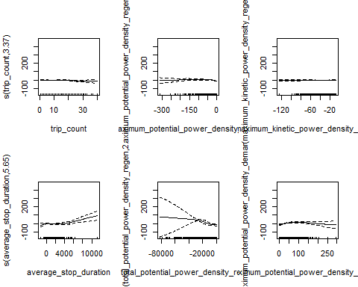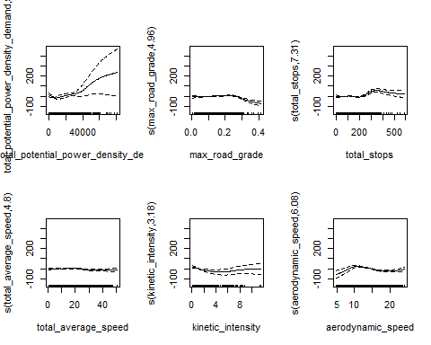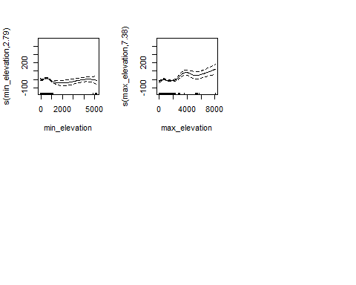

## out of sample mean square error for modified NOx GAM model: 965.6133

## IN sample mean square error for modified NOx GAM model: 810.7304