## Classes 'data.table' and 'data.frame': 3408 obs. of 46 variables:  
## $ fuel_id : Factor w/ 2 levels "0","1": 2 2 2 2 2 2 2 2 2 2 ...  
## $ voc_id : Factor w/ 9 levels "1","2","3","4",..: 7 7 7 7 7 7 7 7 7 7 ...  
## $ class_id : Factor w/ 6 levels "2","3","4","5",..: 6 6 6 6 6 6 6 6 6 6 ...  
## $ drive_id : Factor w/ 3 levels "0","1","2": 1 1 1 1 1 1 1 1 1 1 ...  
## $ trip_count : int 4 1 5 3 7 3 3 4 3 3 ...  
## $ total_average_speed : num 9.38 7.45 8.28 9.41 6.36 ...  
## $ max_speed : num 61.2 32.1 66.2 50 68.1 ...  
## $ driving_average_speed : num 21.9 12 27.8 16.3 24.6 ...  
## $ distance_total : num 172.9 22.3 87.4 148.9 40.3 ...  
## $ acceleration_events_per_mile : num 6.78 13.82 5.61 9.4 6.62 ...  
## $ deceleration_events_per_mile : num 6.78 13.82 5.61 9.4 6.62 ...  
## $ total_stops : int 317 69 111 365 53 185 248 212 222 188 ...  
## $ average_stop_duration : num 121.3 59.3 384.3 75.3 1173.7 ...  
## $ max_elevation : num 1134 980 1069 960 1053 ...  
## $ min_elevation : num 812 829 815 795 814 ...  
## $ max_climbing_rate : num 8.06 3.69 7.65 5.87 5.43 ...  
## $ average_climbing_rate : num 0.82 0.691 0.944 0.69 0.79 ...  
## $ max_descending_rate : num -3.14e-05 -1.95e-05 -2.50e-05 -9.59e-05 -4.17e-04 ...  
## $ average_descending_rate : num -0.821 -0.563 -1.039 -0.599 -0.82 ...  
## $ max_road_grade : num 0.181 0.13 0.187 0.112 0.134 ...  
## $ mean_road_grade : num 1.93e-04 -1.47e-03 4.06e-04 -7.37e-04 -7.39e-05 ...  
## $ maximum_kinetic_power_density_demand : num 18.3 8.11 16.83 14.37 17.6 ...  
## $ total_kinetic_power_density_demand : num 55900 4841 18194 47218 7780 ...  
## $ average_kinetic_power_density_demand : num 3.86 1.51 3.1 3 2.62 ...  
## $ maximum_potential_power_density_demand : num 24.1 11 22.9 17.6 16.2 ...  
## $ total_potential_power_density_demand : num 35276 6232 16921 31872 7110 ...  
## $ average_potential_power_density_demand : num 2.45 2.07 2.82 2.06 2.36 ...  
## $ total_aerodynamic_power_density_demand : num 20563015 705082 19443171 12368140 9663613 ...  
## $ aerodynamic_speed : num 12.16 6.27 16.63 10.16 17.26 ...  
## $ kinetic_intensity : num 1.655 5.828 0.643 2.36 0.571 ...  
## $ average_aerodynamic_power_density_demand: num 723 106 1716 376 1638 ...  
## $ maximum_rolling_power_density_demand : num 268 140 290 219 298 ...  
## $ total_rolling_power_density_demand : num 2728965 351831 1379374 2349934 636325 ...  
## $ average_rolling_power_density_demand : num 94.9 52.1 120.6 70.6 106.9 ...  
## $ characteristic_acceleration : num 0.245 0.229 0.178 0.244 0.17 ...  
## $ characteristic_deceleration : num -0.245 -0.231 -0.178 -0.244 -0.172 ...  
## $ maximum_kinetic_power_density_regen : num -31.5 -11.6 -26.6 -18.7 -21.5 ...  
## $ total_kinetic_power_density_regen : num -55900 -4841 -18194 -47218 -7780 ...  
## $ average_kinetic_power_density_regen : num -3.91 -1.36 -3.26 -2.69 -2.6 ...  
## $ maximum_potential_power_density_regen : num -29.5 -11.9 -25.8 -13.4 -18.8 ...  
## $ total_potential_power_density_regen : num -35291 -6287 -16894 -31895 -7216 ...  
## $ average_potential_power_density_regen : num -2.45 -1.68 -3.11 -1.79 -2.45 ...  
## $ NOX : num 1292 167 653 1112 301 ...  
## $ CO : num 297.2 38.3 150.2 256 69.3 ...  
## $ PM2.5 : num 30.61 3.95 15.47 26.35 7.14 ...  
## $ PM10 : num 33.2 4.28 16.78 28.59 7.74 ...  
## - attr(*, ".internal.selfref")=<externalptr>

## Loading required package: Matrix

## Loaded glmnet 3.0-2

## Loading required package: nlme

## This is mgcv 1.8-31. For overview type 'help("mgcv-package")'.

##   
## Family: gaussian   
## Link function: identity   
##   
## Formula:  
## PM2.5 ~ drive_id + fuel_id + voc_id + class_id + trip_count +   
## acceleration_events_per_mile + average_stop_duration + average_climbing_rate +   
## max_descending_rate + average_descending_rate + mean_road_grade +   
## total_kinetic_power_density_demand + average_kinetic_power_density_demand +   
## total_potential_power_density_demand + average_potential_power_density_demand +   
## average_aerodynamic_power_density_demand + total_rolling_power_density_demand +   
## characteristic_deceleration + s(maximum_potential_power_density_regen) +   
## s(average_kinetic_power_density_regen) + s(maximum_kinetic_power_density_regen) +   
## s(average_aerodynamic_power_density_demand) + s(kinetic_intensity) +   
## s(maximum_potential_power_density_demand) + s(maximum_kinetic_power_density_demand) +   
## s(total_average_speed) + s(average_potential_power_density_regen) +   
## s(total_kinetic_power_density_regen) + s(total_aerodynamic_power_density_demand) +   
## s(aerodynamic_speed) + s(min_elevation) + s(max_elevation)  
##   
## Parametric coefficients:  
## Estimate Std. Error t value Pr(>|t|)  
## (Intercept) -7.673e-01 1.560e-01 -4.918 9.25e-07  
## drive_id1 2.108e-01 6.632e-02 3.179 0.001495  
## drive_id2 -1.196e+00 2.054e-01 -5.826 6.37e-09  
## fuel_id1 2.825e-01 1.464e-01 1.929 0.053776  
## voc_id2 -9.082e-01 2.657e-01 -3.417 0.000641  
## voc_id3 1.481e+00 1.485e-01 9.975 < 2e-16  
## voc_id4 -9.075e-01 9.403e-02 -9.651 < 2e-16  
## voc_id5 -1.809e+00 1.578e-01 -11.461 < 2e-16  
## voc_id6 -1.129e+00 1.082e-01 -10.441 < 2e-16  
## voc_id10 5.922e-01 1.333e-01 4.443 9.25e-06  
## voc_id14 1.059e+00 8.752e-02 12.101 < 2e-16  
## voc_id18 1.904e+00 1.636e-01 11.635 < 2e-16  
## class_id3 3.061e-01 2.007e-01 1.526 0.127220  
## class_id4 9.393e-01 2.501e-01 3.756 0.000176  
## class_id5 5.838e-01 2.218e-01 2.632 0.008530  
## class_id6 6.357e+00 2.389e-01 26.604 < 2e-16  
## class_id7 4.765e+00 2.361e-01 20.186 < 2e-16  
## trip_count -1.878e-02 4.729e-03 -3.971 7.33e-05  
## acceleration_events_per_mile 1.418e-01 2.260e-02 6.273 4.11e-10  
## average_stop_duration 1.820e-04 3.593e-05 5.066 4.34e-07  
## average_climbing_rate -4.962e+00 4.398e-01 -11.283 < 2e-16  
## max_descending_rate -2.472e-03 3.559e-04 -6.946 4.68e-12  
## average_descending_rate 5.438e+00 3.909e-01 13.913 < 2e-16  
## mean_road_grade -1.543e-02 1.511e-03 -10.212 < 2e-16  
## total_kinetic_power_density_demand -2.323e-04 2.445e-05 -9.500 < 2e-16  
## average_kinetic_power_density_demand 6.802e-01 9.117e-02 7.460 1.16e-13  
## total_potential_power_density_demand 1.629e-04 9.653e-06 16.872 < 2e-16  
## average_potential_power_density_demand 1.017e+00 1.607e-01 6.330 2.87e-10  
## average_aerodynamic_power_density_demand -1.004e-03 2.178e-04 -4.608 4.25e-06  
## total_rolling_power_density_demand 1.224e-05 2.696e-07 45.404 < 2e-16  
## characteristic_deceleration 3.880e-01 5.729e-02 6.773 1.54e-11  
##   
## (Intercept) ***  
## drive_id1 **   
## drive_id2 ***  
## fuel_id1 .   
## voc_id2 ***  
## voc_id3 ***  
## voc_id4 ***  
## voc_id5 ***  
## voc_id6 ***  
## voc_id10 ***  
## voc_id14 ***  
## voc_id18 ***  
## class_id3   
## class_id4 ***  
## class_id5 **   
## class_id6 ***  
## class_id7 ***  
## trip_count ***  
## acceleration_events_per_mile ***  
## average_stop_duration ***  
## average_climbing_rate ***  
## max_descending_rate ***  
## average_descending_rate ***  
## mean_road_grade ***  
## total_kinetic_power_density_demand ***  
## average_kinetic_power_density_demand ***  
## total_potential_power_density_demand ***  
## average_potential_power_density_demand ***  
## average_aerodynamic_power_density_demand ***  
## total_rolling_power_density_demand ***  
## characteristic_deceleration ***  
## ---  
## Signif. codes: 0 '***' 0.001 '**' 0.01 '*' 0.05 '.' 0.1 ' ' 1  
##   
## Approximate significance of smooth terms:  
## edf Ref.df F p-value   
## s(maximum_potential_power_density_regen) 2.127 2.730 1.956 0.110226   
## s(average_kinetic_power_density_regen) 3.019 3.859 1.309 0.277751   
## s(maximum_kinetic_power_density_regen) 3.220 4.142 0.508 0.728693   
## s(average_aerodynamic_power_density_demand) 3.980 5.003 12.184 1.30e-11 ***  
## s(kinetic_intensity) 2.473 3.195 6.273 0.000223 ***  
## s(maximum_potential_power_density_demand) 3.934 4.929 0.837 0.488859   
## s(maximum_kinetic_power_density_demand) 3.320 4.192 7.866 1.96e-06 ***  
## s(total_average_speed) 3.394 4.361 4.131 0.001091 **   
## s(average_potential_power_density_regen) 3.686 4.689 45.258 < 2e-16 ***  
## s(total_kinetic_power_density_regen) 3.498 4.507 12.676 2.54e-10 ***  
## s(total_aerodynamic_power_density_demand) 3.749 4.736 11.372 3.31e-10 ***  
## s(aerodynamic_speed) 3.524 4.523 9.543 6.68e-08 ***  
## s(min_elevation) 2.801 3.573 34.965 < 2e-16 ***  
## s(max_elevation) 7.097 7.556 13.348 < 2e-16 ***  
## ---  
## Signif. codes: 0 '***' 0.001 '**' 0.01 '*' 0.05 '.' 0.1 ' ' 1  
##   
## Rank: 139/157  
## R-sq.(adj) = 0.994 Deviance explained = 99.4%  
## GCV = 0.79484 Scale est. = 0.77332 n = 2775

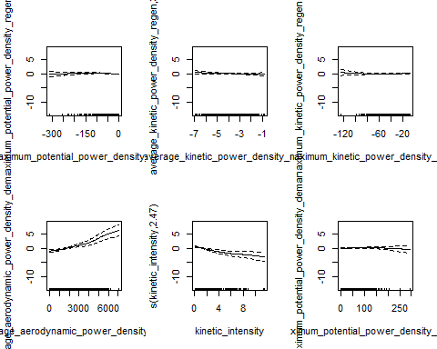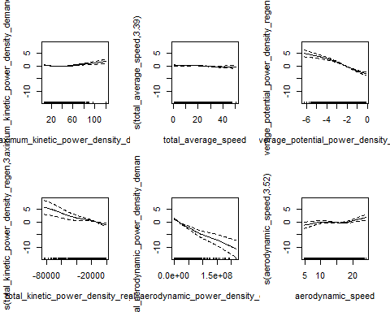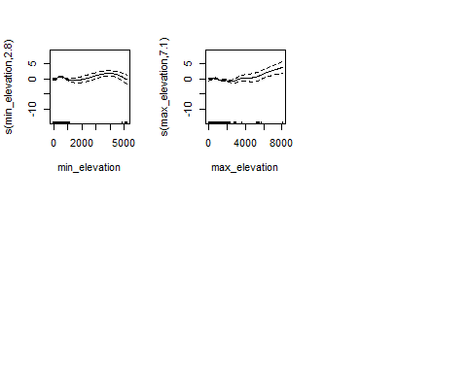

## out of sample mean square error for modified pm2.5 GAM model: 0.8035331

## IN sample mean square error for modified pm2.5 GAM model: 0.7523878

## Analysis of Deviance Table  
##   
## Model 1: PM2.5 ~ drive_id + fuel_id + voc_id + class_id + s(trip_count) +   
## s(total_average_speed) + s(acceleration_events_per_mile) +   
## s(average_stop_duration) + s(max_elevation) + s(min_elevation) +   
## s(average_climbing_rate) + s(max_descending_rate) + s(average_descending_rate) +   
## s(mean_road_grade) + s(maximum_kinetic_power_density_demand) +   
## s(total_kinetic_power_density_demand) + s(average_kinetic_power_density_demand) +   
## s(maximum_potential_power_density_demand) + s(total_potential_power_density_demand) +   
## s(average_potential_power_density_demand) + s(total_aerodynamic_power_density_demand) +   
## s(aerodynamic_speed) + s(kinetic_intensity) + s(average_aerodynamic_power_density_demand) +   
## s(total_rolling_power_density_demand) + s(characteristic_deceleration) +   
## s(maximum_kinetic_power_density_regen) + s(total_kinetic_power_density_regen) +   
## s(average_kinetic_power_density_regen) + s(maximum_potential_power_density_regen) +   
## s(average_potential_power_density_regen)  
## Model 2: PM2.5 ~ drive_id + fuel_id + voc_id + class_id + trip_count +   
## acceleration_events_per_mile + average_stop_duration + average_climbing_rate +   
## max_descending_rate + average_descending_rate + mean_road_grade +   
## total_kinetic_power_density_demand + average_kinetic_power_density_demand +   
## total_potential_power_density_demand + average_potential_power_density_demand +   
## average_aerodynamic_power_density_demand + total_rolling_power_density_demand +   
## characteristic_deceleration + s(maximum_potential_power_density_regen) +   
## s(average_kinetic_power_density_regen) + s(maximum_kinetic_power_density_regen) +   
## s(average_aerodynamic_power_density_demand) + s(kinetic_intensity) +   
## s(maximum_potential_power_density_demand) + s(maximum_kinetic_power_density_demand) +   
## s(total_average_speed) + s(average_potential_power_density_regen) +   
## s(total_kinetic_power_density_regen) + s(total_aerodynamic_power_density_demand) +   
## s(aerodynamic_speed) + s(min_elevation) + s(max_elevation)  
## Resid. Df Resid. Dev Df Deviance F Pr(>F)   
## 1 2599.8 1456.0   
## 2 2687.7 2087.9 -87.898 -631.88 12.918 < 2.2e-16 ***  
## ---  
## Signif. codes: 0 '***' 0.001 '**' 0.01 '*' 0.05 '.' 0.1 ' ' 1