**HW1 #ANSIBLE**

**Team Name:** Dragonite

**Members:**

Vishnu Vardhan Reddy Yeruva

Khushil Ketankumar Modi

Sarjak Patel

Nevil

**Challenge:** To Configure Ansible server on ***VM 1***to deploy a webserver *to****VM2***and ***VM3***on port 8080 that displays the message: “Hello World from SJSU”

**Procedure:**

Set-up 3 virtual machines where 1 acts as master/server and the other 2 VM’s as nodes/slaves

**Setting-up ansible:**

1. Cmd: cd .ssh
2. Cmd: sudo apt install ansible
3. Cmd: sudo apt-get update && apt-get upgrade

**Configuring ansible:**

1. Cmd: sudo gedit /etc/ansible/hosts

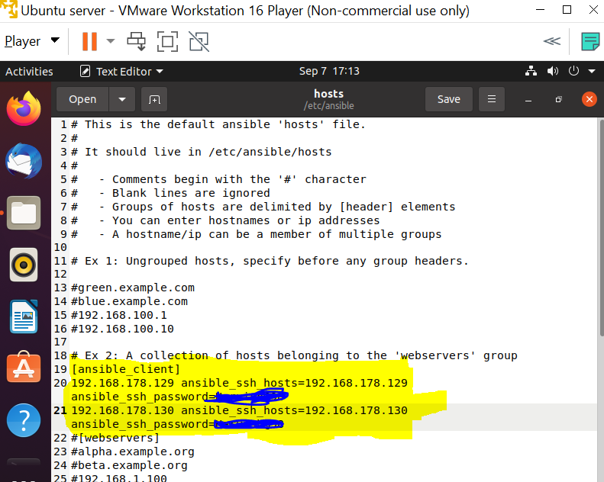

FIG-A

In Fig-A we have been trying to establish a proper SSH connection by providing the target IP address and password for SSH.

1. Cmd: gedit <filename>.yml

#command to write a playbook here we have used hello.yml as our sample file

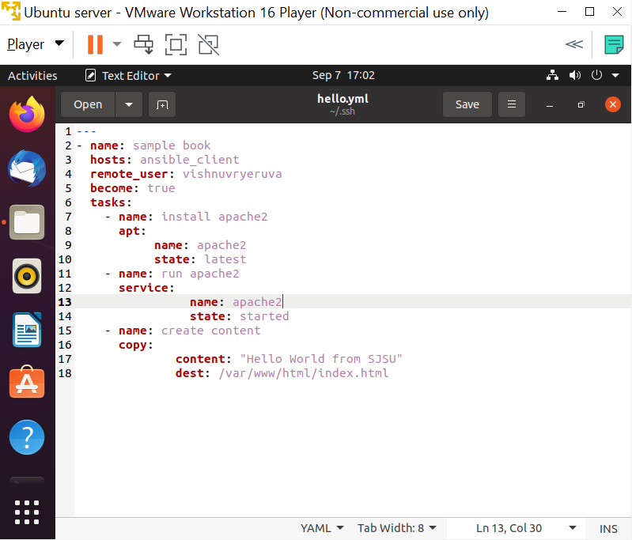

FIG-B

Ansible playbook written in YAML/YML programing language, written to establish connection, install apache to run using apt command-line package manager

**Deploying on virtual machines**

1. Cmd: cat ssh-keygen
2. Cmd: cat <filename>.pub (or) cat id_rsa.pub (by default)

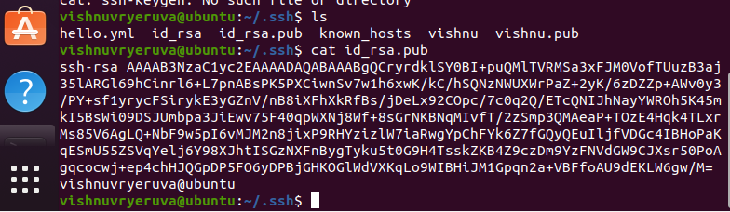

Add this key to nodes authorized_keys file to get a RSA’s secured connection.

(Requires only if using AWS EC2 Instance)

1. Cmd: sudo ansible-playbook hello.yml --ask-become-pass -kk

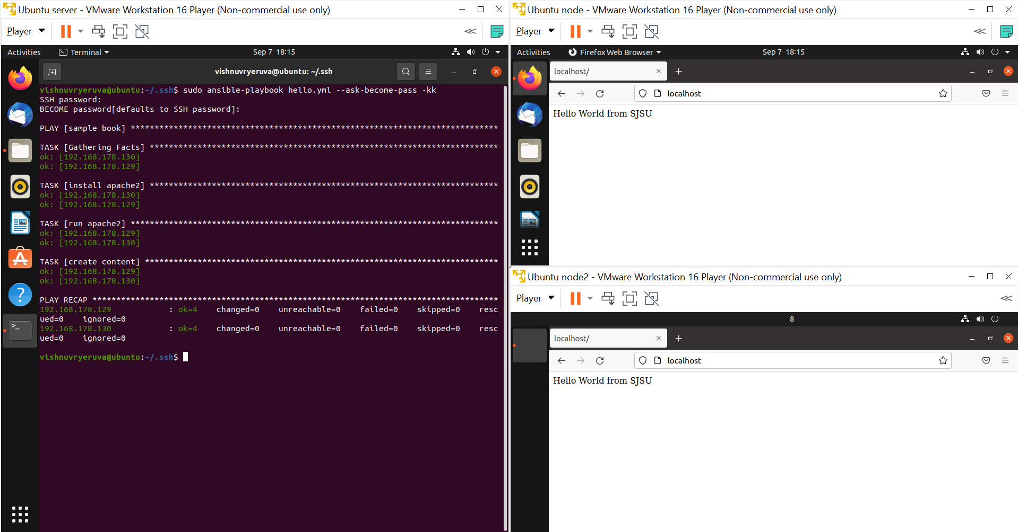

Note: Refer

References:

[(45) Ansible Full Course | Ansible Tutorial For Beginners | Learn Ansible Step By Step | Simplilearn - YouTube](https://www.youtube.com/watch?v=EcnqJbxBcM0)

[(45) How to Use a GUI with Ubuntu Linux on AWS EC2 - YouTube](https://www.youtube.com/watch?v=6x_okhl_CF4)

[(45) Ansible Installation & Configuration on AWS | Install & Configure Ansible on EC2 | Intellipaat - YouTube](https://www.youtube.com/watch?v=Km3BCQnV6sw)

[Install a GUI on an Amazon EC2 instance running Amazon Linux 2](https://aws.amazon.com/premiumsupport/knowledge-center/ec2-linux-2-install-gui/)

[linux - Unable to install Apache2 - Stack Overflow](https://stackoverflow.com/questions/33014470/unable-to-install-apache2)

[How to Use Ansible to Install and Set Up Apache on Ubuntu 18.04 | DigitalOcean](https://www.digitalocean.com/community/tutorials/how-to-use-ansible-to-install-and-set-up-apache-on-ubuntu-18-04)

[How to Use Ansible: An Ansible Cheat Sheet Guide | DigitalOcean](https://www.digitalocean.com/community/cheatsheets/how-to-use-ansible-cheat-sheet-guide)

[How to fix: Connection refused by port 22 Debian/Ubuntu (linuxhint.com)](https://linuxhint.com/fix_connection_refused_ubuntu/)

[vagrant - Ansible provisioning ERROR! Using a SSH password instead of a key is not possible - Stack Overflow](https://stackoverflow.com/questions/42462435/ansible-provisioning-error-using-a-ssh-password-instead-of-a-key-is-not-possibl)

[How to fix: Connection refused by port 22 Debian/Ubuntu (linuxhint.com)](https://linuxhint.com/fix_connection_refused_ubuntu/)

[Ssh-keygen is a tool for creating new authentication key pairs for SSH. This is a tutorial on its use, and covers several special use cases.](https://www.ssh.com/academy/ssh/keygen#:~:text=SSH%20introduced%20public%20key%20authentication,server%20stealing%20the%20user's%20password.)

[Playbook Example: Continuous Delivery and Rolling Upgrades — Ansible Documentation](https://docs.ansible.com/ansible/latest/user_guide/guide_rolling_upgrade.html)