### **Team: Chirps**

**Team Members:** Ashika Anand Babu, Subarna Chowdhury Soma, Vishnu Vardhan Reddy Yeruva

### **Project Name: Public opinion and sentiment analysis on the COVID-19 vaccine using Twitter data**

### **High Level Architecture Design**

#### **Architecture 1:**

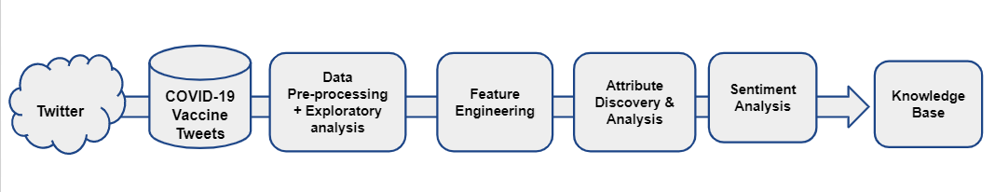

#### **Architecture 2:**

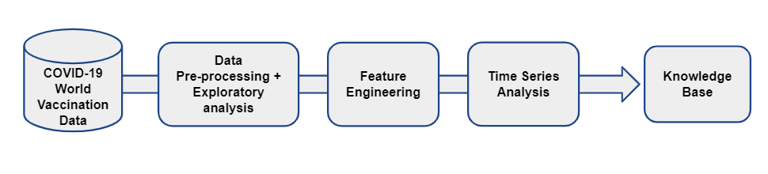

### 

### **Data Flow Diagram**

#### Diagram 1:

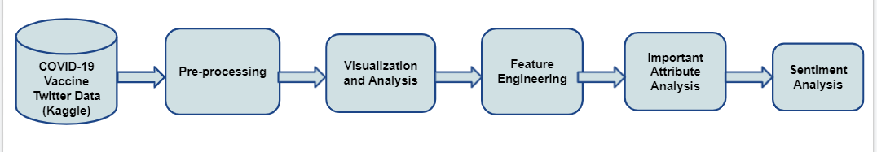

#### Diagram 2:

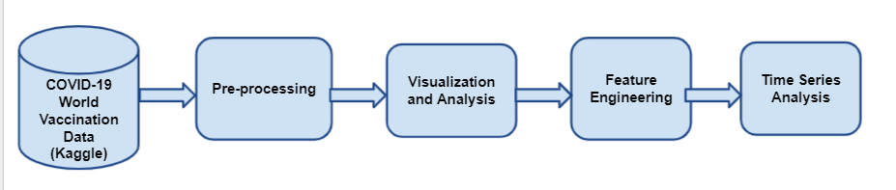

### **Component Level Design**

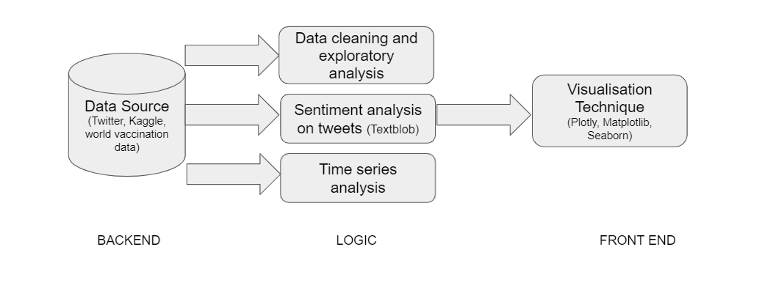

Following are the components for our system:

Backend

1. Data sources
   1. kaggle dataset: gpreda/all-covid19-vaccines-tweets
   2. World Vaccination Data:

Logic

1. Data cleaning + Exploratory analysis to find important features
2. Sentiment Analysis, Word Cloud Visualisation - what are words associated with positive, negative
3. Time series analysis

Front end

1. Plotly
2. Matplotlib
3. Seaborn