**Assignment -2**

**OpenAI GYM:**

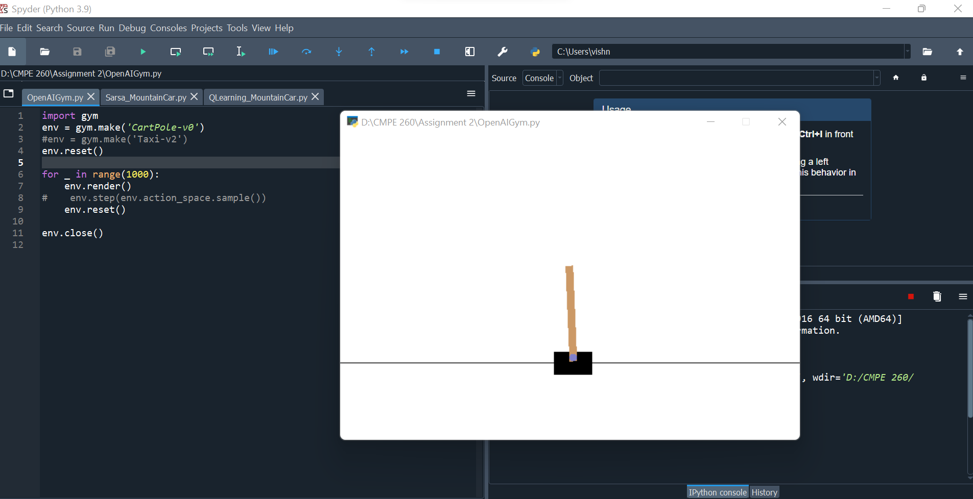

**QLearning:**

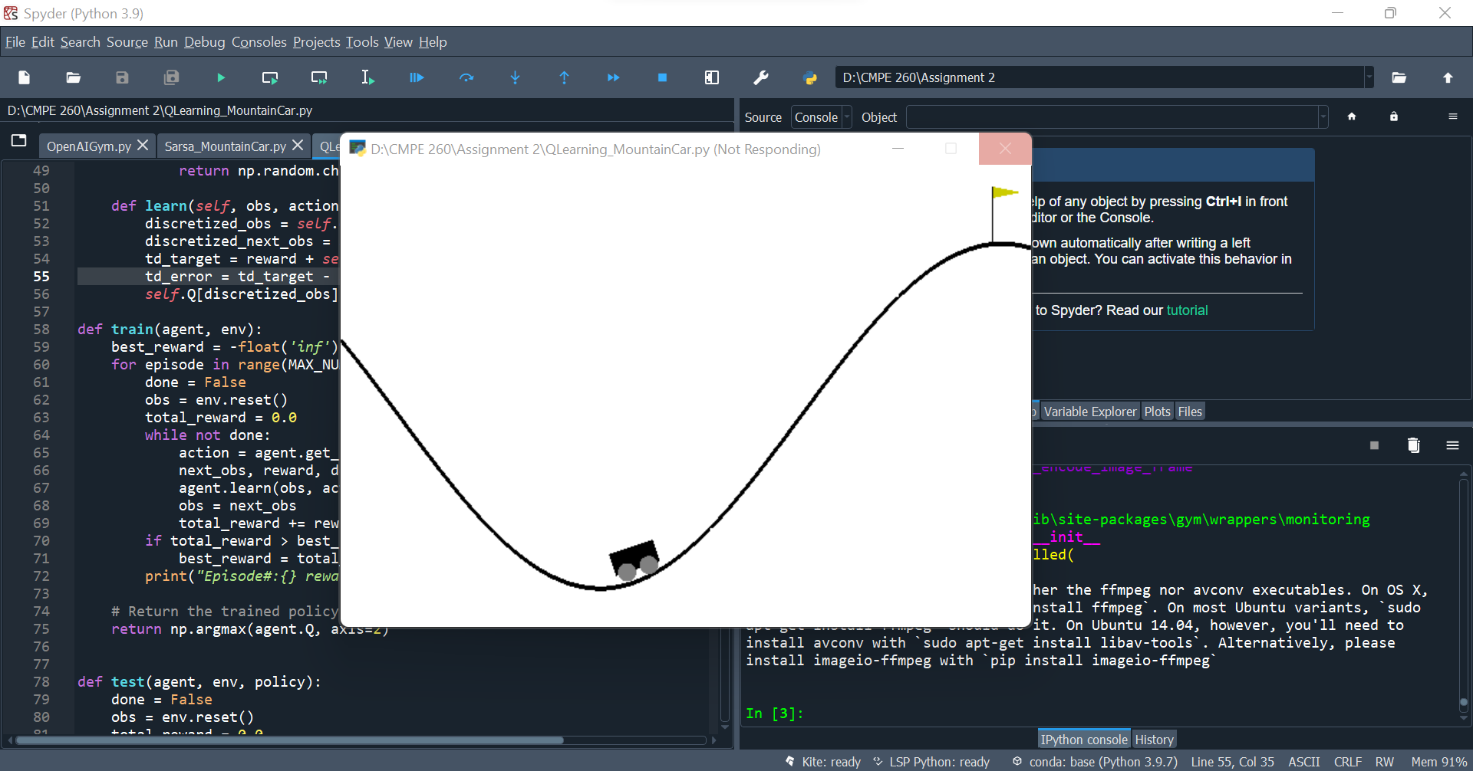

**SARSA (State Action Reward State Action):**

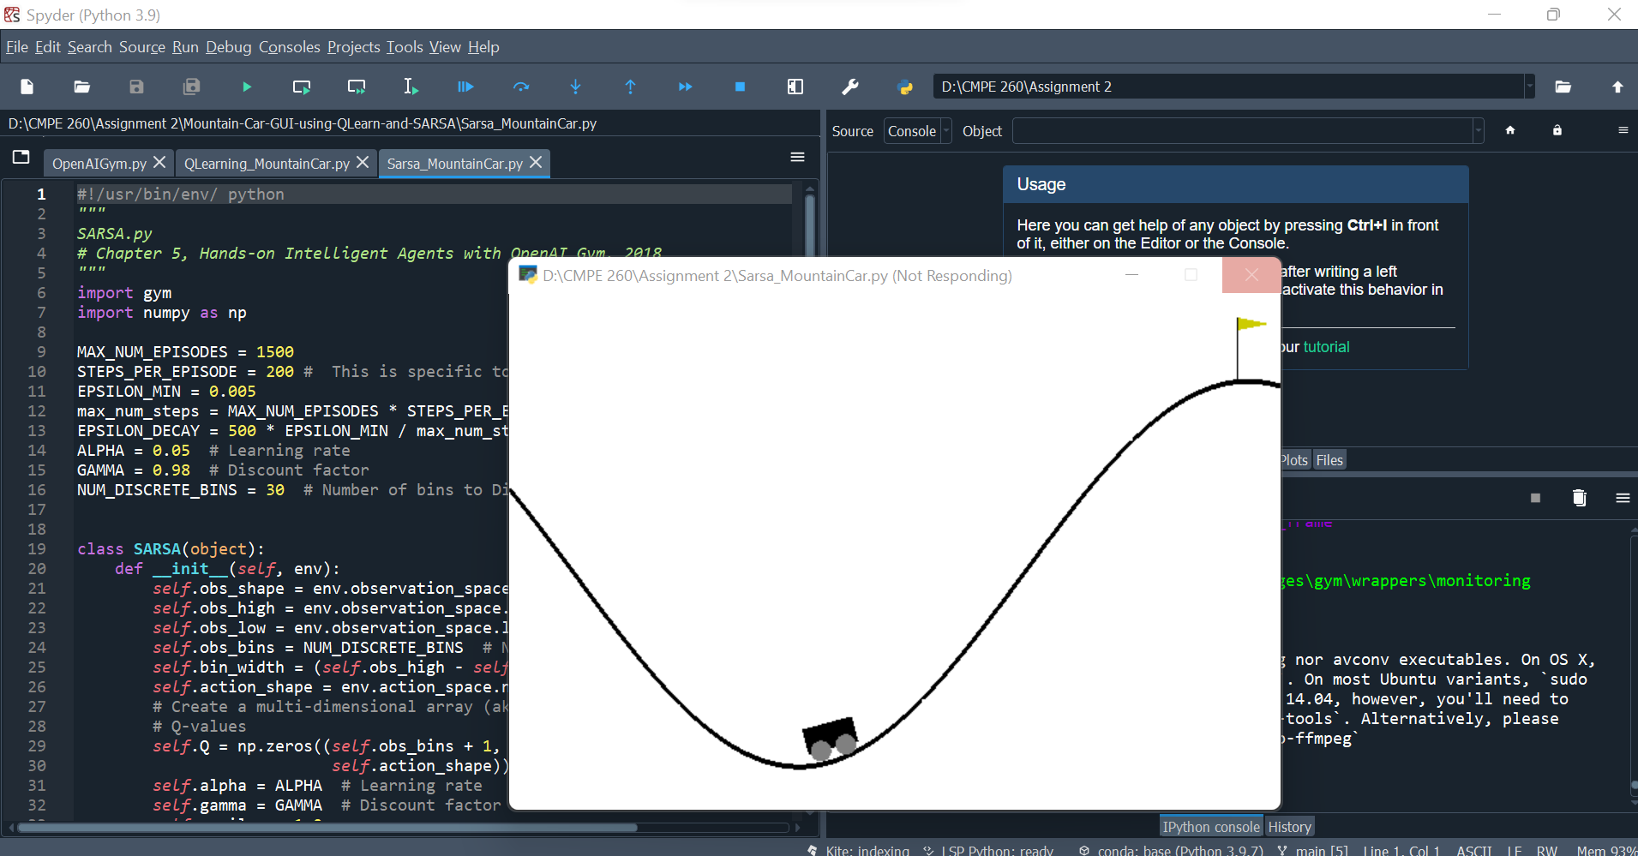

**Qlearning vs SARSA:**

