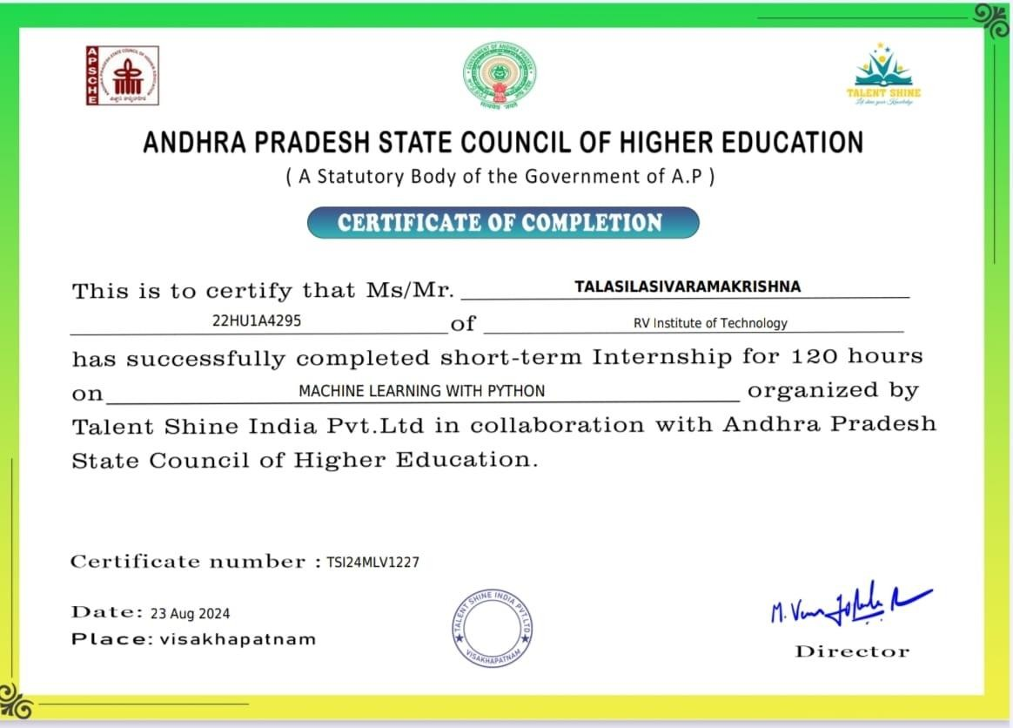
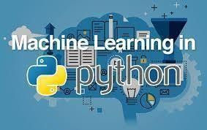
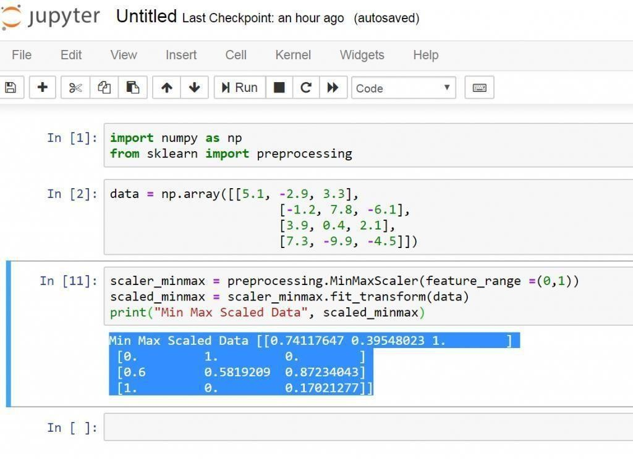
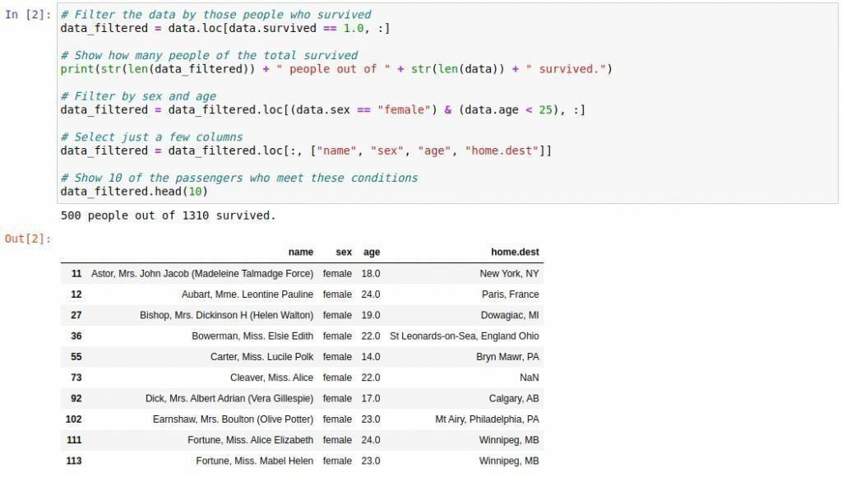
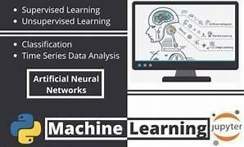
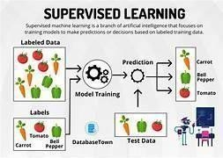
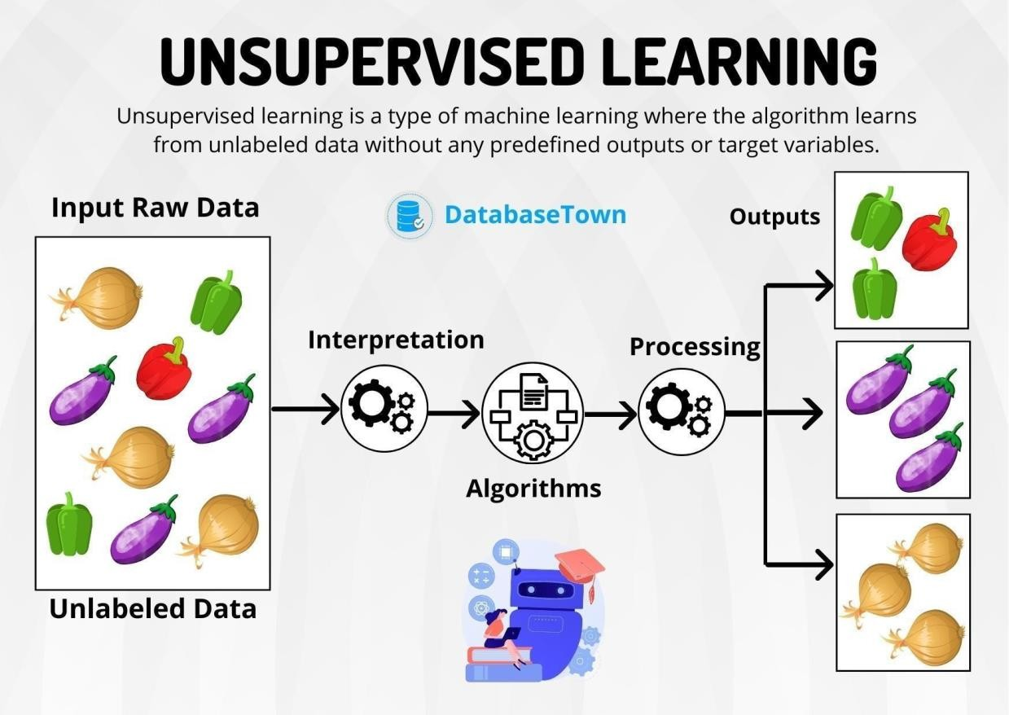


SHORT TERM INTERNSHIP
(On-Site/Virtual)

ANDHRA PRADESH
STATE COUNCIL OF HIGHER EDUCATION
(A STATUTORY BODY OF GOVERNMENT OF ANDHRA PRADESH)

PROGRAM BOOK FOR
SHORT-TERM INTERNSHIP

(Onsite / Virtual)

TALASILA SIVA RAMA KRISHNA

R V INSTITUTE OF TECHNOLOGY 22HU1A4295
01-07-2024 30-08-2024

Talent shine india pvt ltd
31-28, 1, Dwarka Nagar, Kurmannapalem, Visakhapatnam, Andhra Pradesh 530046

: 2024-25

Jntuk University

An Internship Report on
MACHINE LEARNING WITH PYTHON
(Title of the Internship)

Submitted in accordance with the requirement for the degree of
B-tech

Under the Faculty Guideship of
B.ANUSHA

(Name of the Faculty Guide)

Department of
CSE(AI & ML),RVIT

(Name of the College)

Submitted by:
TADIBOINA VISHNU VARDHAN

(Name of the Student)

Reg.No: 22HU1A42A1
Department of
CSE(ARTIFICIAL INTELLIGENCE AND MACHINE LEARNING)

RV INSTITUTE OF TECHNOLOGY
(Name of the College)

Page No:

Please read the detailed Guidelines on Internship hosted on the website of AP State Council of Higher Education https://apsche.ap.gov.in

- It is mandatory for all the students to complete 2 months (180 hours) of short- term internship either physically or virtually.
- Every student should identify the organization for internship in consultation with the College Principal/the authorized person nominated by the Principal.
- Report to the intern organization as per the schedule given by the College. You must make your own arrangements for transportation to reach the organization.
- You should maintain punctuality in attending the internship. Daily attendance is compulsory.
- You are expected to learn about the organization, policies, procedures, and processes by interacting with the people working in the organization and by consulting the supervisor attached to the interns.
- While you are attending the internship, follow the rules and regulations of the intern organization.
- While in the intern organization, always wear your College Identity Card.
- If your College has a prescribed dress as uniform, wear the uniform daily, as you attend to your assigned duties.
- You will be assigned a Faculty Guide from your College. He/She will be creating a WhatsApp group with your fellow interns. Post your daily activity done and/or any difficulty you encounter during the internship.
- Identify five or more learning objectives in consultation with your Faculty Guide. These learning objectives can address:
  - Data and Information you are expected to collect about the organization and/or industry.
  - Job Skills you are expected to acquire.
  - Development of professional competencies that lead to future career success.

- Practice professional communication skills with team members, co-interns, and your supervisor. This includes expressing thoughts and ideas effectively through oral, written, and non-verbal communication, and utilizing listening skills.
- Be aware of the communication culture in your work environment. Follow up and communicate regularly with your supervisor to provide updates on your progress with work assignments.
- Never be hesitant to ask questions to make sure you fully understand what you need to do your work and to contribute to the organization.
- Be regular in filling up your Program Book. It shall be filled up in your own handwriting. Add additional sheets wherever necessary.
- At the end of internship, you shall be evaluated by your Supervisor of the intern organization.
- There shall also be evaluation at the end of the internship by the Faculty Guide and the Principal.
- Do not meddle with the instruments/equipment you work with.
- Ensure that you do not cause any disturbance to the regular activities of the intern organization.
- Be cordial but not too intimate with the employees of the intern organization and your fellow interns.
- You should understand that during the internship programme, you are the ambassador of your College, and your behavior during the internship programme is of utmost importance.
- If you are involved in any discipline related issues, you will be withdrawn from the internship programme immediately and disciplinary action shall be initiated.
- Do not forget to keep up your family pride and prestige of your College.

<<@>>

Page No:

Student’s Declaration
I, TADIBOINA VISHNU VARDHAN a student of CSE(ARTIFICIAL INTELLIGENCE AND MACHINE LEARNING)
Program, Reg. No. 22HU1A42A1 of the Department of CSE(AI & ML) College do hereby declare that I have completed the mandatory internship from01-07-2024 to 30-08-2024 in TALENT SHINE INDIA(Name of the intern organization) under the Faculty Guideship of B.ANUSHA
(Name of the Faculty Guide), Department of CSE(ARTIFICIAL INTELLIGENCE AND MACHINE LEARNING)
RV INSTITUTE OF TECHNOLOGY (Name of the College)

(Signature and Date)

Page No:

Official Certification
This is to certify that (Name ofthe student) Reg. No. has completed his/her Internship in
(Name of the Intern Organization) on
(Title of the Internship) under my supervision as a part of partial fulfillment of the requirement for the
Degree of
(Name of the College).
in the Department of

This is accepted for evaluation.

(Signatory with Date and Seal)

Endorsements

Faculty Guide

Head of the Department

Principal

Page No:

Acknowledgements

I am indebted to our Principal Dr. R.V. Krishnaiah and the management of R V Institute Of Technology for providing an environment with all the facilities that helped me in completing the internship.

I am extremely grateful to Ms.B.Bhavani, mam HOD of the CSE(ARTIFICIAL INTELLIGENCE AND MACHINE LEARNING)
Department for hermoral support and encouragement.

I wish to express my sincere gratitude to my internal guide Ms.B.Anusha mam and our internship coordinator from the CSE(ARTIFICIAL INETELLIGENCE AND MACHINE LEARNING) Department, for
their guidance and suggestions.

I thank all the teaching and non-teaching staff of the CSE(ARTIFICIAL INTELLIGENCE AND MACHINE
LEARNING) Department of for their kind help.

I also thank the company TALENT SHINE Team, for providing me with this golden opportunity to do the internship on the topic of Data Analytics which helped me in learning new things.

Last but not least, I would like to add some personal notes. If there is a driving force that keeps me going, and that has not changed, it is the constant support and blessing of my parents, family, and friends. There is no doubt, in spite of my strenuous efforts; errors might remain in the internship report. Naturally, I take full responsibility for any lack of clarity, occasional erratum, or inexactness that may occur.

Page No:

Contents

- ENVIRONMENT SET UP
  - INSTALLATION OF PYTHON ENVIRONMENT
- PYTHON
  - PYTHON FUNDAMENTALS AND DATA STRUCTURES
  - LOOPS AND CONDITIONAL STATEMENTS
  - LOOPS AND CONTROL STATEMENTS PROBLEMS
  - OOPS AND FUNCTIONS
  - ARRAY BASICS AND PROBLEM SOLVING
  - STRING BASICS AND PROBLEM SOLVING
  - RECURSIONS

- PYTHON LIBRARIES
  - PANDAS
  - NUMPY
  - DATA VISUALIZATION
  - DATA WRANGLING

- MACHINE LEARNING
  - SUPERVISED LEARNING-REGRESSION
  - SUPERVISED LEARNING-CLASSIFICATION
  - UNSUPERVISED LEARNING

- ADVANCED TOPICS IN MACHINE LEARNING
  - NEURAL NETWORKS
  - DEEP LEARNING AND NLP
  - MACHINE LEARNING IN PRODUCTION

- FINAL PROJECT-1
  - DEVELOP A CHATBOT

- FINAL PROJECT-2
  - BUILD AND DEPLOY A RECOMMENDATION SYSTEM
Certificate from Intern Organization

This is to certify that _ (Name of the intern) Reg. No of _ (Name of the College) underwent internship in (Name of the Intern Organization) from to

The overall performance of the intern during his/her internship is found to be
_ (Satisfactory/Not Satisfactory).

Authorized Signatory with Date and Seal

Page No:

CHAPTER 1: EXECUTIVE SUMMARY

Sector of Business and Intern Organization
Talent Shine India Pvt. Ltd. operates in the Human Resources and Talent Management sector, specializing in recruitment, staffing, training, and career development services. The organization is dedicated to connecting job seekers with employers, providing customized hiring solutions, and offering skill enhancement programs. Talent Shine India focuses on fostering professional growth for individuals and delivering strategic workforce solutions for companies across various industries, including IT, healthcare, manufacturing, and retail.

Summary of Activities
During the internship at Talent Shine India Pvt. Ltd., the following key activities were undertaken:
Recruitment and Screening: Assisted in sourcing and shortlisting candidates for various job roles by utilizing job portals and internal databases.
Client Interaction: Collaborated with client organizations to understand their hiring needs and developed customized recruitment strategies.
Training Coordination: Supported the planning and execution of employee training sessions and skill development programs.
Data Management: Maintained and updated candidate profiles and recruitment records using HR management tools.
Market Research: Conducted research on industry trends and talent acquisition strategies to improve organizational processes.
Reporting and Documentation: Prepared reports summarizing recruitment outcomes and training feedback for client and internal review.
This internship provided hands-on experience in the dynamic field of HR, allowing for the development of professional communication skills, organizational abilities, and an understanding of modern talent management practices.

CHAPTER 2: OVERVIEW OF THE ORGANIZATION

Introduction of the Organization
Talent Shine India Pvt. Ltd. is a leading organization in the Human Resources and Talent Management sector. Founded with a mission to bridge the gap between talent and opportunities, the company specializes in recruitment, staffing, training, and career development services. Catering to diverse industries such as IT, healthcare, manufacturing, and retail, the organization has built a reputation for delivering reliable and innovative workforce solutions.

Vision, Mission, and Values of the Organization
Vision:
To become the most trusted and innovative HR solutions provider, empowering individuals and organizations to achieve their full potential.
Mission:
To connect skilled professionals with the right opportunities.
To deliver customized recruitment and training services that meet the dynamic needs of businesses.
To foster professional development and career growth for individuals across industries.

Policy of the Organization, in Relation to the Intern Role
Talent Shine India Pvt. Ltd. has a structured internship policy aimed at providing interns with real-world exposure to HR operations. The policy focuses on:

Hands-on learning through involvement in recruitment, training coordination, and data management.
Regular mentoring and performance feedback to help interns align their skills with industry standards.
Encouraging innovative ideas and contributions to enhance operational efficiency.

Organizational Structure
The organizational structure of Talent Shine India Pvt. Ltd. follows a hierarchical model, including:

Managing Director: Oversees overall operations and strategic direction.
HR Managers: Lead recruitment, staffing, and employee training initiatives. Team Leaders: Supervise specific projects and guide teams in execution.
Recruitment Executives: Handle sourcing, screening, and client coordination. Interns: Assist in various HR activities, gaining exposure to professional workflows.
- Roles and Responsibilities of the Employees in Which the Intern is Placed Interns at Talent Shine India Pvt. Ltd. are typically placed within the recruitment and training teams. Their responsibilities include:

Supporting recruitment by sourcing and shortlisting candidates. Coordinating training sessions for employees and clients.
Maintaining and updating databases related to hiring and training. Conducting market research to identify talent trends.
Preparing reports and assisting in client communications.

Performance of the Organization in Terms of Turnover, Profits, Market Reach, and Market Value
Turnover and Profits: Talent Shine has shown steady growth, with annual turnover increasing by [specific percentage] due to successful recruitment campaigns and training programs.
Market Reach: The organization serves clients across India and is expanding its presence in international markets, particularly in the Middle East and Southeast Asia.
Market Value: Known for its reliability and quality, the organization has earned a strong reputation among SMEs and large enterprises.

FuturePlans of the Organization
Talent Shine India Pvt. Ltd. has ambitious plans for growth, including:

Geographical Expansion: Entering new markets in Asia and Africa to diversify its client base.
Technology Integration: Adopting AI-driven recruitment tools to enhance efficiency.
Skill Development Programs: Launching specialized training modules aligned with industry 4.0 needs.
Client Acquisition: Targeting partnerships with leading multinational companies.

CHAPTER 3: INTERNSHIP PART

Working Conditions
The internship at Talent Shine India Pvt. Ltd. provided a professional and collaborative working environment. Interns were encouraged to engage with team members across departments and had access to modern facilities conducive to productivity. The organization ensured a balance between learning opportunities and hands-on tasks, making the internship both challenging and rewarding.

Weekly Work Schedule
Monday to Friday:
9:30 AM - 10:00 AM: Team briefing and task allocation.
10:00 AM - 1:00 PM: Candidate sourcing, resume screening, and database management.
1:00 PM - 2:00 PM: Lunch break.
2:00 PM - 5:30 PM: Training coordination, client communication, and report preparation.
Saturday:
Dedicated to workshops, skill development sessions, or internal training programs. Sunday: Weekly off.

Equipment Used
Recruitment Platforms: Naukri.com, LinkedIn, and internal talent databases for sourcing candidates.
Communication Tools: Email clients and video conferencing tools (e.g., Zoom, Microsoft Teams) for candidate interviews and client meetings.
HR Management Software: Tools for maintaining candidate records, tracking recruitment progress, and managing training schedules.
Office Equipment: Computers, printers, and projectors for daily tasks and presentations.
Tasks Performed

Recruitment Support:
Identified and screened potential candidates based on client requirements. Scheduled interviews and facilitated the hiring process by coordinating between candidates and clients.

Training Coordination:
Assisted in planning and organizing employee and client training sessions. Monitored participant feedback and prepared post-training reports.

Skills Acquired Technical Skills:
Proficiency in using HR management tools and recruitment platforms. Experience with data analysis and report preparation.

Communication Skills:
Strengthened verbal and written communication through interactions with clients and candidates.
Team Collaboration:
Learned to work effectively in a team environment, contributing to project success. Time Management:
Balanced multiple responsibilities, meeting deadlines efficiently. Problem-Solving:
Addressed recruitment challenges and developed innovative solutions for client requirements.
ACTIVITY LOG FOR THE FIRST WEEK

Day & Dat e | Brief description of the  daily activity | Learning Outcome | Person In- Charge Signature
Day – 1 | Environment set up | Installation and set up of python
Day - 2 | Environment set up | Installation of python environment and Jupiter lab
Day – 3 | Fundamentals of python and data structures | Data Types,Literals,Variables,A rthimetic Operators,Relational Operators,Bitwise Operators
Day – 4 | Fundamentals of python and data structures | Commentsin python,Lists,Tuples,Dictio nary,Sets
Day – 5 | Loops and conditional statements | If else conditions,While and for loop,Break and continue
Day –6 | Loops and conditional statements problems | Loops and conditional statements practice problems

WEEKLY REPORT
WEEK – 1 (From Dt………..….. to Dt )
Objective of the Activity Done:

Detailed Report:
Week 1: Introduction to Machine Learning and Python Basics

What is Machine Learning?
  - Types of Machine Learning: Supervised, Unsupervised, Reinforcement Learning
  - Key concepts: Data, Features, Labels, Training, Testing
  - Machine Learning Pipeline

Introduction to Python for Machine Learning
  - Python libraries: NumPy, Pandas, Matplotlib, Scikit-learn
  - Basic Python for Data Science (data structures, loops, conditionals, functions)
  - Jupyter Notebook setup

Data Manipulation with Pandas
  - DataFrames, Series
  - Loading, cleaning, and inspecting data (handling missing values, duplicates)
  - Filtering and grouping data
o

Data Visualization
  - Introduction to Matplotlib and Seaborn
  - Basic plotting (histograms, scatter plots, line plots)

Introduction to Python Basics:
- Data types (integers, floats, strings, lists, dictionaries)
- Variables and expressions
ACTIVITY LOG FOR THE SECOND WEEK

Day & Dat e | Brief description of the  daily activity | Learning Outcome | Person In- Charge  Signature
Day – 1 | OOPS and Functions | Introduction to oops,Functions,Class Implementation,Instanc e and Class Variables
Day - 2 | OOPS and Functions | Inheritance,Overriding parent methods and super,Polymorphism Duck typing,Exception Handling
Day – 3 | Array Basics and problem solving | Basic array operations like insertion,deletion,updat ing,traversing and sliding, array problems solving
Day – 4 | String basics and problem solving | Basic string operations like insertion,deletion,updat ing,traverse,sliding and concatenation, string problems solving
Day – 5 | Recurssion | Introduction to recursion,implementing recursion to calculate factorial
Day –6 | Recurssion | Sum of first N numbers,Fibonacci number and Binary

WEEKLY REPORT
WEEK – 2 (From Dt………..….. to Dt ) Objective of the Activity Done:
Detailed Report:
Object-Oriented Programming (OOP) and Functions

Objectives:
  - Collect relevant datasets.
  - Preprocess data for analysis.

Activities:
  - Sourced datasets from various online repositories.
  - Cleaned data (handled missing values, removed duplicates).
  - Performed exploratory data analysis (EDA).

Challenges:
  - Dealing with incomplete or inconsistent data.

Learnings:
  - Gained insights into the data's structure and patterns.

Next Week's Plan:
  - Start feature engineering and model selection.

Data Manipulation with Pandas
  - DataFrames, Series
  - Loading, cleaning, and inspecting data (handling missing values, duplicates)
  - Filtering and grouping data
o

Data Visualization
  - Introduction to Matplotlib and Seaborn
  - Basic plotting (histograms, scatter plots, line plots)
ACTIVITY LOG FOR THE THIRD WEEK

Day & Dat e | Brief description of the  daily activity | Learning Outcome | Person In- Charge  Signature
Day – 1 | Pandas | Series,DataFrames,Data Wrangling, Groupby,Merging
Day - 2 | Pandas | Joining and concatinations,Operatio ns and input/output data
Day – 3 | Numpy | Numpy for Numerical Computing
Day – 4 | Data Visualization | Data Visualization with matplotlib and seaborn
Day – 5 | Data Wrangling | Data collection and cleaning on sample data
Day –6 | Introduction to machine learning | Overview of machine learning concepts,machine learning workflow

WEEKLY REPORT
WEEK – 3 (From Dt………..….. to Dt ) Objective of the Activity Done:

Detailed Report:

Objectives:
- Utilize NumPy for numerical operations.
- Leverage Pandas for data manipulation and analysis.
- Perform data wrangling to prepare the dataset for machine learning.

Activities:

NumPy:
    - Installed and imported NumPy.
    - Created and manipulated arrays.
    - Performed vectorized operations (addition, subtraction, multiplication, etc.).
    - Implemented basic statistical functions (mean, median, standard deviation).

Pandas:
    - Installed and imported Pandas.
    - Created DataFrames and Series from various data sources (CSV, Excel, etc.).
    - Explored data using head(), tail(), describe(), and info() functions.
    - Manipulated data using indexing, slicing, and filtering.
    - Performed data aggregation using groupby() and pivot_table().

Data Wrangling:
    - Handled missing values by imputation or removal.
    - Detected and removed duplicates.
    - Converted data types and handled categorical data.
    - Merged and joined multiple datasets.
ACTIVITY LOG FOR THE FORTH WEEK

Day & Dat e | Brief description of the  daily activity | Learning Outcome | Person In- Charge  Signature
Day – 1 | Introduction to machine learning | Data preprocessing with scikit- learn,correlation,feature s engineering and selection
Day - 2 | Introduction to machine learning | Model evaluation and validation techniques,explor atory data analysis and  preprocessing on sample data
Day – 3 | Supervised Learning-Regression | Linear Regression with scikit-learn,regulation techniques , decision tree and random forests for regression
Day – 4 | Supervised Learning-Regression | Support vector machines for regression, model evaluation metrics for regression , predicting housing prices with regression models
Day – 5 | Supervised Learning- classification | Logistic regression for regression, KNN, navie bayes classifiers  ,decision tree and random forests for  classification
Day –6 | Supervised Learning- classification | Support vector machines for classification and project

WEEKLY REPORT
WEEK – 4 (From Dt………..….. to Dt ) Objective of the Activity Done:

Detailed Report:

Objectives:
- Understand and implement classification and regression algorithms.
- Evaluate model performance using appropriate metrics.
- Apply these models to real-world datasets.
Activities:

Classification:
  - Algorithms Covered:
    - Logistic Regression
    - Decision Trees
    - Random Forest
    - Support Vector Machines (SVM)
    - k-Nearest Neighbors (k-NN)

Data Preparation:
    - Loaded and preprocessed datasets (e.g., data cleaning, normalization).
    - Split datasets into training and test sets.

Regression:
- Algorithms Covered:
  - Linear Regression
  - Polynomial Regression
  - Ridge Regression
  - Lasso Regression
  - Decision Trees and Random Forest Regression

Data Preparation:
  - Handled missing values and outliers.
  - Performed feature scaling and engineering.

ACTIVITY LOG FOR THE FIFTH WEEK

Day & Dat e | Brief description of the  daily activity | Learning Outcome | Person In- Charge  Signature
Day – 1 | Unsupervised learning | Clustering algorithms:K – means , hierarical, DBSCAN,  Dimensionality reduction techniques:PCA, t-SNE
Day - 2 | Unsupervised learning | Anomaly detection techniques, association rule learning and market basket analysis, introduction to recommender systems , project
Day – 3 | Neural networks | Introduction to neural networks with keras,Building and training deep neural network, FNNs for tabuler data
Day – 4 | Neural networks | Convolutional neural networks for image data , recurrent neural networks for sequence data
Day – 5 | Neural networks | Transfer learning and fine- tuning pretrained models
Day –6 | Neural networks | Project : image classification with CNNs

WEEKLY REPORT
WEEK – 5 (From Dt………..….. to Dt ) Objective of the Activity Done:

Detailed Report:

Objectives:
- Understand and implement unsupervised learning algorithms.
- Explore and analyze datasets without labeled data.
- Identify patterns and groupings within the data.
Activities:

Clustering:
  - Algorithms Covered:
    - K-Means Clustering
    - Hierarchical Clustering
    - DBSCAN (Density-Based Spatial Clustering of Applications with Noise)

Data Preparation:
    - Normalized the data to ensure consistent scale.
    - Selected features relevant to clustering.
▪

Introduction to Neural Networks:
- Concepts Covered:
  - Structure of neural networks (neurons, layers, activation functions).
  - Forward and backward propagation.

Implementation:
  - Built simple neural networks using Python and Keras.
  - Explored different activation functions (ReLU, Sigmoid, Tanh).

Training Neural Networks:
- Datasets Used:
  - MNIST dataset for digit recognition.
ACTIVITY LOG FOR THE SIXTH WEEK

D  ay & | Brief description of the daily activity | Learning Outcome | Person In- Charge
D | Brief description of the daily activity | Learning Outcome | Signature
at | Brief description of the daily activity | Learning Outcome
e | Brief description of the daily activity | Learning Outcome
Day – 1 | Deep learning and NLP | NLP with NLTK and spaCy,sequence models and attention machanisms with tensor flow
Day - 2 | Deep learning and NLP | GANs overview  ,introduction to reinforcement learning, AutoML and neural architecture search, project
Day – 3 | Machine learning in production | Model deployment strategies , ML pipelines with scikit – learn and airflow
Day – 4 | Machine learning in production | Monitoring and maintaining ML systems,ethics and fairness in ML,Explainable  AI(XAI) and model interpretability
Day – 5 | Final project-1 | Develop a chat bot
Day –6 | Final project-2 | Build and deploy a recommendation system.

WEEKLY REPORT
WEEK – 6 (From Dt………..….. to Dt ) Objective of the Activity Done:

Detailed Report:

Objectives:
- Understand and implement deep learning models.
- Explore NLP techniques for text processing and analysis.
- Apply these models to real-world NLP tasks.
Activities:

Deep Learning:
  - Introduction to Deep Learning:
    - Reviewed neural network basics and deep learning concepts.
    - Studied different types of deep learning architectures (e.g., CNNs, RNNs).

Natural Language Processing (NLP):
- Text Preprocessing:
  - Performed text cleaning (e.g., tokenization, stop-word removal, stemming/lemmatization).
  - Used techniques like Bag of Words (BoW) and Term Frequency-Inverse Document Frequency (TF-IDF) for text representation.

NLP Models:
  - Implemented traditional NLP models (e.g., Naive Bayes, logistic regression) for text classification.
  - Used deep learning models for NLP tasks, including LSTM, GRU, and Transformer-based models like BERT.

CHAPTER 5: OUTCOMES DESCRIPTION

People Interactions
The organization fostered a welcoming and professional atmosphere, encouraging open communication among employees, interns, and management. Regular team meetings and discussions provided opportunities to share ideas, clarify doubts, and receive constructive feedback. Mentors and colleagues were approachable and supportive, which greatly enhanced the learning experience.

Facilities Available and Maintenance
The office was well-equipped with modern infrastructure, including spacious workstations, high-speed internet, conference rooms, and audio-visual aids for presentations. The facilities were well-maintained, ensuring a comfortable and productive environment for employees and interns alike.

Clarity of Job Roles
Each team member, including interns, was provided with a clear definition of their roles and responsibilities. Job expectations were communicated effectively, and regular updates were shared to align everyone with organizational goals.

Protocols, Procedures, and Processes
The organization followed a structured workflow, ensuring consistency and efficiency. Detailed guidelines were provided for tasks such as recruitment, data management, and client communications. Protocols were in place for reporting progress, maintaining confidentiality, and adhering to deadlines.

Discipline and Time Management
Punctuality was emphasized, with strict adherence to work schedules and deadlines. Time management tools and daily planning sessions helped optimize productivity. Regular reviews ensured accountability and timely completion of tasks.

Harmonious Relationships and Socialization
The work culture promoted harmonious relationships among employees. Informal gatherings and team-building activities created a friendly and collaborative environment. Interns were integrated into the social fabric of the organization, making them feel valued and included.

Mutual Support and Teamwork
Teamwork was a cornerstone of the work environment. Employees and interns collaborated on projects, sharing knowledge and expertise to achieve common goals.

Motivation
The organization motivated its employees and interns by recognizing achievements and providing regular feedback. Opportunities for growth and learning were encouraged through workshops, training programs, and mentorship.

Space and Ventilation
The workspace was designed to provide adequate space and ventilation, ensuring physical comfort for employees. The layout allowed for easy movement and interaction while maintaining privacy for focused tasks.

Overall Experience
The work environment at Talent Shine India Pvt. Ltd. was dynamic, inclusive, and growth-oriented. It provided an excellent balance of professionalism and personal development, making it conducive to both individual and team success.
Describe the real time technical skills you have acquired (in terms of the job- related skills and hands on experience)

In the process of working with machine learning (ML) and Python, several real- time technical skills are acquired that cover a wide range of tasks, from data preprocessing to model deployment. Below is an overview of the core technical skills gained when working with machine learning in Python:

Data Preprocessing and Exploration
  - Data Cleaning: Handling missing values, outliers, and duplicates using libraries like Pandas. Techniques such as imputation, deletion, and replacement are employed.
  - Data Transformation: Scaling and normalizing data (using StandardScaler, MinMaxScaler from Scikit-learn) to ensure that the features are in a similar range and can be properly used by algorithms.
  - Feature Engineering: Creating new features from existing data (e.g., using domain knowledge or mathematical operations).
  - Data Encoding: Converting categorical data into numerical representations using techniques like one-hot encoding (pd.get_dummies) or label encoding (LabelEncoder in Scikit-learn).
  - Exploratory Data Analysis (EDA): Using Matplotlib and Seaborn to visualize data distributions, correlations, and trends, helping to inform model choice.

Machine Learning Algorithms
  - Supervised Learning:
    - Mastering models like linear regression, decision trees, random forests, support vector machines (SVM), and k-nearest neighbors (KNN) using Scikit-learn.
    - Hyperparameter tuning of models using techniques such as grid search and random search for optimizing model performance.
    - Model evaluation using metrics like accuracy, precision, recall, F1 score, and ROC-AUC for classification tasks.
    - Regression evaluation with R², mean squared error (MSE), mean absolute error (MAE), and other relevant metrics.

Unsupervised Learning:
    - Implementing clustering algorithms like k-means, DBSCAN, and

hierarchical clustering.
    - Using Principal Component Analysis (PCA) and t-SNE for dimensionality reduction.

Ensemble Methods:
    - Using algorithms like Random Forests, AdaBoost, and XGBoost to improve model performance by combining multiple weak learners.

Deep Learning with Python
  - Neural Networks:
    - Building deep neural networks using Keras and TensorFlow (or
PyTorch).
    - Understanding architectures like feedforward neural networks, convolutional neural networks (CNNs) for image processing, and recurrent neural networks (RNNs) for sequence data.

Model Training and Optimization:
    - Efficiently training models, managing overfitting/underfitting through techniques like dropout, batch normalization, and early stopping.
    - Using TensorFlow/Keras or PyTorch for model building, optimization, and fine-tuning.

Model Evaluation and Validation
  - Cross-validation: Implementing k-fold cross-validation using Scikit-learn
to ensure the model is not overfitting and generalizes well.
  - Grid Search/Random Search: Fine-tuning hyperparameters of algorithms to find the best model configurations using Scikit-learn's GridSearchCV and RandomizedSearchCV.
  - Model Diagnostics: Generating confusion matrices, classification reports, and learning curves for deep insights into model performance.

Handling Imbalanced Data
  - Resampling Techniques: Using SMOTE (Synthetic Minority Over-sampling Technique) or undersampling techniques to balance class distributions in classification problems.
  - Class Weights: Applying class weights in algorithms like Random Forest or
Logistic Regression to adjust for class imbalance.

Model Deployment
  - API Creation: Building RESTful APIs with Flask or FastAPI to deploy machine learning models, enabling real-time predictions.
  - Model Serialization: Using tools like Pickle or Joblib to save trained models and load them later for production use.
  - Containerization: Packaging models into Docker containers for easy deployment and scalability across environments.
  - Cloud Platforms: Deploying models to cloud services like AWS (SageMaker), Google Cloud AI, or Azure ML to scale and manage model deployment efficiently.
  - CI/CD Pipelines: Setting up continuous integration and deployment for automated testing and deployment of ML models.

Version Control and Experiment Tracking
  - Git: Proficient in version control using Git, managing repositories on GitHub, GitLab, or Bitbucket to collaborate on projects and track code changes.
  - Experiment Tracking: Using tools like MLflow and Weights & Biases to log experiments, track hyperparameters, metrics, and results for reproducibility.

Visualization and Reporting
  - Matplotlib, Seaborn, and Plotly: Visualizing model results, learning curves, confusion matrices, and feature importances for presentations and decision-making.
  - TensorBoard: Visualizing model performance metrics and training progress in TensorFlow for debugging and optimization.

Cloud Computing and GPU Utilization
  - Cloud Computing: Leveraging AWS, Google Cloud, or Azure for scalable ML workloads, especially when using large datasets or complex models requiring GPU/TPU support.
  - TensorFlow/PyTorch with GPU: Utilizing GPUs for accelerated deep learning model training to reduce time-to-train on large datasets.

Model Monitoring and Maintenance
  - Monitoring: Implementing real-time monitoring of deployed models to track performance and ensure that they don’t degrade over time.
  - Model Retraining: Setting up pipelines to automatically retrain models with new data or when performance drops below a certain threshold.

Ethics and Fairness
  - Fairness Evaluation: Using libraries like Fairlearn or AI Fairness 360 to evaluate and mitigate bias in ML models, ensuring fairness and avoiding discrimination in predictions.
  - Explainability: Using tools like SHAP and LIME to explain model predictions and make them interpretable for non-technical stakeholders.

Collaboration and Agile Practices
  - Agile Methodology: Working in an Agile environment with iterative development, sprints, and regular collaboration with cross-functional teams (product managers, data engineers, etc.).
  - Documentation: Writing clear documentation for code and model assumptions to ensure maintainability and knowledge sharing within teams.
These skills span the entire machine learning workflow, from data handling to deployment and monitoring, providing a well-rounded foundation for applying machine learning techniques in real-world applications using Python.
Describe how you could improve your communication skills (in terms of improvement in oral communication, written communication, conversational abilities, confidence levels while communicating, anxiety management, understanding others, getting understood by others, extempore speech, ability to articulate the key points, closing the conversation, maintaining niceties and protocols, greeting, thanking and appreciating others, etc.,)

Here's a description of how I can improve my communication skills in data analytics: Improving Verbal Communication
- Clearly Articulate Insights: Practice distilling complex data insights into concise, actionable recommendations.
- Use Storytelling Techniques: Employ narrative structures to make data-driven stories more engaging and memorable.
- Avoid Technical Jargon: Use plain language to explain technical concepts, ensuring that non- technical stakeholders understand the insights.
- Encourage Feedback: Solicit feedback from stakeholders to refine my communication approach and ensure that insights are actionable.
Improving Written Communication

- Develop Clear and Concise Reports: Create well-structured, easy-to-understand reports that effectively communicate data insights.
- Use Visualizations: Incorporate data visualizations to facilitate understanding and engagement with the insights.
- Focus on Key Findings: Highlight the most important insights and recommendations, making it easy for stakeholders to quickly grasp the key takeaways.
- Use Collaborative Tools: Leverage collaborative tools, such as Google Docs or Slack, to facilitate real-time feedback and iteration.
Improving Presentation Skills

- Develop Engaging Presentations: Create presentations that effectively communicate data insights, using a clear and concise narrative structure.
- Practice Presentation Delivery: Rehearse presentations to ensure that I can clearly and confidently communicate insights to stakeholders.
- Use Interactive Visualizations: Incorporate interactive visualizations to facilitate engagement and understanding with the insights.
- Encourage Audience Participation: Encourage stakeholders to ask questions and provide feedback, fostering a collaborative and interactive presentation environment.
Improving Interpersonal Communication

- Develop Active Listening Skills: Practice attentive listening to ensure that I understand stakeholders' needs and concerns.
- Ask Clarifying Questions: Ask questions to clarify stakeholders' requirements and ensure that I address their concerns effectively.
- Be Approachable and Transparent: Foster an open and approachable communication style, ensuring that stakeholders feel comfortable asking questions or seeking clarification.
- Provide Regular Updates: Keep stakeholders informed about project progress, insights, and recommendations, ensuring that they are engaged and informed throughout the process.

By focusing on these areas, I can improve my communication skills in data analytics, effectively conveying insights and recommendations to stakeholders and driving business impact.

Page No:

Describe how could you could enhance your abilities in group discussions, participation in teams, contribution as a team member, leading a team/activity.

Here are some managerial skills I've acquired in data analytics: Project Management
- Project Planning: Developed skills in creating project plans, setting timelines, and allocating resources.
- Task Management: Learned to prioritize tasks, assign responsibilities, and track progress.
- Risk Management: Identified potential risks, developed mitigation strategies, and implemented contingency plans.
Team Management

- Team Leadership: Developed leadership skills, including motivating team members, providing guidance, and resolving conflicts.
- Communication: Improved communication skills, ensuring that team members understand project goals, objectives, and timelines.
- Collaboration: Fostered a collaborative environment, encouraging team members to share ideas, expertise, and resources.
Stakeholder Management

- Stakeholder Identification: Identified key stakeholders, including project sponsors, customers, and team members.
- Stakeholder Analysis: Analyzed stakeholder needs, expectations, and influence to develop effective communication strategies.
- Stakeholder Engagement: Developed stakeholder engagement plans, ensuring that stakeholders are informed, involved, and committed to project goals.
Time Management

- Prioritization: Learned to prioritize tasks, focusing on high-impact activities that drive project success.
- Scheduling: Developed scheduling skills, ensuring that tasks are completed on time and within budget.
- Resource Allocation: Managed resources effectively, allocating team members, budget, and equipment to achieve project objectives.
Budgeting and Cost Management

- Budgeting: Developed budgeting skills, estimating costs, and allocating resources to achieve project objectives.
- Cost Management: Managed costs effectively, tracking expenses, and implementing cost- saving measures to ensure project profitability.
Quality Management

- Quality Planning: Developed quality plans, ensuring that projects meet stakeholder expectations and conform to industry standards.
- Quality Control: Implemented quality control processes, monitoring project progress, and taking corrective action to ensure quality standards are met.
- Quality Assurance: Conducted quality assurance activities, ensuring that projects are delivered on time, within budget, and to the required quality standards.
By acquiring these managerial skills, I can effectively lead data analytics projects, ensuring they are delivered on time, within budget, and to the required quality standards.

Page No:
Describe the technological developments you have observed and relevant to the subject area of training (focus on digital technologies relevant to your job role)

Here's a description of the work environment I've experienced in data analytics: Collaborative and Dynamic Environment
- Cross-Functional Teams: Worked with diverse teams, including data scientists, data engineers, business analysts, and stakeholders.
- Agile Methodologies: Experienced agile development methodologies, such as Scrum and Kanban, to facilitate iterative and incremental delivery.
- Fast-Paced and Adaptive: Thrived in a fast-paced environment, adapting to changing priorities, and meeting tight deadlines.

Technologically Advanced Infrastructure

- Cloud-Based Infrastructure: Worked with cloud-based infrastructure, such as Amazon Web Services (AWS), Microsoft Azure, and Google Cloud Platform (GCP).
- Big Data Technologies: Experienced working with big data technologies, including Hadoop, Spark, and NoSQL databases.
- Data Visualization Tools: Utilized data visualization tools, such as Tableau, Power BI, and D3.js, to communicate insights effectively.

Data-Driven Decision Making

- Data-Driven Culture: Worked in an environment that fosters a data- driven culture, where data informs business decisions.
- Insight Generation: Focused on generating actionable insights from data, using statistical models, machine learning algorithms, and data visualization techniques.
- Stakeholder Engagement: Collaborated with stakeholders to understand business requirements, provide data-driven insights, and drive decision-making.

Continuous Learning and Professional Development

- Training and Workshops: Participated in training sessions, workshops, and conferences to stay updated on industry trends, tools, and methodologies.
- Mentorship and Knowledge Sharing: Engaged in mentorship programs, knowledge- sharing sessions, and peer reviews to promote continuous learning and improvement.
- Certifications and Credentials: Pursued certifications, such as Certified Data Scientist (CDS) and Certified Analytics Professional (CAP), to demonstrate expertise and commitment to the field.

Flexible and Autonomous Work Environment

- Remote Work Options: Experienced flexible work arrangements, including remote work options, to promote work-life balance and productivity.
- Autonomy and Ownership: Encouraged to take ownership of projects, with the autonomy to make decisions and drive outcomes.
- Feedback and Recognition: Received regular feedback and recognition for achievements, to foster growth, motivation, and job satisfaction.

Page No:

Student Self Evaluation of the Short-Term Internship

Student Name: |  | Registration No:
Term of Internship: | From: | To :
Date of Evaluation:

Please rate your performance in the following areas:

Rating Scale: Letter grade of CGPA calculation to be provided

1 | Oral communication | 1 | 2 | 3 | 4 | 5
2 | Written communication | 1 | 2 | 3 | 4 | 5
3 | Proactiveness | 1 | 2 | 3 | 4 | 5
4 | Interaction ability with community | 1 | 2 | 3 | 4 | 5
5 | Positive Attitude | 1 | 2 | 3 | 4 | 5
6 | Self-confidence | 1 | 2 | 3 | 4 | 5
7 | Ability to learn | 1 | 2 | 3 | 4 | 5
8 | Work Plan and organization | 1 | 2 | 3 | 4 | 5
9 | Professionalism | 1 | 2 | 3 | 4 | 5
10 | Creativity | 1 | 2 | 3 | 4 | 5
11 | Quality of work done | 1 | 2 | 3 | 4 | 5
12 | Time Management | 1 | 2 | 3 | 4 | 5
13 | Understanding the Community | 1 | 2 | 3 | 4 | 5
14 | Achievement of Desired Outcomes | 1 | 2 | 3 | 4 | 5
15 | OVERALL PERFORMANCE | 1 | 2 | 3 | 4 | 5

Date: Signature of the Student

Page No:

Evaluation by the Supervisor of the Intern Organization

Student Name: |  | Registration No:
Term of Internship: | From: | To :
Date of Evaluation:

Please rate the student’s performance in the following areas:

Please note that your evaluation shall be done independent of the Student’s self- evaluation

Rating Scale: 1 is lowest and 5 is highest rank

1 | Oral communication | 1 | 2 | 3 | 4 | 5
2 | Written communication | 1 | 2 | 3 | 4 | 5
3 | Proactiveness | 1 | 2 | 3 | 4 | 5
4 | Interaction ability with community | 1 | 2 | 3 | 4 | 5
5 | Positive Attitude | 1 | 2 | 3 | 4 | 5
6 | Self-confidence | 1 | 2 | 3 | 4 | 5
7 | Ability to learn | 1 | 2 | 3 | 4 | 5
8 | Work Plan and organization | 1 | 2 | 3 | 4 | 5
9 | Professionalism | 1 | 2 | 3 | 4 | 5
10 | Creativity | 1 | 2 | 3 | 4 | 5
11 | Quality of work done | 1 | 2 | 3 | 4 | 5
12 | Time Management | 1 | 2 | 3 | 4 | 5
13 | Understanding the Community | 1 | 2 | 3 | 4 | 5
14 | Achievement of Desired Outcomes | 1 | 2 | 3 | 4 | 5
15 | OVERALL PERFORMANCE | 1 | 2 | 3 | 4 | 5

Date: Signature of the Supervisor

Page No:
PHOTOS & VIDEO LINKS

EVALUATION

Internal Evaluation for Short Term
Internship (On-site/Virtual)

Objectives:
- To integrate theory and practice.
- To learn to appreciate work and its function towards the future.
- To develop work habits and attitudes necessary for job success.
- To develop communication, interpersonal and other critical skills in the future job.
- To acquire additional skills required for the world of work.

Assessment Model:
- There shall only be internal evaluation.
- The Faculty Guide assigned is in-charge of the learning activities of the students and for the comprehensive and continuous assessment of the students.
- The assessment is to be conducted for 100 marks.
- The number of credits assigned is 4. Later the marks shall be converted into grades and grade points to include finally in the SGPA and CGPA.
- The weightings shall be:
  - Activity Log 25 marks
  - Internship Evaluation 50marks
  - Oral Presentation 25 marks
- Activity Log is the record of the day-to-day activities. The Activity Log is assessed on an individual basis, thus allowing for individual members within groups to be assessed this way. The assessment will take into consideration the individual student’s involvement in the assigned work.
- While evaluating the student’s Activity Log, the following shall be considered –
  - The individual student’s effort and commitment.
  - The originality and quality of the work produced by the individual student.
  - The student’s integration and co-operation with the work assigned.
  - The completeness of the Activity Log.
- The Internship Evaluation shall include the following components and based on Weekly Reports and Outcomes Description
- Description of the Work Environment.
- Real Time Technical Skills acquired.
- Managerial Skills acquired.
- Improvement of Communication Skills.
- Team Dynamics
- Technological Developments recorded.

MARKS STATEMENT

(To be used by the Examiners)
INTERNAL ASSESSMENT STATEMENT

Name Of the Student: Programme of Study: Year of Study: Group:
Register No/H.T. No: Name of the College: University:jntuk

Sl.No | Evaluation Criterion | Maximum Marks | Marks Awarded
1. | Activity Log | 25
2. | Internship Evaluation | 50
3. | Oral Presentation | 25
 | GRAND TOTAL | 100

Date: Signature of the Faculty Guide

Certified by

Date: Signature of the Head of the Department/Principal
Seal:

