MediStock
Medical Inventory Management Platform
Project Understanding, Requirements & Design Document

Table of Contents
- 1. Project Understanding and Objectives
- 2. Problem Statement
- 3. User Roles and Permissions
- 4. Functional Requirements
- 5. Non-Functional Requirements
- 6. Workflow Diagram
- 7. System Architecture Diagram
- 8. Database Schema (ER Diagram)
- 9. UI Wireframes

1. Project Understanding and Objectives
MediStock is a full-stack medical inventory management platform (React.js frontend + Spring Boot backend) built for pharmacies, hospitals, and healthcare organizations. The platform centralizes medicine stock tracking, expiry monitoring, supplier management, and inventory analytics so that healthcare facilities can avoid stockouts, reduce wastage from expired medicine, and make data-driven purchasing decisions.

Objectives
- Provide real-time visibility into medicine stock levels across categories and batches.
- Proactively surface low-stock and expiry risks before they become operational problems.
- Centralize supplier records, purchase history, and performance tracking.
- Offer role-based dashboards with analytics for pharmacists and admins.
- Deliver a secure, scalable, production-deployable system with proper authentication, notifications, and reporting.

2. Problem Statement
Pharmacies, hospitals, and clinics frequently manage medicine inventory using manual registers or disconnected spreadsheets. This creates several recurring problems:
- No real-time visibility — staff don't know current stock levels until a physical count, leading to stockouts of critical medicines or over-ordering of others.
- Expiry losses go undetected — without automated tracking, medicines expire on shelves unnoticed, resulting in financial loss and, in worst cases, risk of dispensing expired medicine.
- Fragmented supplier management — supplier contacts, purchase history, and performance are tracked informally (or not at all), making it hard to evaluate reliability or negotiate better terms.
- No actionable insights — decision-makers lack dashboards or reports to understand stock movement trends, category-wise consumption, or supplier performance.
- Manual, error-prone processes — searching for a specific medicine batch, checking expiry, or reconciling stock is slow and error-prone when done manually.
MediStock solves this by providing a single, role-based, web-based platform that automates stock tracking, expiry alerts, supplier workflows, notifications, and analytics — reducing waste, preventing stockouts, and giving healthcare organizations a reliable system of record for their medicine inventory.

3. User Roles and Permissions

Role Descriptions
Role | Description | Key Permissions
Admin | Full system owner/administrator | Manage all users and roles; view system-wide analytics and monitoring; manage suppliers, medicines, and categories; access all reports and audit/activity logs; configure system settings
Pharmacist | Manages day-to-day pharmacy operations | Add/update/delete medicines and batches; manage stock and purchase orders; view inventory dashboard, low-stock and expiry alerts; manage suppliers and purchase history; generate and export reports
Staff | Front-line operational user | View medicine inventory and stock status; search/filter medicines; record stock usage/dispensing; receive low-stock and expiry notifications (read-only on analytics and supplier management)

Permission Matrix
Capability | Admin | Pharmacist | Staff
User & role management | Yes | No | No
Add/edit/delete medicines | Yes | Yes | No
Update stock quantities | Yes | Yes | Limited
Manage suppliers & purchase orders | Yes | Yes | View only
Expiry & low-stock alerts | Yes | Yes | Yes
Analytics dashboards | System-wide | Operational | No
Reports & data export | Yes | Yes | No
System monitoring/logs | Yes | No | No

4. Functional Requirements

4.1 Authentication & Access Control
- JWT-based login and session management; OAuth2 (Google) login.
- Password reset and user profile management.
- Role-based access control (Admin, Pharmacist, Staff).

4.2 Medicine Inventory Management
- Add, update, and delete medicines; manage categories.
- Track medicine batches (batch number, manufacturing date, expiry date, quantity, price, supplier).
- Maintain inventory change history.

4.3 Supplier Management
- Add/manage supplier details (name, contact, email, address, supplied medicines).
- Track purchase orders and supplier history.
- Track supplier performance metrics.

4.4 Stock Monitoring & Alerts
- Real-time stock level tracking with automatic updates on transactions.
- Low-stock and out-of-stock alerts.
- Inventory movement/audit trail.

4.5 Expiry Tracking
- Monitor expiry dates per batch; flag near-expiry and expired stock.
- Generate expiry reports and notifications.

4.6 Search & Filtering
- Search/filter medicines by name, category, supplier, batch number, expiry date, and stock status.

4.7 Dashboards & Analytics
- Pharmacist dashboard: inventory overview, low-stock items, expiring medicines, purchase summary, supplier insights.
- Admin dashboard: inventory analytics, user activity, supplier analytics, stock movement reports, system monitoring.

4.8 Notifications
- Email, SMS, and push notifications for low-stock, expiry, and purchase alerts.

4.9 Reports & Data Export
- Generate and download inventory, purchase history, and expiry reports as PDF/Excel.

4.10 Purchase Order Management
- Create, track, and receive purchase orders from suppliers.

5. Non-Functional Requirements
Category | Requirement
Security | JWT + OAuth2 authentication, role-based authorization, encrypted credentials, input validation, CORS/SSL configuration
Performance | API response times optimized for real-time stock queries; efficient dashboard loading even with large inventories
Scalability | Support growth in medicines, suppliers, and concurrent users without redesign; containerized (Docker) for horizontal scaling
Reliability/Availability | Stable production deployment with monitoring/logging; automated backups and disaster recovery for the database
Usability | Intuitive, responsive UI (web + mobile-friendly) for pharmacists and staff with minimal training
Maintainability | Modular Spring Boot services, documented APIs, automated tests (JUnit, Mockito, Postman, React Testing Library)
Data Integrity | Accurate, consistent stock and expiry data across concurrent updates
Auditability | Full activity/audit logging of inventory and user actions for compliance and traceability
Interoperability | REST APIs enabling integration with external services (email, SMS, push notification providers, cloud storage)

6. Workflow Diagram
The diagram below shows the core lifecycle of a medicine entry — from being added to inventory, through stock monitoring, threshold-based alerting, and reporting.
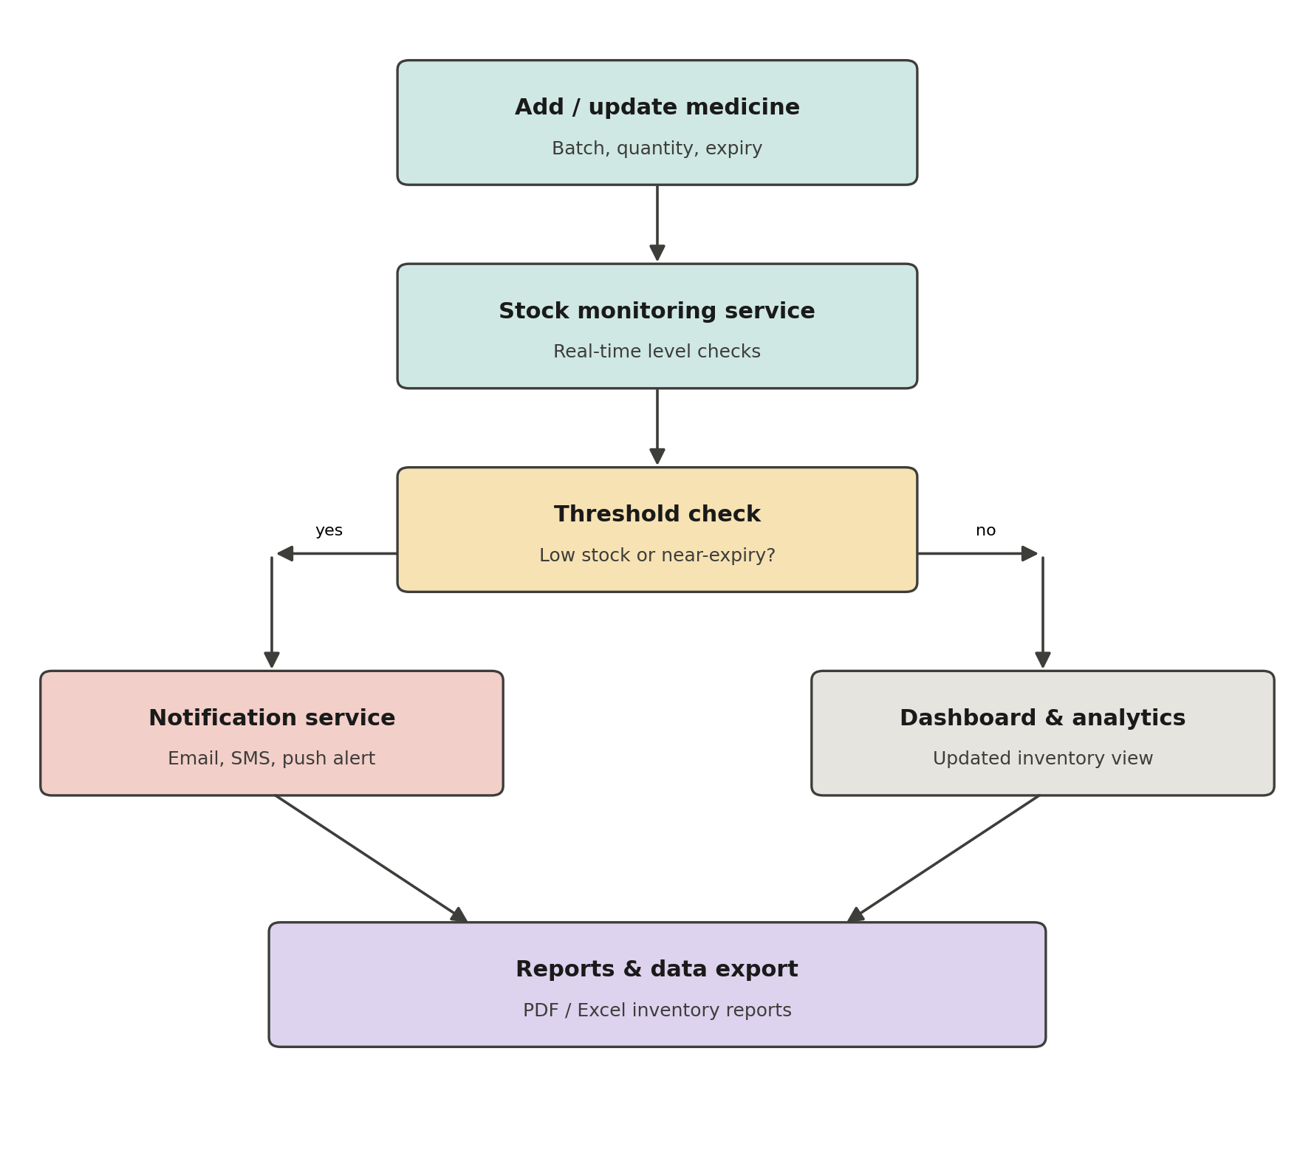
Figure 1: MediStock core inventory workflow

7. System Architecture Diagram
The architecture follows a layered design: a React client layer, an API gateway handling security and authentication, modular Spring Boot backend services, a relational data layer, and integrations with external services.
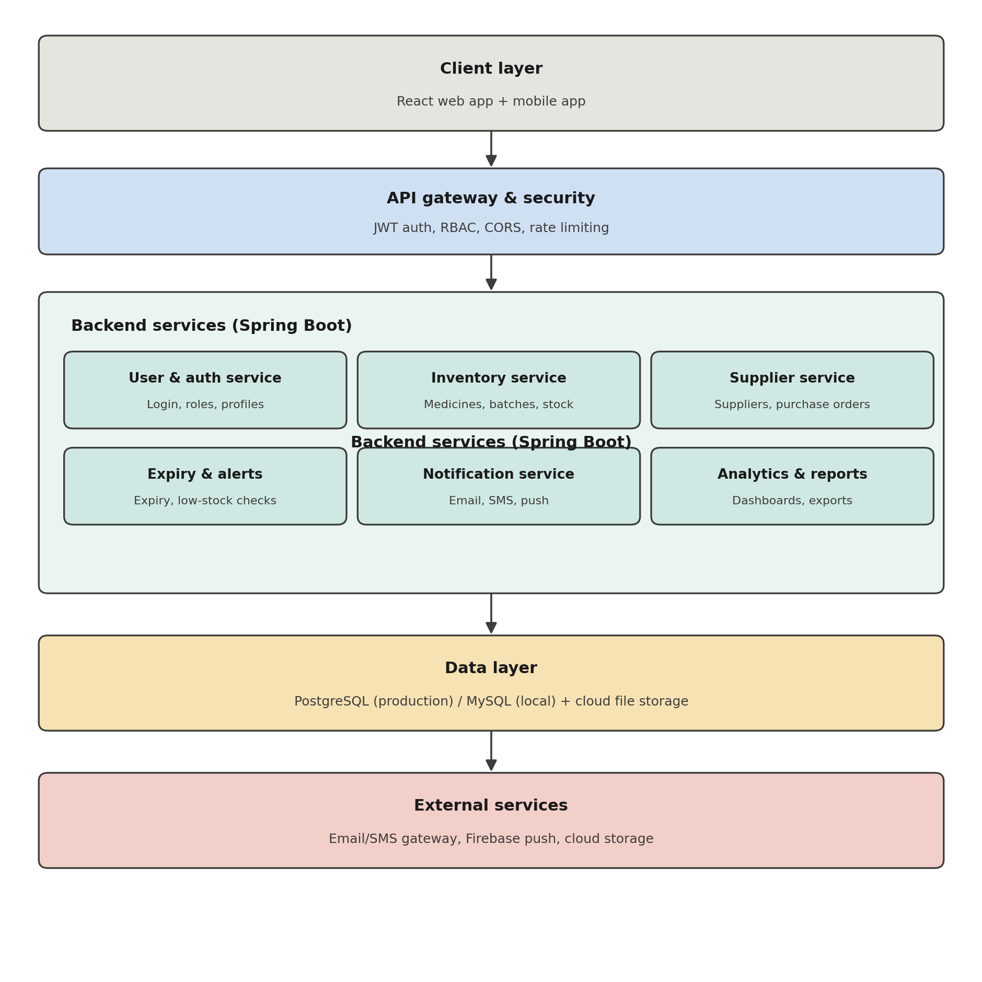
Figure 2: MediStock system architecture

8. Database Schema (ER Diagram)
The core data model centers on Medicines and Batches, linked to Suppliers, Categories, Purchase Orders, Stock Logs, and Notifications, with Users and Roles governing access.
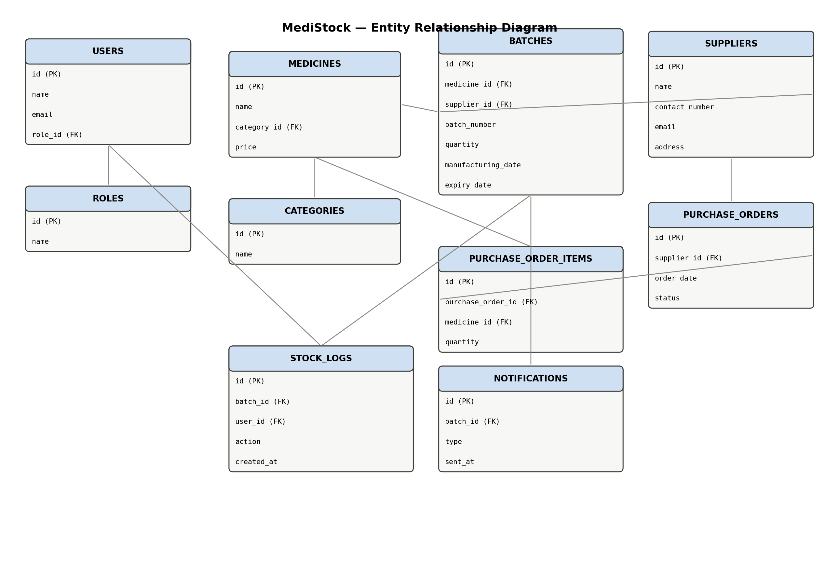
Figure 3: MediStock entity relationship diagram

9. UI Wireframes
The pharmacist dashboard wireframe below illustrates the primary landing screen: key inventory statistics, a live inventory table with stock/expiry status, and supplier performance insights.
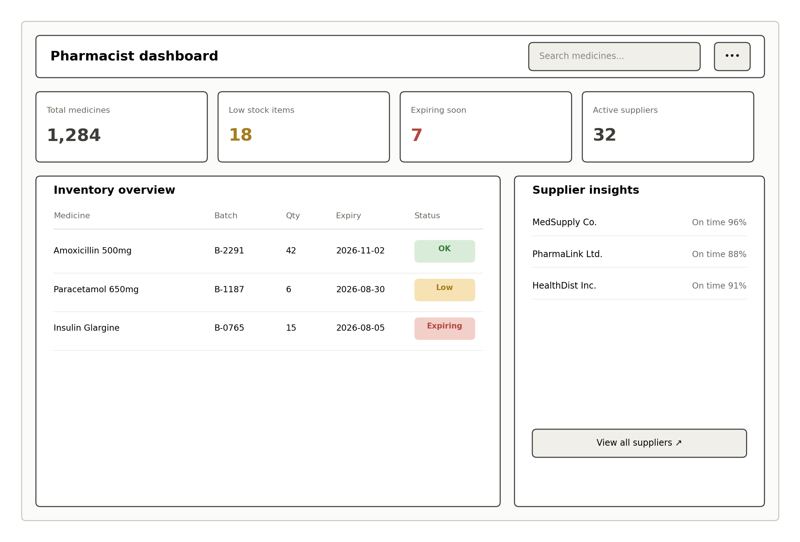
Figure 4: Pharmacist dashboard wireframe

