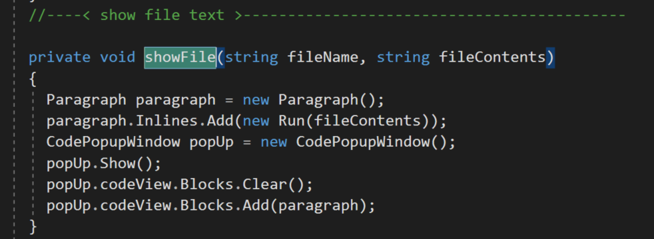

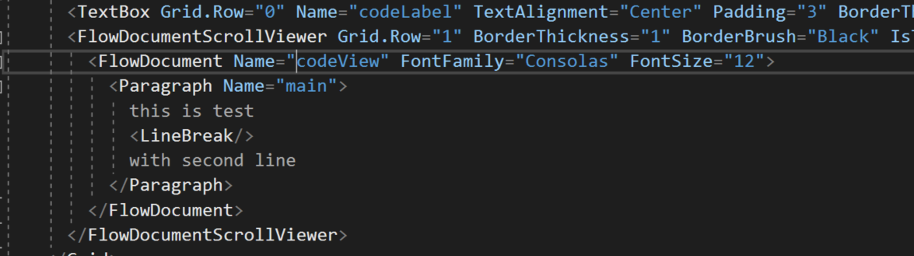

**Steps to show code in popup window:**

Comm provides SendFiles and SaveFiles folders on each end (for two different machines).

1. Add Window to GUI – named CodePopUpWindow perhaps
2. Add FileList mouse double-click event handler
   1. Build “sendFile” message including the selected item and relative path
   2. Post to server
3. Add ServerProc sendFile
   1. Extract name of file and relative path from request message
   2. Build reply message that has “file” attribute with filename value and path attribute
   3. Copy the specified file to the SendFiles folder
   4. Post to the client
      1. The “file” attribute causes Comm to send the file from SendFiles folder
4. Add ClientProc sendFile
   1. Extract filename from message
   2. Read file text as one string from file in SaveFiles folder
   3. Call show showFile(fileName, fileContents)