FFCSync: A Concurrent FCFS Course Registration Simulator Using IPC, Thread Pools and Ordered Synchronization
BCSE303L – Operating Systems: Project Report
Team Members with RegNos
[Student Name] – [Registration Number]
[Student Name] – [Registration Number]
[Student Name] – [Registration Number]
Submitted to
Prof. Geraldine Bessie Amali, SCOPE
School of Computer Science and Engineering

Contents
S.No | Topic | Page No
 | Abstract | 3
1 | Introduction | 4
2 | Problem Statement | 5
3 | Existing System / Approach / Method | 6
3.1 | Drawbacks / Limitations of the Existing Approach | 6
4 | Proposed / Developed Model | 7
4.1 | Design | 7
4.2 | Module Wise Description | 8
4.3 | Implementation | 9
5 | OS Concepts Used | 10
6 | Results and Discussion | 12
7 | Conclusion | 15
 | References | 16
 | Appendix: Sample Code | 17
Abstract
When an FFCS registration window opens, many students compete for the same limited seats at once. Without correct synchronization, two requests that both see "one seat left" can both succeed, and requests can be served in a different order from the one in which they arrived.
FFCSync is a C++20 simulation of FFCS registration on Linux. Client processes send requests to a server process over a Unix domain socket. The server gives every admitted request a sequence number, places it in a bounded FIFO queue and processes it with a pool of worker threads. A ticket-ordered commit gate lets requests change shared state strictly in arrival order, so no section is ever oversold.
Every concurrent run is checked against a single-threaded reference engine. All 38 test cases pass, ThreadSanitizer reports no data races, and every benchmark run was correct. The benchmark also shows that adding workers does not raise throughput, because commits are deliberately serialized.
Keywords: IPC, Unix domain sockets, threads, mutual exclusion, condition variables, bounded buffer, FCFS, deadlock prevention.

1. Introduction
VIT's Fully Flexible Credit System (FFCS) lets students choose their courses, faculty and time slots. Registration happens in scheduled windows, and popular sections fill within moments. Each seat is a shared resource and each request is an independent actor competing for it. This is the same problem an operating system faces when processes compete for a shared resource.
FFCSync rebuilds this situation as a small teaching simulation. Its objectives are:
- keep the server as the only owner of registration state, reachable by clients only through IPC;
- process requests with a bounded queue and a worker-thread pool built from standard primitives;
- define first-come-first-served (FCFS) precisely and enforce it under concurrency;
- prove correctness against a sequential reference engine and measure performance honestly.

2. Problem Statement
Given a catalog of students, courses and sections, and ADD/DROP requests arriving concurrently from several client processes, build a registration server that never oversells a section, enforces every registration rule (prerequisites, timetable clashes, credit and bucket limits, and so on), and returns results consistent with a defined FCFS order. The main difficulties are:
- Race conditions: "check for a free seat" and "take the seat" are two steps that another thread can interleave.
- Ordering: a mutex guarantees exclusion, but not which waiting thread enters next.
- IPC: a stream socket has no message boundaries, so messages must be framed.
- Resources and shutdown: the server must not buffer without limit, and must stop without losing admitted requests.

3. Existing System / Approach / Method
In FFCS, students log in to a web portal during their slot, choose a course, faculty and slot, and submit; a seat is allotted while seats remain. Its internal design is not public, so this section considers the general approaches used to build such seat-allocation services:
- Unsynchronized check-then-act: request handlers read and update the seat count in parallel.
- One global lock: a single mutex protects every check-and-update.
- Database transactions: row locks or optimistic concurrency, with retries on conflict.

3.1 Drawbacks / Limitations of the Existing Approach
- The unsynchronized approach oversells: two handlers can both see one free seat and both register.
- A global lock is safe but not FCFS. The OS decides which blocked thread gets the lock, so a later request can take the last seat from an earlier one.
- With optimistic transactions, whichever commits first wins, and repeatedly aborted requests can starve.
- None of these defines what the correct concurrent outcome is, so ordering errors are hard to test for.

4. Proposed / Developed Model
FFCSync has three programs: ffcsync_server (owns all state), ffcsync_client (sends requests) and ffcsync_seq (the single-threaded reference engine).

4.1 Design
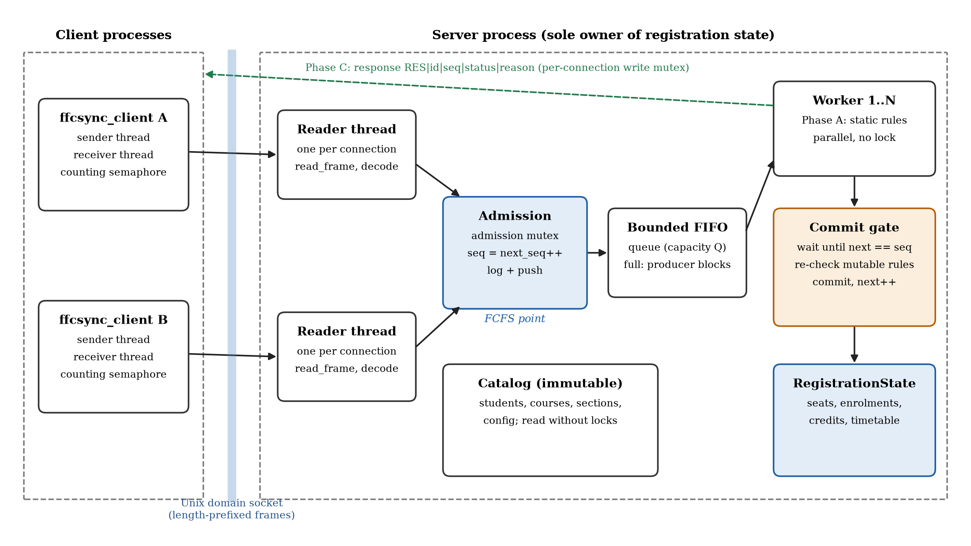
Figure 1: FFCSync architecture
Each client connection gets a reader thread in the server. The reader admits a request by giving it the next sequence number and pushing it onto a bounded FIFO queue; when the queue is full, the reader blocks. Worker threads then process each request in three phases:
- Phase A (parallel): check the rules that use only unchanging data: window open, student and section exist, prerequisites met.
- Phase B (one at a time, in sequence order): in the commit gate, re-check seats, duplicates, clashes, credits and buckets against the current state, then commit.
- Phase C (parallel): send the response to the client.
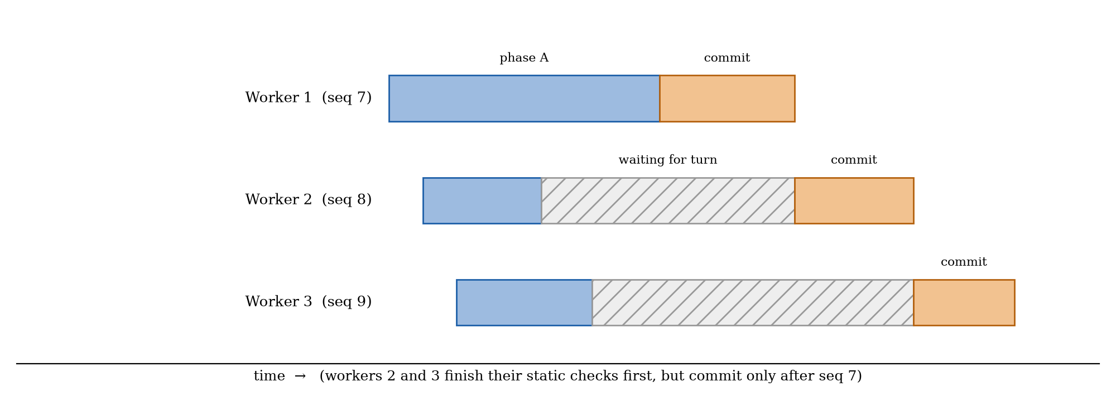
Figure 2: Workers may finish phase A out of order, but commit in sequence order
FCFS rule: requests are ordered by the sequence number given at admission, and commits happen in that order. The final state therefore always equals what the single-threaded engine produces when it replays the server's admission order. Checking seats again inside the gate avoids acting on stale information.
The registration rules are checked in a fixed order, and the first rule that fails is reported:
Table 1: Rejection reasons, in evaluation order
Checked in parallel (unchanging data) | Checked inside the commit gate (current state)
WINDOW_CLOSED, UNKNOWN_STUDENT, UNKNOWN_SECTION, PREREQ_NOT_MET | ALREADY_REGISTERED, COURSE_ALREADY_TAKEN, SECTION_FULL, TIMETABLE_CLASH, CREDIT_LIMIT, BUCKET_LIMIT, NOT_REGISTERED (for DROP)

4.2 Module Wise Description
Table 2: Modules of FFCSync
Module | Responsibility
Data model and loader | Students, courses, sections and registration state; reads the CSV data files.
Rules engine | Static and state-dependent rule checks, and the commit step shared by both engines.
Sequential engine | Processes requests one at a time; serves as the reference for correctness.
Invariant checker | Verifies capacity, credit totals, bucket limits and timetables after every run.
Bounded queue | Blocking FIFO between reader threads (producers) and workers (consumers).
Commit gate | Lets one request at a time commit, strictly in sequence order.
Concurrent engine | Admission point, worker pool and orderly shutdown.
IPC and server | Socket setup, message framing, reader threads and signal handling.
Client | Sends single requests or whole workload files and records latency.

4.3 Implementation
FFCSync is written in C++20 and built with CMake and g++ on Linux (WSL2). It uses only standard primitives: std::thread, std::mutex, std::condition_variable and std::counting_semaphore. The example dataset has 20 students, 10 courses and 12 VIT-style sections; two sections have a single seat to create contention. Credits are stored in tenths (4.0 credits = 40) so that limit checks are exact.
Each message is a 4-byte length followed by the text payload, for example:
REQ|R07|ADD|S002|CSE2005-B1 (client -> server)
RES|R07|7|ACCEPTED|OK|38 (server -> client)

Testing uses the doctest framework and CTest. Instead of hard-coding the winners of races, each concurrent run's admission order is replayed through the sequential engine, and both must produce identical results and final state.

5. OS Concepts Used
Table 3: OS concepts and where they appear
OS concept | Where it is used in FFCSync
Processes and protection | Server and clients are separate processes; only the server owns state
System calls | socket, bind, listen, accept4, connect, read, send, poll, pipe2, sigaction, unlink
Threads | Reader, worker and accept threads in the server; sender and receiver in the client
IPC in Unix | Unix domain stream socket with length-prefixed messages
Mutual exclusion | Mutexes protect the admission counter, queue, registration state and socket writes
Producer–consumer (bounded buffer) | Request queue between reader threads and worker threads
Monitors / condition variables | Waiting in the queue and commit gate without busy-waiting
Bakery-style ticket ordering | Sequence number = ticket; the commit gate serves tickets in order
Semaphores | Client limits how many requests are in flight
FCFS scheduling | Commits are served non-preemptively in arrival order
Deadlock prevention | Fixed lock order removes circular wait
Signals | SIGINT/SIGTERM trigger a graceful shutdown

5.1 Synchronization and the Bounded Buffer
The request queue is the classical bounded-buffer problem: reader threads produce requests and worker threads consume them. A mutex protects the queue, and two condition variables (not_full, not_empty) put threads to sleep instead of busy-waiting. A full queue blocks the producer, which slows the client down instead of letting memory grow without limit.

5.2 Ticket Ordering for FCFS
A mutex alone does not decide which waiting thread enters next, so it cannot guarantee FCFS. The commit gate borrows the idea of the Bakery algorithm: the sequence number is a ticket, and the gate's next counter is "now serving". A worker waits on a condition variable until its ticket is called, commits, and then calls the next ticket.

5.3 Deadlock Prevention
Locks are only ever nested in one fixed order (admission lock, then queue lock), so circular wait cannot occur. Workers take requests from a FIFO queue in ticket order, so the lowest outstanding ticket can always proceed.

5.4 IPC and Signals
Clients and server communicate through a Unix domain stream socket. A stream has no message boundaries, so each message carries a length prefix, and reads loop until a complete message has arrived. The SIGTERM handler only writes one byte to a pipe; the main loop notices it and shuts down safely.

6. Results and Discussion

6.1 Correctness
Table 4: Test results (38 test cases, all passing)
Test | Result
Every registration rule (unit tests) | Pass
Hand-checked expected-output workloads | Pass
IPC: partial messages, malformed messages, client disconnects | Pass
8 threads racing for one seat, 100 runs per worker count | Exactly one winner, always the first ticket
Randomized concurrent runs compared with the reference engine | Identical in all runs
Real server with 3 client processes (1,800 requests) | Identical to reference
ThreadSanitizer | No data races

Table 5 shows a hand-checked workload in which each request triggers a different rule. The server produces exactly this output.
Table 5: Results of the hand-checked workload
Seq | Op | Student | Section | Status | Reason
1 | ADD | S001 | CSE2005-A1 | ACCEPTED | OK
2 | ADD | S003 | CSE2005-A1 | REJECTED | PREREQ_NOT_MET
3 | ADD | S999 | CSE2005-A1 | REJECTED | UNKNOWN_STUDENT
4 | ADD | S001 | CSE9999-Z9 | REJECTED | UNKNOWN_SECTION
5 | ADD | S001 | CSE2005-A1 | REJECTED | ALREADY_REGISTERED
6 | ADD | S001 | CSE2005-B1 | REJECTED | COURSE_ALREADY_TAKEN
7 | ADD | S002 | CSE2005-B1 | ACCEPTED | OK
8 | ADD | S006 | CSE2005-B1 | REJECTED | SECTION_FULL
9 | ADD | S004 | CSE2005-A1 | ACCEPTED | OK
10 | ADD | S004 | CSE3002-A1 | REJECTED | TIMETABLE_CLASH
11 | ADD | S005 | HUM1021-A2 | ACCEPTED | OK
12 | ADD | S005 | MAT2001-G1 | ACCEPTED | OK
13 | ADD | S005 | ENG1011-B2 | REJECTED | BUCKET_LIMIT
14 | DROP | S006 | CSE2005-B1 | REJECTED | NOT_REGISTERED
15 | DROP | S002 | CSE2005-B1 | ACCEPTED | OK
16 | ADD | S006 | CSE2005-B1 | ACCEPTED | OK

Figure 3 shows the demonstration in which two separate client processes race for the last seat of CSE2005-B1. The request admitted first (sequence 3) gets the seat; the other is rejected with SECTION_FULL.
== 3. two client processes race for the LAST seat of CSE2005-B1 (capacity 1) ==
client A| A01 seq=4 REJECTED SECTION_FULL
client B| B01 seq=3 ACCEPTED OK
server| [admit ] seq=3 id=B01 queue=0/4
server| [worker 1] seq=3 ACCEPTED OK
server| [admit ] seq=4 id=A01 queue=0/4
server| [worker 2] seq=4 REJECTED SECTION_FULL

Figure 3: Two client processes racing for the last seat

6.2 Performance
Workloads of 1,000 and 10,000 requests were sent by four client processes, with three runs each, on an AMD Ryzen 5 4500U laptop under WSL2. Every run was checked against the reference engine before its numbers were kept.
Table 6: Results for 10,000 requests (median of three runs)
Configuration | Throughput (req/s) | p95 latency (µs) | Correct
Sequential server | 154,414 | 3,197 | yes
1 worker | 149,978 | 3,269 | yes
2 workers | 122,729 | 3,839 | yes
4 workers | 59,266 | 8,246 | yes

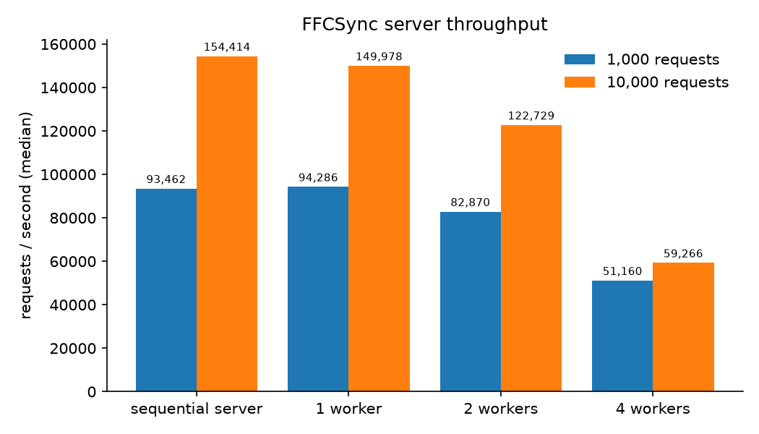
Figure 4: Median server throughput
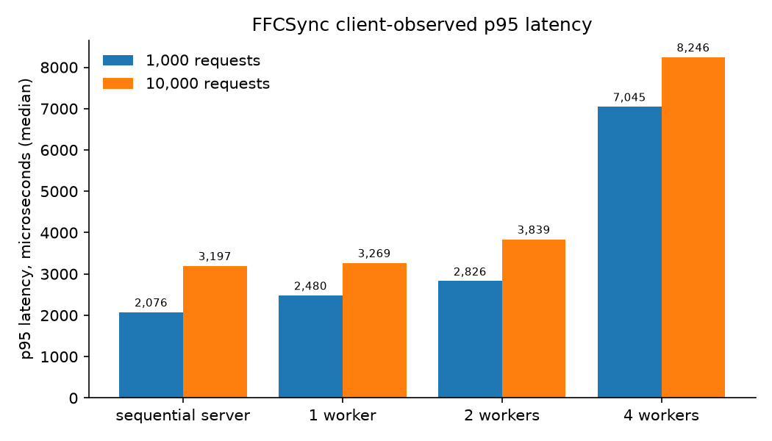
Figure 5: Median p95 latency seen by clients
All runs were correct, but more workers made the server slower. Checking the rules takes under a microsecond, so there is little parallel work, while commits are serialized by design. Extra workers only wait at the gate, which is the convoy effect of FCFS service. The server's cost is dominated by IPC and thread hand-offs, not by the rules themselves.

7. Conclusion
FFCSync shows how process isolation, IPC, a bounded producer–consumer queue, a worker pool and ticket-ordered synchronization keep a high-contention registration system correct. No section was ever oversold, and every concurrent result matched the reference engine. The measured price of strict FCFS ordering is that extra worker threads do not improve throughput.

Limitations
- State is kept in memory only, and communication is local to one machine.
- The FFCS rules are simplified (no waitlists, slot clashes by name only).
- Commits are fully serialized, so more workers do not add speed.

Possible Enhancements
- Order only conflicting requests (same student or section) so independent ones commit in parallel.
- Add a write-ahead log so state survives a crash.
- Support waitlists and priority policies, such as by year of study.
- Move to a network transport with authentication for multi-machine use.

References
[1] A. Silberschatz, P. B. Galvin and G. Gagne, Operating System Concepts, 10th ed. Wiley, 2018.
[2] A. S. Tanenbaum and H. Bos, Modern Operating Systems, 4th ed. Pearson, 2016.
[3] W. Stallings, Operating Systems: Internals and Design Principles, 9th ed. Pearson, 2018.
[4] M. Kerrisk, The Linux Programming Interface. No Starch Press, 2010.
[5] A. Williams, C++ Concurrency in Action, 2nd ed. Manning, 2019.
[6] L. Lamport, "A new solution of Dijkstra's concurrent programming problem," Communications of the ACM, vol. 17, no. 8, pp. 453–455, 1974.
[7] Linux man-pages project, unix(7), socket(2), poll(2), sigaction(2). [Online]. Available: https://man7.org/linux/man-pages/
[8] cppreference.com, "Concurrency support library." [Online]. Available: https://en.cppreference.com/w/cpp/thread

Appendix: Sample Code

A.1 Ordered commit gate
class CommitGate {
public:
template <typename F>
auto run_in_order(std::uint64_t seq, F&& f) {
std::unique_lock lock(mu_);
turn_.wait(lock, [&] { return next_ == seq; });
// On scope exit (normal return or exception): advance the turn,
// release the mutex and wake the waiters so the next seq can go.
struct PassTurn {
CommitGate& gate;
std::unique_lock<std::mutex>& lock;
~PassTurn() {
++gate.next_;
lock.unlock();
gate.turn_.notify_all();
}
} pass{*this, lock};
return f();
}

A.2 Bounded FIFO queue (push and pop)
// Blocks while full. Returns false (and drops the item) if the queue is closed.
bool push(T item) {
std::unique_lock lock(mu_);
not_full_.wait(lock, [&] { return closed_ || items_.size() < capacity_; });
if (closed_) return false;
items_.push_back(std::move(item));
if (items_.size() > high_water_) high_water_ = items_.size();
lock.unlock();
not_empty_.notify_one();
return true;
}
// Blocks while empty. Returns nullopt once the queue is closed and drained.
std::optional<T> pop() {
std::unique_lock lock(mu_);
not_empty_.wait(lock, [&] { return closed_ || !items_.empty(); });
if (items_.empty()) return std::nullopt;
T item = std::move(items_.front());
items_.pop_front();
lock.unlock();
not_full_.notify_one();
return item;
}

A.3 Admission point
std::uint64_t ConcurrentEngine::submit(const RegistrationRequest& req, Completion on_done) {
std::unique_lock lock(admission_mu_);
if (closed_) return 0;
const std::uint64_t seq = next_seq_++;
admissions_.push_back(RegistrationResult{seq, req, Status::Rejected, Reason::Ok});
if (options_.workers == 0) {
// Sequential server mode: process right here, still holding admission_mu_.
const auto t0 = Clock::now();
RegistrationResult result = commit(seq, req, check_static(catalog_, req));
const auto us = micros_since(t0);
lock.unlock();
if (on_done) on_done(result, us);
return seq;
}
// Pushing while holding admission_mu_ keeps queue order identical to seq
// order. If the queue is full this blocks the producer (back-pressure);
// workers only need the queue's own mutex, so they keep draining.
if (options_.verbose) {
log("[admit ] seq=" + std::to_string(seq) + " id=" + req.request_id +
" queue=" + std::to_string(queue_.size()) + "/" + std::to_string(queue_.capacity()));
}
queue_.push(Job{seq, req, std::move(on_done)});
return seq;
}

A.4 Worker loop
void ConcurrentEngine::worker_loop(int worker_id) {
while (auto job = queue_.pop()) {
const auto t0 = Clock::now();
// Phase A (parallel, no lock): rules that only read the immutable catalog.
const Reason static_verdict = check_static(catalog_, job->request);
// Phase B (serialised, in seq order): re-check mutable facts and commit.
RegistrationResult result = gate_.run_in_order(
job->seq, [&] { return commit(job->seq, job->request, static_verdict); });
const auto us = micros_since(t0);
if (options_.verbose) {
log("[worker " + std::to_string(worker_id) + "] seq=" + std::to_string(job->seq) +
" " + std::string(to_string(result.status)) + " " +
std::string(to_string(result.reason)));
}
// Phase C (parallel): deliver the result, outside every lock.
if (job->on_done) job->on_done(result, us);
}
}

