**Weekly Report**

**Summer Internship Corporate–B.Tech. I.T.**

**School of Engineering & Technology**

**Navrachana University**

**--------------------------------------------------------------------------------------------------------**

**BASIC DETAILS**

**Student Name:** Darpan Ashwin Patel

**Student ID:** 18103610

**Duration (Date From – To):** 17/05/2021 – 21/05/2021

**Week No:** 1

**Date of report submission:** 24/05/2021

**Name of Faculty Supervisor (NUV):** Ms. Priya Vadgama

**Name of Internship Mentor:** Jay Sir

**Organization Name:** Global Enterprise/Appeal Guru

---------------------------------------------------------------------------------------------------------

**ACTIVITY REPORT:**

|  |  |  |
| --- | --- | --- |
| **Date** | **Brief Description of activities** | **Outcome** |
| 17/05/2021 | Introduction conducted by Jay Sir. | We were introduced about the company and their work. We were given brief details about the Employee Client Communication System which we need to develop in our internship. |
| 18/05/2021 – 20/05/2021 | Developing of SRS which includes Requirement Gathering, Features and wireframes. | We had a meeting on Google meet with Jay sir and Rahil sir where we gathered the requirement of the system and suggested some features according to the requirement.  After requirement gathering we started working on SRS and Wireframes.  After completing the SRS we have shared it with our mentor.  There was no suggestion in SRS and all the wireframes were right and were told to start developing the system from tomorrow. |
| 21/05/2021 – 22/05/2021 | System Backend scripting | I have started preparing backend scripts for data entry for employee in database and I have also prepared a code for sending the user credentials through mail while adding the employee. |

**ADDITIONAL INFORMATION:**

**Link for SRS:** [**https://drive.google.com/file/d/1Ob8eMLNnGYL7SpBAqnlQVh2bsk97GjLT/view?usp=sharing**](https://drive.google.com/file/d/1Ob8eMLNnGYL7SpBAqnlQVh2bsk97GjLT/view?usp=sharing)

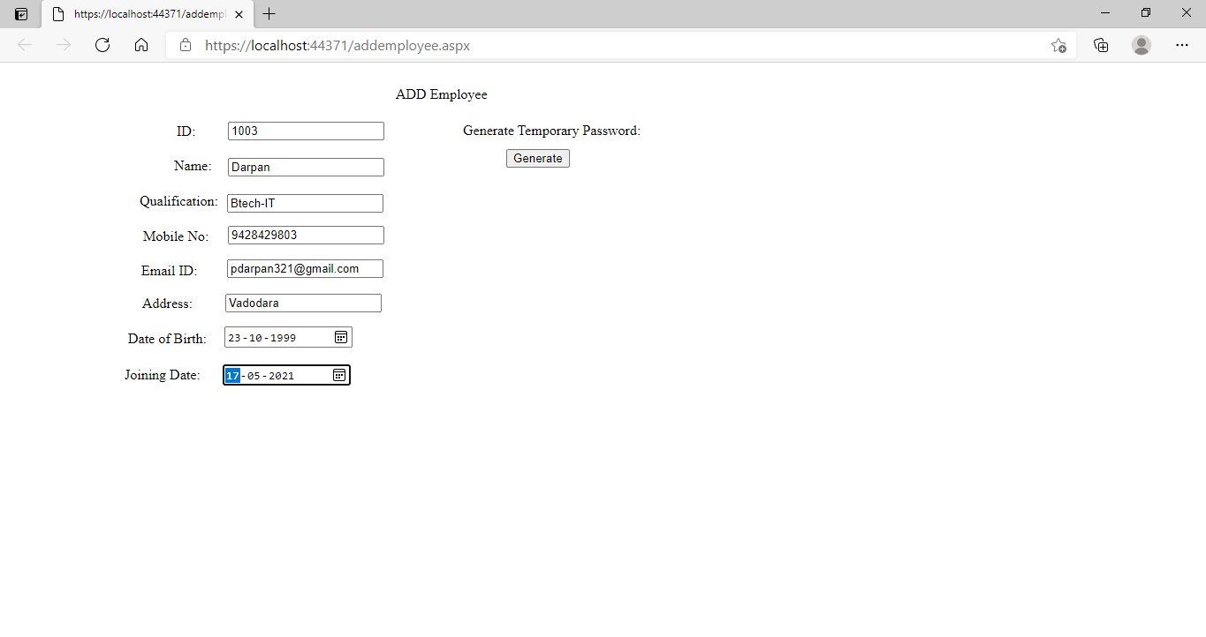

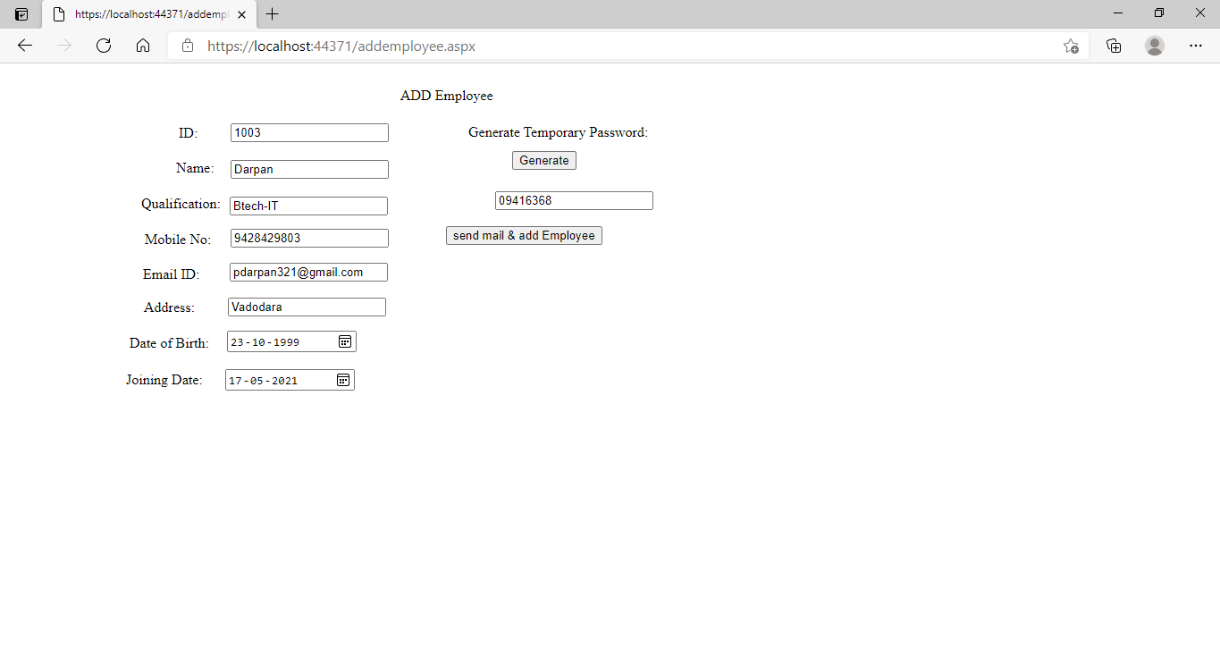

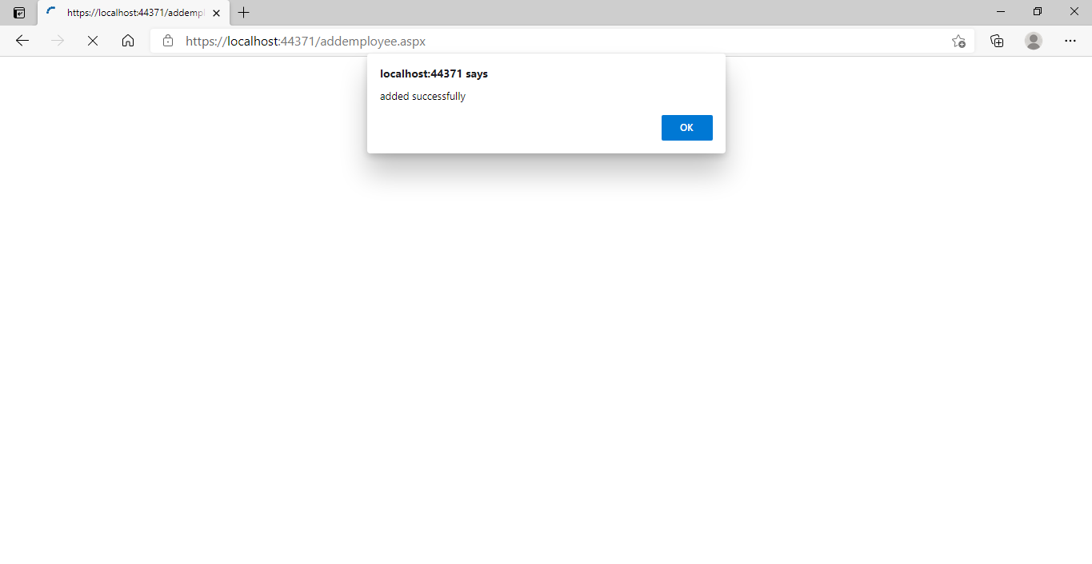

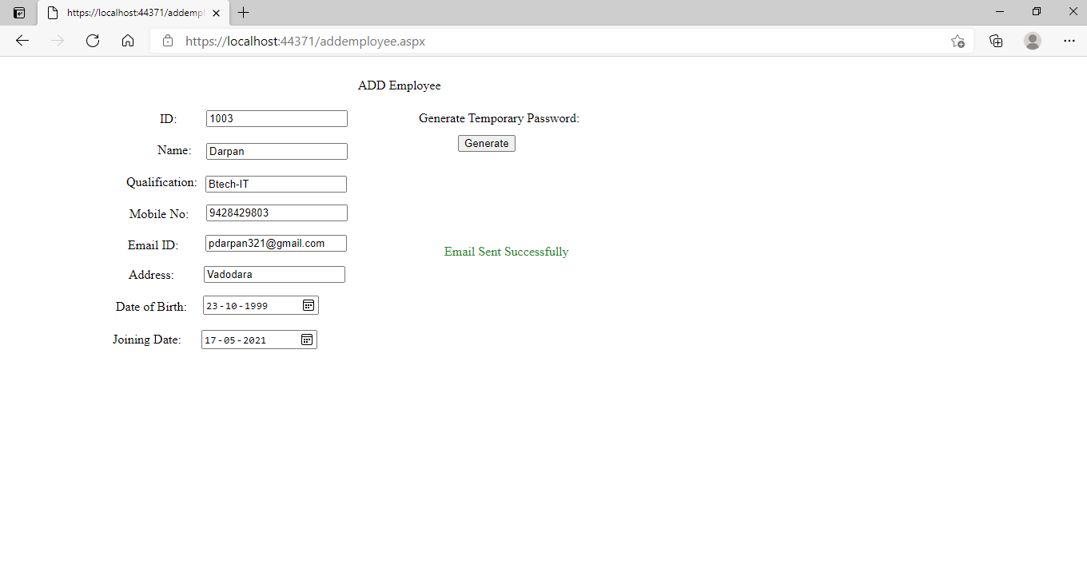

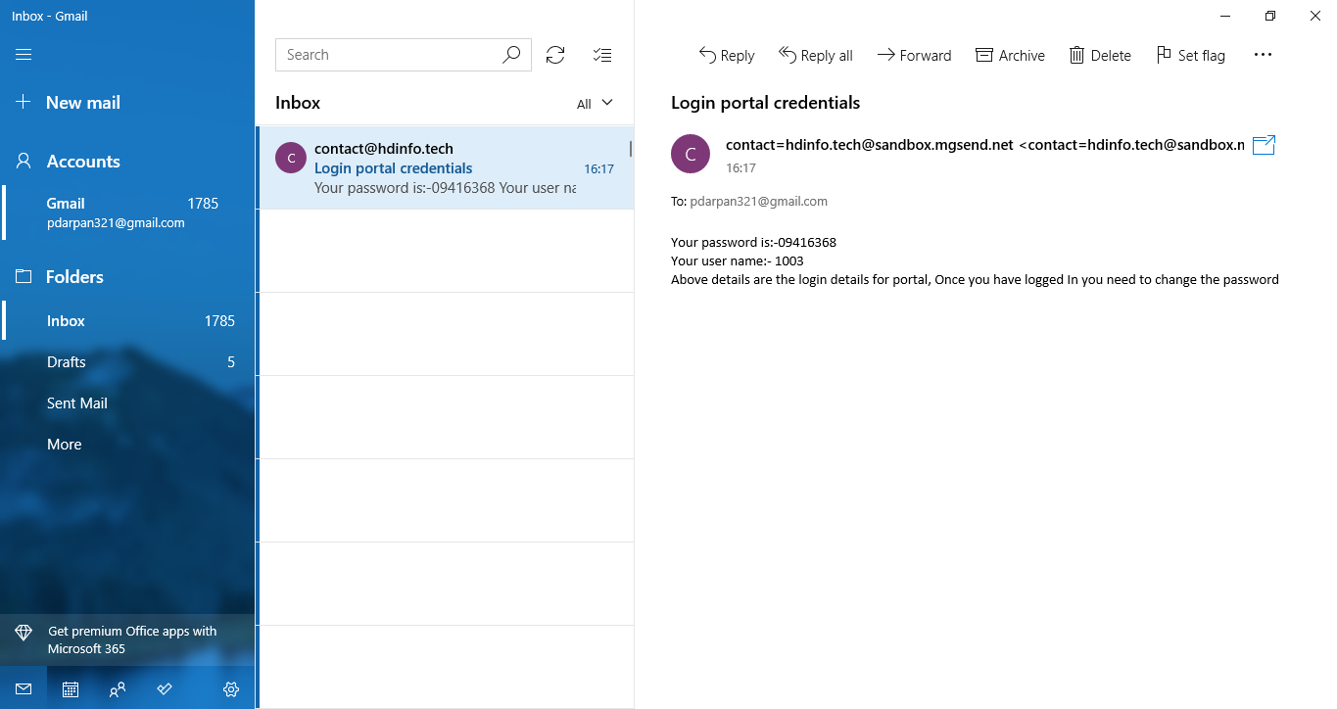

**-------------------------------------End of Report -----------------------------------------------**