**Weekly Report**

**Summer Internship Corporate–B.Tech. I.T.**

**School of Engineering & Technology**

**Navrachana University**

**--------------------------------------------------------------------------------------------------------**

**BASIC DETAILS**

**Student Name:** Darpan Ashwin Patel

**Student ID:** 18103610

**Duration (Date From – To):** 24/05/2021 – 29/05/2021

**Week No:** 2

**Date of report submission:** 01/06/2021

**Name of Faculty Supervisor (NUV):** Ms. Priya Vadgama

**Name of Internship Mentor:** Jay Sir

**Organization Name:** Global Enterprise/Appeal Guru

---------------------------------------------------------------------------------------------------------

**ACTIVITY REPORT:**

|  |  |  |
| --- | --- | --- |
| **Date** | **Brief Description of activities** | **Outcome** |
| 24/05/2021 | Preparing backhand scripts in asp.net C# for embedding into the system. | I have started preparing scripts in asp.net C# so that I can embed that scripts into the final design. |
| 25/05/2021 | Preparing backhand scripts in asp.net C# for embedding into the system. | I started with add employee page which was started in the last week as well but in this there are some dynamic features as well like selecting the team fetching the team no and all those things. |
| 26/05/2021 – 27/05/2021 | Preparing backhand scripts in asp.net C# for embedding into the system. | After the above part was completed, I started with login sessions in asp.net where I have created codes for storing different login, logout time of particular employee and apart from this once the employee logs in then he/she can view the last session time like how much time did last session consumed. |
| 28/05/2021 – 29/05/2021 | Preparing backhand scripts in asp.net C# for embedding into the system. | After that I have also created a code using zoom API where user needs to click on the create button and a zoom meeting would be created as there is a feature where employee or client can communicate through video call as well for certain possible scenarios and so I have created this feature so that they do not need to log into there zoom account to create a meeting. |

**ADDITIONAL INFORMATION:**

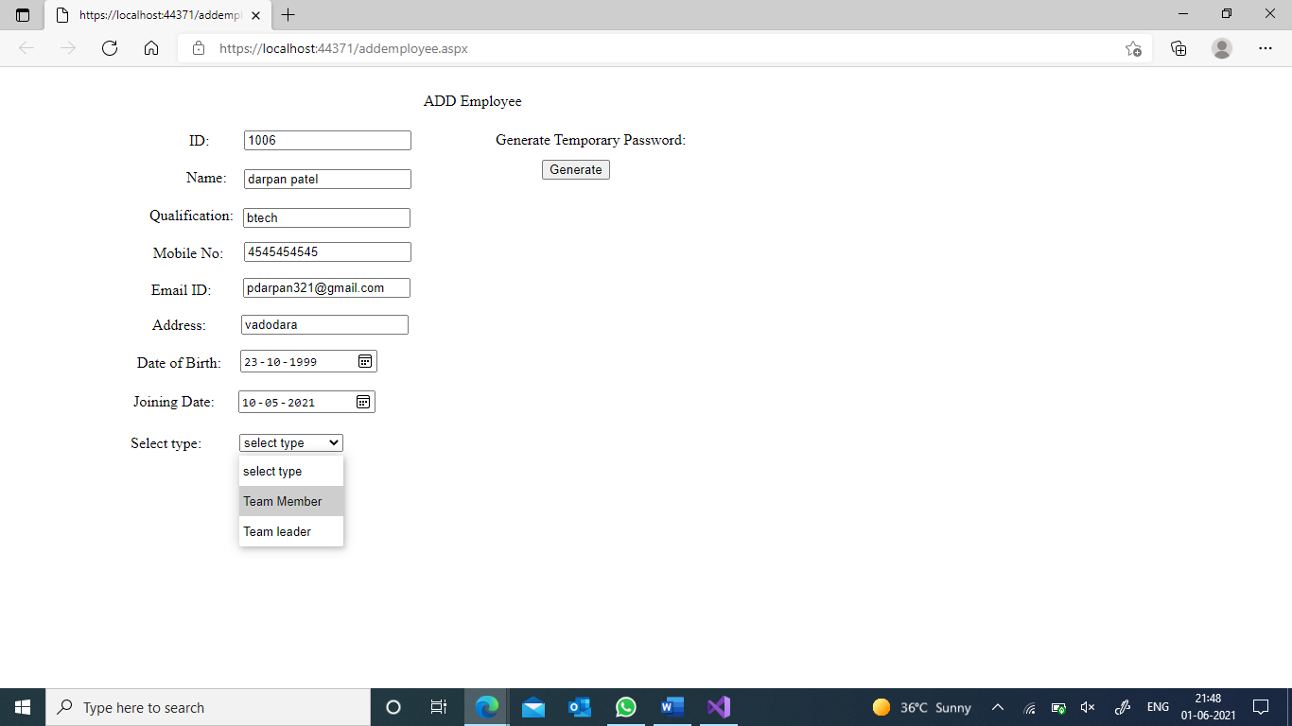

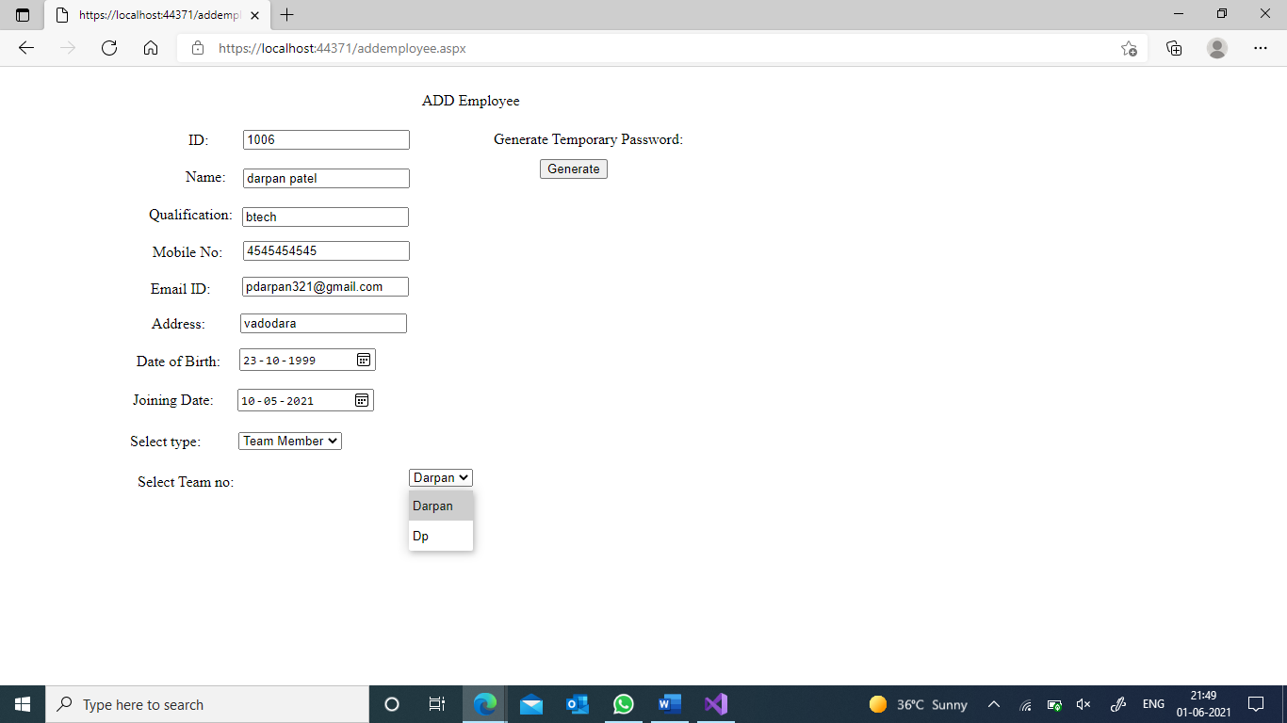

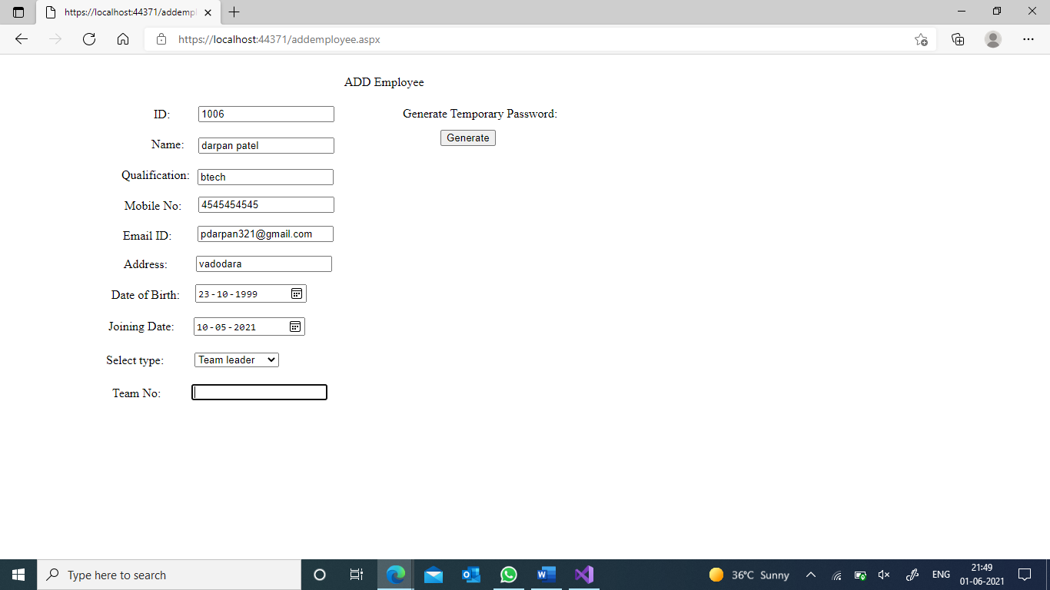

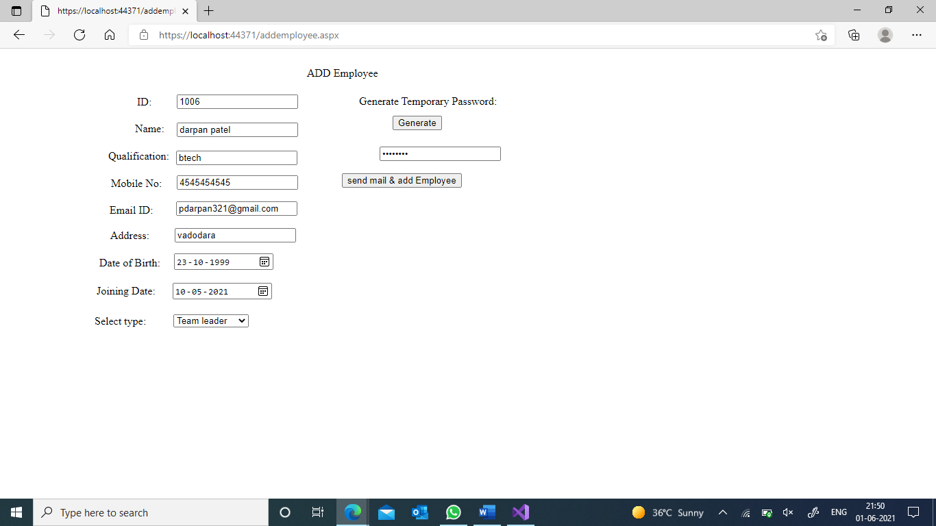

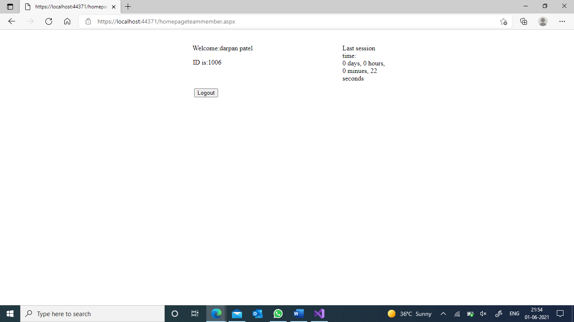

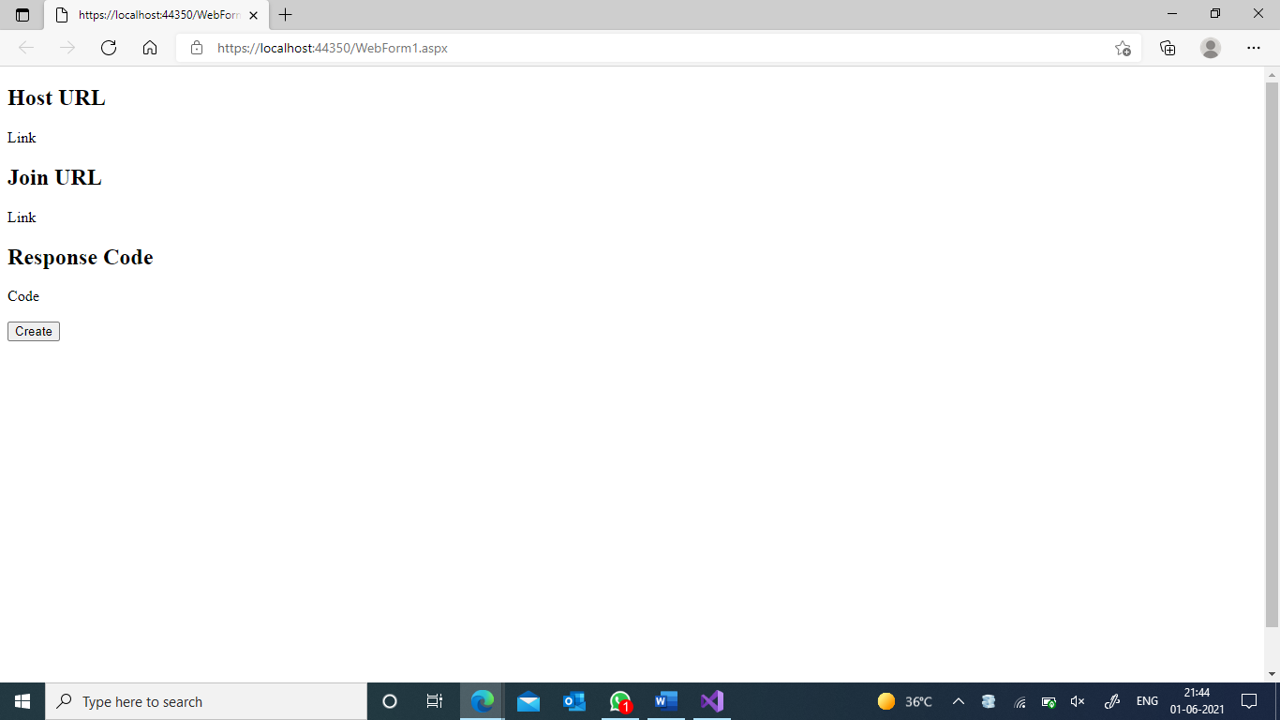 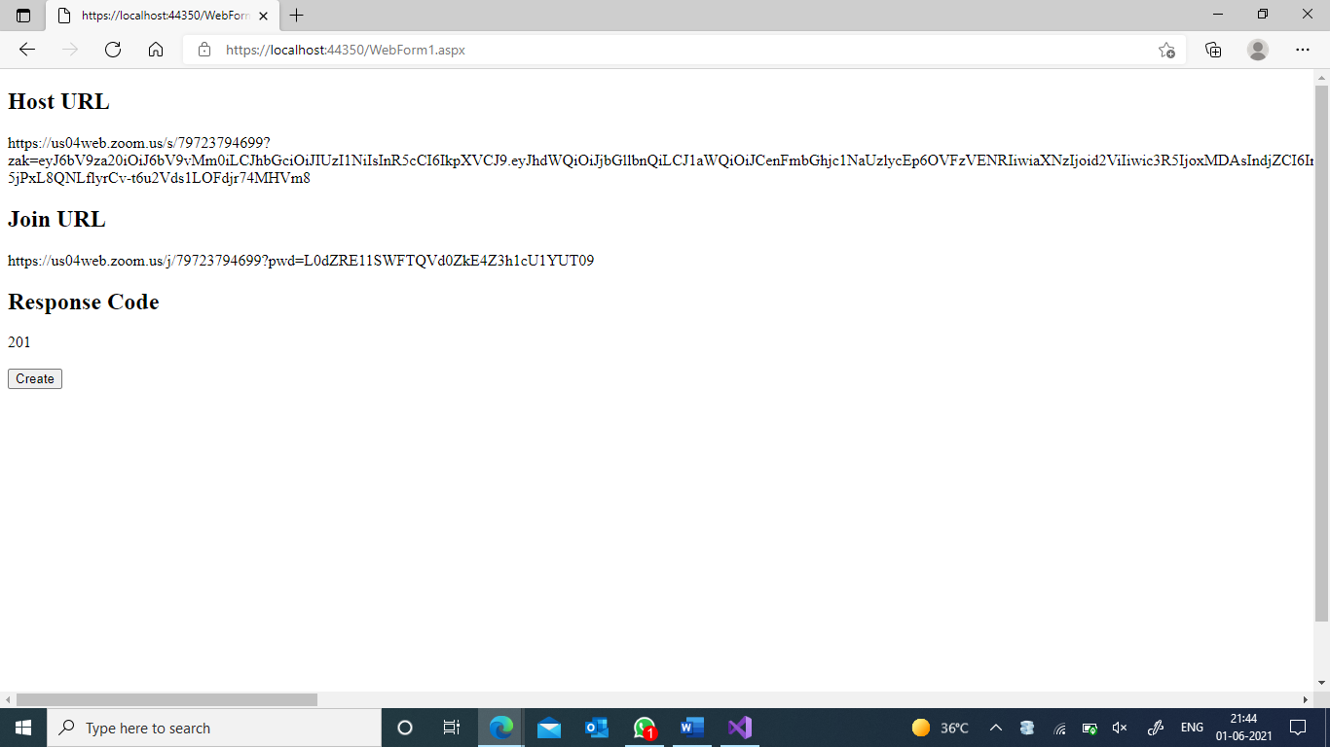

**-------------------------------------End of Report -----------------------------------------------**