**Weekly Report**

**Summer Internship Corporate–B.Tech. I.T.**

**School of Engineering & Technology**

**Navrachana University**

**--------------------------------------------------------------------------------------------------------**

**BASIC DETAILS**

**Student Name:** Darpan Ashwin Patel

**Student ID:** 18103610

**Duration (Date From – To):** 31/05/2021 – 05/06/2021

**Week No:** 3

**Date of report submission:** 08/06/2021

**Name of Faculty Supervisor (NUV):** Ms. Priya Vadgama

**Name of Internship Mentor:** Jay Sir

**Organization Name:** Global Enterprise/Appeal Guru

---------------------------------------------------------------------------------------------------------

**ACTIVITY REPORT:**

|  |  |  |
| --- | --- | --- |
| **Date** | **Brief Description of activities** | **Outcome** |
| 30/05/2021-01/06/2021 | Worked on zoom sdk | As earlier in the last week I added a creating meeting in the system so now I worked on this zoom sdk so that I can embed it within the system and I started with a short design of the page. |
| 02/06/2021– 03/06/2021 | 2 days rest | As I took the vaccination and due to that I was sick for 2 days and was not able to work for this 2 days. |
| 04/06/2021– 05/06/2021 | Continued zoom sdk | I have completed and created a short code used for joining into the meeting as this will help the user using system that they can create a meeting as well as join a meeting using that system only they do not need to login into the third party apps. |

**ADDITIONAL INFORMATION:**

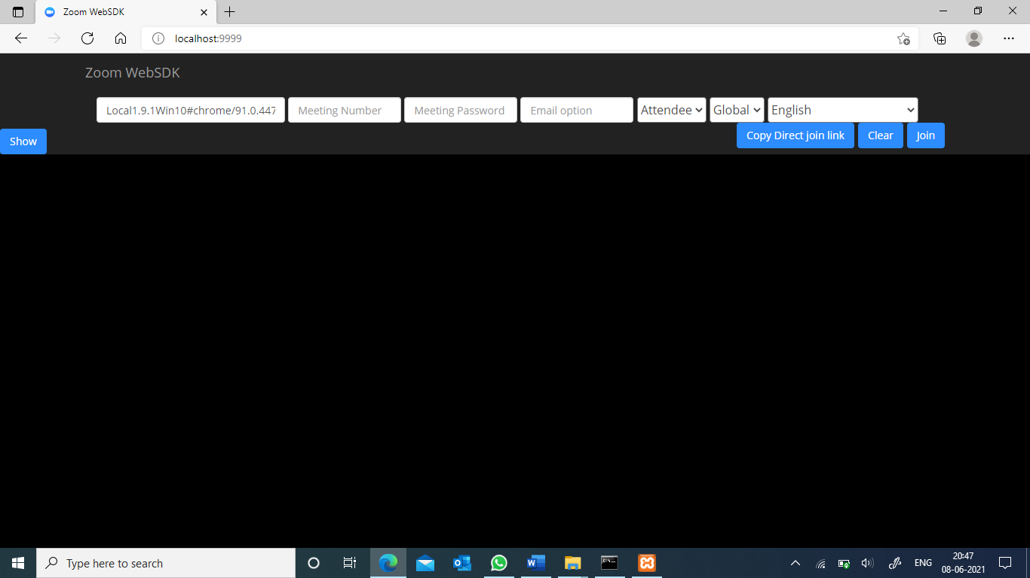

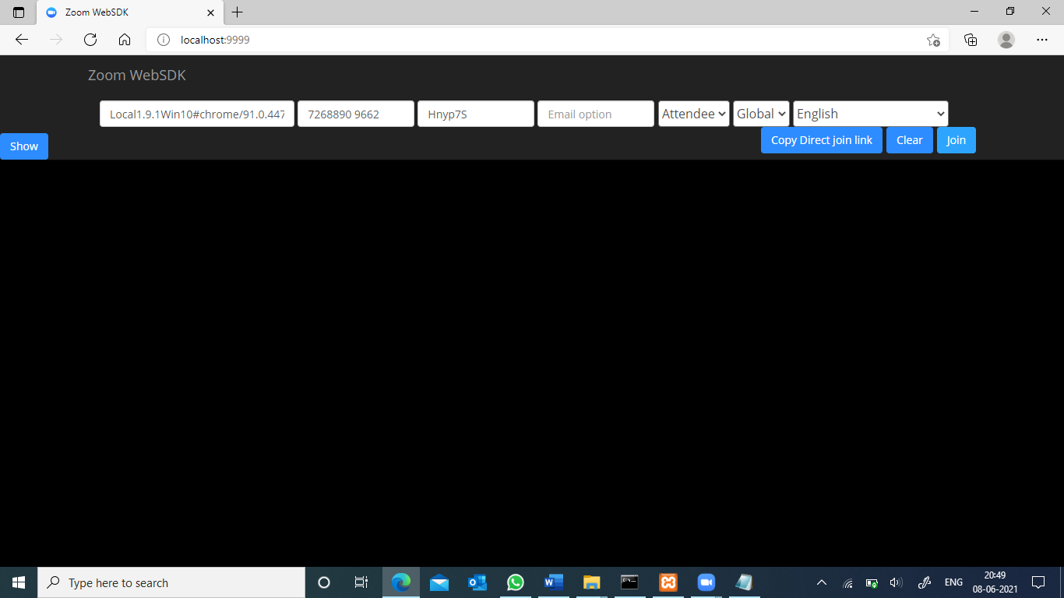

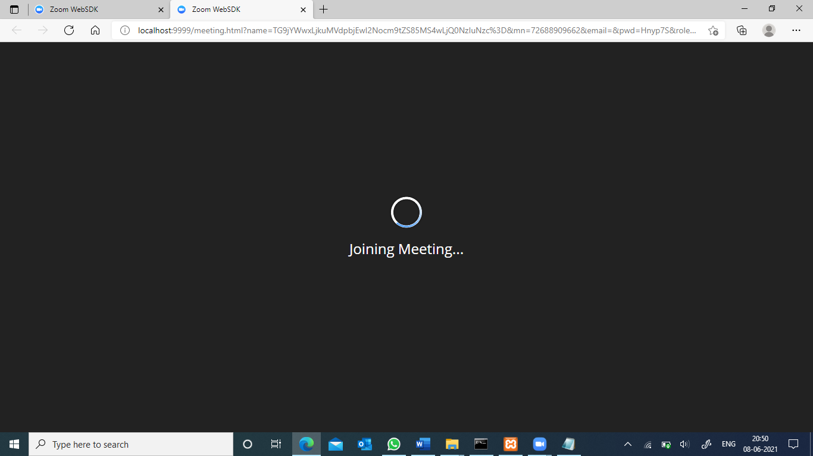

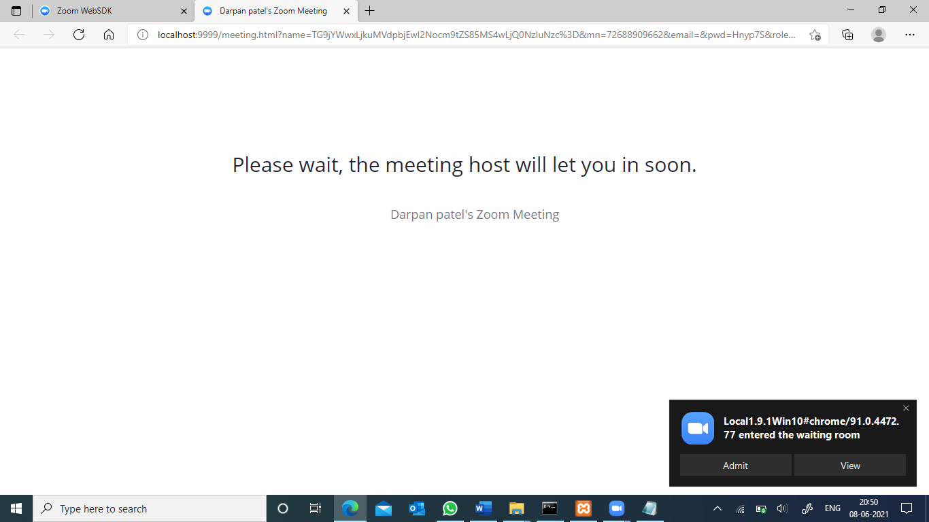

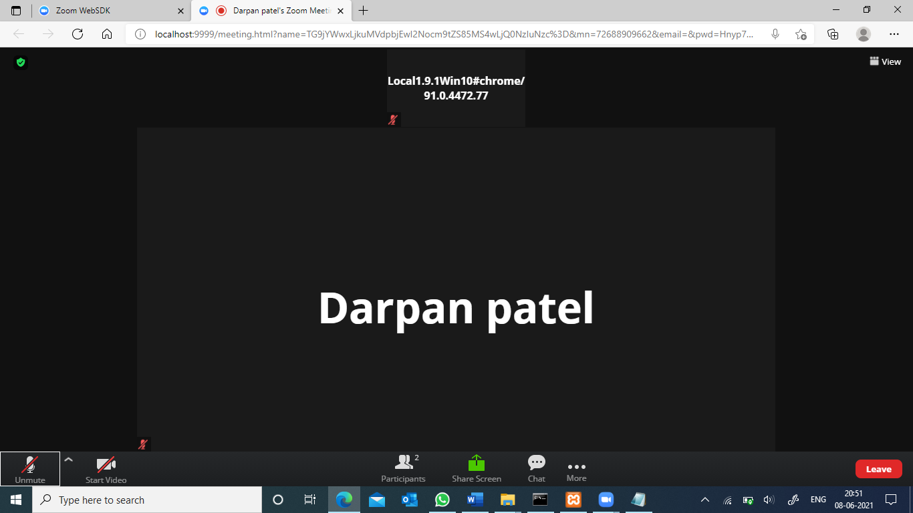

**-------------------------------------End of Report -----------------------------------------------**