**Weekly Report**

**Summer Internship Corporate–B.Tech. I.T.**

**School of Engineering & Technology**

**Navrachana University**

**--------------------------------------------------------------------------------------------------------**

**BASIC DETAILS**

**Student Name:** Darpan Ashwin Patel

**Student ID:** 18103610

**Duration (Date From – To):** 07/06/2021 – 12/06/2021

**Week No:** 4

**Date of report submission:** 15/06/2021

**Name of Faculty Supervisor (NUV):** Ms. Priya Vadgama

**Name of Internship Mentor:** Jay Sir

**Organization Name:** Global Enterprise/Appeal Guru

---------------------------------------------------------------------------------------------------------

**ACTIVITY REPORT:**

|  |  |  |
| --- | --- | --- |
| **Date** | **Brief Description of activities** | **Outcome** |
| 07/06/2021 | I have worked with zoom code and design as well as prepared code for chat transcript | I have embedded the zoom code which I created earlier into the design which harsh shared and I have also prepared a code for chat transcript which I further added to the design shared by harsh |
| 08/06/2021– 09/06/2021 | Learning and understanding SignalR in ASP.NET. | I have learned and understand about SignalR which is an open-source software library for Microsoft ASP.NET which allows server code to send asynchronous notification to client side web application and can be used for developing Real Time chat application. |
| 10/06/2021– 11/06/2021 | Preparing backend code for group chat. | I and harsh have worked together for preparing code for group chat application where multiple users can join and chat with each other. We had successfully completed the group chat and its working good in desktop. |
| 12/06/2021 | Preparing backend code for private chat. | I and harsh had worked together for preparing code for private chat application where one to one communication can be done. We are still working on it. |

**ADDITIONAL INFORMATION:**

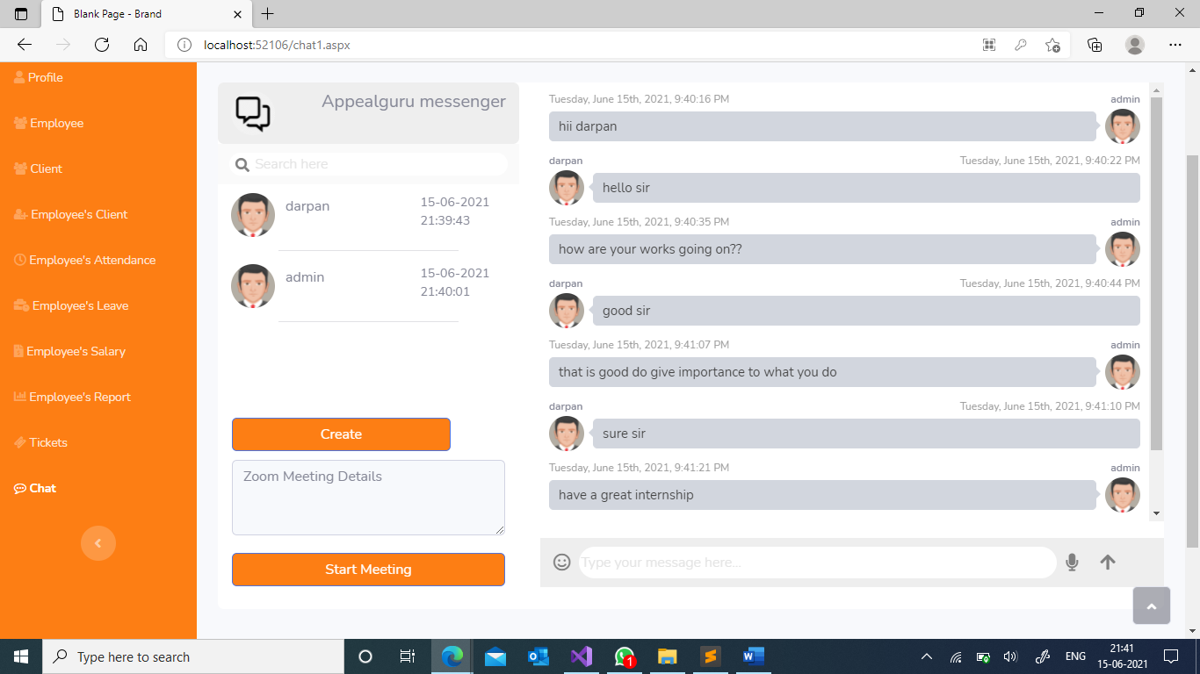

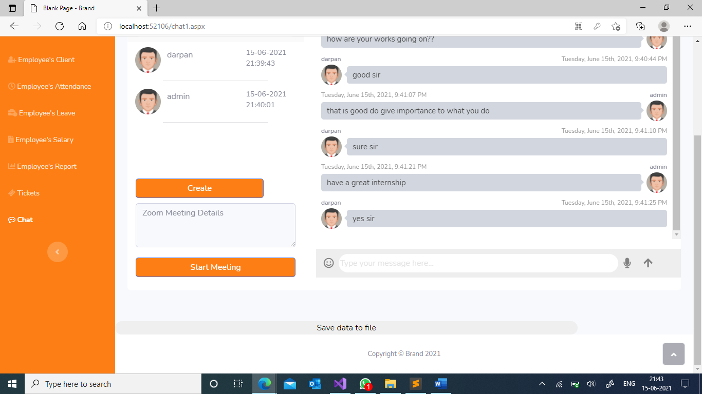

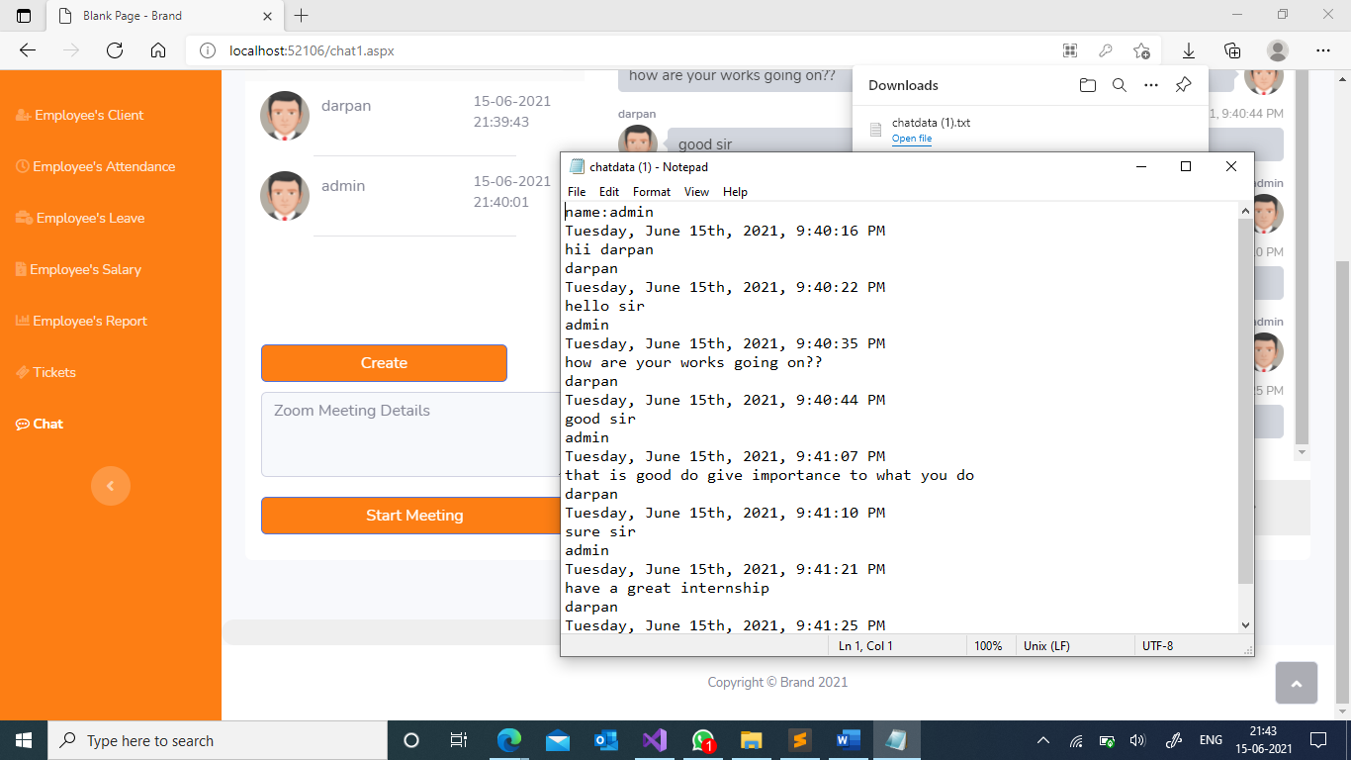

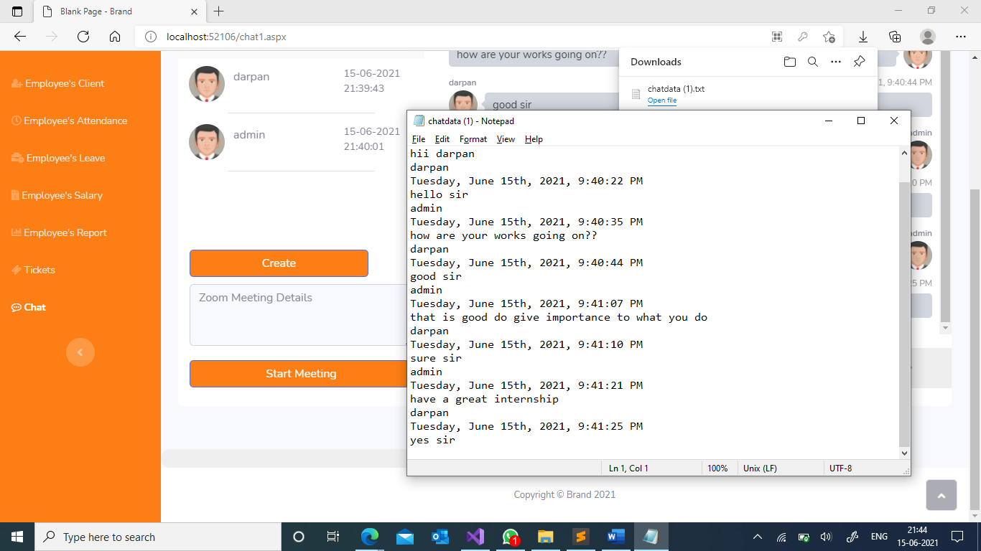

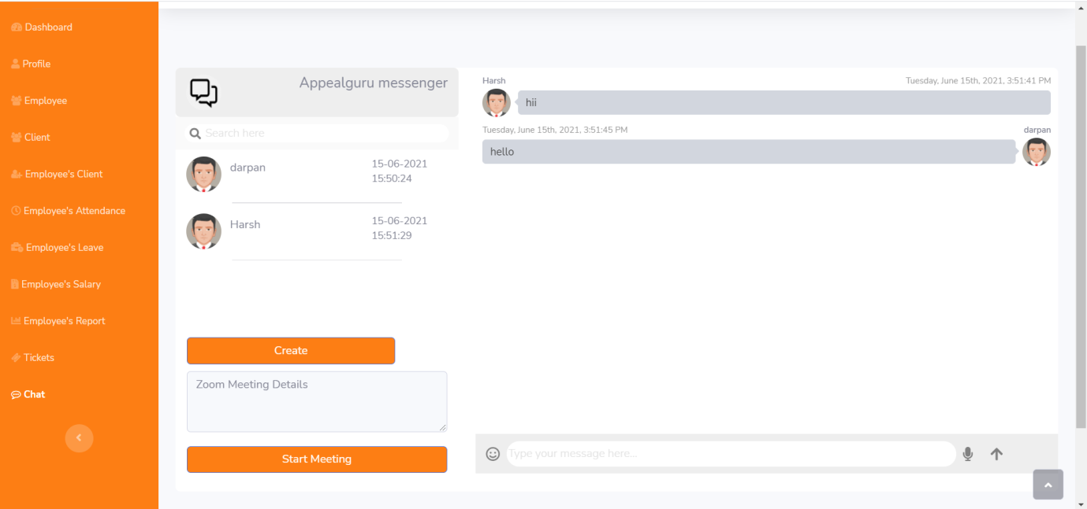 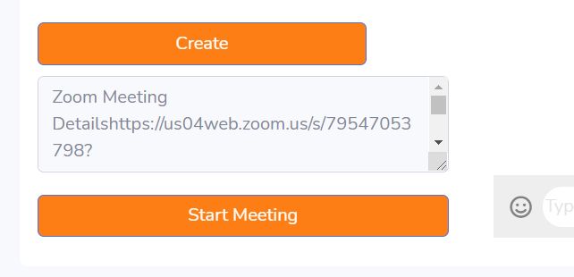 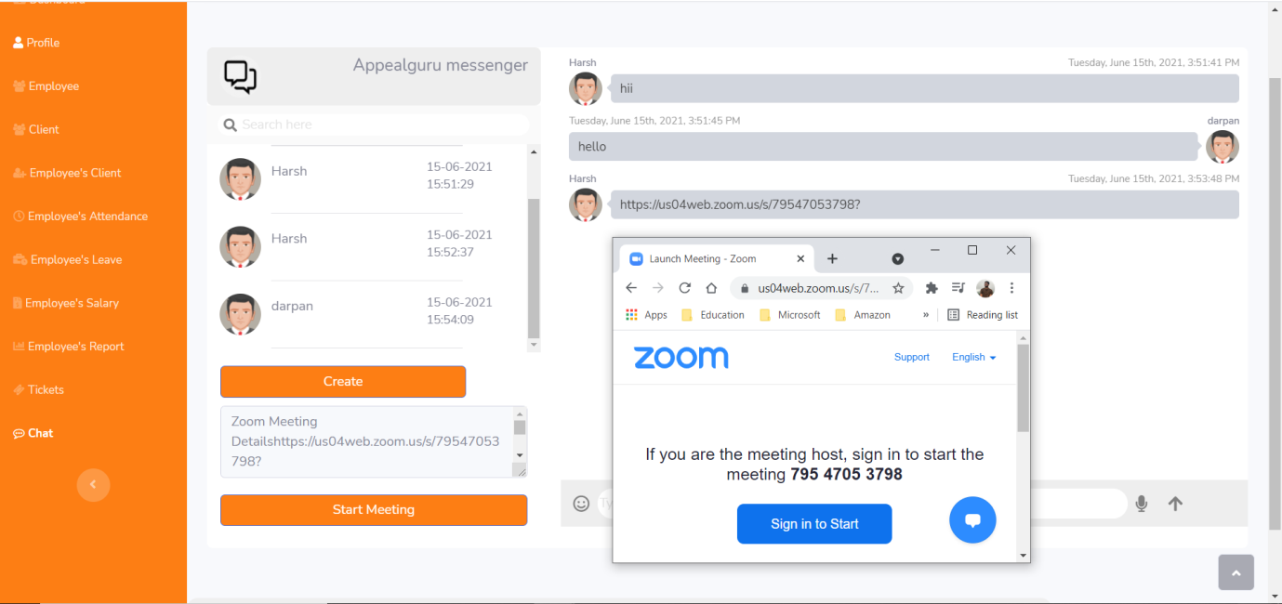

**-------------------------------------End of Report -----------------------------------------------**