A PROJECT REPORT ON

**FLAPPY BIRDS USING LUA**

A DISSERTATION

SUBMITTED FOR THE MID TERM PROJECT EVALUATION (MTE) FOR THE COMPLETION OF COURSE COMPUTER GRAPHICS (CO-313)



SUBMITTED BY

**VISHRUTH KHARE**

**(2K18/CO/393)**

**VISHWAS AGARWAL**

**(2K18/CO/395)**

UNDER THE SUPERVISION OF

**Ms. CHINGMUANKIM NAULAK**

*DEPARTMENT OF COMPUTER SCIENCE & ENGINEERING*

*DELHI TECHNOLOGICAL UNIVERSITY*

*(Formerly Delhi College of Engineering)*

*Bawana Road, Delhi- 110042*

*Session: November, 2020*

**DECLARATION**

We, **Vishruth Khare**, Roll No. 2K18/CO/393 and **Vishwas Agarwal**, Roll No. 2K18/CO/395 of B.Tech Computer Engineering, hereby declare that the project titled **“Flappy Birds Using Lua”** which is submitted by us to the Department of Computer Engineering, Delhi Technological University (DTU), Delhi for the mid-term project evaluation (MTE), is complete and working and has properly cited all it's quotations along with a working model.

New Delhi

India

November ’20

**ABSTRACT**

Flappy bird is a mobile game turned Web Variation in which a player controls a bird’s flight to refrain from colliding with obstacles. Tapping the keys for a longer period of time allows the bird to fly higher, while letting go causes the bird to fall down. This project will bring the mobile game to life ny creating a web variant which is unprecedented. The FPGA will render an image of the bird flying through an environment, and display the flapping motion of the wings according to the player’s ability to tap the relevant keys. We will be imploring Lua Love2D framework for the implementation of a aforementioned game development. The necessary gaming design and development have been kept in mind while deploying the game features. We believe that this first attempt of the employment of Web frame application in a Mobile Based game will be an important step for a wider deployment in the research area of computer games.

**INTRODUCTION**

The game is a side-scroller where the player controls a bird, attempting to fly between rows of green pipes, which are equally sized gaps placed at random heights, without coming into contact them. Each successful pass through a pair of pipes awards the player one point. If the player touches the pipes, it ends the game. The bird briefly flaps upward each time the player taps the key; if the key is not tapped, the bird falls due to gravity. The player is awarded with several milestones, such as a bronze medal if they reached twenty points, a silver medal from Forty points, a gold medal from Fifty, and a platinum medal from Hundred points. The achievements get stored in the collectible haul.

**Compatibility** : Any system with Love2D framework installed can compile, execute and play this game.

**TECHNOLOGY USED**

We have used **Lua Programming** **Language** for the development of the project. Lua is an extensible, lightweight programming language written in C. It started as an in-house project in 1993 by Roberto Ierusalimschy, Luiz Henrique de Figueiredo, and Waldemar Celes. It was designed from the beginning to be a software that can be integrated with the code written in C and other conventional languages. It does not try to do what C can already do but aims at offering what C is not good at: a good distance from the hardware, dynamic structures, no redundancies, ease of testing and debugging. For this, Lua has a safe environment, automatic memory management, and good facilities for handling strings and other kinds of data with dynamic size.

**Features :** Lua provides a set of unique features that makes it distinct from other languages. These include:

* Extensible
* Simple
* Efficient
* Portable
* Free and open

**Lua Interpreter :** The Lua Interpreter is written in ANSI C, hence it is highly portable and can run on a vast spectrum of devices from high-end network servers to small devices. Both Lua's language and its interpreter are mature, small, and fast. It has evolved from other programming languages and top software standards. Being small in size makes it possible for it to run on small devices with low memory.

**METHODOLOGY**

* 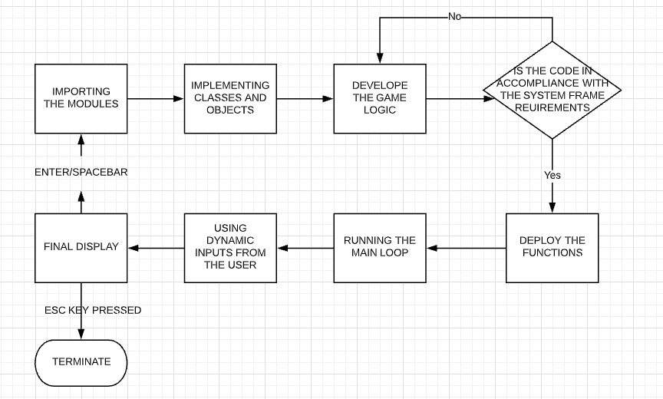We first import the desired modules and import the Love2D framework in out Script
* Then the classes and objects are implemented for the bird, pipes, background, Achievements, Pause Screen and the final display screen.
* We develop the relevant game logic that will ensure smooth play and in accomplice with the screen resolution and system settings.
* Once everything is in check, the player executes the code which means the functions get deployed in the main.lua code.
* Once the main function gets compiled, it keeps on executing until the player presses hit an obstacle or makes an illegal move.
* Finally the score along with the trophy is displayed on the screen and the main.lua function keeps on looping until the Player presses the Escape Key to trigger an escaping sequence that closes the window.

**GAME LOGIC**

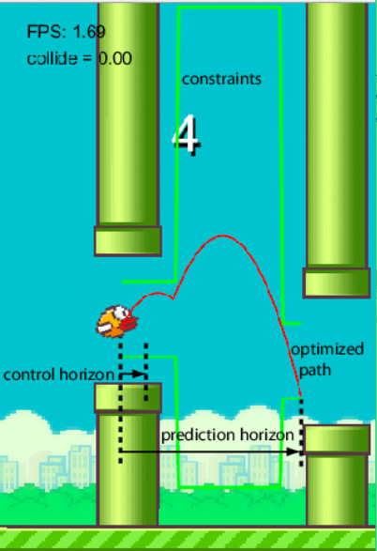For the successful execution of any game, The game logic has to beconcrete and accordance with the fundamentals of the game.

We have 50 pixels wide pillars which move from right to left and every next pillar has a different random height. In order to make them moving, logically, after each iteration we need to clear the screen and redraw the graphic with the pillars at their new position. However, we cannot do that because of the low refresh rate of the screen, which would cause flickering of the graphics. In order to activate all of its pixels the screen needs a bit more time.

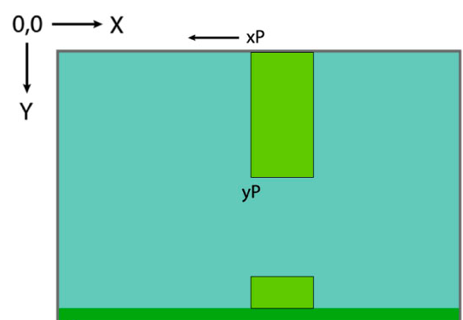

The graphics we follow is the standard system where the screen moves in the X-Direction and the user will have to trigger the up-down movement by the press of the key.

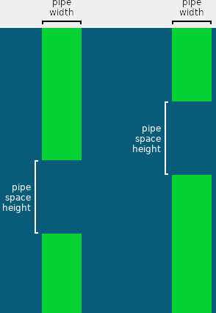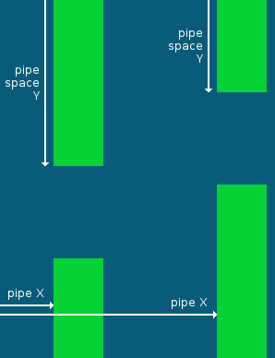

The bird's Y position moves down by a certain speed each frame. Each frame this speed is increased to simulate gravity.

When a key is pressed, the bird's speed is set to a high number in the upward direction.

The pipes share the same width, and the same space height between the segments. Each pipe has its own X position, and Y position the space.

Since there are only two pipes in the playing area at one time, the information for only two pipes needs to stored. Once a pipe goes out of the playing area, it gets a new space position and its X position is reset to the right edge of the playing area.

The bird has collided with the top segment if...

* The left edge of the bird is to the left of the right edge of the pipe
* The right edge of the bird is to the right of the left edge of the pipe
* The top edge of the bird is above the bottom edge of the pipe segment.

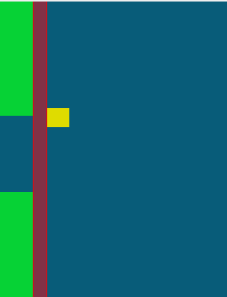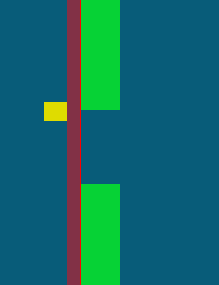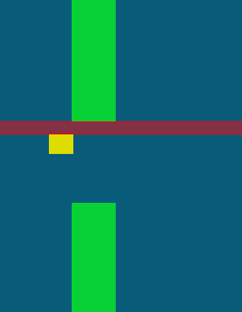

(Collision for the upper Pipe)

**BIRD and GRAVITY**

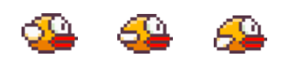

The bird's Y position is made into a variable, and every frame it increases by 30 multiplied by dt,

making the bird move

down 30 pixels per second. Instead of moving at a constant speed, the number added to the bird's Y position also increases over time.

The bird's speed is made into a variable which starts at 0, and every frame it increases by a fixed scalar (Gravity) times the frame height.

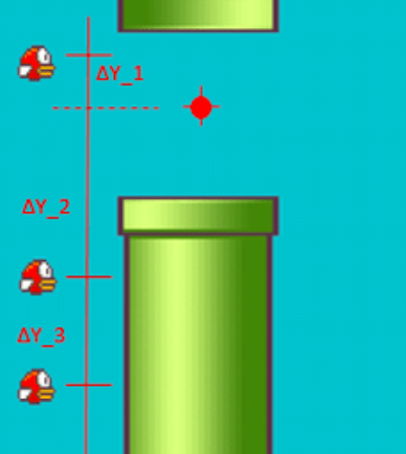

**PIPES**

Pipes are the most important part of the game because they have to be made sensitive to collision with the bird. Their appearance in the game is totally randomized thereby making it exceedingly difficult for the player to cope as the game proceeds.

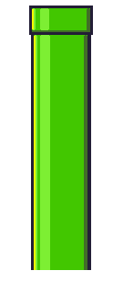

Two rectangles are drawn for the upper and lower segments.

The top rectangle's height is set to where the space between the two segments starts.

The bottom rectangle starts at the Y position of the top rectangle's height plus the amount of space between them

The bottom rectangle's height is the playing area's height, minus the height of the top rectangle and the space.

The pipe width is the same for both segments, so this is made into a variable.

**DISPLAY SCREEN**

****We also have several achievements as Trophies as the player keeps on crossing the hurdles, his score gets incremented and on the basis of the score. Digital trophies are given to the player. Also the background is a png file that is attached and it keeps on re-looping as the bird progresses throughout the game. Various other facades are there in the game that give a complete look of the dynamism of the game.

**DESIGN AND REQUIREMENTS**

The following sections are going to be focusing on the core development of the game along with implementation techniques and the code.

*User Actions –*

|  |  |
| --- | --- |
| KEY | ACTION |
| Spacebar (in-game) / Left Click | Jump |
| Spacebar on Pause Screen | Restart |

*Technical Game Details –*

|  |  |
| --- | --- |
| PARAMETER | VALUE |
| Frames per second | 60 |
| Resolution | 1280x720 (below this is self-adjusting) |
| Framework | Love2D |
| Pipe Gap | 200px |
| Gravity | 30px per second |

As already mention, the game continues until the user wants to. The resolution is of self-adjusting nature as the Virtual Width and Height have been set to 512x218. Below this value, the pixels start to distort and collapse. The frame rate ideally is made accustomed to 60 frames per second but that can be changed according to the need of the user. Gravity works at 30 pixel per second which when decreased increases the difficulty of the game.

**SOURCE CODE**

* **MAIN**
* push = require 'push'
* -- classic OOP class library
* Class = require 'class'
* -- bird class we've written
* require 'Bird'
* require 'Pipe'
* require 'PipePair'
* require 'StateMachine'
* require 'states/BaseState'
* require 'states/PlayState'
* require 'states/TitleScreenState'
* require 'states/ScoreState'
* require 'states/CountdownState'
* require 'states/PauseState'
* -- physical screen dimensions
* WINDOW_WIDTH = 1280
* WINDOW_HEIGHT = 720
* -- virtual resolution dimensions
* VIRTUAL_WIDTH = 512
* VIRTUAL_HEIGHT = 288
* -- background image and starting scroll location (X axis)
* local background = love.graphics.newImage('images/background.png')
* local backgroundScroll = 0
* -- ground image and starting scroll location (X axis)
* local ground = love.graphics.newImage('images/ground.png')
* local groundScroll = 0
* -- speed at which we should scroll our images, scaled by dt
* local BACKGROUND_SCROLL_SPEED = 30
* local GROUND_SCROLL_SPEED = 60
* -- point at which we should loop our background back to X 0
* local BACKGROUND_LOOPING_POINT = 413
* function love.load()
* -- initialize our nearest-neighbor filter
* love.graphics.setDefaultFilter('nearest', 'nearest')
* math.randomseed(os.time())
* -- app window title
* love.window.setTitle('Fifty Bird')
* smallFont = love.graphics.newFont("fonts/font.ttf", 8)
* mediumFont = love.graphics.newFont("fonts/flappy.ttf", 14)
* flappyFont = love.graphics.newFont("fonts/flappy.ttf", 28)
* hugeFont = love.graphics.newFont("fonts/flappy.ttf", 56)
* love.graphics.setFont(flappyFont)
* -- initialize our virtual resolution
* push:setupScreen(VIRTUAL_WIDTH, VIRTUAL_HEIGHT, WINDOW_WIDTH, WINDOW_HEIGHT, {
* vsync = true,
* fullscreen = false,
* resizable = true
* })
* gStateMachine = StateMachine {
* ['title'] = function () return TitleScreenState() end,
* ['play'] = function () return PlayState() end,
* ['score'] = function () return ScoreState() end,
* ['countdown'] = function () return CountdownState() end,
* ['pause'] = function () return PauseState() end
* }
* gStateMachine:change('title')
* sounds = {
* ['explosion'] = love.audio.newSource('sounds/explosion.wav', 'static'),
* ['jump'] = love.audio.newSource('sounds/jump.wav', 'static'),
* ['hurt'] = love.audio.newSource('sounds/hurt.wav', 'static'),
* ['score'] = love.audio.newSource('sounds/score.wav', 'static'),
* ['music'] = love.audio.newSource('sounds/marios_way.mp3', 'static'),
* ['pause'] = love.audio.newSource('sounds/pause.wav','static')
* }
* medals = {
* ['rock'] = love.graphics.newImage('images/medals/rock.png'),
* ['bronze'] = love.graphics.newImage('images/medals/bronze.png'),
* ['silver'] = love.graphics.newImage('images/medals/silver.png'),
* ['gold'] = love.graphics.newImage('images/medals/gold.png'),
* ['crown'] = love.graphics.newImage('images/medals/crown.png')
* }
* sounds['music']:setLooping(true)
* sounds['music']:play()
* love.keyboard.keysPressed = {}
* love.mouse.buttonsPressed = {}
* end
* function love.resize(*w*, *h*)
* push:resize(w, h)
* end
* function love.keypressed(*key*)
* love.keyboard.keysPressed[key] = true
* if key == 'escape' then
* love.event.quit()
* end
* end
* function love.keyboard.wasPressed( *key*)
* return love.keyboard.keysPressed[key]
* end
* function love.mousepressed(*x*, *y*, *button*)
* love.mouse.buttonsPressed[button] = true
* end
* function love.mouse.wasPressed(*button*)
* return love.mouse.buttonsPressed[button]
* end
* function love.update(*dt*)
* -- scroll background by preset speed * dt, looping back to 0 after the looping point
* backgroundScroll = (backgroundScroll + BACKGROUND_SCROLL_SPEED * dt)
* % BACKGROUND_LOOPING_POINT
* -- scroll ground by preset speed * dt, looping back to 0 after the screen width passes
* groundScroll = (groundScroll + GROUND_SCROLL_SPEED * dt)
* % VIRTUAL_WIDTH
* gStateMachine:update(dt)
* love.keyboard.keysPressed = {}
* love.mouse.buttonsPressed = {}
* end
* function love.draw()
* push:start()
* -- draw the background at the negative looping point
* love.graphics.draw(background, -backgroundScroll, 0)
* gStateMachine:render()
* -- draw the ground on top of the background, toward the bottom of the screen,
* -- at its negative looping point
* love.graphics.draw(ground, -groundScroll, VIRTUAL_HEIGHT - 16)
* push:finish()
* end
* **BIRD**
* Bird = Class{}
* local GRAVITY = 20
* function Bird:init()
* -- load bird image from disk and assign its width and height
* self.image = love.graphics.newImage('images/bird.png')
* self.width = self.image:getWidth()
* self.height = self.image:getHeight()
* -- position bird in the middle of the screen
* self.x = VIRTUAL_WIDTH / 2 - (self.width / 2)
* self.y = VIRTUAL_HEIGHT / 2 - (self.height / 2)
* self.dy = 0
* end
* function Bird:collides( pipe )
* if (self.x + 2) + (self.width - 4) >= pipe.x and self.x + 2 <= pipe.x + PIPE_WIDTH then
* if (self.y + 2) + (self.height - 4) >= pipe.y and self.y + 2 <= pipe.y + PIPE_HEIGHT then
* return true
* end
* end
* return false
* -- body
* end
* function Bird:render()
* love.graphics.draw(self.image, self.x, self.y)
* end
* function Bird:update(dt)
* self.dy = self.dy + GRAVITY * dt
* if love.keyboard.wasPressed('space') or love.mouse.wasPressed(1) then
* self.dy = -5
* sounds['jump']:play()
* end
* self.y = self.y + self.dy
* end
* **PIPE-PAIR**
* Pipe = Class{}
* local PIPE_IMAGE = love.graphics.newImage('images/pipe.png')
* local PIPE_SCROLL = -60
* PIPE_SPEED = 60
* PIPE_HEIGHT = 288
* PIPE_WIDTH = 70
* function Pipe:init(orientation, y)
* self.x = VIRTUAL_WIDTH
* self.y = y
* self.width = PIPE_IMAGE:getWidth()
* self.height = PIPE_HEIGHT
* self.orientation = orientation
* end
* function Pipe:update(dt)
* end
* function Pipe:render()
* love.graphics.draw(PIPE_IMAGE, self.x, (self.orientation == 'top' and self.y + PIPE_HEIGHT or self.y), 0, 1, self.orientation == 'top' and -1 or 1)
* end
* **STATE MACHINE**

StateMachine = Class{}

function StateMachine:init(states)

self.empty = {

render = function() end,

update = function() end,

enter = function() end,

exit = function() end

}

self.states = states or {} -- [name] -> [function that returns states]

self.current = self.empty

end

function StateMachine:change(stateName, enterParams)

assert(self.states[stateName]) -- state must exist!

self.current:exit()

self.current = self.states[stateName]()

self.current:enter(enterParams)

end

function StateMachine:update(dt)

self.current:update(dt)

end

function StateMachine:render()

self.current:render()

end

* **DYNAMIC DISPLAY AND PUSH**
* local push = {
* defaults = {
* fullscreen = false,
* resizable = false,
* pixelperfect = false,
* highdpi = true,
* canvas = true
* }
* }
* setmetatable(push, push)
* --TODO: rendering resolution?
* --TODO: clean up code
* function push:applySettings(settings)
* for k, v in pairs(settings) do
* self["_" .. k] = v
* end
* end
* function push:resetSettings() return self:applySettings(self.defaults) end
* function push:setupScreen(WWIDTH, WHEIGHT, RWIDTH, RHEIGHT, settings)
* settings = settings or {}
* self._WWIDTH, self._WHEIGHT = WWIDTH, WHEIGHT
* self._RWIDTH, self._RHEIGHT = RWIDTH, RHEIGHT
* self:applySettings(self.defaults) --set defaults first
* self:applySettings(settings) --then fill with custom settings
* love.window.setMode( self._RWIDTH, self._RHEIGHT, {
* fullscreen = self._fullscreen,
* resizable = self._resizable,
* highdpi = self._highdpi
* } )
* self:initValues()
* if self._canvas then
* self:setupCanvas({ "default" }) --setup canvas
* end
* self._borderColor = {0, 0, 0}
* self._drawFunctions = {
* ["start"] = self.start,
* ["end"] = self.finish
* }
* return self
* end
* function push:setupCanvas(canvases)
* table.insert(canvases, { name = "_render" }) --final render
* self._canvas = true
* self.canvases = {}
* for i = 1, #canvases do
* self.canvases[i] = {
* name = canvases[i].name,
* shader = canvases[i].shader,
* canvas = love.graphics.newCanvas(self._WWIDTH, self._WHEIGHT)
* }
* end
* return self
* end
* function push:setCanvas(name)
* if not self._canvas then return true end
* return love.graphics.setCanvas( self:getCanvasTable(name).canvas )
* end
* function push:getCanvasTable(name)
* for i = 1, #self.canvases do
* if self.canvases[i].name == name then
* return self.canvases[i]
* end
* end
* end
* function push:setShader(name, shader)
* if not shader then
* self:getCanvasTable("_render").shader = name
* else
* self:getCanvasTable(name).shader = shader
* end
* end
* function push:initValues()
* self._PSCALE = self._highdpi and love.window.getPixelScale() or 1
* self._SCALE = {
* x = self._RWIDTH/self._WWIDTH * self._PSCALE,
* y = self._RHEIGHT/self._WHEIGHT * self._PSCALE
* }
* if self._stretched then --if stretched, no need to apply offset
* self._OFFSET = {x = 0, y = 0}
* else
* local scale = math.min(self._SCALE.x, self._SCALE.y)
* if self._pixelperfect then scale = math.floor(scale) end
* self._OFFSET = {x = (self._SCALE.x - scale) * (self._WWIDTH/2), y = (self._SCALE.y - scale) * (self._WHEIGHT/2)}
* self._SCALE.x, self._SCALE.y = scale, scale --apply same scale to X and Y
* end
* self._GWIDTH = self._RWIDTH * self._PSCALE - self._OFFSET.x * 2
* self._GHEIGHT = self._RHEIGHT * self._PSCALE - self._OFFSET.y * 2
* end
* --[[ DEPRECATED ]]--
* function push:apply(operation, shader)
* if operation == "start" then
* self:start()
* elseif operation == "finish" or operation == "end" then
* self:finish(shader)
* end
* end
* function push:start()
* if self._canvas then
* love.graphics.push()
* love.graphics.setCanvas(self.canvases[1].canvas)
* else
* love.graphics.translate(self._OFFSET.x, self._OFFSET.y)
* love.graphics.setScissor(self._OFFSET.x, self._OFFSET.y, self._WWIDTH*self._SCALE.x, self._WHEIGHT*self._SCALE.y)
* love.graphics.push()
* love.graphics.scale(self._SCALE.x, self._SCALE.y)
* end
* end
* function push:finish(shader)
* love.graphics.setBackgroundColor(unpack(self._borderColor))
* if self._canvas then
* local _render = self:getCanvasTable("_render")
* love.graphics.pop()
* love.graphics.setColor(255, 255, 255)
* --draw canvas
* love.graphics.setCanvas(_render.canvas)
* for i = 1, #self.canvases - 1 do --do not draw _render yet
* local _table = self.canvases[i]
* love.graphics.setShader(_table.shader)
* love.graphics.draw(_table.canvas)
* end
* love.graphics.setCanvas()
* --draw render
* love.graphics.translate(self._OFFSET.x, self._OFFSET.y)
* love.graphics.setShader(shader or self:getCanvasTable("_render").shader)
* love.graphics.draw(self:getCanvasTable("_render").canvas, 0, 0, 0, self._SCALE.x, self._SCALE.y)
* --clear canvas
* for i = 1, #self.canvases do
* love.graphics.setCanvas( self.canvases[i].canvas )
* love.graphics.clear()
* end
* love.graphics.setCanvas()
* love.graphics.setShader()
* else
* love.graphics.pop()
* love.graphics.setScissor()
* end
* end
* function push:setBorderColor(color, g, b)
* self._borderColor = g and {color, g, b} or color
* end
* function push:toGame(x, y)
* x, y = x - self._OFFSET.x, y - self._OFFSET.y
* local normalX, normalY = x / self._GWIDTH, y / self._GHEIGHT
* x = (x >= 0 and x <= self._WWIDTH * self._SCALE.x) and normalX * self._WWIDTH or nil
* y = (y >= 0 and y <= self._WHEIGHT * self._SCALE.y) and normalY * self._WHEIGHT or nil
* return x, y
* end
* --doesn't work - TODO
* function push:toReal(x, y)
* return x+self._OFFSET.x, y+self._OFFSET.y
* end
* function push:switchFullscreen(winw, winh)
* self._fullscreen = not self._fullscreen
* local windowWidth, windowHeight = love.window.getDesktopDimensions()
* if self._fullscreen then --save windowed dimensions for later
* self._WINWIDTH, self._WINHEIGHT = self._RWIDTH, self._RHEIGHT
* elseif not self._WINWIDTH or not self._WINHEIGHT then
* self._WINWIDTH, self._WINHEIGHT = windowWidth * .5, windowHeight * .5
* end
* self._RWIDTH = self._fullscreen and windowWidth or winw or self._WINWIDTH
* self._RHEIGHT = self._fullscreen and windowHeight or winh or self._WINHEIGHT
* self:initValues()
* love.window.setFullscreen(self._fullscreen, "desktop")
* if not self._fullscreen and (winw or winh) then
* love.window.setMode(self._RWIDTH, self._RHEIGHT) --set window dimensions
* end
* end
* function push:resize(w, h)
* local pixelScale = love.window.getPixelScale()
* if self._highdpi then w, h = w / pixelScale, h / pixelScale end
* self._RWIDTH = w
* self._RHEIGHT = h
* self:initValues()
* end
* function push:getWidth() return self._WWIDTH end
* function push:getHeight() return self._WHEIGHT end
* function push:getDimensions() return self._WWIDTH, self._WHEIGHT end
* return push
* **CLASS**
* local function include_helper(*to*, *from*, *seen*)
* if from == nil then
* return to
* elseif type(from) ~= 'table' then
* return from
* elseif seen[from] then
* return seen[from]
* end
* seen[from] = to
* for k,v in pairs(from) do
* k = include_helper({}, k, seen) -- keys might also be tables
* if to[k] == nil then
* to[k] = include_helper({}, v, seen)
* end
* end
* return to
* end
* -- deeply copies `other' into `class'. keys in `other' that are already
* -- defined in `class' are omitted
* local function include(*class*, *other*)
* return include_helper(class, other, {})
* end
* -- returns a deep copy of `other'
* local function clone(*other*)
* return setmetatable(include({}, other), getmetatable(other))
* end
* local function new(*class*)
* -- mixins
* class = class or {} -- class can be nil
* local inc = class.__includes or {}
* if getmetatable(inc) then inc = {inc} end
* for _, other in ipairs(inc) do
* if type(other) == "string" then
* other = _G[other]
* end
* include(class, other)
* end
* -- class implementation
* class.__index = class
* class.init = class.init or class[1] or function() end
* class.include = class.include or include
* class.clone = class.clone or clone
* -- constructor call
* return setmetatable(class, {__call = function(*c*, ...)
* local o = setmetatable({}, c)
* o:init(...)
* return o
* end})
* end
* -- interface for cross class-system compatibility (see https://github.com/bartbes/Class-Commons).
* if class_commons ~= false and not common then
* common = {}
* function common.class(*name*, *prototype*, *parent*)
* return new{__includes = {prototype, parent}}
* end
* function common.instance(*class*, ...)
* return class(...)
* end
* end
* -- the module
* return setmetatable({new = new, include = include, clone = clone},
* {__call = function(*_*,...) return new(...) end})

**RESULTS**

The outcome of the above project is Phenomenal. Since its pre-requisites are nothing therefore it is compatible with all environments be it MacOS, Windows or Linux. The game is of self-adjusting nature hence the output appears evenly on all screen types as well. The game requires a minimal storage of approx. 13Mb hence can it is very space efficient as well. Booting of the game depends on the RAM but still being a 8bit game pre-dominantly, it requires a minimum of 1GB of RAM to run flawlessly. The gameplay is seamless and we have included the following new features in the game:

1. Background Sound, collision sound, and flapping sound.
2. Changeable Gravity to change the difficulty of the gameplay.
3. Moveable Pillars as you move up the ladder to enhance the difficulty of the game.
4. Invert color screen to break the concentration ( but this has to be executed separately as only the background changes )

**Gameplay**

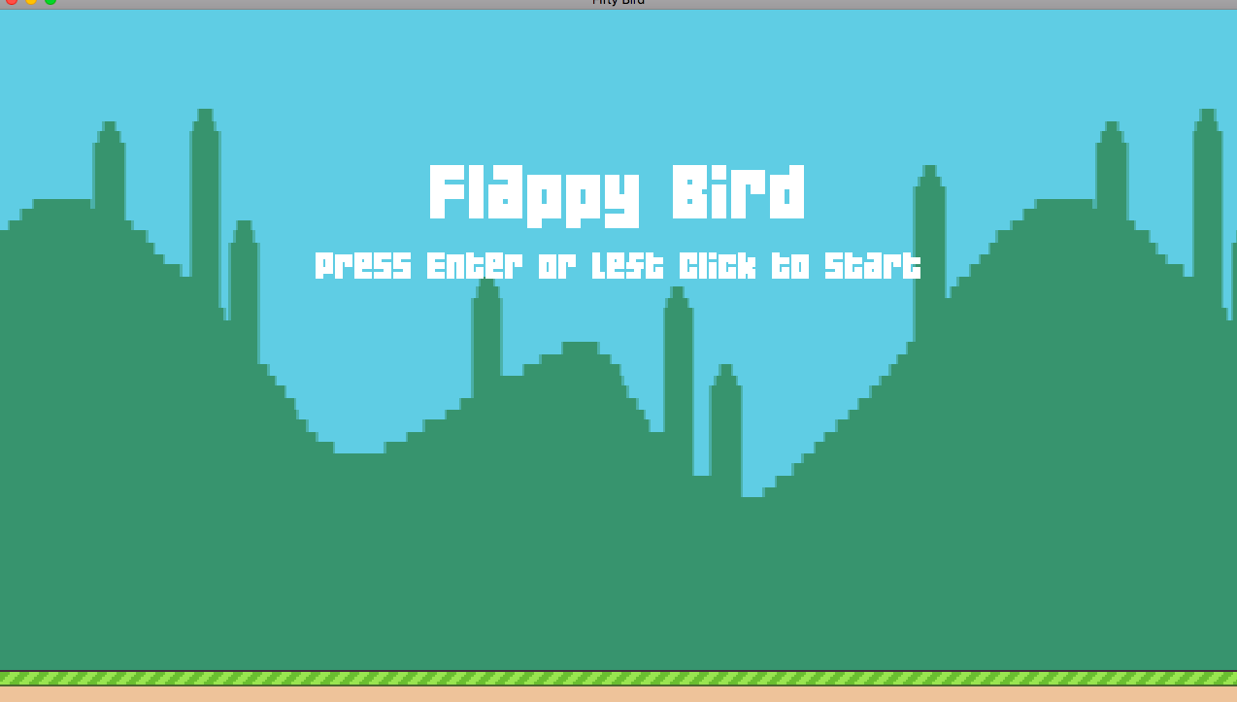

(Opening Screen)

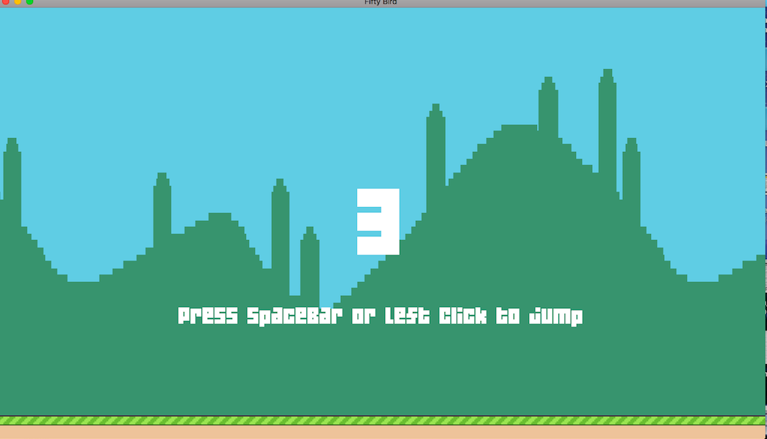

(Timer just before the start of the game)

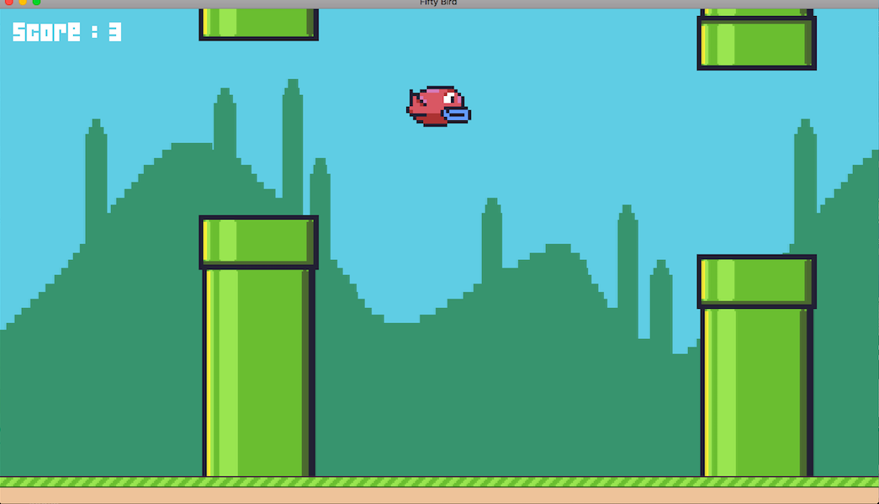

(In the middle of the game)

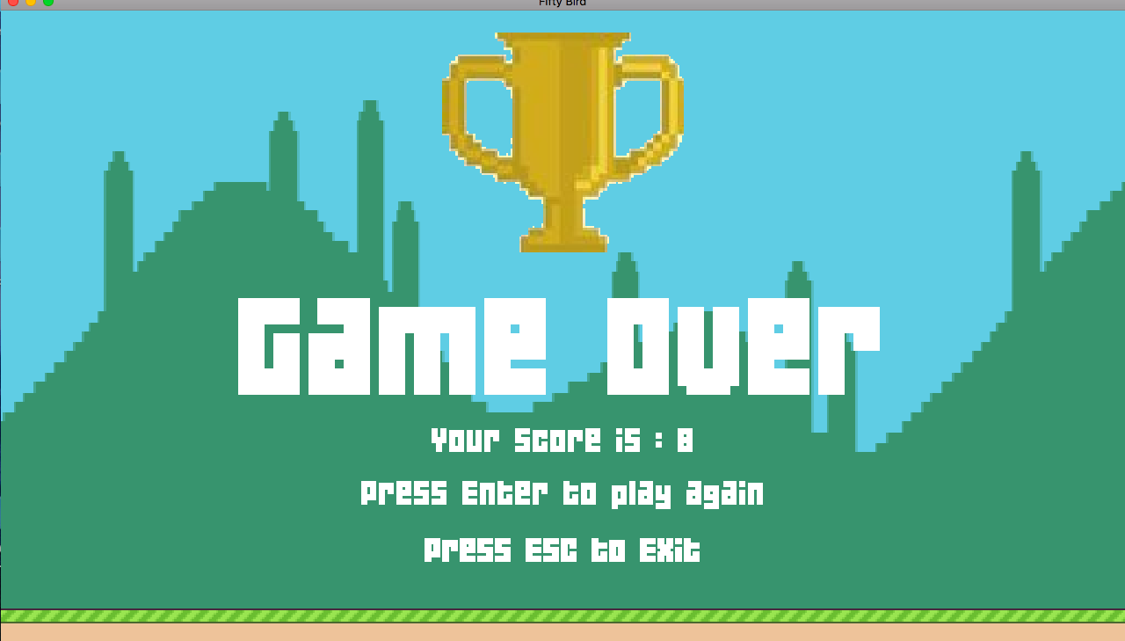

(Final display screen along with score and trophy)

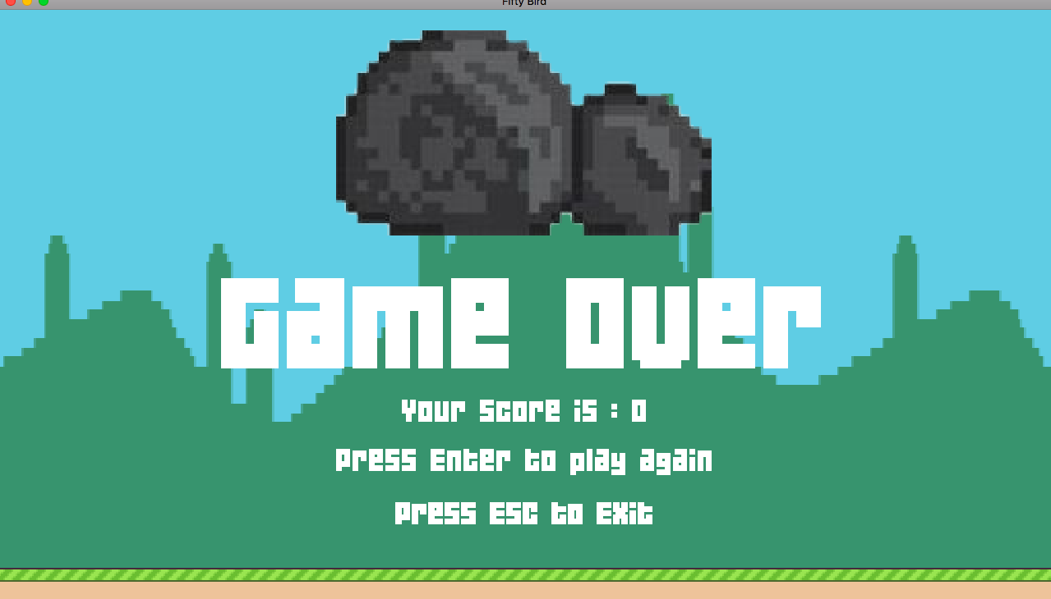

(Explosion window and sound if you didn’t reach a desired level)

**CONCLUSION**

The clone of Flappy Birds was implemented successfully using a high level scripting language. The game logic was deployed successfully and the gameplay was also smooth. The game is suitable for all age groups and its availability on Desktop broadens the scope of its usage. The game is fairly simple and we have tried to add more features to the original classic game. Nevertheless, there is still some scope to add more features like creating multiple logins or making multi-player compatible game but that is beyond the scope of the script that we have been using. Using Lua, we learned a lot about Object Oriented approach, configuration with other platforms and above all the concept of Graphics as used in Computers. Our course curriculum helped us explore more about the project that we were dwelling into and hence give us a wider perspective of how graphics and simple coding gives us a user experience so soothing and something to cherish over and over.