Create DB:
mkdir vishruth

use vishruth

show dbs

To insert one record:
db.vishruth.insertOne({name:"Vishruth",dept:"ise"})
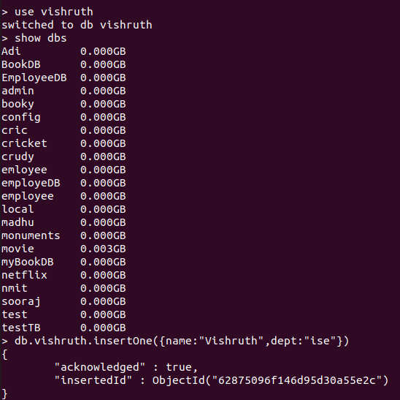

To insert many:
db.vishruth.insertMany([{name:"batman",dept:"ise"},{name:"sai",dept:"ise"}])

To display:
db.vishruth.find();
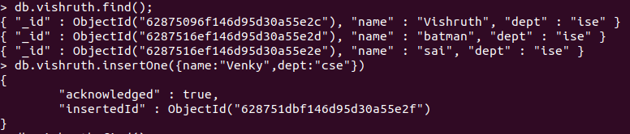
To display better:
db.vishruth.find().pretty();
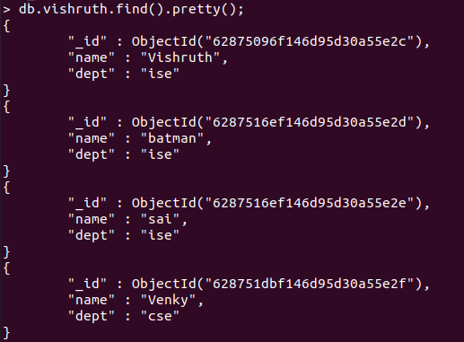

To update using set:
db.vishruth.updateOne({"name":"sai"},{$set:{"dept":"mech"}})

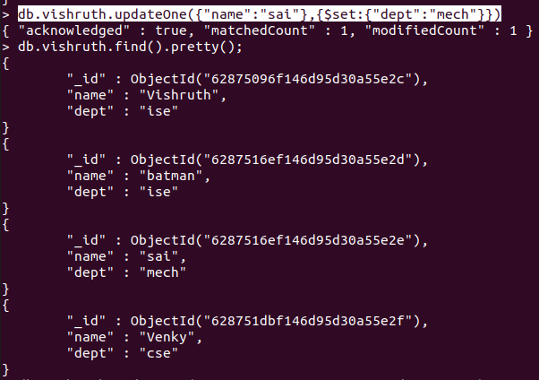

To update using unset:
db.vishruth.updateOne({"name":"sai"},{$unset:{"dept":""}})
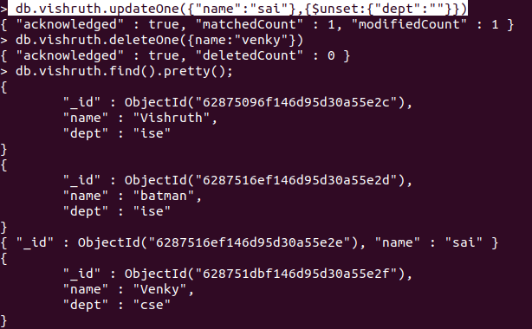

To delete :
db.vishruth.deleteOne({name:"Venky"})
