Hadoop:
EX:2
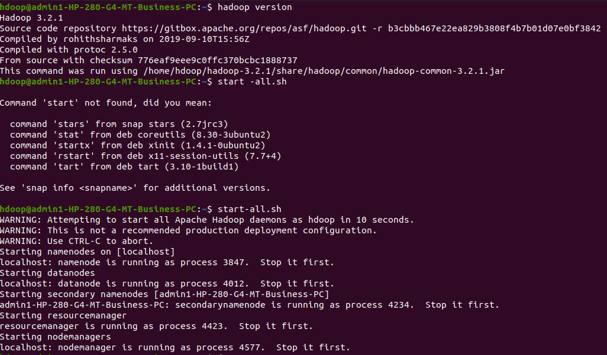
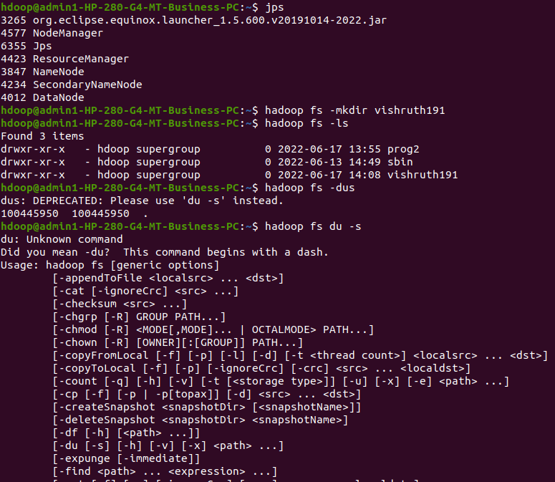
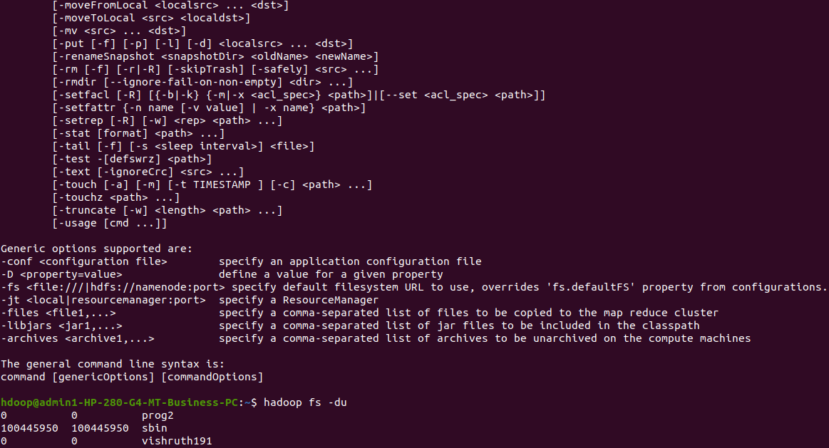

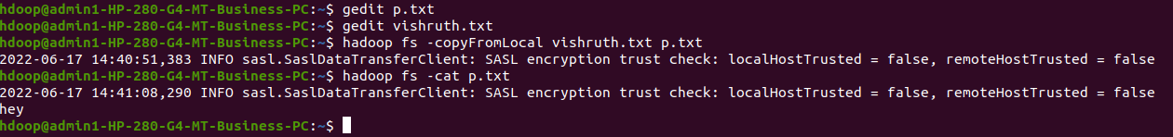

hdoop@admin1-HP-280-G4-MT-Business-PC:~$ start -all.sh

hdoop@admin1-HP-280-G4-MT-Business-PC:~$ jps

hdoop@admin1-HP-280-G4-MT-Business-PC:~$ hadoop fs -mkdir vishruth191
hdoop@admin1-HP-280-G4-MT-Business-PC:~$ hadoop fs -ls

hdoop@admin1-HP-280-G4-MT-Business-PC:~$ hadoop fs -dus

hdoop@admin1-HP-280-G4-MT-Business-PC:~$ hadoop fs du -s

hdoop@admin1-HP-280-G4-MT-Business-PC:~$ gedit p.txt
hdoop@admin1-HP-280-G4-MT-Business-PC:~$ gedit vishruth.txt
hdoop@admin1-HP-280-G4-MT-Business-PC:~$ hadoop fs -copyFromLocal vishruth.txt p.txt

hdoop@admin1-HP-280-G4-MT-Business-PC:~$ hadoop fs -cat p.txt
2022-06-17 14:41:08,290 INFO sasl.SaslDataTransferClient: SASL encryption trust check: localHostTrusted = false, remoteHostTrusted = false
hey

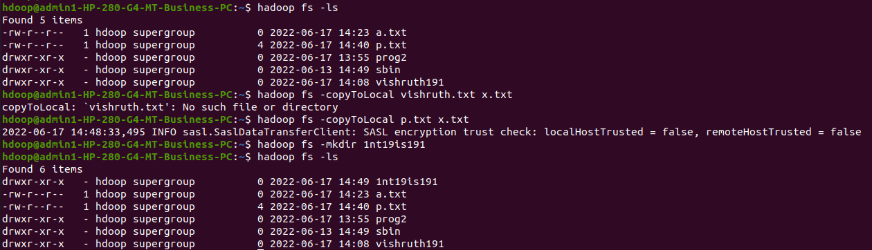

hdoop@admin1-HP-280-G4-MT-Business-PC:~$ hadoop fs -copyToLocal vishruth.txt x.txt

hdoop@admin1-HP-280-G4-MT-Business-PC:~$ hadoop fs -mkdir 1nt19is191
hdoop@admin1-HP-280-G4-MT-Business-PC:~$ hadoop fs -ls

hdoop@admin1-HP-280-G4-MT-Business-PC:~$ hadoop fs -cp p.txt y.txt

hdoop@admin1-HP-280-G4-MT-Business-PC:~$ hadoop fs -cat y.txt

2022-06-17 14:51:11,175 INFO sasl.SaslDataTransferClient: SASL encryption trust check: localHostTrusted = false, remoteHostTrusted = false
hey

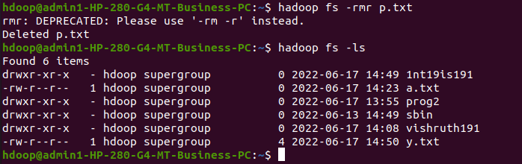

hdoop@admin1-HP-280-G4-MT-Business-PC:~$ hadoop fs -rmr p.txt
rmr: DEPRECATED: Please use '-rm -r' instead.
Deleted p.txt

hdoop@admin1-HP-280-G4-MT-Business-PC:~$ hadoop fs -ls
Found 6 items

EXERCISE:3

