Vishruth SR

1NT19IS191

EXERCISE 4:

**Question: Map Reduce programs**

**1.No. of transactions done by each user**

**2. Total amount of money transacted by each user**

**Code:**

**package BD;**

import java.io.IOException;

import java.util.*;

import org.apache.hadoop.fs.Path;

import org.apache.hadoop.io.*;

import org.apache.hadoop.mapred.*;

public class TransactionCount {

//MAPPER CODE

public static class Map extends MapReduceBase implements

Mapper<LongWritable, Text, Text, IntWritable> {

private final static IntWritable ***one*** = new IntWritable(1);

//private Text word = new Text();

public void map(LongWritable key, Text value, OutputCollector<Text,

IntWritable> output, Reporter reporter) throws IOException {

String myString = value.toString();

String[] userCount = myString.split(",");

output.collect(new Text(userCount[3]), ***one***);

}

}

//REDUCER CODE

public static class Reduce extends MapReduceBase implements

Reducer<Text, IntWritable, Text, IntWritable> {

public void reduce(Text key, Iterator<IntWritable> values,

OutputCollector<Text, IntWritable> output, Reporter reporter) throws

IOException { //{little: {1,1}}

int finaluserCount = 0 ;

Text mykey = key ;

while(values.hasNext()) {

IntWritable value = values.next();

finaluserCount += value.get();

}

output.collect(mykey, new IntWritable(finaluserCount));

}

}

//DRIVER CODE

public static void main(String[] args) throws Exception {

JobConf conf = new JobConf(TransactionCount.class);

conf.setJobName("wordcount");

conf.setOutputKeyClass(Text.class);

conf.setOutputValueClass(IntWritable.class);

conf.setMapperClass(Map.class);

conf.setCombinerClass(Reduce.class);

conf.setReducerClass(Reduce.class);

conf.setInputFormat(TextInputFormat.class);

conf.setOutputFormat(TextOutputFormat.class); // hadoop jar

FileInputFormat.*setInputPaths*(conf, new Path(args[0]));

FileOutputFormat.*setOutputPath*(conf, new Path(args[1]));

JobClient.*runJob*(conf);

}

**}**

**OUTPUT:**hdoop@admin1-HP-280-G4-MT-Business-PC:~$ cd $HADOOP_HOME

hdoop@admin1-HP-280-G4-MT-Business-PC:~/hadoop-3.2.1$ cd sbin

hdoop@admin1-HP-280-G4-MT-Business-PC:~/hadoop-3.2.1/sbin$ jps

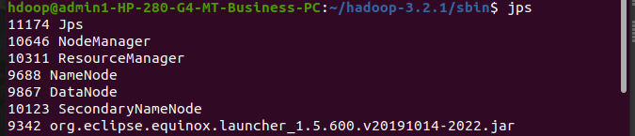hdoop@admin1-HP-280-G4-MT-Business-PC:~/hadoop-3.2.1/sbin$ hdfs dfs -mkdir -p /input117

hdoop@admin1-HP-280-G4-MT-Business-PC:~/hadoop-3.2.1/sbin$ hdfs dfs -copyFromLocal /home/hdoop/Desktop/prog4.csv /input117

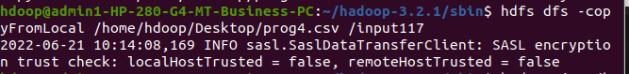

hdoop@admin1-HP-280-G4-MT-Business-PC:~/hadoop-3.2.1/sbin$ hadoop jar /home/hdoop/Desktop/PRATHEEK.jar /input117 /output117

hdoop@admin1-HP-280-G4-MT-Business-PC:~/hadoop-3.2.1/sbin$ hdfs dfs -cat /output117/part*

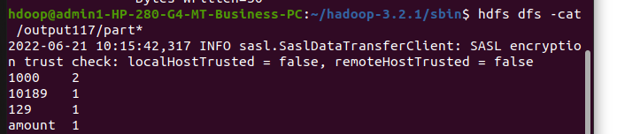

.csv file :

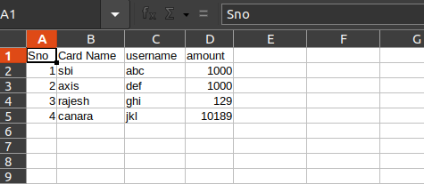

Exercise 5 :