|  |  |  |
| --- | --- | --- |
| **CLASS:** M.Sc. CS |  | **SEM:** I(2022-2023) |
| **SUBJECT:** Analysis of Algorithm and Researching Computing |  | **PAPER:** I |
| **NAME: Sachin Vishwakarma** |  | **ROLL NO.: 537** |

**Q.1) Write a Program for Randomized Selection Algorithm**

from random import randrange

def partition(x, pivot_index = 0):

i = 0

if pivot_index !=0: x[0],x[pivot_index] = x[pivot_index],x[0]

for j in range(len(x)-1):

if x[j+1] < x[0]:

x[j+1],x[i+1] = x[i+1],x[j+1]

i += 1

x[0],x[i] = x[i],x[0]

return x,i

def RSelect(x,k):

if len(x) == 1:

return x[0]

else:

xpart = partition(x,randrange(len(x)))

x = xpart[0] # partitioned array

j = xpart[1] # pivot index

if j == k:

return x[j]

elif j > k:

return RSelect(x[:j],k)

else:

k = k - j - 1

return RSelect(x[(j+1):], k)

x = [3,1,8,4,7,9]

for i in range(len(x)):

print (RSelect(x,i))

Output:

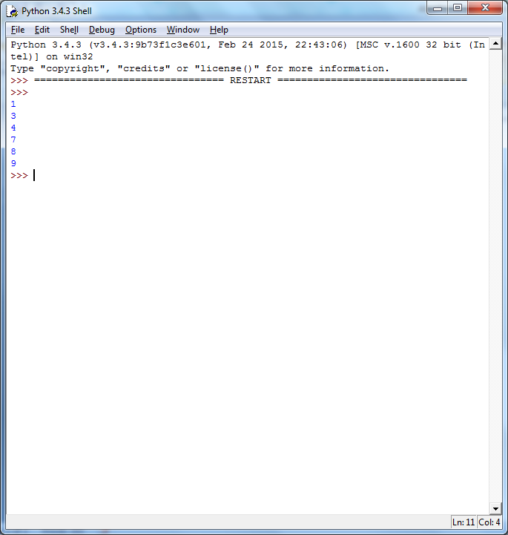

**Q.2) Write a Program for Heap Sort Algorithm**

Python program for implementation of heap Sort

# To heapify subtree rooted at index i.

# n is size of heap

def heapify(arr, n, i):

    largest = i  # Initialize largest as root

    l = 2 * i + 1     # left = 2*i + 1

    r = 2 * i + 2     # right = 2*i + 2

    # See if left child of root exists and is

    # greater than root

    if l < n and arr[i] < arr[l]:

        largest = l

    # See if right child of root exists and is

    # greater than root

    if r < n and arr[largest] < arr[r]:

        largest = r

    # Change root, if needed

    if largest != i:

        arr[i],arr[largest] = arr[largest],arr[i]  # swap

        # Heapify the root.

        heapify(arr, n, largest)

# The main function to sort an array of given size

def heapSort(arr):

    n = len(arr)

    # Build a maxheap.

    for i in range(n, -1, -1):

        heapify(arr, n, i)

    # One by one extract elements

    for i in range(n-1, 0, -1):

        arr[i], arr[0] = arr[0], arr[i]   # swap

        heapify(arr, i, 0)

# Driver code to test above

arr = [ 12, 11, 13, 5, 6, 7]

heapSort(arr)

n = len(arr)

print ("Sorted array is")

for i in range(n):

    print ("%d" %arr[i]),

Output:

Sorted array is

5 6 7 11 12 13

**3) Write a Program to perform Radix Sort Algorithm**

Python program for implementation of Radix Sort

# A function to do counting sort of arr[] according to

# the digit represented by exp.

def countingSort(arr, exp1):

    n = len(arr)

    # The output array elements that will have sorted arr

    output = [0] * (n)

    # initialize count array as 0

    count = [0] * (10)

    # Store count of occurrences in count[]

    for i in range(0, n):

        index = (arr[i]/exp1)

        count[ (index)%10 ] += 1

    # Change count[i] so that count[i] now contains actual

    #  position of this digit in output array

    for i in range(1,10):

        count[i] += count[i-1]

    # Build the output array

    i = n-1

    while i>=0:

        index = (arr[i]/exp1)

        output[ count[ (index)%10 ] - 1] = arr[i]

        count[ (index)%10 ] -= 1

        i -= 1

    # Copying the output array to arr[],

    # so that arr now contains sorted numbers

    i = 0

    for i in range(0,len(arr)):

        arr[i] = output[i]

# Method to do Radix Sort

def radixSort(arr):

    # Find the maximum number to know number of digits

    max1 = max(arr)

    # Do counting sort for every digit. Note that instead

    # of passing digit number, exp is passed. exp is 10^i

    # where i is current digit number

    exp = 1

    while max1/exp > 0:

        countingSort(arr,exp)

        exp *= 10

# Driver code to test above

arr = [ 170, 45, 75, 90, 802, 24, 2, 66]

radixSort(arr)

for i in range(len(arr)):

    print(arr[i]),

Output:

2 24 45 66 75 90 170 802

**4) Write a Program to Perform Bucket Sort Algorithm**

# Python3 program to sort an array

# using bucket sort

def insertionSort(b):

    for i in range(1, len(b)):

        up = b[i]

        j = i - 1

        while j >=0 and b[j] > up:

            b[j + 1] = b[j]

            j -= 1

        b[j + 1] = up

    return b

def bucketSort(x):

    arr = []

    slot_num = 10 # 10 means 10 slots, each

                  # slot's size is 0.1

    for i in range(slot_num):

        arr.append([])

    # Put array elements in different buckets

    for j in x:

        index_b = int(slot_num * j)

        arr[index_b].append(j)

    # Sort individual buckets

    for i in range(slot_num):

        arr[i] = insertionSort(arr[i])

    # concatenate the result

    k = 0

    for i in range(slot_num):

        for j in range(len(arr[i])):

            x[k] = arr[i][j]

            k += 1

    return x

# Driver Code

x = [0.897, 0.565, 0.656,

     0.1234, 0.665, 0.3434]

print("Sorted Array is")

print(bucketSort(x))

Output:

Sorted array is

0.1234 0.3434 0.565 0.656 0.665 0.897

**5) Write a Program to Perform Folyd-Warshall algorithm**

# Python Program for Floyd Warshall Algorithm

# Number of vertices in the graph

V = 4

# Define infinity as the large enough value. This value will be

# used for vertices not connected to each other

INF  = 99999

# Solves all pair shortest path via Floyd Warshall Algorithm

def floydWarshall(graph):

    """ dist[][] will be the output matrix that will finally

        have the shortest distances between every pair of vertices """

    """ initializing the solution matrix same as input graph matrix

    OR we can say that the initial values of shortest distances

    are based on shortest paths considering no

    intermediate vertices """

    dist = map(lambda i : map(lambda j : j , i) , graph)

    """ Add all vertices one by one to the set of intermediate

     vertices.

     ---> Before start of an iteration, we have shortest distances

     between all pairs of vertices such that the shortest

     distances consider only the vertices in the set

    {0, 1, 2, .. k-1} as intermediate vertices.

      ----> After the end of a iteration, vertex no. k is

     added to the set of intermediate vertices and the

    set becomes {0, 1, 2, .. k}

    """

    for k in range(V):

        # pick all vertices as source one by one

        for i in range(V):

            # Pick all vertices as destination for the

            # above picked source

            for j in range(V):

                # If vertex k is on the shortest path from

                # i to j, then update the value of dist[i][j]

                dist[i][j] = min(dist[i][j] ,

                                  dist[i][k]+ dist[k][j]

                                )

    printSolution(dist)

# A utility function to print the solution

def printSolution(dist):

    print "Following matrix shows the shortest distances\

 between every pair of vertices"

    for i in range(V):

        for j in range(V):

            if(dist[i][j] == INF):

                print "%7s" %("INF"),

            else:

                print "%7d\t" %(dist[i][j]),

            if j == V-1:

                print ""

# Driver program to test the above program

# Let us create the following weighted graph

"""

            10

       (0)------->(3)

        |         /|\

      5 |          |

        |          | 1

       \|/         |

       (1)------->(2)

            3           """

graph = [[0,5,INF,10],

             [INF,0,3,INF],

             [INF, INF, 0,   1],

             [INF, INF, INF, 0]

        ]

# Print the solution

floydWarshall(graph);

Output:

Following matrix shows the shortest distances between every pair of vertices

0 5 8 9

INF 0 3 4

INF INF 0 1

INF INF INF 0

**6) Write a Program for Counting Sort Algorithm in python**

Python program for counting sort

# The main function that sort the given string arr[] in

# alphabetical order

def countSort(arr):

    # The output character array that will have sorted arr

    output = [0 for i in range(256)]

    # Create a count array to store count of inidividul

    # characters and initialize count array as 0

    count = [0 for i in range(256)]

    # For storing the resulting answer since the

    # string is immutable

    ans = ["" for _ in arr]

    # Store count of each character

    for i in arr:

        count[ord(i)] += 1

    # Change count[i] so that count[i] now contains actual

    # position of this character in output array

    for i in range(256):

        count[i] += count[i-1]

    # Build the output character array

    for i in range(len(arr)):

        output[count[ord(arr[i])]-1] = arr[i]

        count[ord(arr[i])] -= 1

    # Copy the output array to arr, so that arr now

    # contains sorted characters

    for i in range(len(arr)):

        ans[i] = output[i]

    return ans

# Driver program to test above function

arr = "geeksforgeeks"

ans = countSort(arr)

print "Sorted character array is %s"  %("".join(ans))

Sorted character array is eeeefggkkorss

**7) Write a program for Set Covering Problem**

def set_cover(universe, subsets):

    """Find a family of subsets that covers the universal set"""

    elements = set(e for s in subsets for e in s)

    # Check the subsets cover the universe

    if elements != universe:

        return None

    covered = set()

    cover = []

    # Greedily add the subsets with the most uncovered points

    while covered != elements:

        subset = max(subsets, key=lambda s: len(s - covered))

        cover.append(subset)

        covered |= subset

    return cover

def main():

    universe = set(range(1, 11))

    subsets = [set([1, 2, 3, 8, 9, 10]),

        set([1, 2, 3, 4, 5]),

        set([4, 5, 7]),

        set([5, 6, 7]),

        set([6, 7, 8, 9, 10])]

    cover = set_cover(universe, subsets)

    print(cover)

if __name__ == '__main__':

    main()

Output:

[set([1, 2, 3, 8, 9, 10]), set([4, 5, 7]), set([5, 6, 7])]

8) Write a Program for found a subset with given sum

# A recursive solution for subset sum

# problem

# Returns true if there is a subset

# of set[] with sun equal to given sum

def isSubsetSum(set,n, sum) :

    # Base Cases

    if (sum == 0) :

        return True

    if (n == 0 and sum != 0) :

        return False

    # If last element is greater than

    # sum, then ignore it

    if (set[n - 1] > sum) :

        return isSubsetSum(set, n - 1, sum);

    # else, check if sum can be obtained

    # by any of the following

    # (a) including the last element

    # (b) excluding the last element

    return isSubsetSum(set, n-1, sum) or isSubsetSum(set, n-1, sum-set[n-1])

# Driver program to test above function

set = [3, 34, 4, 12, 5, 2]

sum = 9

n = len(set)

if (isSubsetSum(set, n, sum) == True) :

    print("Found a subset with given sum")

else :

    print("No subset with given sum")

Output:

Found a subset with given sum