Session 2, Assignment 2

# Question 1:

Write a program which accepts sequence of coma separated numbers…..???

# Answer:

values = input ("Enter numbers seprated with comas")

list = values.split (",")

print (list)

Result: Enter numbers seprated with comas1,2,3,4,5

['1', '2', '3', '4', '5']

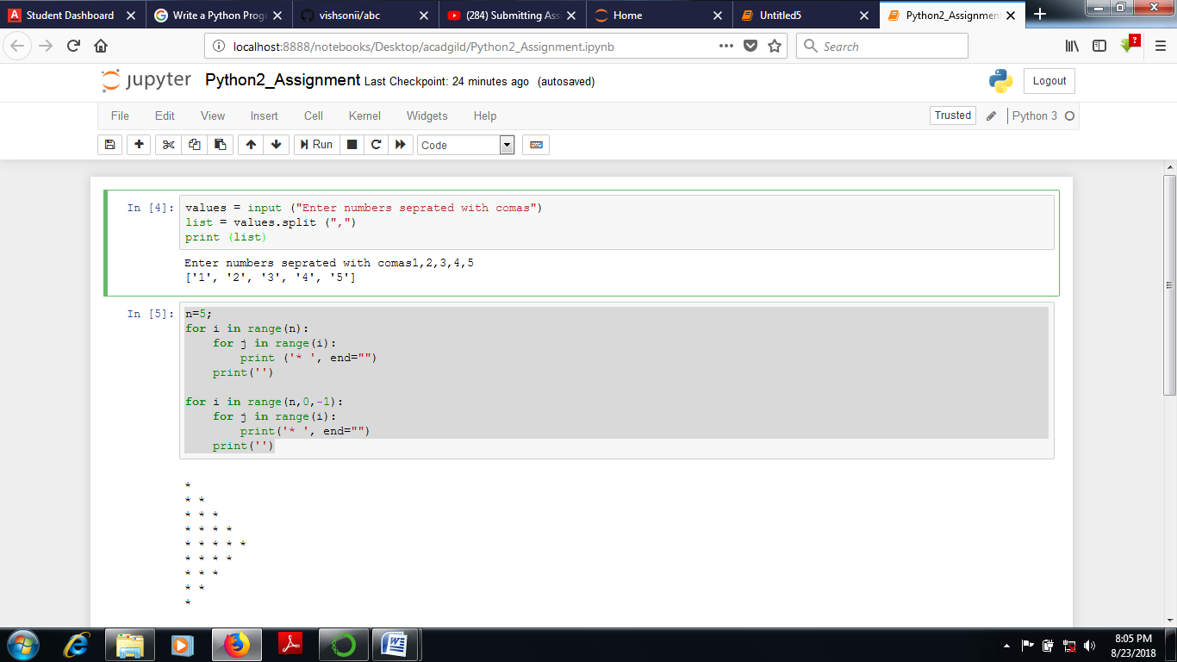

# Question 2:

Create a pattern using nested for loop

# Answer:

n=5;

for i in range(n):

for j in range(i):

print ('* ', end="")

print('')

for i in range(n,0,-1):

for j in range(i):

print('* ', end="")

print('')

# # Result

*

* *

* * *

* * * *

* * * * *

* * * *

* * *

* *

*

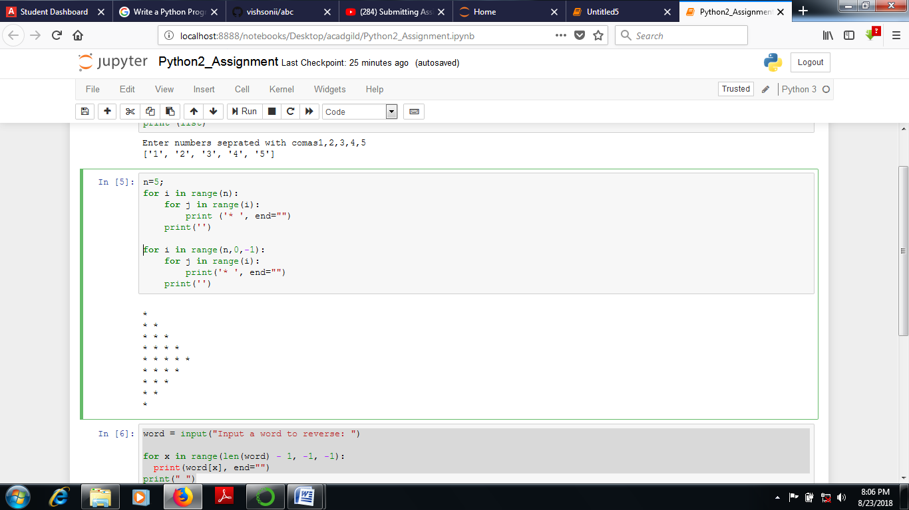

# Question 3:

Write a program to and reverse the outputAnswer:

# word = input("Input a word to reverse: ")

# for x in range(len(word) - 1, -1, -1):

# print(word[x], end="")

# print(" ")

# #Result:

Input a word to reverse: AcadGild

dliGdacA

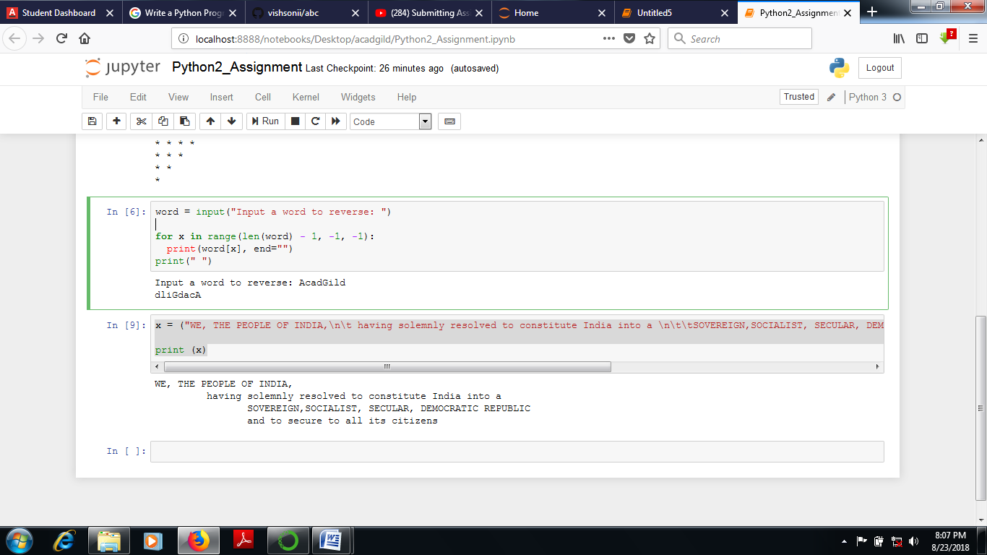

# Question 4:

Write a python program to print the given string in the format mentioned……?

# Answer:

# x = ("WE, THE PEOPLE OF INDIA,\n\t having solemnly resolved to constitute India into a \n\t\tSOVEREIGN,SOCIALIST, SECULAR, DEMOCRATIC REPUBLIC \n\t\tand to secure to all its citizens")

# print (x)

# #Result:

x = ("WE, THE PEOPLE OF INDIA,\n\t having solemnly resolved to constitute India into a \n\t\tSOVEREIGN,SOCIALIST, SECULAR, DEMOCRATIC REPUBLIC \n\t\tand to secure to all its citizens")

​

print (x)

WE, THE PEOPLE OF INDIA,

having solemnly resolved to constitute India into a

SOVEREIGN,SOCIALIST, SECULAR, DEMOCRATIC REPUBLIC

and to secure to all its citizens

