Session 1, Assignment 1

# Question 1:

Install the Jupyter notebook and run first program.

# Answer:

Installed, 1st program run:

Print (“Hello World”)

Result: Hello World

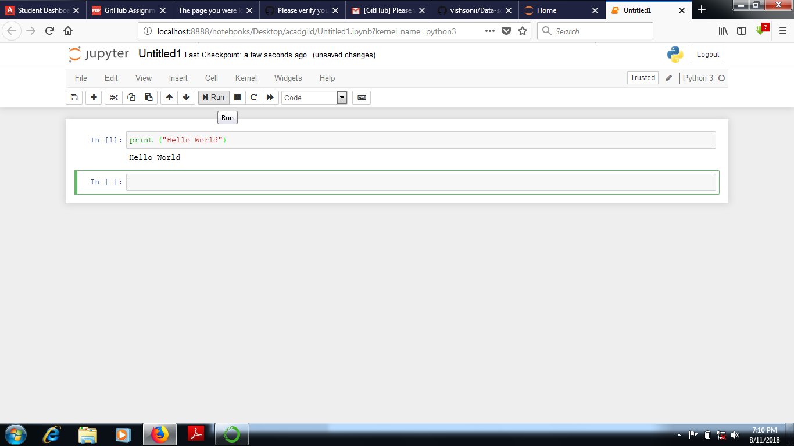

# Question 2:

Write a program which will find all numbers which are divisible by 7 and are not multiple of 5 between 2000, 3200?

# Answer:

x_list = []

for x in range(2000, 3201):

if (x%7==0) and (x%5!=0):

x_list.append(str(x))

print(','.join(x_list))

# # Result

2002,2009,2016,2023,2037,2044,2051,2058,2072,2079,2086,2093,2107,2114,2121,2128,2142,2149,2156,2163,2177,2184,2191,2198,2212,2219,2226,2233,2247,2254,2261,2268,2282,2289,2296,2303,2317,2324,2331,2338,2352,2359,2366,2373,2387,2394,2401,2408,2422,2429,2436,2443,2457,2464,2471,2478,2492,2499,2506,2513,2527,2534,2541,2548,2562,2569,2576,2583,2597,2604,2611,2618,2632,2639,2646,2653,2667,2674,2681,2688,2702,2709,2716,2723,2737,2744,2751,2758,2772,2779,2786,2793,2807,2814,2821,2828,2842,2849,2856,2863,2877,2884,2891,2898,2912,2919,2926,2933,2947,2954,2961,2968,2982,2989,2996,3003,3017,3024,3031,3038,3052,3059,3066,3073,3087,3094,3101,3108,3122,3129,3136,3143,3157,3164,3171,3178,3192,3199

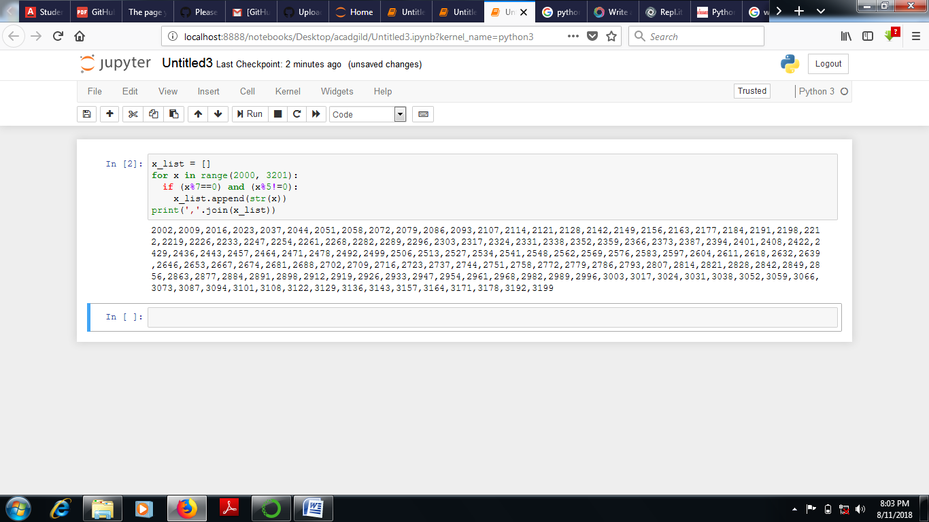

# Question 3:

Write a program to accept user 1st name and last name…………..?

# Answer:

firstname = input ("What is your first name?: ")

lastname = input ("what is your last name?: ")

print (lastname + " " + firstname)

# #Result:

What is your first name?: vishal

what is your last name?: soni

soni vishal

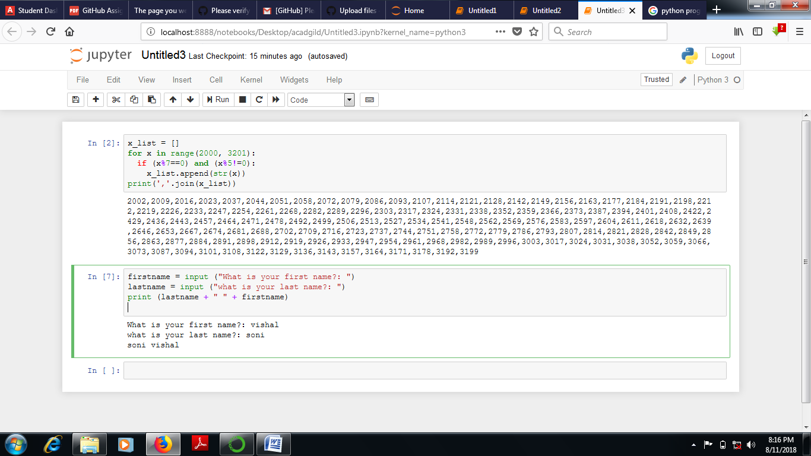

# Question 4:

Write a python program to find volume of sphere with dia 12 cm?

# Answer:

pi = 22/7

r = 12/2

dia = input ("insert dia of sphere: ")

volume = 4/3 * pi *r**3

print ("Volume is: ", volume)

# #Result:

insert dia of sphere: 12

Volume is: 905.142857142857

