Project structure 1 : resume.html

Project structure 2 : login.html

Project structure 3 : data

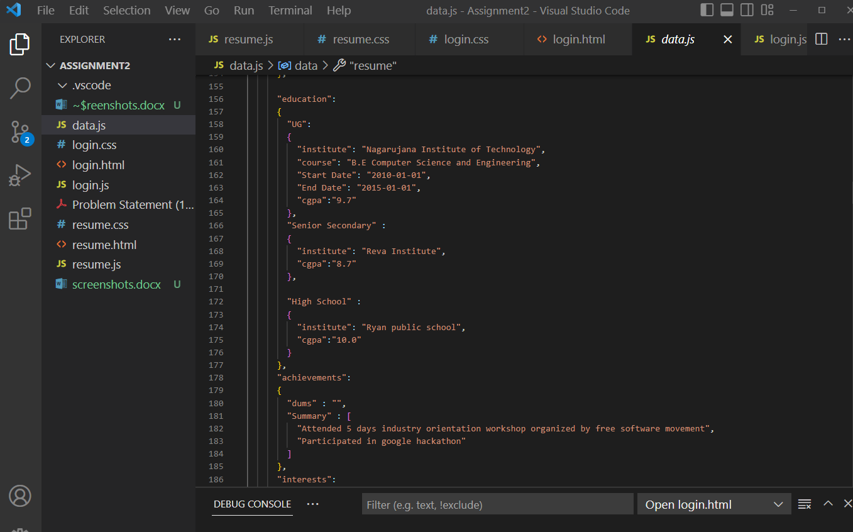

Project structure 4 : login.js

Project structure 5: resume.js

Username and password:

Invalid username/password:

Valid username password:

